Akimkhan Alua
Kazakh Ablai Khan University of
International Relations and World Languages,
Almaty, Kazakhstan
Using authentic materials to enhance communication skills in senior-level english lessons.

Abstract. The article examines the influence of authentic materials on the development of communication skills of high school students. The study, which lasted two weeks, involved 10 students aged 15-17. The classes used authentic materials such as newspaper articles, video blogs, podcasts and TV shows. The results showed a significant improvement in listening skills, fluency of speech and the use of idiomatic expressions. There was an increased motivation and interest in learning English. The article analyzes the advantages and difficulties of using authentic materials. The results confirm the effectiveness of this approach for the development of communication skills and can be used in the development of methodological recommendations for teachers.
Key words: authentic materials, communication skills, foreign language learning, a real-life materials.

INTRODUCTION
In the modern world, English language proficiency has become a vital skill for social integration and professional success. The growing need for effective intercultural communication highlights the importance of developing communication skills in high school English lessons. These skills are necessary to participate in various real-world situations, however, traditional language teaching often relies on textbooks designed specifically for educational purposes, which may not reflect the dynamic, authentic nature of the language used by native speakers. As Ahmad Faiz (2023) notes, "authentic materials provide a relevant and meaningful learning context, increasing student motivation and participation while developing their communication and linguistic skills."​
Familiarity with real life conditions through the use of authentic materials motivates students to deepen their language knowledge, bringing language education in line with the requirements of the real world (M. Zhambylkyzy and O.V. Molotovskaya, 2021). This approach not only increases the level of language proficiency, but also contributes to a better understanding of cultural nuances, idiomatic expressions and various communicative styles that are necessary for language acquisition. However, the concept of authenticity is not without problems. The traditional notion of authenticity — the simple use of "real" materials — is not enough. Instead, authenticity should be understood as a complex, context-dependent construct that develops along with the personality and experience of students (Pinner, 2016). Teachers should carefully select materials that combine linguistic complexity and accessibility so as not to overload students and distract them from the learning process.
One of the most promising solutions to this problem is the integration of authentic materials — texts, audio and video materials created for native speakers — into the English language curriculum. These materials not only improve the level of language proficiency, but also develop intercultural communication skills, which is a key component of modern education. Pinner (2016) argues that authenticity is a "dynamic, context-dependent component" that bridges the gap between the classroom and the real world, emphasizing its role in promoting student engagement and identity formation.
The main hypothesis of this article is that the systematic use of authentic materials significantly improves the communication skills of high school students. In particular, these materials enhance students' ability to understand and reproduce natural speech in authentic communicative contexts, which is consistent with the communicative approach, which argues that language is best learned through interaction in the real world (Pinner, 2016).
The aim of this article is to evaluate the effectiveness of authentic materials in the development of communicative skills. To achieve this goal, the following tasks will be solved:
- Conduct a study to assess the impact of authentic materials on students' communication skills.
- Evaluate the potential problems that teachers and students face when using authentic materials.
- Analyze the results of the study to determine the effectiveness of authentic materials.
The analysis and research plan will focus on methods of introducing such materials into the school curriculum, their impact on various aspects of communication skills, as well as strategies for solving potential problems such as the complexity of speech perception and the presence of culturally specific concepts.
METHODS
This study used a mixed methodology and approach to evaluate the effectiveness of authentic materials in the development of communication skills in English lessons for high school students. The methodology was developed to provide a comprehensive understanding of the impact of authentic materials on the linguistic and intercultural competencies of students while solving problems related to their implementation.
The study was conducted over 2 weeks in a high school English subgroup. There was used both qualitative and quantitative data collection methods. The main tools were surveys, pre-, post-tests. These methods have been chosen to provide a detailed view of the effectiveness of authentic materials and real-world classroom setting.
The research involved 10 high school students aged 15-17 years old who speak English at the Pre-intermediate level. An English teacher with at least two years of teaching experience also participated in the study. The selection of participants was based on their desire to participate and their previous familiarity with traditional teaching methods, which provided a basis for comparison.
Authentic materials were used in the study:
- Text materials: newspaper articles, blog entries and excerpts from novels written for native English speakers.
- Audio materials: podcasts, radio broadcasts and recorded interviews.
- Video materials: video clips, TV shows and YouTube videos created for an English-speaking audience.
These materials were selected based on their relevance to the interests of the students and the curriculum. To ensure accessibility, the materials were analyzed for linguistic complexity and cultural relevance.
Procedure:
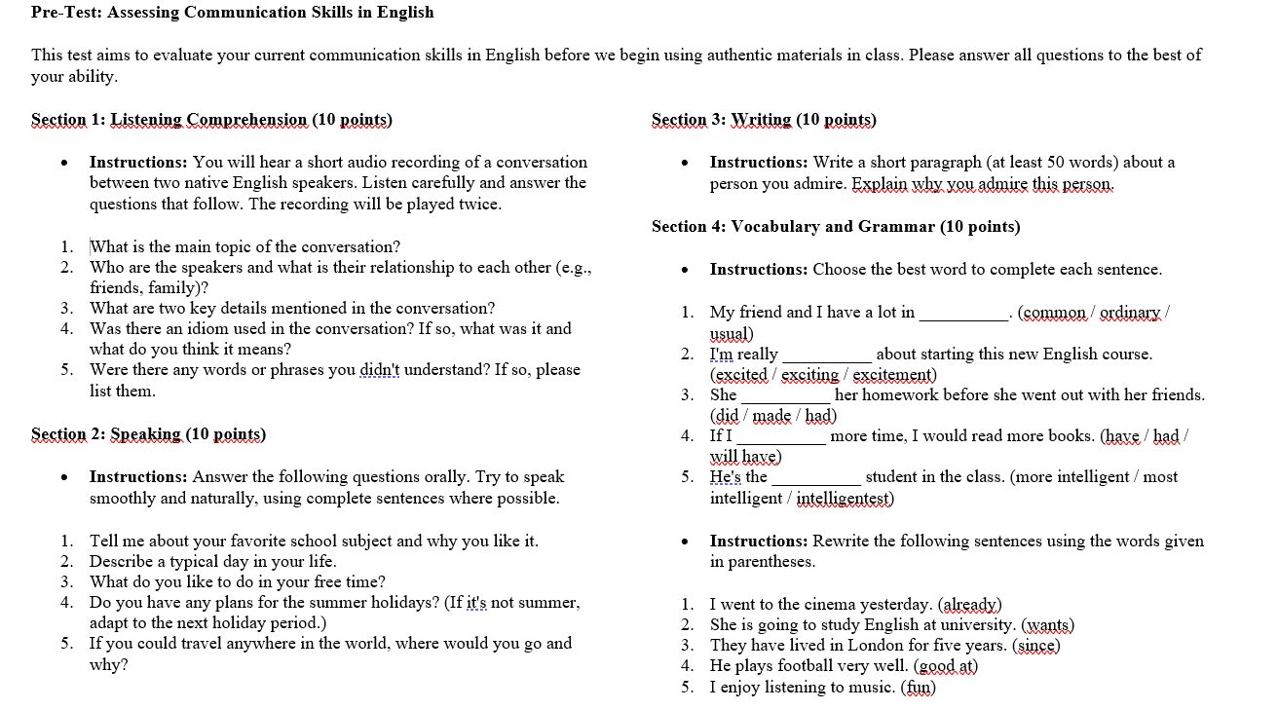
At the beginning of their studies, students took a preliminary test designed to assess their basic communication skills.
Picture -1 (Pre-Test: Assessing Communication Skills in English)
The test assessed their listening comprehension, fluency, and ability to use idiomatic expressions. Each week, students were introduced to one type of authentic material in the classroom. The classes included listening exercises, group discussions, role-playing games and written assignments based on materials. Teacher was taught about cultural nuances, idiomatic expressions and communication strategies to eliminate gaps in understanding. To ensure the success of the study, the teacher took an active part even before it began. This included collecting data to select suitable materials, design the learning process, and predict potential problems. Teacher participation was crucial because the study showed that students were more receptive to change and were eager to participate when the teacher presented them with new materials.
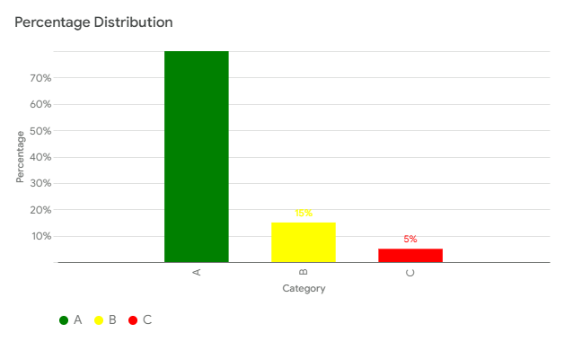
Students provided weekly feedback on materials and events through structured questionnaires. The teacher also documented their own observations and experiences through regular feedback forms. For two weeks, the teacher used authentic materials (TV shows, news, interviews) in the classroom to make learning more interesting, improve language understanding and introduce students to culture. The results of the experiment turned out to be very positive. More than 80% [Diagram -1] of students appreciated the experience of working with such materials, noting that classes have become more interesting, and the understanding of spoken language has improved. In addition, their horizons have expanded, critical thinking has developed, and in general, learning has become more immersed in the language environment.
Diagram -1 (Analysis of the research results)
Of course, there were difficulties: the selection of materials turned out to be a difficult task, because you need to take into account the level and interests of students. Some points required simplification or additional explanations, and working with authentic materials took more time than with educational ones. Nevertheless, the teacher believes that authentic materials are an effective tool and plans to continue using them by adding new types such as movies, songs, podcasts and blogs. There are also plans to create a database of materials with tasks for different levels. The experiment was recognized as a success, and the teacher is confident that authentic materials will help him make learning even more effective.
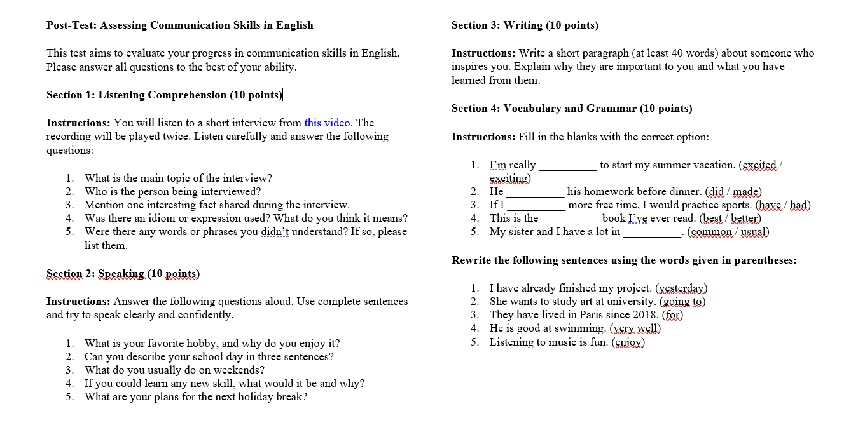
At the end of the study, the students underwent post-testing, similar in format to pre-testing. The results were compared to assess the improvement of communication skills. [picture -2]
Picture -2 (Post-Test: Assessing Communication Skills in English)
RESULTS
The analysis of the research data allowed us to draw important conclusions about the effectiveness of authentic materials in the development of communication skills in high school students. The main results are presented below, based on preliminary and subsequent testing, as well as on feedback from students using structured questionnaires.
Pre-test results:
The initial assessment served as the basis for assessing the students' communication skills. On average, students demonstrated limited abilities in the following areas:
- Understanding by ear: 45% of the students were able to accurately understand the key information contained in the audio materials.
- Fluency of speech: Students scored an average of 2.8 out of 5, reflecting frequent pauses and limited use of idiomatic expressions.
- Use of idiomatic expressions: Only 20% of the students could adequately use idiomatic expressions in oral or written assignments.
Post-test results:
After a two-week intervention using authentic materials, significant improvements were observed:
- Understanding by ear: 80% of the students demonstrated an improved ability to capture nuances and key details in audio materials, which is 35% more than in the preliminary testing.
- Fluency in spoken language: the average score increased to 4.2/5, due to reduced pauses and more natural use of language.
- The use of idiomatic expressions: 65% of students effectively used idiomatic expressions, indicating an improvement of 45%.
The introduction of authentic materials into English language teaching has led to impressive results. Students were very enthusiastic about lessons based on real materials such as TV shows, podcasts and movies, which made the classes more interesting compared to traditional ones. More than 80% of the students confirmed this. Thanks to the use of such materials, 70% of students began to better understand the cultural characteristics of English-speaking countries, and 60% noted the development of critical thinking, as they analyzed the use of language in real situations.
Of course, there were difficulties. Some students had difficulty understanding the language in authentic materials, and teachers noted that preparing for such lessons takes longer. In addition, understanding materials related to a particular culture sometimes required additional explanations.
Despite these difficulties, the results are impressive. Statistical analysis confirmed significant progress in students' language skills. Students have become more motivated and confident in using the English language. Authentic materials helped bridge the gap between theory and practice, preparing students for real communication.
In general, the use of authentic materials has proven to be an effective method of teaching English, contributing to the development of communication skills and increasing interest in the language. The teachers highly appreciated the potential of this approach and plan to include authentic materials in their curricula.
After the end of the experiment, a survey of students was conducted to identify the usefulness of authentic materials in English lessons, there were 15 questions in total. More than 80% of the students responded positively and 20% negatively.
After collecting all the data, several potential problems were identified that may arise when using authentic materials in language teaching. These problems concern both the complexity of the materials and their application in the educational process.
Problem | Description
The complexity of the language used in authentic materials | Materials often contain complex constructions and vocabulary that do not correspond to the level of students.
The presence of cultural concepts that may be unfamiliar to students | The authentic materials contained specific cultural references that were not always clear to students.
Difficulties in finding authentic materials that match the level and interests of students | Search for suitable materials for a certain level of students.
The time required to prepare lessons using authentic materials | The teacher faced temporary difficulties in adapting materials to the needs of students.
The students had difficulty understanding the language, which requires additional clarification. | The need for additional explanations to understand the cultural context of the materials took time, in the early days it took a full 50 minutes.
Table -1 (Analysis of the research results)
DISCUSSION
The results of this study provided convincing evidence of the positive impact of using authentic materials on the development of communication skills of high school students. The significant improvement in listening comprehension, fluency of speech and the use of idiomatic expressions after a two-week intervention confirms the effectiveness of authentic materials in creating a more exciting and realistic language learning environment.
The findings are consistent with previous research in this area. For example, the work of Ahmad Faiz (2023) highlights the relevance and importance of authentic materials in increasing student motivation and participation, as well as in developing their communication skills. The study by M. Zhambylkyzy and O.V. Molotovskaya (2021) also confirms the importance of using authentic materials to develop language skills in accordance with the requirements of the real world. Despite the positive results, it is important to consider the limitations of this study. The small sample size and relatively short intervention period limit the ability to generalize the results to a wider student population. In addition, the complexity of authentic materials and the presence of culturally specific concepts can create difficulties for some students, requiring additional training and explanations from the teacher.
In future studies, it would be useful to examine the impact of authentic materials over a longer period of time and with the participation of more students. It would also be interesting to conduct a comparative analysis of the effectiveness of various types of authentic materials such as movies, songs, podcasts and blogs that the teacher plans to use in the future.
Overall, this study makes an important contribution to understanding the role of authentic materials in the development of students' communication skills. Despite some limitations, the results of the study confirm the effectiveness of this approach and provide valuable information for teachers interested in using authentic materials in their teaching practice.
CONCLUSION
The conducted research has proved the effectiveness of using authentic materials in the process of teaching a foreign language in high school. The application of this approach contributes to a significant increase in the level of students' communication skills, including listening, speaking and the use of lexical units in speech. The results of the study demonstrate the positive impact of authentic materials on the motivation of students and the formation of their interest in the language being studied. The use of authentic materials allows you to create a natural language environment in the educational process, as close as possible to real communicative situations.
Despite the limited sample size and the relatively short period of the experiment, the data obtained indicate the prospects of using authentic materials in the educational process. The results of the study can serve as a basis for the development of methodological recommendations on the use of authentic materials in teaching foreign languages. Further research in this area should be aimed at studying the long-term effect of using authentic materials, as well as at identifying the best ways to integrate them into the educational process, taking into account the age and individual characteristics of students.
REFERENCES
1. Faiz, A. (2023). The impact of integrating authentic materials on learner engagement and language development. Transformational language, literature, and technology overview in learning (transtool), 2 (4), 1-7. Retrieved from https://doi.org/10.37547/ijll/Volume03Issue05-04
2. Zhambylkyzy, M., & Molotovskaya, O. V. (2021).Authentic materials in teaching English. Bulletin of the Kazakh National Pedagogical University named after Abai, 6(70), 101-107. Retrieved from DOI: 10.32523/2616-7174-2021-136-3-138-147
3. Khodjaeva, N. A. (2023). The use of authentic materials in teaching a foreign language. International Journal of Literature and Languages, 3(5), 16-19. Retrieved from https://doi.org/10.37547/ijll/Volume03Issue05-04
4. Rahimov, I. (2024). The importance of using authentic materials in EFL classes. International Journal of Pedagogics, 4(6), 97-104. Retrieved from https://doi.org/10.37547/ijp/Volume04Issue06-17
5. Al Majali, K. (2022). The effect of authentic material on the cultural awareness and motivation of Jordanian EFL learners. Bulletin of the Transylvanian University in Brasov. Series IV: Philology and Cultural Studies, 15 (64), 1-14. https://doi.org/10.31926/but.pcs.2022.64.15.1.1
6. Pinner, R. S. (2016). Reconceptualising authenticity for English as a global language. Multilingual Matters. Retrieved from https://doi.org/10.21832/9781783095681

