**МЕМЛЕКЕТТІК ЕМЕС МЕКЕМЕСІ**

**«БАСҚАРУ НЕГІЗДЕРІНІҢ МЕКТЕБІ»**

**Тақырыбы: The ecological fairy tale:**

**“Cleaning garbage!”**

**Кәріпжан Маржан**

**Ағылшын тілі пәнінің жетекшісі**

**Талдықорған қаласы**

**2021 жыл**

**The ecological fairy tail “Cleaning Garbage!”**

**Aim:** Explain environmental education of children with toys made of unnecessary materials.

**Task:** Creating toys made of unnecessary materials together with children. Teach respect for nature without polluting the environment.

**Expected result:** Environmental education of students through the disposal of unnecessary garbage. Teach nature to respect it without polluting it. If we are clean, we will be healthy.

Together with the students, we organized an ecological fairy tale as a puppet theater. The students liked and were interested in painting empty bottles and making dolls out of it. Our fairy tale is called" Do not pollute the garbage". The children played their own roles using dolls made by them.

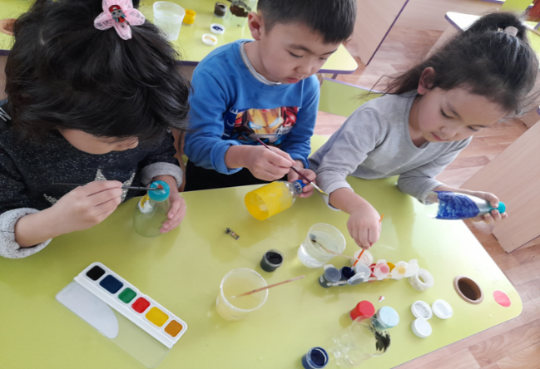 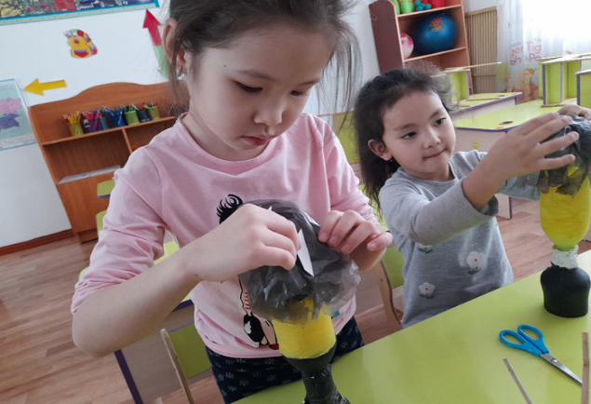

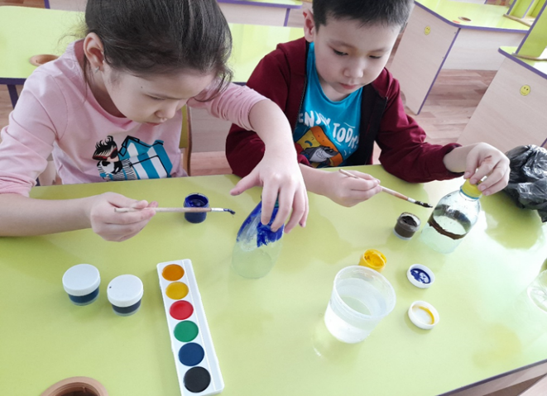 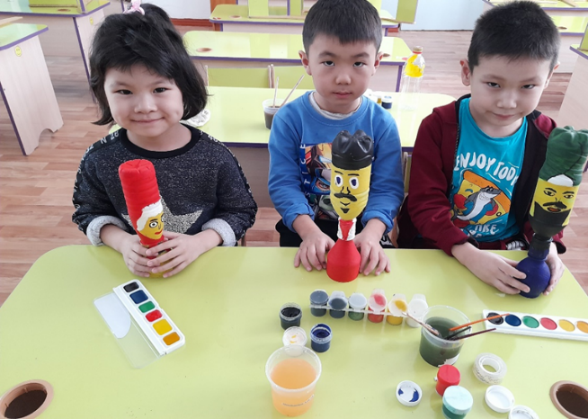

In one distant region there was one beautiful place. The mountain is green, the grass is green. The water was clean. There were many animals in the forest. People lived in peace with each other.

-Oh, neibour Hello!

-Hello! How are you?

-I am Ok. And you?

-I am Very good! Thank you!

-How about going home and drinking tea?

-Oh good idea! Let`s Go!

But people gradually became too lazy.Garbage was thrown into the forest, the water was polluted.

(Ән айтып кетіп бара жатып, Қоқыс тастап жатқан көрініс көрсетіледі.)

Seeing this, the animals left the forest. And in this place where the sun did not go out, and the rain did not fall. After hearing this, the Queen of garbage rejoiced and established her kingdom here. (қарқылдап күледі)

-Wow, there's a lot of garbage here! Now this land is my land!

People, seeing this and fearing it, quickly consult with each other.

-What we do now? All Earth is garbage!

- The Queen of garbage is terrible!

- Now she gathers terrible people here!

- And then they will drive us away.

-Oh, No! What do we do ? (басын ұстайды)

At that time, an old man said that all the garbage should be collected and cleaned immediately.

-People listen to me! This is not going to happen. If we don't find a way, we won't be here long!

- What do we do now? What are you talking about?"

- We ourselves made our land garbage. Now we have to collect everything ourselves! We need to clear our land of garbage!

- Yes, you're right!

-Yes! Let's go!

Hearing this, the Queen of garbage gets angry.

-No! Do not collect!

- Get out of our land!

- No, I'll drive you out now! People immediately began to collect brooms, shovels, and garbage bags.

-No!!!! This is my land!!! Do not touch the garbage!

People put the garbage in the sink and cleaned the water. Seeing this, the Queen of garbage, afraid of cleanliness, ran away. This place was clean and the sun was shining. The rain cleared the ground. The Beast in the forest is back. People were very happy. Now they didn't throw garbage at all.

- Our land has been cleared! -The sun came out! Уippee

-And now let's all have tea!

–Good Idea!!!