Zarechnyi school-lyceum
Lesson plan
Module: | My school
Teacher: | E.Alieva
Date: | 01.12.2022
Class: 2 A | Number of students present: | Number of students absent:
Theme: | My school Days
Lesson objectives | Students will be able to:  1.Learn and practice new vocabulary  - 2.read the text  - 3.write the text about “School days”.

Plan
Этап урока/ Время  Stages | Действия педагога и ученика / Teacher’s and student’s actions | Оценивание  Assessment | Ресурсы  Resources
Beginning | 1.Organization moment  - Good morning, pupils! Сәлеметсіздер ме, балалар! Здравствуйте, дети! How are you? I`m glad to see you.Come here,make a circle.  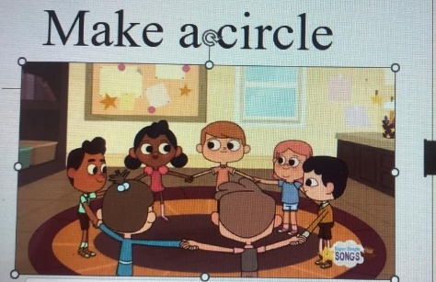  -Who is on duty today?  - What date is it today?  - What weather are we having today?  - What season is it now?  - How are you today?  Thank you,sit down .  I see you are ready to begin our lesson.I hope you will work well and ger good marks.  Today is The 1st of December  Thursday  Today we are going to talk about your school.What school subjects do we study?What are you favourite school subjects.  Phonetic drill.  Lets do the phonetics drill.Look at the interactive board .Listen and repeat after me.  . 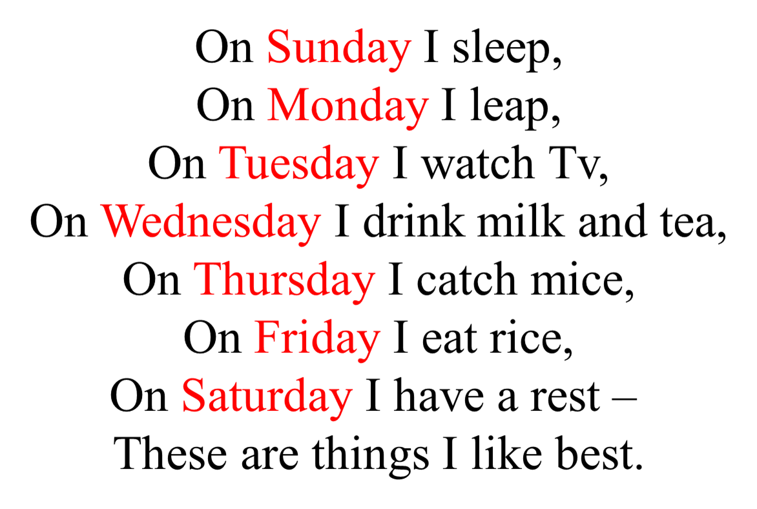  - Previous words.(Lets check your homework) to interrogate homework to the song, the guys throw the ball to each other on whom he stops and goes out, but in addition to this student, 2 more students come out: one asks questions, and the other student checks the correctness of the answer.  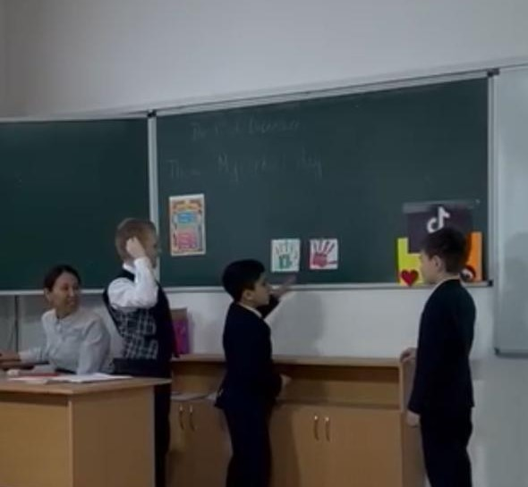 | Teacher’s assessment  Teacher’s assessment | Blackboard  PPT  Interactiveboard  PPT
Middle | 3.Introduction of the new material  Let’s learn the new words and phrases. Listen to me more attentively and repeat after me  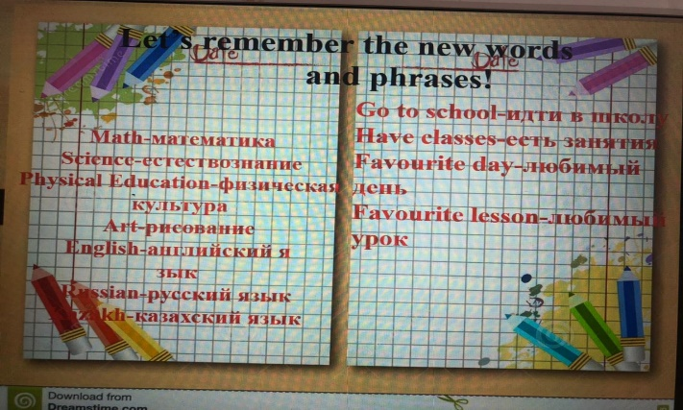  Perfect!  TASK1.Individual work  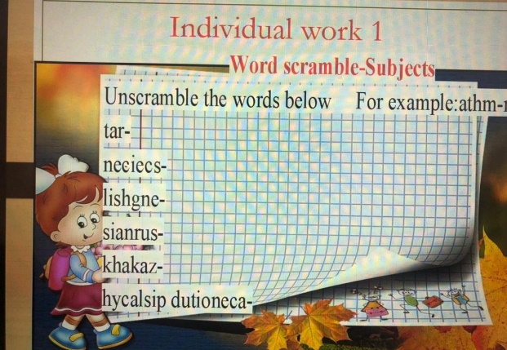  Totally 3 points  - For excellent job is 3points  - For good job is 2 points  - For satisfactory job is 1 points  TASK2.Pair work(work in pairs, students rely on new words and phrases to complement the dialogue, for this they are provided with a template to help and each pair tells their dialogue at the blackboard)  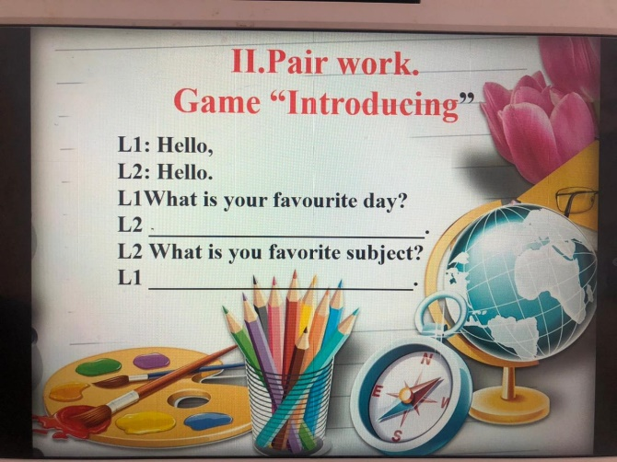  Totally 3 points  - For excellent job is 3points  - For good job is 2 points  - For satisfactory job is 1 points  Amazing!  Physical training  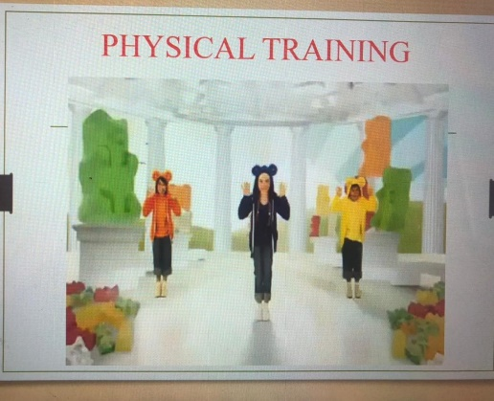  Let’s have a break and do a physical training. Repeat after the dancers.  Nicely done!  Task3.Group work  Dividing 3 groups using the box(1st group-ruler,2nd group-pen,3rd group-pencil)  Each group is given text, pictures and sentences. It will be necessary for the students to read the text about the school day and distribute the sentences for each group with a different text according to the pictures and paste it on A3 paper. Then each group goes out and defends its cluster.  Totally 4 points  - For excellent job is 3-4points  - For good job is 2 points  - For satisfactory job is 1 points  Perfect! | Teacher’s assessment  TA  Formative assessment | PPT  PPT  Worksheets,  PPT  Worksheets,
End | 6.Reflection.  Reflection in tiktok style. The students are given cards where hearts are printed (it means they liked the lesson), comments (the student writes what he liked and what he would like to change) and an arrow, that is, tell a friend if the lesson was useful and learned something new, there is a tiktok picture on the board and there are cells for each card and children choose where to put their card  Home task  *learn the new words  *do the exercise on the cards  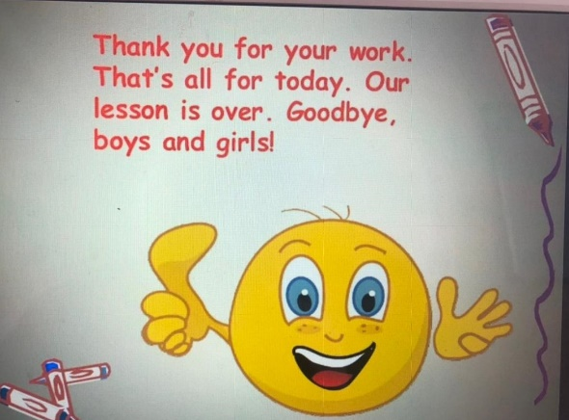 | Formative assessment! | Interactive whiteboard

