Short term lesson plan

Unit of a long term plan:  Unit 5 Our Health. Lesson plan __ |  |  | School:
Date: |  |  | Teacher's name:
CLASS: 6 A |  |  | Number present: | absent:
Lesson title |  | Food and drink.
Learning objectives(s) |  | 6.S1 provide basic information about themselves and others at sentence level on an increasing range of general topics  6.S2 ask simple questions to get information about a limited range of general topics  6.S3 give an opinion at sentence level on a limited range of general and curricular topics  6.L4 understand the main points of supported extended talk on a range of general and curricular topics  6.R5 deduce meaning from context in short texts on a limited range of familiar general and curricular topics  6.W1 plan, write, edit and proofread work at text level with support on a limited range of general and curricular topics  6.W5 link without support sentences using basic coordinating connectors
Lesson objectives |  | All learners will be able to:  - Identify the theme, new words and use them as the basis for discussion.  - Demonstrate knowledge for usage of the structures: there is/ are, lots of, a lot of, some, much/ many for making stories about eating habits. Transfer information from the given information into a graphic organizer.  - Be able to separate healthy and unhealthy food  Most learners will be able to:  - Select, compile, and synthesize information for an oral presentation  - Provide a point of view in conversations and discussions; speak about school lunch.  Some learners will be able to:  - Respond to and discuss the reading passage using interpretive, evaluative and creative thinking skills.  - Make a presentation about your school lunch and canteen. and after Respond to and discuss the reading passage using interpretive, evaluative and creative thinking skills.  - Make a presentation about your school lunch.
Level of thinking |  | Higher order thinking skills (according to the revised Bloom's taxonomy).
Assessment criteria |  | - Read the given text of description and identify the general information.  - Demonstrate skills of organizing and expressing ideas accurately.  - Illustrate a viewpoint in a discussion.
Target language |  | Salad, chips, soup, sweets, fish, apple, bread, rice, pasta, nuts, eggs, burger, crisps, sandwich. fussy drinks, juice, ice cream, meat, school meals.
Values links |  | Responsibility, Global Citizenship, Respect and Love to people and school, Care to modern technology, Love to nearest and dearest.
Cross-curricular links |  | Social Science, Psychology, Information Technology, Art, Medicine.
Previous learning |  | Vocabulary relating to people's activity, school and school subjects.
Plan
Planned timings | Planned activities (replace the notes below with your planned activities) |  |  |  | Resources
Start  2 min.  3 min  2 min  1 min  3 - 4 min  Main part  10 min  3 min  10 min  3 min | Class organisation  Hello song.  Emotional mood ( Are you …..? )  Tongue twist.  Check homework. (Assessment)  Pre-learning (W)  The lesson greeting.  The teacher sets the lesson objectives, letting students know what to anticipate from the lesson.  The teacher shows the picture and introduces the objectives of the lesson.  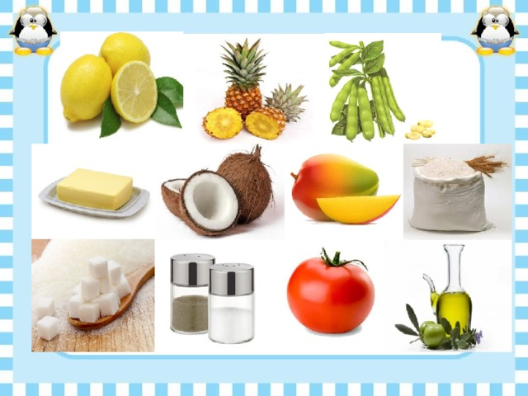  Warm up. Free talk.  What do you usually eat and drink for breakfast?  - I usually eat ….. drink …..  On the blackboard you can see the types of food.  Please, make 2 teams and separate the word that you have.  Meat: chicken, sausage, beef,  Vegetables: potato, pea, carrot, beans, cucumber  Fruit: apple, lemon, cherry, pear  Drinks: juice, tea, water, fizzy drink, coke  Food: salad, chips, burger, bun, rise, crisps.  Look at the unknown words – practice in pronunciation.  Practice in speaking.  Make a dialogue.  method :  Face-to-face (What is your favourite food? )  Shoulder –to-shoulder (What do you like to drink?) (Assessment)  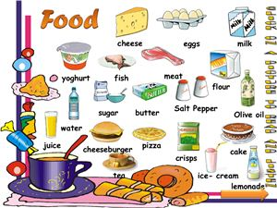  Listen attentively the next video and answer: What is the aim and main idea of this video-song?  Is your favourite food healthy?  Work in 3 small groups  - Make a poster with the healthy food  - Make a poster with junk food  - Experts. My school lunch is …..  (Usually my school lunch consists of: )  (Assessment)  Homework.  What can you eat at school? Ex.1.p.60  What are children in different countries eat for lunch?  The teacher asks Sts. whose lunch is healthy?  Ex.3 p.60. Speak about healthy and unhealthy eating. |  |  |  | Song  Box  Tongue twist.  Договорки  Pictures  PPT  Ball  Sheets with words  Speaking  Video.  Posters  Writing  Worksheet  Student Book p.60  CD2.04  Slide (Homework)
End  2 min. | Students express their attitude to the lesson and give self-assessment using the method: “ Like”: |  |  |  | Small heards  red  green  yellow

Appendix1
Teacher observation checklist
Student's name ________________________________________
Positive Aspects
- Completed the individual role-card.
- Used extracts from the text to support his/her ideas.
- Asked open-ended questions.
- Listened while others talked.
- Encouraged peers to share their ideas.
- Added his/her own comments and ideas to other student's comments and ideas.
Negative Aspects
- Didn't complete the individual role-card.
- Didn't appear to be listening or interrupted when others were speaking.
- Did not use text to support his/her opinions.
Comments _________________________________________________

