Unit 2. Family and friends |  |  |  |  |  |  | School: BIL
Date:17.11.2021 |  |  |  | Teacher name: Koigeldieva A.T.
Grade:7 B |  |  |  | Number present: |  | absent:
Theme of the lesson |  |  |  | Describing people
Learning objectives(s) that this lesson is contributing to |  |  | 7.R1 Understand the main points in texts on a limited range of unfamiliar general and curricular topics.  7.R2 Understand specific information and details in texts on a range of familiar general and curricular topics.  7.S7 Use appropriate subject-specific vocabulary and syntax to talk about a range of general topics, and some curricular topics.  7.C1 Use speaking and listening skills to solve problems creatively and cooperatively in groups.
Lesson objectives |  |  | All learners will be able to:  - understand the information about people`s appearance describe somebody`s appearance at sentence level  Most learners will be able to:  -Make sentences about people`s appearance with support  Some learners will be able to:  - describe the appearance of people based on pictures,write, connecting with the theme of the lesson, some adjectives correctly
Success criteria |  |  | Recognize common questions about somebody`s appearance Describe and establish correctly somebody`s appearance in pair or group work Make up with a little support some information about people`s appearance
Value links |  |  | National unity, peace and harmony in our society
Cross curricular links |  |  | Culture
ICT skills |  |  | Active board, cards etc
Previous learning |  |  | Present simple,singular and plural nouns
Plan
Planned timings  (minutes) | Planned activities |  |  |  |  |  |  |  | Resources
Beginning  10 | Organizational moment  Teacher greets students. Students respond to greeting and take their places.  Warm-up  - teacher distributes chocolates with a predictions for the future, the students read each of their own  1.You will be very famous singer and have a lot of fans because.  2.You will be very famous and rich and live in a big house.  3.Уou will be a great scientist and discover many scientific discoveries.  4. Уou will travel around the world and have many friends all over the world.  5. You will be the president of a large company.  6. You will be a great artist and paint famous paintings.  7.You will be a business woman and open your own restaurant.  8. You will be a doctor.  9.You will speak in 7 languages.  10. You will be very kind and help many people.  11. You will be the minister of education and science.  12. You will be an English teacher.  - learners are informed about the lesson objectives  Checking-up their home task.  - make sentences in present simple tense (affirmative, negative and interrogative)  working with curious «ˈkyo͝orēəs» cabbage (every cabbage leaf has a task)  Do you like reading books in the evening?  What time do you go to bed?  What do they like for breakfast?  What does your mom do every day?  What subjects do you study at school?  What do you like to do?  Where do you like to go with your family for the weekend?  Where do you live?  What does your friend like?  How many books do you read in month? |  |  |  |  |  |  |  | chocolates with a predictions under  A cabbage with questions
Middle  25 | Introduce new vocabulary  blue eyes – көк көз  brown eyes – қоңыр көз  black eyes – қара көз  good – looking – әдемі  long – ұзын  short- қысқа  straight – тік  wavy – толқынды  medium-length – орташа ұзындық  dark – тұйық түсті  fair – ашық түсті  a moustache – мұрт  a beard –сақал  tall – ұзын бойлы  curly- бұйра  attractive – тартымды  slim- арық  fat – толық  - Work with pictures  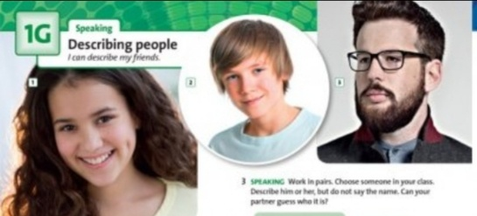  Exercise 1. Look at the photos.What do people look like? Complete the descriptions below.  1.She is good-looking with long dark __________hair.  2. He has got medium-length ___________ fair hair  3. He has got ________ dark, a beard and a moustache.  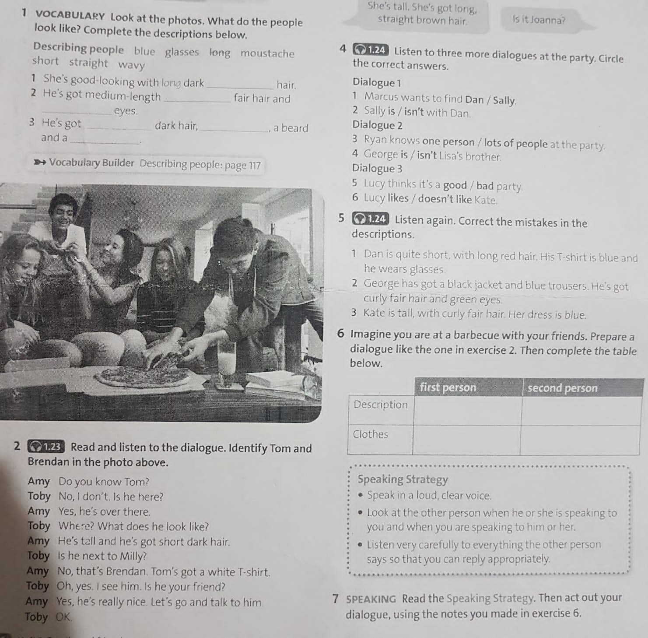  Reinforcing a lesson  Online quiz |  |  |  |  |  |  |  | interactive board  Solutions elementary 3rd edition student’s book  https://www.youtube.com/watch?v=18FBrDGngzY  https://wordwall.net/ru/resource/23436155/solutions-elementary-describing-people
End  5 | Game: «Snowball»  Home assignment:  1.Describe the members of your family.  2. Exercise 1,2,3,4,5 W/B page 16.  3. learn new words by heart.
Additional information
Differentiation – how do you plan to give more support? How do you plan to challenge the more able learners? |  |  |  |  | Assessment – how are you planning to check students’ learning? |  |  | Health and safety check  ICT links
Additional support  Supporting questions, help with vocabulary  More-able learners  Challenging questions |  |  |  |  | Monitoring of learners’ participation and answers |  |  | Varied activities (group-individual, receptive-productive, sitting-walking)  Classroom safety rules will be discussed.
Reflection  Were the lesson objectives/learning objectives realistic? What did the learners learn today? What was the learning atmosphere like? Did my planned differentiation work well? Did I stick to timings? What changes did I make from my plan and why? |  | Use the space below to reflect on your lesson. Answer the most relevant questions from the box on the left about your lesson.
Summary evaluation
What two things went really well (consider both teaching and learning)?
1:
2:
What two things would have improved the lesson (consider both teaching and learning)?
1:
2:
What have I learned from this lesson about the class or individuals that will inform my next lesson?

