Lesson plan

Unit of a long term plan Body parts |  |  |  |  | School: Body parts
Date: |  |  |  |  | Teacher name:
CLASS: 3 |  |  |  |  | Number present: |  |  | absent:
Lesson title |  |  | Body parts
Learning objectives(s) that this lesson is contributing to (link to the Subject programme) |  |  | 3.S2 ask questions to find out about present experiences on a limited range of general and some curricular topics  3.R5 understand the main points of short simple texts on a limited range of familiar general and some curricular topics by using contextual clues  3.UE1 use singular nouns, plural nouns – including some common irregular plural forms;
Lesson objectives |  |  | All learners will be able to list active vocabulary on the topic “Body parts’’ in 2-3 sentences using singular and plural nouns  Most learners will be able to practice active vocabulary on the topic ‘’Body parts’’ using singular and plural nouns in 3-4 sentences  Some learners will be to present a topic using active vocabulary ‘’Body parts’’ using singular and plural nouns in 5-6 sentences
Assessment criteria |  |  | A learner can name active vocabulary on the topic “Body parts’’ in 2-3 sentences using singular and plural nouns
Language
objective
Values links |  |  | Respect each other, support, creativity
Cross-curricular links |  |  | Lesson is connected with Biology
Previous learning |  |  | Animals
Plan
Planned timings |  | Planned activities (replace the notes below with your planned activities) |  |  |  |  | Resources
Start  3 min  5min |  | Greeting.  Activity 1. Creating positive atmosphere (method Compliment)  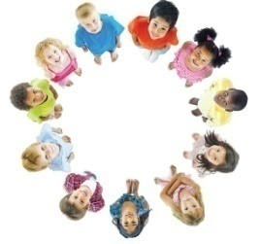  Descriptor: Learners make a big circle and wish each other good work to the lesson.  Activity2 .Division into groups (Puzzle method)  Descriptor: Learners choose the card and find your group.(by cards)‘’Puzzle method’’  The first group – Rabbit  The second group - Fox  Activity 2.Introduction with the name of the lesson (method Brainstorming)  What do you know about your body? What does the monster look like?  Has it got any hands?    Descriptor: Learners answer the questions , make 2-3 sentences and guess the title of the lesson.  We have got eyes and we can see.  We have got ears and we can hear.  We have got legs and we can walk.  We have got mouths and we can talk.  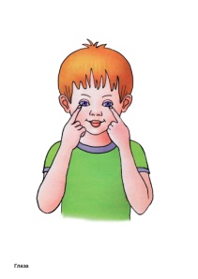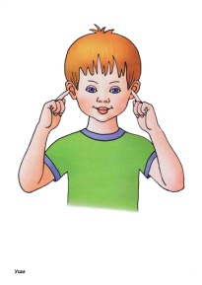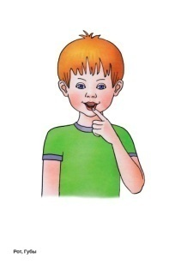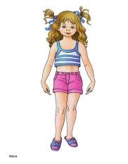  Descriptor: Learners answer the questions and guess the title of the lesson.The pupils repeat, chorally and/or individually. |  |  |  |  | https://magazineclonerepub.blob.core.windows.net/mcepub/533/151775/image/5a6df490-b2da-4fb2-b73a-84a857402e18.jpg  https://yandex.kz/images/search?text=картинка%20монстрика%20для%20детей&stype=image&lr=10295&source=wiz  http://dochkiisinochki.ru/kartochki-chasti-tela-dlya-detej.html
Middle  30 min |  | Activity 1. Introduction with new words.  Task 1. Speaking Compose (method)  Listen to the teacher and repeat the new words.  Descriptor: Learners listen to the teacher and repeat the new words.  Activity 2 . Review active vocabulary.  (method “Matching”)–group work  Task 2.Match the words with their translations  hair ноги  legs нос  nose глаза  head уши  hands рот  ears голова  mouth кисть руки  eyes волосы  Descriptor: Learners get worksheets with words and their translations; match the words with their translations.  Descriptor: Answer keys:  hair ноги  legs нос  nose глаза  head уши  hands рот  ears голова  mouth кисть руки  eyes волосы  Assessment by praising words (Very good, well done, excellent, etc.)  Activity2 Complete and choose the sentences Use have got or has got.  The first group choose and complete the sentences using the verb Have got  The second group choose and complete the sentences using the verb Has got  1 We have got green eyes.  2 Nurlybek _______________ big hands.  3 They ___________________ brown hair.  4 I _____________________ a small nose.  5 My sister __________________ red hair.  6 You _________________ a small head  Answer keys: 1)Have got 2) Has got 3) Have got 4) Have got 5) Has got 6) Have got  Descriptor: Learners should fill in these verbs correctly.  Assessment by “up and down” (excellent, well done, bad.)  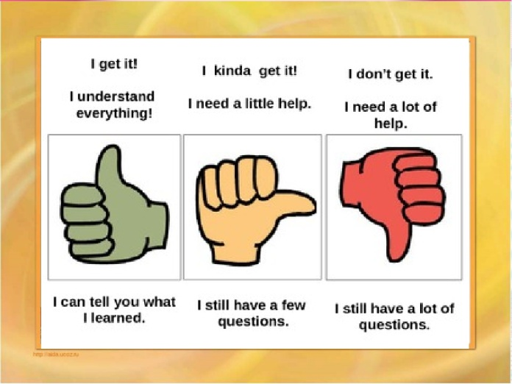  Dynamic pause “Head, shoulders, knees”  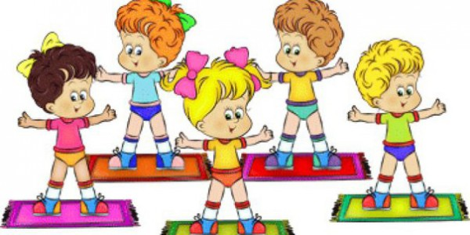  Descriptor: Learners listen to the song and do the actions  Activity3 Read the text and find the nouns.  The first group in singular form  The second group in plural form  Our body  What do you know about your body? The human body (man's body) is very beautiful. It consists of arms, legs, a trunk, a head, a neck and so on. The eyes help us to see, the ears help us to hear, the mouth and lips help us to speak and eat food.  All people have different faces. There are two eyes, a nose, a mouth on our face. We have hair, a neck, two shoulders, ten fingers, ten toes, ten nails, two feet, two knees, two cheeks, two eyebrows, a forehead, a chin.  Everybody has his/her own skin. It comes in many colors. People who live in Africa have brown or black skin. People who live in Europe have white skin.  Our hair can be straight or curly, long, short, dark, blonde, gray.  Humans have muscles, fat, bones, joints.  There are two kidneys, two lungs, a heart, a stomach, a liver and other organs in humans’ bodies.  There are 32 teeth and one tongue in our mouth. Some people (kids and adults) lose some of their teeth, so they don't have 32 teeth.  Descriptor: Learners read the text and find the nouns.  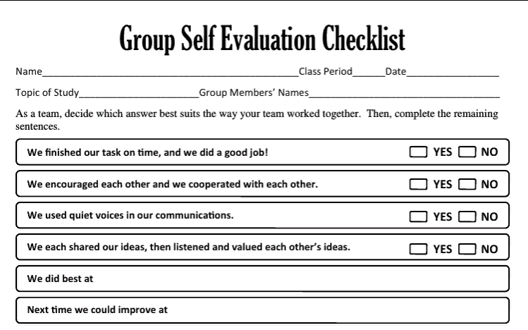  Formative assessment: group self-assessment by checklist “plus-mines”  Descriptor: Learners assess the other group using group self evaluation checklist. |  |  |  |  | Slide1  Worksheets  Pupils book p.7  https://youtu.be/h4eueDYPTIg  https://www.fabishek.com/2016/04/chasti-tela-korotkie-teksty-na-anglijskom-dlya-detej-i-nachinayushhix/  Worksheets  https://ds05.infourok.ru/uploads/ex/10bf/0008ea5e-d7ac7cd3/hello_html_f5d0f32.png
End  3 min |  | Feedback  Activity1.Reflection“traffic light”.  - Color the traffic light into green if the learner understood everything learned at the lesson.  - Color the traffic light into red if the learner did not understand everything learned at the lesson.  - Color the traffic light into yellow if the learner partly understood what learned at the lesson.  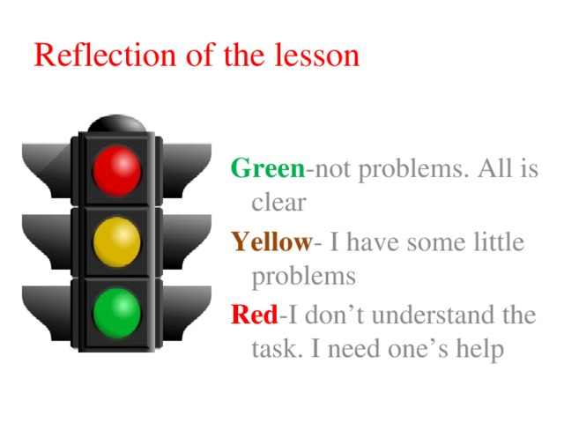 |  |  |  |  | https://arhivurokov.ru/kopilka/uploads/user_file_570dcb7b58822/img_user_file_570dcb7b58822_17.jpg
Additional information
Differentiation – how do you plan to give more support? How do you plan to challenge the more able learners? |  |  |  | Assessment – how are you planning to check learners’ learning? |  | Health and safety check
Differentiation by outcome (according to the lesson objectives)  Differentiation by task (according to the learner’s knowledge level)  Differentiation by ability (according to the learner s’ ability) |  |  |  | - Teacher assessment - recommendation and praising words – during the lesson  -Assessment by up and down (excellent, well done, bad)  - Group self-assessment by checklist “plus-mines” |  | ICT technology is used no more 15 minutes.  Dynamic pause in the middle of the lesson help to relax  Learners are paid attention to the rules of sitting at the table
Reflection | Use the space below to reflect on your lesson. Answer the most relevant questions from the box on the left about your lesson.
Summary evaluation

What two things went really well (consider both teaching and learning)?

1:

2:

What two things would have improved the lesson (consider both teaching and learning)?

1:

2:

What have I learned from this lesson about the class or individuals that will inform my next lesson?

