Short-Term Lesson Plan

Unit: Feelings
Teacher’s name:
Date:
Grade: |  | Number present: |  |  | Number absent:
Theme: Let’s speak about feelings and emotions!
Learning objectives that this lesson is contributing to: |  | 8.1.4.1 evaluate and respond constructively to feedback from others  8.3.1.1 use formal and informal registers in their talk on a growing range of general and curricular topics  8.2.3.1 understand with little or no support most of the detail of an argument in extended talk on a wide range of general and curricular topics
Lesson objectives: |  | - talk about feelings and emotions  - make up sentences with given words  - make predictions on the given task  - ask and answer questions on the theme  - use analytic skills managing the task
ICT and materials |  | - projector  - voting cards (green and red per student)  - laminated cards (1 per student)  - whiteboard marker (1 per student)
Lesson Procedure
Lesson Stage/  Time | Teacher’s Actions |  | Students’ Actions | Assessment |  | Resources
Beginning  (7 min)  2 min  5 min | Greetings  The teacher greets students and sets the goals and criteria of the lesson.  Lead-in: Guess the theme via voting  The teacher calls out the words and asks students to raise a green card for a positive meaning and a red card for a negative meaning. At the end of the activity the teacher offers students to guess the theme.  E.g.: nervous, generous, greedy supportive, selfish, caring, etc. |  | Students greet the teacher and each other.  Students listen to the words and raise a green card for a positive meaning and a red card for a negative meaning. At the end of the activity students guess the theme. | Frontal-Individual Assessment: Voting
Middle (33 min)  7 min  5 min  5 min  5 min  6 min  5 min | Speaking task 1: How are these people feeling?  - The teacher displays photos of people, who are expressing different emotions, on the board. The teacher asks students to describe the photos using the given words and the plan.  Words:  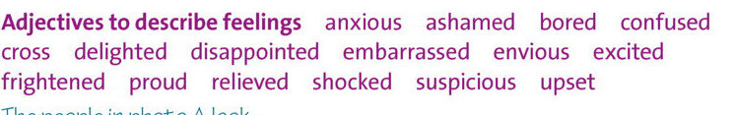  Plan:  Speaking task 2/a: Can you read people’s emotions?  - The teacher displays a test on the screen or gives students a paper variant of the test. The teacher gives students several minutes to cope with the task and then asks them to write their answers on the laminated cards. This frontal-individual assessment allows checking all students at the same time.  E.g.:  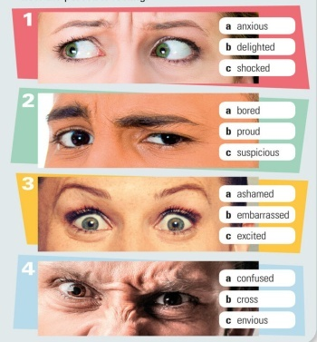  Speaking task 2/b: What makes you..?  - The teacher tells students to ask each other in chain the question “What makes you + emotion from Speaking task 2/a?” The teacher encourages students to use the following structures in their answers (the teacher writes them on the board):  - Noun + make(s) me …  - V_{ing} + make(s) me …  E.g:  - What makes you anxious?  - A test makes me anxious.  Speaking task 3: How do you feel when?  - The teacher asks students to work in pairs asking and answering each other the given questions (the questions can be displayed or printed). The teacher encourages students to use modifying adverbs in their answers (the teacher writes them on the board). The teacher monitors the class checking the students’ work.  Questions:  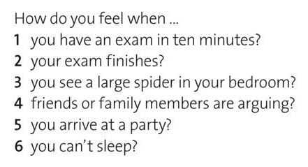  Modifying adverbs: a little bit,  a bit, rather, very, extremely  E.g.:  St1: How do you feel when you take a test?  St2: I feel a bit nervous.  Speaking task 4: Idioms  - The teacher asks students to look at the list of idioms and match them with the feelings they mean. After that the teacher offers students to take time to make sentences with the idioms. The teacher also asks students to use the construction “it makes me” and modifying adverbs.  Idioms:  # Idiom Feeling  1 to rack one’s brains to be confused  2 to get on one’s nerves to be annoying  3 to get butterflies in one’s stomach to be excited  4 to be tight-fisted to be greedy/stingy  5 to get a lump in one’s throat to be worried  6 to make one’s blood boil to make smb angry/furious  E.g.: Load music gets on my nerves. It makes me rather annoying.  Speaking task 5: Additional vocabulary.  - The teacher asks students to read the words and do differentiated tasks.  Differentiation:  - more-able students give the definitions to the words;  - less-able students translate the words.  Words: to be disorganized, to be a procrastinator, to be oversensitive, to be hot-tempered, to be negative, to be controlling, to be a perfectionist |  | Students work as a class. They describe the photos using the given words and the plan.  Students examine the test, answer the questions and write their answers on the laminated cards.  Students work in chain asking and answering the question “What makes you + emotion from speaking task 2/a?”. Students use the given structures in their answers.  Students work in pairs asking and answering each other the given questions. They use modifying adverbs in their answers.  Students look at the list of idioms and match them with the feelings they mean. Then they take time to make sentences with the idioms. They also use the construction “it makes me” and modifying adverbs.  Students read the words and do differentiated tasks. | Class Assessment  Frontal-Individual  Assessment: Laminated cards  Chain-Assessment  Monitoring Assessment  Frontal Assessment  Frontal-Assessment |  | Photos of people with different emotions  Test (slide or printed)  Displayed or printed questions  List of idioms  List of words
End (5 min) | Reflection  The teacher asks students the question: - What is your biggest shortcoming?  Feedback  The teacher asks students to use their laminated cards and a marker to draw their feeling/emotion at the end of the lesson. |  | Students answer the question: - What is your biggest shortcoming?  Students use their laminated cards and a marker to draw their feeling/emotion at the end of the lesson. | Chain-Assessment  Frontal-Individual  Assessment: Laminated cards

