INDEPENDENT WORK
on the educational p rogram of professional development training course for teachers "Development of professional competencies of a teacher of English"

Scaffolding strategies in ELT
Course participant:
AlmagulMakhmetovaKarataevna
Occupation: teacher
Place of work: Aiyrtau district
Birlestik Secondary School
Introduction.In education, there are several different ways to teach and learn. Every student has their own preferred method to absorb information. When it comes to knowledge, the general idea is that you should be able to learn how to do something new and then be able to do it independently. This concept refers to the scaffolding method of teaching. Becoming an independent learner is an important development for students. They begin to take responsibility for their own learning and become self-motivated.That is why teachers are often searching for effective strategies to aid students in this process. Scaffolding is one such strategy. So, what exactly is scaffolding? And how can you use it effectively?
In my work, I will write about scaffolding strategies in ELT and how I use them in my teaching process. I will give the definition and theory, will show ways to implement scaffolding in the classroom.
Theoretical part. Back in 1976, researchers David Wood, Gail Ross, and Jerome Bruner coined the term “scaffolding” in a report entitled, “The Role of Tutoring in Problem Solving.”[See pic.1]
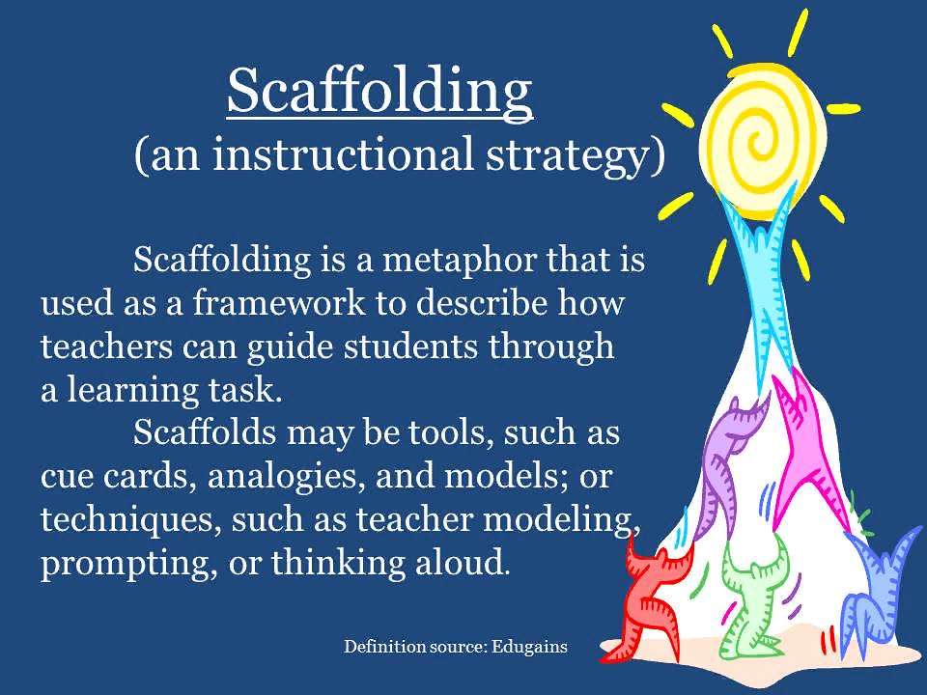
Picture1.Retrieved from: [https://media.edutopia.org/styles/responsive]The date of visite 05.04.2022.
Two years after their report, the researchers revised their theory of scaffolding. Psychologist Lev Vygotsky found that there are two important aspects to consider the scaffolding in education, namely: A child’s development level. A child’s potential development level.
In education, the mental image and symbolism is similar to grasp. A teacher acts as an “activator” who helps a student master a new concept. They use “fading,” or the process of gradually lowering their support level (or scaffolding), as a student gains hold of the new concept, process, or task.
Each child has their own level of differences between the first and the second, labeled their “proximal zone of development.” As such, scaffolding in education must target the proximal zone of development to be successful. In essence, each student may require a different level of support and fading.
The term scaffolding refers to a process of teaching. In scaffolding, teachers model or demonstrate how to solve a problem for their students. They let the students try to solve the problem themselves by taking a step back and only giving support when needed.
There are a set of training wheels to help the rider to ride a bike by first learning how to ride a bike.They are adjustable and provide the beginner rider with the necessary support. Without this support from the training wheels, the rider would likely find that bike riding is too complex a task as they have had no prior practice. The training wheels act as a scaffold and will only come off when the rider feels confident in their ability to ride a bike – which wouldn’t have happened without the wheels.
Scaffolding enables students to solve problems, carry out tasks and achieve goals independently. They can even use the knowledge they gain in the classroom and apply it to a range of situations.[See pic. 2]

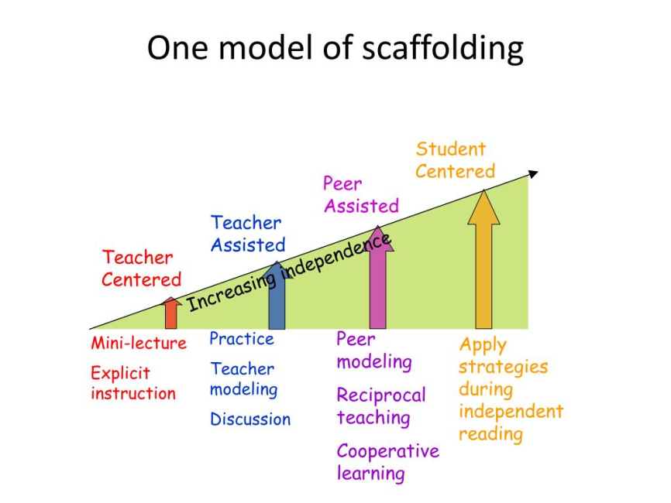
Picture 2. Retrieved from: [https://image2.slideserve.com/4920284/one-model-of-scaffolding-l.jpg] The date of visite 05.04.2022.
This therefore makes the technique likely to reduce the negative emotions that students may experience when attempting a difficult task, such as feeling demotivated and discouraged. If teachers have provided effective scaffolding strategies, then students will already have the knowledge they need to complete the task and will feel confident in their abilities.
Other benefits of scaffolding include keeping students focused and motivated and reducing anxiety that may arise due to mistakes. Whilst completing tasks or assessments, if scaffolding is provided then students will view incorrect answers as an opportunity to maximise their learning. Reflection is a highly useful skill and being able to see the positive side of what may be perceived as a negative situation will help students take advantage of their learning.
Scaffolding is an ideal way to help students bridge the gap between what they are currently able to do independently and their long-term learning goal or outcome. A student’s learning journey can be significantly enhanced through scaffolding – if provided effectively.
For it to be effective, scaffolding needs to be carefully organised to provide learners with considerable guidance. It is especially useful to students early in their learning. As their knowledge increases, these strategies should begin to fade and will gradually disappear from the teaching process as students will have become independent. This will enhance the durability of the knowledge along with how useful it is in acquiring additional skills.
Simply put, scaffolding is what you do first with kids. For those students who are still struggling, you may need to differentiate by modifying an assignment or making accommodations like choosing a more accessible text or assigning an alternative project.
In order to meet students where they are and appropriately scaffold , you have to know the individual and collective zone of proximal development (ZPD) of your learners. Education researcher Eileen Raymond says, “The ZPD is the distance between what children can do by themselves and the next learning that they can be helped to achieve with competent assistance.”
So let’s get to some scaffolding strategies that can be helpful when it comes to student learning.[See pic.3]
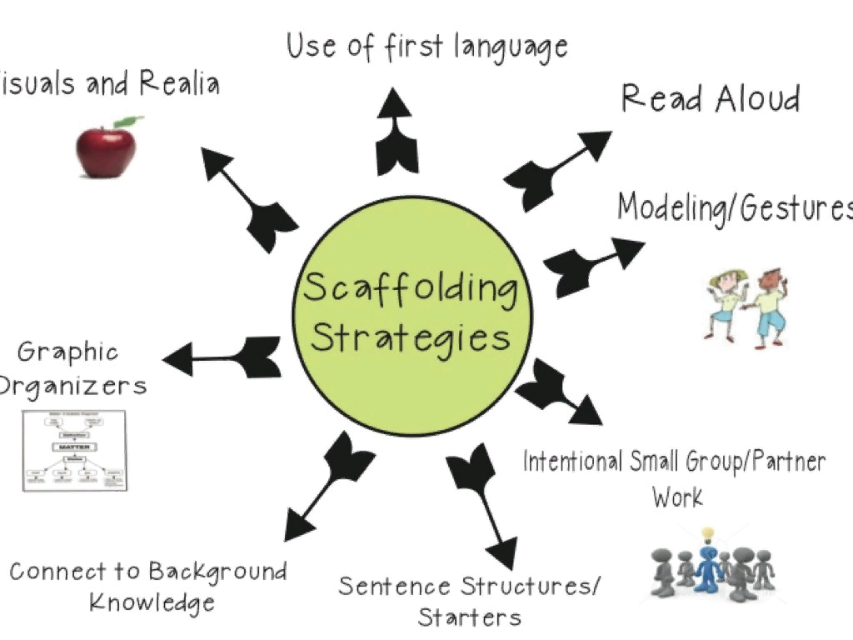
Picture 3.Retrieved from: https://img.haikudeck.com/mg/D6097974-3630-4730-9A70-769C942A99E9.jpg The date of visite 05.04.2022.
1. SHOW AND TELL
How many of us say that we learn best by seeing something rather than hearing about it? Modeling for students is a cornerstone of scaffolding, in my experience. Have you ever interrupted someone with “Just show me!” while they were in the middle of explaining how to do something? Every chance you have, show or demonstrate to students exactly what they are expected to do.
- Try a fishbowl activity, where a small group in the center is circled by the rest of the class; the group in the middle, or fishbowl, engages in an activity, modeling how it’s done for the larger group.
- Always show students the outcome or product before they do it. If a teacher assigns a persuasive essay or inquiry-based science project, a model should be presented side-by-side with a criteria chart or rubric. You can guide students through each step of the process with the model of the finished product in hand.
- Use think alouds, which will allow you to model your thought process as you read a text, solve a problem, or design a project. Remember that children’s cognitive abilities are still in development, so opportunities for them to see developed, critical thinking are essential.

2. TAP INTO PRIOR KNOWLEDGE
Ask students to share their own experiences, hunches, and ideas about the content or concept of study and have them relate and connect it to their own lives. Sometimes you may have to offer hints and suggestions, leading them to the connections a bit, but once they get there, they will grasp the content as their own.
Launching the learning in your classroom from the prior knowledge of your students and using this as a framework for future lessons is not only a scaffolding technique— hey also need time to verbally make sense of and articulate their learning with the community of learners who are engaged in the same experience and journey. As we all know, structured discussions really work best with children regardless of their level of maturation.
If you aren’t weaving in think-pair-share, turn-and-talk, triad teams, or some other structured talking time throughout the lesson, you should begin including this crucial strategy on a regular basis.

3. PRE-TEACH VOCABULARY
Sometimes referred to as front-loading vocabulary, this is a strategy that we teachers don’t use enough. Many of us, myself included, are guilty of sending students all alone down the bumpy, muddy path known as Challenging Text—a road booby-trapped with difficult vocabulary. We send them ill-prepared and then are often shocked when they lose interest, create a ruckus, or fall asleep.
Pre-teaching vocabulary doesn’t mean pulling a dozen words from the chapter and having kids look up definitions and write them out—we all know how that will go. Instead, introduce the words to kids in photos or in context with things they know and are interested in. Use analogies and metaphors, and invite students to create a symbol or drawing for each word. Give time for small-group and whole-class discussion of the words. Not until they’ve done all this should the dictionaries come out. And the dictionaries will be used only to compare with those definitions they’ve already discovered on their own.
With the dozen or so words front-loaded, students are ready, with you as their guide, to tackle that challenging text.

4. USE VISUAL AIDS
Graphic organizers, pictures, and charts can all serve as scaffolding tools. Graphic organizers are very specific in that they help kids visually represent their ideas, organize information, and grasp concepts such as sequencing and cause and effect.
A graphic organizer shouldn’t be The Product but rather a scaffolding tool that helps guide and shape students’ thinking. Some students can dive right into discussing, or writing an essay, or synthesizing several different hypotheses, without using a graphic organizer of some sort, but many of our students benefit from using one with a difficult reading or challenging new information. Think of graphic organizers as training wheels—they’re temporary and meant to be removed.

5. PAUSE, ASK QUESTIONS, PAUSE, REVIEW
This is a wonderful way to check for understanding while students read a chunk of difficult text or learn a new concept or content. Here’s how this strategy works: Share a new idea from discussion or the reading, then pause (providing think time), and then ask a strategic question, pausing again.
You need to design the questions ahead of time, making sure they’re specific, guiding, and open-ended. (Even great questions fail if we don’t give think time forresponses, so hold out during that Uncomfortable Silence.) Keep kids engaged as active listeners by calling on someone to give the gist of what was just discussed, discovered, or questioned. If the class seems stuck on the questions, provide an opportunity for students to discuss in pairs.
With all the diverse learners in our classrooms, there is a strong need for teachers to learn and experiment with new scaffolding strategies. I often say to teachers I support that they have to slow down in order to go quickly. Scaffolding a lesson may, in fact, mean that it takes longer to teach, but the end product is of far greater quality and the experience much more rewarding for all involved.Many would agree it’s just plain good teaching.
However, research suggests that untimely fading of support can negatively affect how students learn. The process needs to be slow and gradual for students to fully reap the benefits of the scaffolding.
Here are a few effective scaffolding techniques to use in the classroom:
- Question students to check their understanding
- Break the task into smaller, more manageable parts
- "Think aloud" – verbalise the thinking process when completing a task
- Pre-teach vocabulary – introduce words to students through photos or in context with things they know and are interested in
- Use "worked examples" – this refers to a step-by-step demonstration of how to perform a task or solve a problem

Practical part.Scaffolding is a teaching method that guides students by gradually reducing teacher assistance. There is a shift of responsibility over the learning process from the teacher to the student. The temporary support it provides helps students reach higher levels of comprehension and skill acquisition that they would not be able to achieve without assistance. Scaffolding in my classroom begins when I explain information the students to understand. Then I present a problem and solve it out loud. To explain the process, I share how he or she reached the solution by explaining or sharing images of the process.The general ways to accomplish this include:
Breaking a task into smaller parts
Verbalizing the process
Promoting cooperative learning through dialogue with peers
Using prompts, coaching, or models
Show And Tell
Modelling is one of the best ways to teach because students can learn by example. In the “show and tell” method, you can solve a problem out loud by walking students through the steps. We can also try a fishbowl activity, in which we can break the students into groups and place them in a concentric circle. The students in the middle of the circle can perform the activity while teaching the students.
Leverage Prior Knowledge.
For the most part, learning in the classroom resembles practical life experiences. We can try to tap into the student’s experiences and prior knowledge when teaching new concepts. This way, they can relate their learning to their lives and use problem-solving skills.
Talk Time
Students can better remember what they learn if they have the time to absorb it and a chance to talk about it. We can break up the students into discussion groups to verbally share what they have learned.
Pre-Teach Vocabulary
Before introducing a new and challenging text to students, don't pull out any complex vocabulary.We take the time to teach these words with images or within a context they are familiar with. This way, when they come across new or complex terms in reading, they do not shy away from it and they have the prior knowledge to better absorb the information.
Use Visuals
Graphic organizers of information are guiding tools to help students process information. For example, We often use diagrams when teaching compare-and-contrast essays.
Practice Pausing
When running a lesson, we breeze through a lot of concepts at once. It’s important for me how students are absorbing the information. In this way we ask questions, pause, review” technique. While ask questions give students enough time to think about them before answering.
Describe Concepts
By using visual aids, can better explain concepts orally. At the same time, ask students to illustrate the concept themselves. This way, not only do students get a variety of ways to learn, but we are also able to check in on what’s being understood.
Promote Success
When moving on to a new subject or a more advanced concept, first explain to students the goals of the assignment. If we are able to share how this new concept builds on what a student already knows, then the students may enter the lesson with confidence and the headspace to absorb information.
Extra Tips For Application
Since scaffolding depends on a student’s proximal zone of development, it also inherently depends on a student’s age,take into account the age and individual characteristics of children.
WPre-School
Start with some guidance and modelling. Then step away I see how a young child reacts and continue modelling based on their level.
Elementary School
It can begin by teaching a concept like addition or subtraction on a whiteboard then a teacher create a game by which students get to apply the knowledge. Students can work on the problems independently while it offer help when needed.
Middle – High School
At this level, scaffolding in instruction can be passed along to the students. For example,you can introduce a topic that is controversial, or has two points of view.You candivide the class into groups that get to learn and teach about each side. Students then rely on one another to challenge and discuss points.
Higher Education
In a sense, online education is an example of scaffolding. Once students have a grasp on the software and method of learning, they can move along at their own pace and increase their knowledge. Students can work together or independently. At the high school specifically, students learn in a pedagogical model where by peers can work together to build their understanding.
Conclussion. Scaffolding in education is just one process by which instructors can teach. However, when it is done properly, there are many different ways to implement the strategy. Across different age levels and varying abilities, scaffolding can provide for an interactive and engaging environment to learn.
Scaffolding can be a successful way to teach and learn, but it does have its fair share of challenges. Some challenges include:
It requires sufficient personnel
It can be time consuming
If a teacher misunderstands a student’s level of comprehension, they may not position the student adequately to be able to learn a new concept
Instructors must be properly trained
Teachers need to give up control in fading
On the upside, when scaffolding is done properly, there are a lot of long-term benefits, including:
Improved comprehension
Enhanced problem-solving abilities
Maximized engagement by students
A positive learning environment
Increased collaboration between students and even students and teachers.
Scaffolding refers to a variety of techniques that teachers can implement in their teaching to help students become independent learners. The gradual process involves teachers removing their support when they feel the student is strong enough in their abilities to work alone. If done well, it can help reduce negative self-perceptions and enhances motivation. As a result, it can help students become independent learners.

References

1.Berk, L., &Winsler, A. (1995). Scaffolding children's learning: Vygotsky and early childhood learning.Washington, DC: National Association for Education of Young Children.
2.Dixon-Krauss, L. (1996). Vygotsky in the classroom.Mediated literacy instruction and assessment. White Plains, NY: Longman Publishers.
3.Silver, D. (2011). Using the ‘Zone’Help Reach Every Learner. Kappa Delta Pi Record, 47(sup1), 28-31.
4.Vygotsky, L. S. (1978).Mind in society: The development of higher psychological processes. Cambridge, MA: Harvard University Press.
5.Wood, D., Bruner, J., & Ross, G. (1976). The role of tutoring in problem solving.Journal of Child Psychology and Child Psychiatry, 17, 89−100.
6.Wood, D., & Middleton, D. (1975). A study of assisted problem-solving.British Journal of Psychology,

