Short-term plan Term 1  Unit 2. Values in Myths and Legends |  |  | School:№7 school-lyceum
Date:04.11.2020 |  | Teacher’s name: Khamidullaev Nurbek
Grade: 4Е,4Ж,4А,4Е |  | Number present: |  | Absent:
Theme of the Lesson:  People and Places |  | People and places
Learning objective(s) that this lesson is contributing to and assessment criteria |  | 4.L8 understand short narratives on a limited range of general and some curricular topics  4.S3 give short, basic description of people and objects on a limited range of general and some curricular topics  4.UE3 use adjectives, including possessive adjectives on a limited range of general and some curricular topics to describe things
Lesson objectives |  | All learners will be able to:  - Watch the video and understand the main points of the Story  - Identify the most familiar words and complete comprehension activities
Most learners will be able to:
- complete the tasks almost without mistakes;
- make their own story with support;;
Some learners will be able to:
- Using prediction cards retell the main pain parts of the story with little support
- make their own story with little support;;;
Assessment criteria |  | Learners have met the learning objective if they can:  Understand the main points of the text  Identify the most familiar words and complete the tasks  Complete tasks without mistakes
School’s mission, vision and Global Citizenship |  | Skills for life-long learning.  Understanding cultural diversity, being ready for intercultural communication and changes
Value links |  | Through the activities about the family and friends, learners will be taught how to be respectful and tolerant
Cross curricular links |  | Kazakh
ICT skills |  | Using video/pictures
Previous learning |  | Values in Myths and Legends
Health and safety |  | Short physical exercises in between the activities
Plan
Planned timings | Planned activities |  |  |  | Resources
Beginning | Greeting  -Good morning, students!  -Good morning, teacher!  -How are you today?  -We are fine, thank you!  -What date is it today?  -What’s the weather like today?  -It is sunny/cold/rainy today.  Warm up  Learners are given worksheets where they need to write right words under the picture.  L/o presented  Elicit boys’ names in English. Explain they’re going to watch a story. First, learners listen to the introduction. Read: Once upon a time there was a boy called Jack. He lived with his mother in the country. They had no money but they had a cow. |  |  |  | Worksheet 1
Middle | Pre watching  Story prediction  Teacher distributes worksheet, and then Ls complete the first line of the table. Teacher ask these questions and it will help keep young children engaged in the story. The questions also encourage children to form their own opinions  While watching  Speaking practice  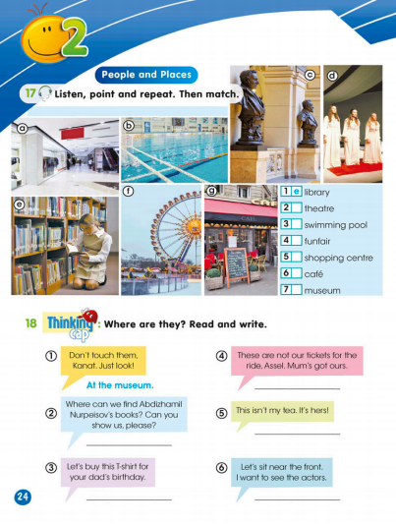  Read,translate and repeat  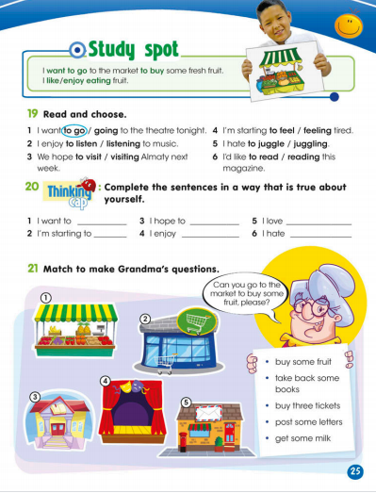  Hot seat activity. One learner is Jack and sits at front of class. Learners ask Jack questions. e.g.  How old are you? Where do you live? Have you got a brother/sister? Do you like school? What’s your favourite game? Do you like going to the market? Are you clever? Do you like giants?  Choose a different learner to ‘hot seat’ the mother then the giant.  Extra time  Formative assessment  Tick the correct sentences and put a cross next to the  wrong sentences. |  |  |  | Worksheet 2  https://youtu.be/rKB1_wBueFM  Worksheet 3  Worksheet 4
End | Plenary  Ask the children questions about the story, such as,  - "Who are the main characters?"  - "What do you like about the story?"
REFLECTION
Were the lesson objectives/learning objectives realistic?
What did the learners learn today?

What was the learning atmosphere like?

Did my planned differentiation work well?
Did I stick to timings?

What changes did I make from my plan and why?
Summary evaluation
What two things went really well (consider both teaching and learning)?
1:

2:

What two things would have improved the lesson (consider both teaching and learning)?
1:

2:

What have I learned from this lesson about the class or achievements/difficulties of individuals that will inform my next lesson?

