LESSON  Unit 7: Breakthrough technologies |  |  |  | School: School-lyceum №3
Date: |  |  |  | Teacher name: Klen O.V.
Grade: 10 |  |  |  | Number present: prppresenpresent: present: present: present: present: | Number absent:
Theme of the lesson: |  | Nanotechnology
Learning objectives |  | 10.1.1 - use speaking and listening skills to solve problems creatively and cooperatively in groups;  10.2.1 - understand the main points in unsupported extended talk on a wide range of general and curricular topics, including talk on a limited range of unfamiliar topics;  10.5.7 use appropriate subject-specific vocabulary and syntax to talk about a range of general and curricular topics  10.6.4 - use a wide variety of determiners and pre-determiner structures on a wide range of familiar general and curricular topics;
Lesson objobjectives |  | All learners will be able to:  Listen and read for gist, read for specific information,  Most learners will be able to:  Listen and read for gist, read for specific information, get an overview of a module  Some learners will be able to:  Listen and read for gist, read for specific information, talk about forms of module
Criteria |  | Listen and read for gist, read for specific information,  Most learners will be able to:  Listen and read for gist, read for specific information, get an overview of a module  Some learners will be able to:  Listen and read for gist, read for specific information, talk about forms of module
ICT skills |  | Using videos& pictures, working with URLs
Plan
Planned timings | Planned activities |  | Learners’ activities |  |  | Evaluation | Resources
Begining  5 min | GREETINGS  *Module Objectives  The teacher invites students to look at pictures, watch videos and guess what the topic of the lesson is called.  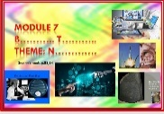  The answer:  Breakthrough technologies/ the theme: Nanotechnology and ask Ss to suggest what they think the module will be about. Go through the objectives list to stimulate Ss' interest in the module.  **Vocabulary  To introduce the module of Breakthrough technologies  Go through the words/phrases in the list and explain/elicit their meanings  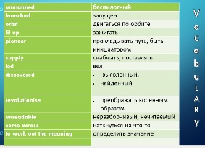  ***Watch the video (1.47 min), read four short texts and complete the sentences |  | *Learners answer that the module is about applications of Breakthrough technologies/ Nanotechnology, materials & substances, mobile apps and computer accessories & gadgets  ***Answer Key  A.1.discovered  2.revolutionised  3.led  B.1.launched  2.unmanned  3.orbit  C.1. pioneered  2.supply  3.lit up  D. 1. Came across  2. writing  3.work out  4. unreadable |  |  | Verbal evaluation | ***  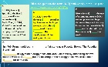  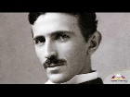
Middle  30 min | Elicit Ss' guesses as to what the text may be about (p.84-85).  ****  Play the recording. Ss listen, read and check.  2 a) To listen and read for specific information  • to ask Ss to read questions 1-6 and possible answers. Ss listen and read the text again and choose the correct answers.  • to check Ss' answers and ask them to justify them.  *****  2b) To express an opinion  Ask Ss to discuss the question in groups and justify their opinions with reasons. Then ask various Ss around the class to tell the rest of the class.  ******  Speaking.  To identify the main idea, to summarise a text:  To give Ss time to look through the text again; and find the main idea in each paragraph. To ask Ss to make notes and then give Ss time to use their notes to summarise the text. To remind that they should use their own words while writing the summary as much as possible.  To ask various Ss around the class to read their summary to the rest of the class.  To express an opinion  The teacher asks Ss to consider the questions, then elicit answers from various Ss around the class with reasons.  *******  Writing.  To work in groups.  The teacher invites Ss to make their own sentences with this grammar construction and words on the topic. |  | Ss to works in pairs and then ask share their answers with the class.  Suggested  Answer Key  I think the text could be about microscopic robots that are partly made of DNA molecules. Through molecular biology and nanotechnology they can be used for medical applications. They could be used to perform operations like miniature robot surgeons and they may be called spider-bots. They could allow many treatments that are currently not possible.  ****Ss answers:  1 D (microscopic robot... device)  2 A (understand its surrounding environment,  make decisions and move automatically)  3 В (a possible walking distance of around 100  nanometres)  4 A (One day, people could live ... with miniature  robot surgeons ... protecting the insides of their bodies.)  5 C (most of these concerns are over safety  regulations ... would like further tests to be carried out on products before they are allowed to enter the market)  6 C (these microscopic robots ... will allow  treatments to be given that are currently impossible)  *****  Suggested Answers:  A: I don't think nanobots will replace humans, but I think they will replace certain medicines and remove the need for certain surgeries.  В I disagree. I think there will be no need for doctors if we have nanobots inside us keeping us healthy.  ******  Suggested Answers  A microscopic robot was recently created by a team of researchers in the USA. They call it a nano-spider and it can crawl along molecules of DNA. It ca walk and turn and even make its own products and it is made out of DNA molecules. So far, it can walk 100 nanometres, but researchers are trying to make it walk longer distances. Nanotechnology seems to be very useful and may have a lot of medical applications. Some people are concerned about how safe nanotechnology is. A lot of money is spent oi nanotechnology and in the future scientists believe nano-robots may be able to operate on people.  *******  Ss fill the gap.  Each St describes the positive and negative effects of nanotechnology.  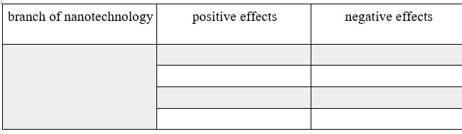 |  |  | Verbal evaluation  Mutual evaluation  Individual evaluation | ****  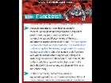
End  5 min | REFLECTION  Students reflect on the lesson completing the sentences  Homework: to learn new vocabulary units  Saying goodbye |  | Today at the lesson I …  The most useful and interesting thing was …  I was good / bad / active at … |  |  | Self-assessment

