https://bilimportal.kz/dokumentyi/svidetelstvo?paymentID=21841

Unit:  Theme:CLIL: Biology:Healthy eating  Lesson: | School: 32  Teacher Aslanova Ch.K.
Grade: 9 V
Learn objectives: | 9.3.3.1 explain and justify their own point of view on a range of general and curricular topics  9.3.7.1 use appropriate subject-specific vocabulary and syntax to talk about an increased range of general and curricular topics
Lesson objectives: | All learners will be able to:  -explain and justify their own point of view of healthy diet  -learn specific vocabulary  -learn make a cluster  Most of students will be able to:  -can explain and justify own diet  -can use new Vocabulary  -make a cluster  Some of learners will be able to:  -say the main idea of the text  -make a cluster
Criteria | -identify the main idea of the text  -identify inconsistencies in arguments in extended text
Plan
Beginning | Greetings  Teacher start the lesson with follow words: «An apple a day keeps doctor away»  Teacher asks students which work in two groups come to board and write words as many as it is possible on the board on topic «Food»
Middle | Teacher uses «Jigsaw» reading method.  Teacher gives two groups of students different paragraphs. Students read text scimming  Students start to count on the first and second.  The first group is «red group»  The second group is «blue group».  Who is the first goes to the red group.  Who is the second goes to the blue group.  Students start answer questions according to the text and help to each other.  Task 1. Teacher gives worksheet with sentence. Students choose True or False according to the text.  - The key to healthy eating is getting the balance right between the different types of food. (TRUE)  - Fast food can reduce the risk of illness such as heart disease, diabetes and perhaps even depression.(TRUE)  - Eating breakfast help to feel good throughout the day.  - Processed foods are particularly unhealthy because they1 are full of fats, sugar and salt are very high in calories.  - Our body don't need fruits, vegetables and proteins(FALSE)  Task 2. Teacher gives worksheet with the sentences. Students complete sentence with their own answer.  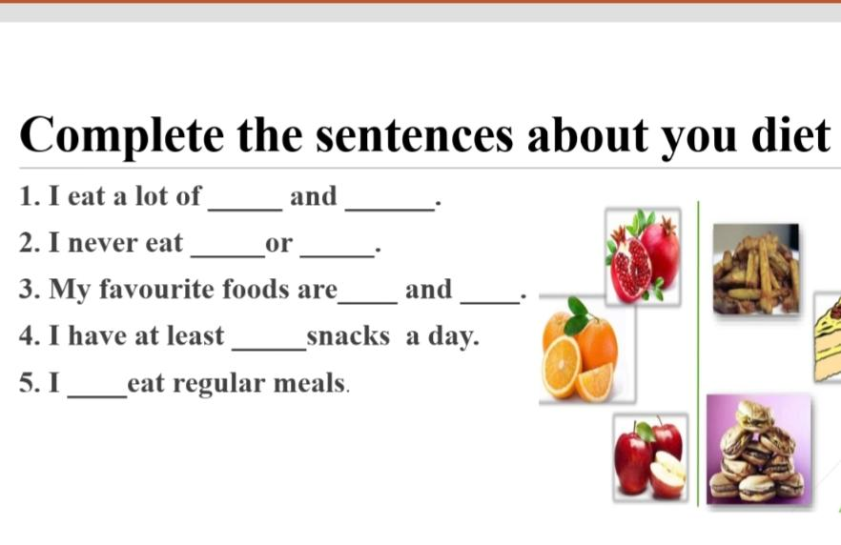  Task 3. Students make a cluster.  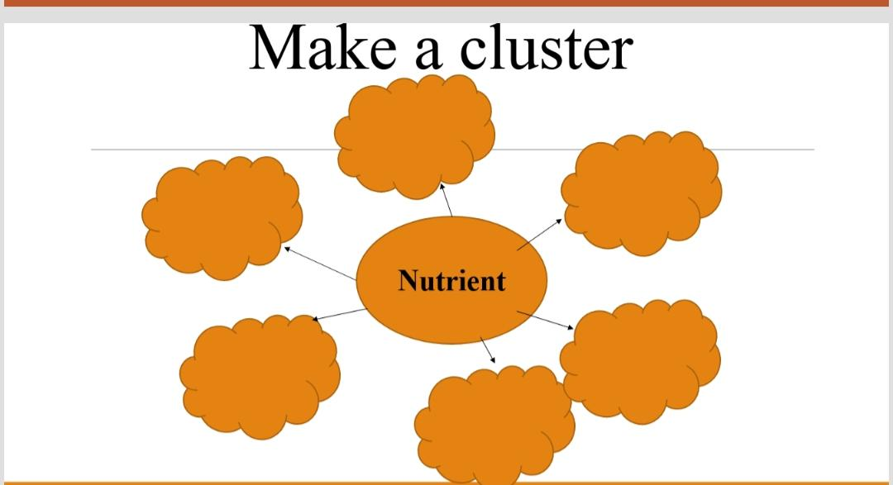
Ending | Reflection  Teacher use traffic light method.  Students say:  -understand  -difficalt  -don't understand
Home work | Students make their own diet about healthy eating

