The theme: Number system conversion
Objective of the lesson:
- to learn how computers store data;
- to convert numbers from one number system to another
The type of the lesson: combination of introduction and practice of new theme
Terminology
- Number systems - системы счисления
- binary – двоичная
- decimal- десятичная
- octal- восьмеричная
- hexadecimal - шестнадцатеричная
- the base of number system- основание системы счисления
- to convert – переводить
- to transform – преобразовывать
- to store- хранить

The procedure of the lesson
- Organizing moment.
- Introduction of the theme and objectives of the lesson.
- Entering new words.
- Presentation of the theme.
- Practical work with new theme
- Summary and home task.

1. Organizing moment
2. Introduction of the theme and objectives of the lesson.
3. Entering new words.
4. Presentation of the theme.
There are three types of conversion:
- Decimal Number System to Other Base
[for example: Decimal Number System to Binary Number System]
- Other Base to Decimal Number System
[for example: Binary Number System to Decimal Number System]
- Other Base to Other Base
[for example: Binary Number System to Hexadecimal Number System]

Decimal Number System to Other Base
To convert Number system from Decimal Number System to Any Other Base is quite easy; you have to follow just two steps:
A) Divide the Number (Decimal Number) by the base of target base system (in which you want to convert the number: Binary (2), octal (8) and Hexadecimal (16)).
B) Write the remainder from step 1 as a Least Signification Bit (LSB) to Step last as a Most Significant Bit (MSB).
Decimal to Binary Conversion | Result
Decimal Number is : (12345)₁₀  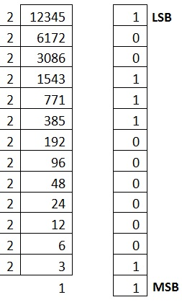 | Binary Number is  (11000000111001)₂

Decimal to Octal Conversion | Result
Decimal Number is : (12345)₁₀  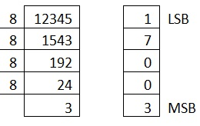 | Octal Number is  (30071)₈

Decimal to Hexadecimal Conversion | Result
Example 1  Decimal Number is : (12345)₁₀  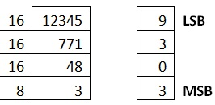 | Hexadecimal Number is  (3039)₁₆
Example 2  Decimal Number is : (725)10  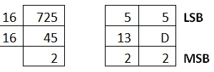 | Hexadecimal Number is  (2D5)16  Convert  10, 11, 12, 13, 14, 15  to its equivalent...  A, B, C, D, E, F

Other Base System to Decimal Number Base
To convert Number System from Any Other Base System to Decimal Number System, you have to follow just three steps:
A) Determine the base value of source Number System (that you want to convert), and also determine the position of digits from LSB (first digit’s position – 0, second digit’s position – 1 and so on).
B) Multiply each digit with its corresponding multiplication of position value and Base of Source Number System’s Base.
C) Add the resulted value in step-B.
Explanation regarding examples:
Below given exams contains the following rows:
A) Row 1 contains the DIGITs of number (that is going to be converted).
B) Row 2 contains the POSITION of each digit in the number system.
C) Row 3 contains the multiplication: DIGIT* BASE^POSITION.
D) Row 4 contains the calculated result of step C.
E) And then add each value of step D, resulted value is the Decimal Number.

Binary to Decimal Conversion
Binary Number is : (11000000111001)₂
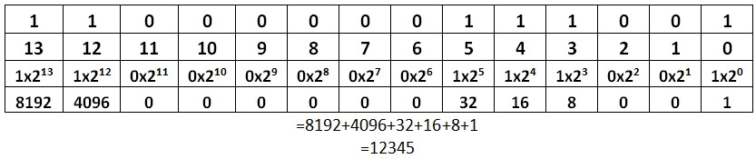

Octal to Decimal Conversion | Result
Octal Number is : (30071)₈  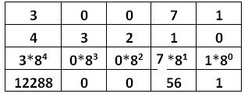 | =12288+0+0+56+1  =12345  Decimal Number is: (12345)₁₀

Hexadecimal to Decimal Conversion | Result
Hexadecimal Number is : (2D5)₁₆  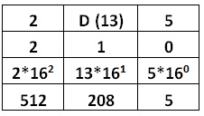 | =512+208+5  =725  Decimal Number is: (725)₁₀

5. Practical work with new theme
Task 1.
Convert numbers from decimal to binary and check your answers by converting binary back to decimal.
1. 11 = ______________
2. 17 = ______________
3. 28 = ______________
4. 255 = ______________

Task 2.
- Go to the https://quizlet.com
- Insert in the search bar: 1.2 Number system
- Click on 1.2 Number system

6. Summary, home task.
What kind of number system do you know?
What is the number system we use in our day-to-day life?
Home task: Learn the terminology and definitions and an exercise 1 on page 11

