Тема: How much does it cost? At the shop
Тип урока: практическое занятие, с применением инновационных средств обучения
Цели:
- закрепить лексические и грамматические навыки по теме;
- развивать навыки устной речи;
- воспитывать осознанное отношение к изучению языка.
Задачи:
- знать лексико-грамматический материал;
- уметь самостоятельно высказываться по теме.
Метод обучения: развивающий, эвристический
Материальное обеспечение:
- компьютер, проектор, раздаточный материал
Литература: Easy English №13, English vocabulary in Use (pre-intermediate and intermediate)
Ход урока
Организационный момент
- Приветствие
- Постановка целей урока, сообщение темы и плана урока
Проверка домашнего задания
Лексический состав языка на тему: «At the currency exchange money»
1. Cost
2. Exchange
3. Change
4. Cash
5. Pay by credit card
6. Currency

Основная часть урока
Объяснение нового материала:
Types of shops
Bakery
Greengrocer’s
Chemist’s
Grocery
Clothes shop
Newsagent’s
Stationer’s
Butcher’s
Post office
Book shop
Gift shop
Exercise 1. Where do you need to go? Give some advice to your friend: you need to go to…
1. I want to get a newspaper.
2. I’d like to buy food for a week.
3. I need some stamps.
4. We must get Jim a present.
5. I’d like to buy a book.
6. I want to buy some clothes for myself and my children in one shop.

Measures and sizes:
A kilogram of
Half a kilo of
A quarter of
A packet of
A stab of
A bar of
A loaf of
Idioms
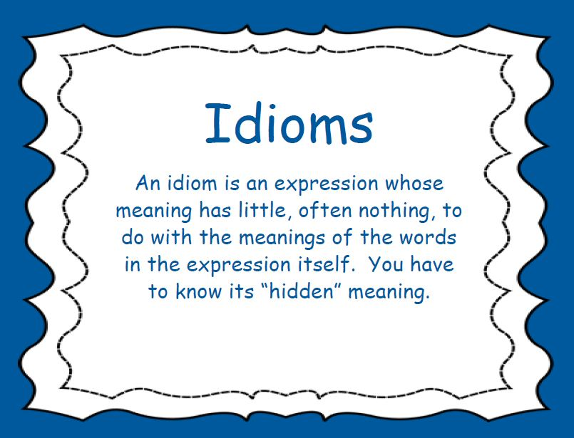
To buy goods on credit
To sell something off
Something sells like hot cakes
A shoplifter
All over the shop
At/in the sales
The sales are on/over
Window shopping
Exercise 2. Complete the sentences with the correct idioms:
1. What a mess! There are empty boxes all … .
2. Women like shopping but what is really exciting is not buying but … .
3. The police are looking for the famous … who has already robbed ten shops.
4. I have problems with buying Easy English. It always … .

Useful expressions
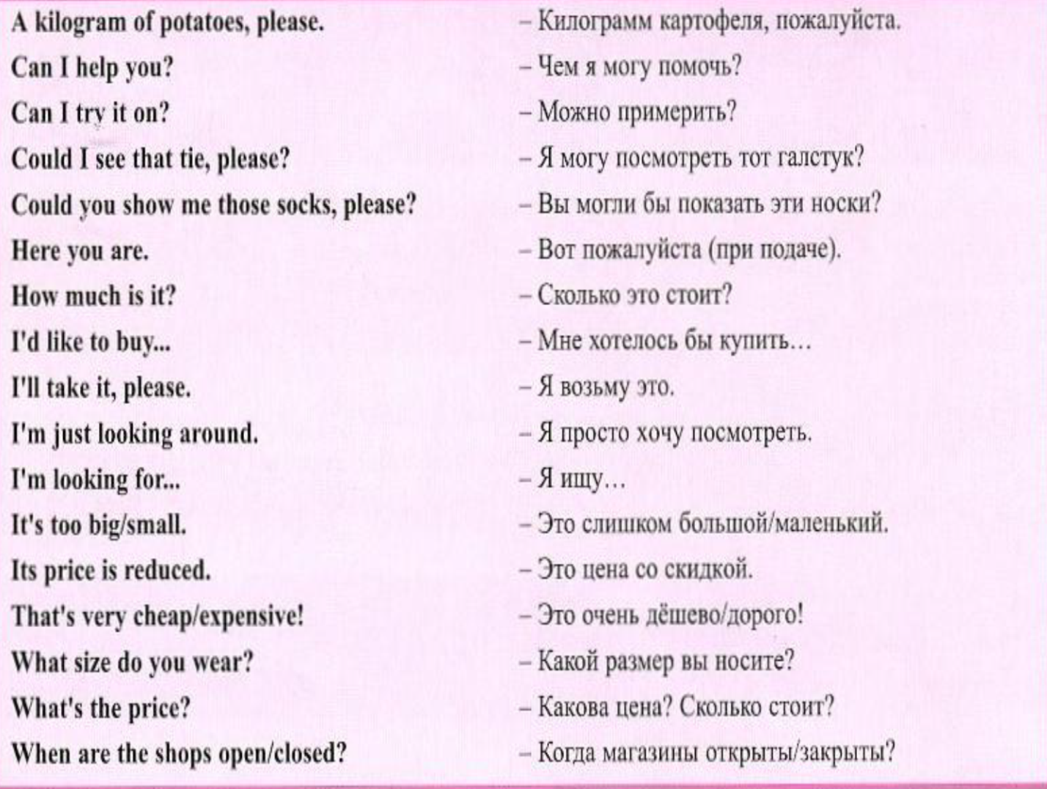
Exercise 3 . Complete your own dialogue using useful expressions given above

Exercise 4. Look at the department store. Which floor will you go to buy?
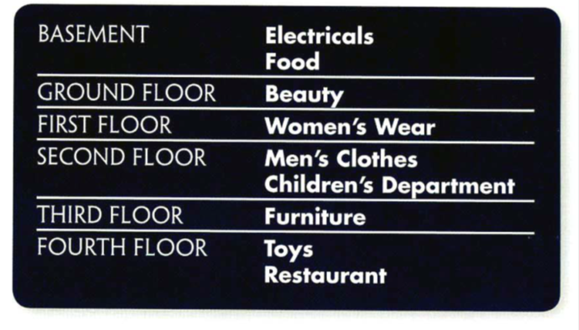
1. An armchair
2. Lipstick
3. A cup of tea
4. A packet of tea
5. A skirt
6. Some baby clothes
7. A tie
8. A TV
9. A bed
10. A doll

Exercise 5. Match the words in column a with the definitions in column b:
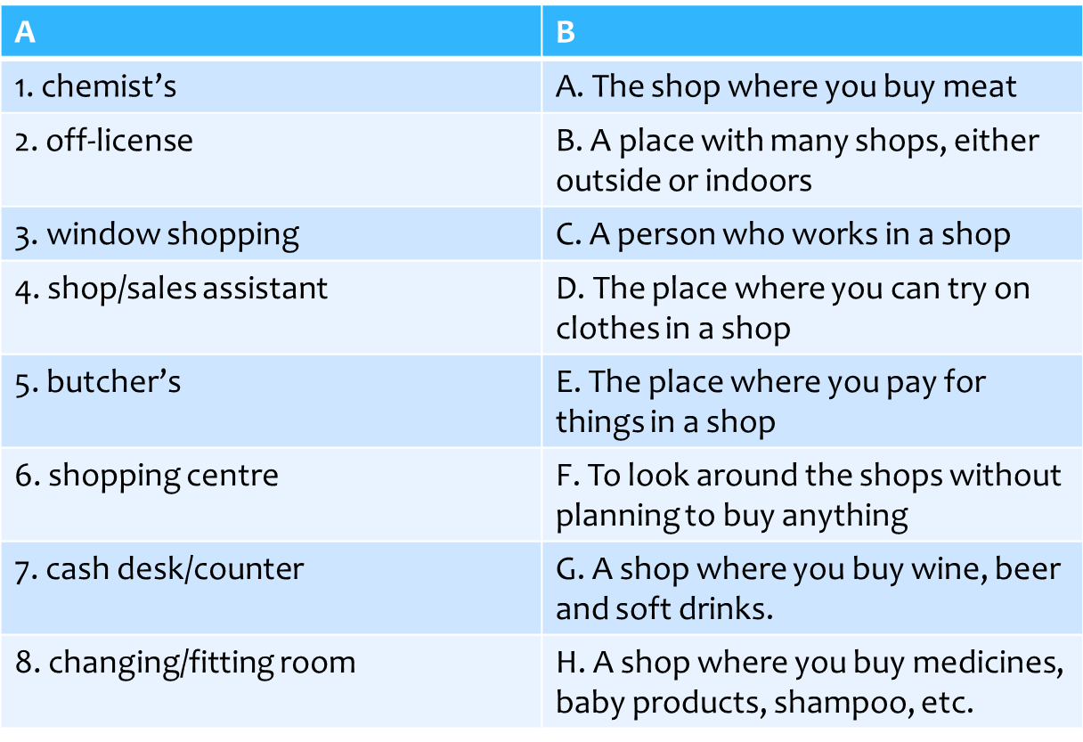
Exercise 6. Make sentences out of the given words:
a. like/buy/I’d/to/sweater/green/a
b. looking/I’m/around/just
c. size/you/What/wear/do?
d. this/dress/much/yellow/is/How
e. like/Would/a/one/you/green/black/or/one/a?

Exercise 7. Complete the shopping dialogue with a suitable word or phrase from the column:
Assistant A: Can I help you?
Customer: Yes, I’m 1…. blouse like this, but in blue.
A A: I see. And what 2… are you?
C: 42 usually.
A A: OK. I’ll just go and see if we’ve got any.
C: Fine.
Assistant B: Can I help you?
C: No, it’s OK. I’m 3 … thanks.
A A: Here we are. The last one in stock.
C: Great. Can I try it on?
A A: Yes, of course. The 4… is just over there. How was it?
C: Yeah, fine. I’ll 5… .
SHOPPING
Vocabulary
common – общий
buyer – покупатель
seller – продавец
to look for – искать
offering – предлагающий
to advertise – рекламировать
to afford – позволить
wares – товары
to purchase – покупатьt
to induce – побудить
to leave profit – оставить прибыль
to deal with – иметь дело с
the needed things – нужные вещи
goods – товары
better quality – лучшего качества
to save smb’s time – сэкономить чье-либо время
to order – заказывать

Shopping has common elements wherever it takes place. A buyer looks for a seller who is offering something the buyer wants or needs at a price the buyer can afford to pay. Sellers often advertise their wares in newspapers, on the radio or TV, on posters etc. Sellers use a variety of tactics to induce buyers to purchase from them at a price which leaves some profit.
Shopping is a part of our daily life. And we have to deal with it whether we like it or not. There are people who hate going shopping. So they make a list of what they need and run through stores buying the needed things. Sometimes they even don’t care about the price. And there are people who go from store to store looking for goods of better quality and lower price. Those don’t worry about the time they spend shopping.
But there is a very good service called Postal Market. It really helps you to save your time and get goods of high quality. You just have to look through a catalogue, choose the things you like, order them and wait a little to get them.
Questions:
1. How do sellers advertise their wares?
2. What do the sellers do to increase their profit?
3. Is there any service which helps to save time during shopping?
4. What kind of a service is it?

Оценивание
Домашнее задание https://www.youtube.com/watch?v=YjXiCZpelf0
Watch video mentioned above and answer the following questions:
- For whom does a woman looking for a present?
- What size does he take?
- How much does a jacket cost with the discount?

Заключительная часть The lesson is over, good-bye

Қазақстан Республикасының білім және ғылым министрлігі
Министерство образования и науки Республики Казахстан
Алматы экономика және құкық колледжі
Алматинский колледж экономики и права
КЕЛІСІЛДІ:  Әдіскер | БЕКІТЕМІН:  Директордың оқу –өндірістік ісі  жөніндегі орынбасары
СОГЛАСОВАНО:  Методист________Сулейменова С.Р.  «____»_________________2019 г | УТВЕРЖДАЮ:  Зам.директора по УПР  ______________Молдаханова Б.Ж.  «____»_________________2019 г.

Открытый урок по английскому языку на тему:
«How much does it cost? At the shop»

Пән оқытушысы
Преподаватель: Садыкбекова Д.К.

Тіл пәндердің ПЦК
отырысында қарастырылды:
№ __ хаттама «_____» _____ 2019 ж.
ПЦК төрайымы___________А.О. Джаксыгулова
Рассмотрено на заседании
ПЦК языковых дисциплин:
Председатель ПЦК Джаксыгулова А.О.

АЛМАТЫ – 2019

