Lesson plan
Unit 3: Our Countryside |  |  |  |  | School - Gymnasium №3, Kostanay
Date: |  |  |  |  | Teacher name: Lobach Y.A.
CLASS: 6 |  |  |  |  | Number present: |  |  | absent:
Theme of the lesson |  | Learning about the fauna of Kazakhstan
Learning objectives |  | 6.3.1.1- understand the main points in a growing range of short, simple texts on general and curricular topics;  6.3.7.1 - use appropriate subject-specific vocabulary and syntax to talk about a limited range of general topics, and some curricular topics;
Lesson objectives |  | All learners will be able to:  Name some animals;  Make up a simple dialogue;
Most learners will be able to:
Answer the questions on the text;
Find the words in the crossword;
Some learners will be able to:
Perform an extended dialogue;
Find all the words in the crossword;
Assessment criteria |  | Learners can understand the content of the text;  Learners can name the animals;
Value links |  | Respect and support classmates
Cross curricular links |  | Nature study
Previous learning |  | Flora of Kazakhstan
Plan
Planned timings | Planned activities |  |  |  |  |  | Resources
Start  2 min  3 min  5 min | Greeting  Warming - up. Method “Compliments”  The teacher asks the question “How are you today?” The learners raise the card which expresses their mood and feelings. They see the explanation on the board (orange – communicative, active, red – aggressive, irritated, green – quiet, calm, blue – indifferent, uninterested, yellow – happy, glad). Then the teacher says that learners have different mood and suggests to improve it by saying a compliment to a neighbor.  Answering the questions:  - What date is it today?  - What day of the week is it today?  - What season is it now?  - What is the weather like today?  - What is your favorite animal?  - Why do you like it?  Game “Snow ball”  Ss remember the animals. The 1st student name the animal. The 2nd student repeats the first animal and name another one. The 3rd student repeats the first, the second animals and name another one. The rest students do the same. |  |  |  |  |  | Coloured  papers
Middle  (28 min)  5 min  10 min  5 min  8 min  5 min | Active learning  Vocabulary  Study the words  heritage – наследие  abundance – изобилие  predator – хищник  harrier – лунь  falcon – сокол  elk – лось  marmot – сурок  badger – барсук  rodent – грызун  jerboas – тушканчик  minnow – пескарь  dace - плотва  Reading  Ss read and translate the text “The Naurzum national nature reserve”  Ss watch the video and answer the questions  - When was the Naurzum national nature reserve founded?  - How many species of birds visit the reserve every year?  - Which predators can you name?  - What mammals live in the reserve?  - What species of fishes can you name?  Dynamic break  Speaking activity (PW)  Ex.7, p.99  In pairs discuss why you want to visit the Naurzum national nature reserve.  (Differentiated task)  Less able learners – make simple dialogue.  More and the most able learners make an extended dialogue.  (Teacher comments the performance of a dialogue by each pair.)  Use of English  Crossword “Word search”  Peer assessment (exchange the papers)  10-8 - Excellent!  7-5 – Good job!  4-2 – Not bad!  1-0 – Try again! |  |  |  |  |  | Handout 1  https://www.youtube.com/watch?v=qA8dpkPehDo  Handout 2
End (2min) | Reflection  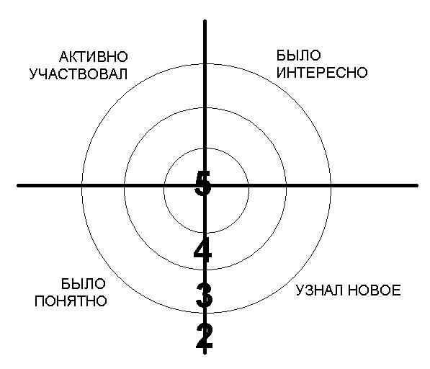  Ss stick the papers with their names in any area.
Additional information
Differentiation |  |  |  | Assessment |  | Health and safety check
By the task: (at the 14th minute)  Less able learners make a simpledialogue.  More able and the most able learners make an extended dialogue. |  |  |  | Observation and praising words;  Monitor learners during the pair work and giving feedback;  Peer assessment after searching the words; |  | Every day classroom precautions;  Movements while dynamic break
Reflection  Were the lesson objectives/learning objectives realistic?  Did I stick to timings?  What changes did I make from my plan and why? |  |  | The lesson objectives/learning objectives were realistic.  I stuck to timings.  I made changes from my plan in order to involve more pupils in work because it is vital purpose of education.
Summary evaluation

Handout 1
The Naurzum national nature reserve
heritage – наследие
abundance – изобилие
predator – хищник
harrier – лунь
falcon – сокол
elk – лось
marmot – сурок
badger – барсук
rodent – грызун
jerboas – тушканчик
minnow – пескарь
dace - плотва

The Naurzum national nature reserve one of the oldest in Kazakhstan, was founded in 1931. Nowadays its territory makes up to 1,914,000 hectares. Administratively, it belongs to the Naurzum and Auyelikol regions of the Kostanay oblast.
In 2002 the Government of the Republic of Kazakhstan recommended Naurzum National Nature Reserve for the inclusion in the List of Cultural and Natural World Heritage Sites of UNESCO.
The reserve’s fauna features with an abundance of animal kingdom. Every year, the reserve is visited by 282 species of birds, 158 out of which are indificating in the reserve territory. The most widely presented there are predators - 28 species, 18 out of which are indificating in the reserve, among them are the golden eagle, imperial eagle and steppe eagle; harriers — pale harrier, Montagu’s and marsh harrier; falcons — saker falcon, black kite, hawks. Such number of bird species is determined with a great number of basins and sources in the territory of the reserve. 23 bird species are entered to the Red Book.
As far as is it concerns mammals 42 species of they live permanently in the reserve. Among them are the elk, roe deer, wild bear and marmot. There also live such predators as the wolf, fox, corsac, lynx. Badgers live near the lakes. The most numerous group of animals in the steppes is presented with rodents - the large-toothed souslik, red-cheeked souslik, little souslik, hamster, and also eared hedgehog, jerboas, brown hair.
The lake is also inhabited with 10 species of fishes, among them are the goldfish and Chinese carp, lake minnow, carp, dace and peled. The fans of eco-tourism, hunters and inveterate fishers will take great enjoyment in visiting the Naurzum reserve.

Handout 2

