MSI «Secondary school of the village of Ishimskoye
of the Department of Education for the Zhaksy district
of the Department of Education of the Akmola region»

SCIENTIFIC WORK
Theme: «Learning English through Kazakh fairy tales»
English language section
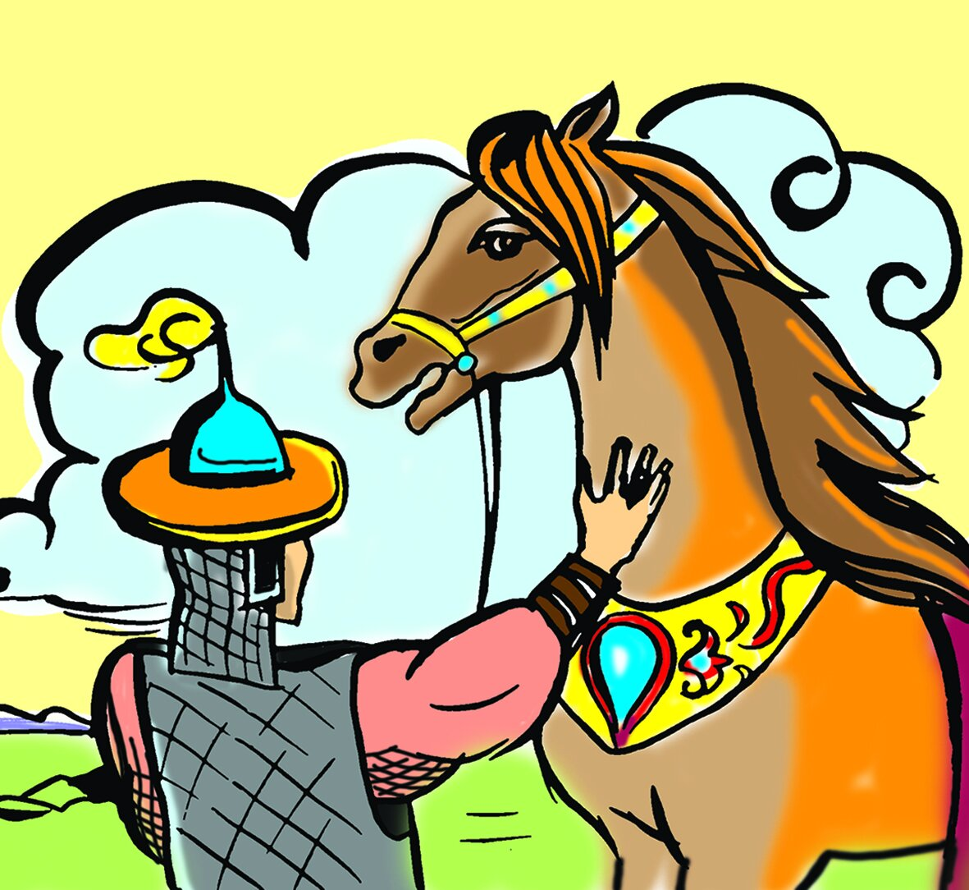

Author: Ramazan Shyngys
Scientific adviser: Bopesheva M.T

PLAN
INTRODUCTION
MAIN PART
2.1. Fairy tale is the fruit of imagination
2.2. Fairy tale introduces children to education
2.3. Popularization of Kazakh fairy tales through teaching English
PRACTICAL PART
3.1. Presentation of the Kazakh fairy tale "Koshkar and Teke" in English
CONCLUSION
Literature
Survey

Research work on the topic:
"Learning English through Kazakh fairy tales"
Comment
The research paper , written by a student on the topic "Learning English through Kazakh fairy tales", provides an explanation of Kazakh fairy tales and an analysis of the popularization and teaching of Kazakh fairy tales in English.
During the writing of the creative and search work, the student conducted explanatory work among schoolchildren, determining the educational significance of fairy tales in the Kazakh language, reading, discussing, and drawing attention to one of the most pressing issues at the moment. In the research work: tried to explore the topic in detail.
It was noted that the student was much sought after in the process of writing this creative work. The student did a lot of research when writing this project, during extracurricular hours , sitting at a personal computer, looking at articles, looking at some information from newspapers and magazines. The work consists of an introduction, the main part, conclusions, references and appendices. The problems presented in the paper are selected according to each subheading, and there are enough examples.
On this work, I conducted training and exchange of experience with the student. Students were interested in English, their country, and wanted to get to know this country more closely, so they tried to reveal the topic in detail.
I am confident that in the future my pupil will be a versatile polyglot who values and protects his native land, country, speaks English, and is an example for other young people. In general, we can say that the work was done at its own level. I propose to give a high assessment, taking into account the content and significance of the research work.
Leading the project:

Annotation
The power that will make the future brighter than the present and move human society forward is only in education. "Learning the language of the educated generation of the people. It is no secret that today the prospects for mastering the English language will not be blurred," as they say, providing high — quality, meaningful education to the younger generation is the main requirement of today. In scientific work, it is folk tales and their heroes that have a great influence on the primary education of young people. Fairy tales have preserved in their characters ancient traditions, methods of education and qualities that develop the child's horizons. In this paper, the problem of learning English through Kazakh fairy tales is considered. These are folk tales and its characters, which have a great influence on the initial education of the younger generation in scientific work. Fairy tales have preserved in their heroes traditions, traditions, methods of education and qualities that develop the horizons of the child.
INTRODUCTION
"Mom, tell me a story." We often say these words in childhood. My mother sits on the edge of the bed and reads in a quiet voice. We love these fairy tales, we want to hear them again and again to plunge into the fantasy world, where horses fly into the sky,castles grow overnight, and animals speak with a human voice.
Do we believe in the authenticity of fairy tales? Sometimes we believe, sometimes we don't. But I want to believe. Why? Is this a fairy tale? When did fairy tales appear? What will fairy tales look like?
Fairy tale is one of the main genres of folklore. The fairy tale genre is a developed, illustrated form of folk prose, i.e. folklore artistic prose. Its purpose is to provide aesthetic education to the listener along with teaching. The fairy tale has a wide range of functions: it is an educational, artistic and aesthetic literary treasure. the whole genre feature of the fairy tale is reflected in these two characteristics. Therefore, the main task of fairy – tale prose is to make the plot as attractive as possible, make it more expressive and colorful. Therefore, the fairy tale is not directed to the truth, and the fairy tale does not try to prove that the story happened in life.The composition of the fairy tale is subordinated to the glorification of the main hero, so it is built according to a certain scheme. All this gives the fairy tale an ideological, substantive and artistic integrity. This integrity gives this genre other qualities: unity and stability of composition and aesthetic ideals, obligeness of artistic conditionality, correspondence to the spoken language, and the use of stable phrases.
The purpose of teaching English is to teach students the basics of communication in English. Learning a foreign language at an early age allows you to organize the skills of communicative development of students, the interests of students, and have the opportunity to speak more than one language at a time. The main person in the school is the teacher, the main goal facing this teacher is to form a fully developed personality with a rich spiritual soul. Therefore, the organization of the development of creative thinking and active mental work of students requires the introduction of new tools and methodological approaches to the educational process. In the context of increasing relations between our country and other countries, it is our task to train a person who is fluent in English, who will be able to use his knowledge in the future in the context of relations in various spheres. The transition of the Republic of Kazakhstan to the path of development of world civilization, becoming an independent country, requires a good command of the English language.
Relevance of research work: the relevance of this study is related to the need to teach children a foreign language from primary school. Integrated teaching of Kazakh fairy tales in English brings great benefits, they help the child overcome the language barrier and instill a love for a foreign language, maximizing the effectiveness of teaching English from an early age. In addition, by enriching the language base and, on the one hand, educating the nation as a patriot, we will learn English together. Education of competent and educated young people is the first goal of teachers. In society, it is necessary to prepare survival skills from the younger generation. In the process of educating teenagers, it is necessary to master cultural and competent relations with society, since the level of achievement of youth development is the acquisition of creative knowledge.
The purpose of the research is to teach English through Kazakh fairy tales. Popularization of Kazakh fairy tales abroad, instilling in them National Education, patriotism, and national qualities.
Tasks:
- General analysis of fairy tales in the Kazakh language;
- Determining the role and influence of a fairy tale in raising a child and determining the best ways to influence it on the child;
- Teaching English through Kazakh fairy tales;
- Understanding the speech material, the ability to speak about memory.
Material values: photo, presentation, diagram.
Research forecast: study of fairy tales, teach them to use them in everyday life.
Research stages:
1. topic analysis
2. collection of materials
3.conducting survey work.
4. binding
5.generalization and systematization of materials.
Research methods: monitoring, analysis, comparison, examination, synthesis.
Sources of scientific information: scientific literature, archival materials, Internet, printed products.
Research novelty: new types of everyday use of fairy tales. In the lessons, more and more of these fairy tales are played out. It is necessary to adopt a special law or regulation on the popularization and promotion of Kazakh and English fairy tales. If there are bookshelves in front of each school, then any pupil will come, take a fairy-tale book, read it, put it in its place, or bring another book instead.
MAIN PART
2.1. Fairy tale is the fruit of imagination
Most people have a habit of treating fairy tales as if they were their own traditions. The main goal of the teacher is to introduce the child to the content of the fairy tale, talk about the fairy tale, introduce the most important information that lies in the fairy tale into the child's mind, and show it on the stage in a playful way, entering the roles of the characters. This method is called the traditional method of working with fairy tales. And this method is called unconventional, because children can not only listen to the fairy tale here,but also take the end of the fairy tale out of their thoughts, mix several scenes and change some actions in the fairy tale.
Through each fairy tale, we learn the thoughts and fantasies of our ancestors, the way of life, and the richness of language. Every fairy tale is an educational tool. For example, fairy tales for children teach a child honesty, ingenuity, and humanity.Unfortunately, at present , feature films and cartoons based on foreign fairy tales are often shown on radio and television.It tells stories about the names of characters, land and water аттары unfamiliar and alien to our mentality.It is much more effective to watch or listen to Kazakh fairy tales. In my research work, I studied and read Kazakh fairy tales, showed my discoveries and suggestions on how to develop them in the modern era of science and technology, and how to promote them.This news is useful and effective. Fairy tales are born in very ancient times, even when there was no writing and drawing. They were passed down from generation to generation by word of mouth.As with other types of oral literature, fairy tales are born in connection with the work and living conditions of a person. Fairy-tale people, who did not know the phenomena of creation, the secrets of nature, did not fully understand what they were made of, fantasized about everything, considered it a relief for their hard work. In the future, the growth of human thinking had a great influence on the birth of fairy tales. Fairy tales are divided into several types, depending on the specifics of their content. The main ones are:
1. Fantastic Fairy Tales.
2. Fairy tales about zoos.
3. Fairy tales of everyday life.
4. Fairy Tales of Legends.
Fairy tales, which expand the horizons of children and make the world more colorful, expand the child's understanding, understanding, and knowledge of the world. It has a strong tongue, sharpens, develops thinking and imagination. For example: in the fairy tale" Kanbak Shal", the victory of a weak shawl over the mind, the power of arguments is greater, and the lack of pay makes the listener feel interested and even wants to tell the fairy tale to the narrator.
2.2. Fairy tale introduces children to education
Out of interest in fairy tales, the idea of studying it arose. Since reading books at school, I have tried to grow up educated, disciplined, and confident by reading fairy tales. A fairy tale is an amazing work that captures the child's imagination. In folk oral literature, it is a genre that is particularly interesting, artistic, and imaginative. Every child who reads a fairy tale is disgusted by the behavior of negative characters, trying to look like positive characters in it.
The fairy tale is a noble heritage of Kazakh folk oral literature, passed down from father to son as a legacy and continues to develop, grow and replenish from ancient times to the present day. The fairy tale not only educates the younger generation, but also has the greatest impact on their thinking and cultural speech in their native language, as well as on the skills of competent writing.The famous Kazakh writer academician M. Auezov was one of the first among Kazakh folklorists to define fairy tales as follows: "a fairy tale is a fictional wholesale story that expresses the attitude of the country to the world in ancient times, or a special example that represents a certain category of the country."
English fairy tales are different. There are fairy tales with the participation of fictional characters, heroic tales about the gentle power and great ogres, and about the struggle of a positive hero, usually a peasant son, with the participation of Jack, a representative of the common people.
The heroes of one fairy tale are hardworking, honest, noble and brave; some of them become real folk heroes. Thus, the son of a worker, Jack, the hero of the fairy tale "Adventures of Jack The Giant-Killer", having embarked on the fight against ogres-ogres, at first thinks only about the reward, but then becomes a real fighter for the liberation of his people from evil-giants.
The characters of other English fairy tales are not always kind, they are capable of delusion and deception, they are distinguished by business and strength, for example, the ogres deceive, the girl Molly in the fairy tale "Molly Whuppie" and Jack in the fairy tale "Jack and the Beanstalk" achieve happiness for himself and his loved ones.
Children who read the fairy tale are impressed by the main character, begin to discuss his actions in detail and correctly evaluate them, and the child receives the necessary good and correct upbringing. The child is convinced that evil and good, humiliation and violence, lies and truth, love and hatred will never go unanswered.
English folk tales are different from the usual Kazakh fairy tales, but if you look at them more closely, you can see familiar motivations, plots and images of characters. It is important to develop a child's creative thinking through the use of fairy-tale therapy.Creative thinking allows children to study the options and compose the content of the fairy tale in a constructive and creative way, contributing to the skills of solving problems in a fairy tale. Creativity comes from the English word "Creativity", which means creativity. Creativity is the result of an activity associated with the creation of a new product, a creative product.
Through a fairy tale, you can instill the following qualities in your child:
- The child's creativity develops;
- Creative thinking develops;
- The child develops ingenuity;
- Ability to express your thoughts;
- Ability to get into the role;
- Self-restraint;
- Speech culture, etc. qualities will develop.

2.3. Popularization of Kazakh fairy tales through teaching English
In the works of Aristotle and Al-Farabi, as a great word that expresses artistic meaning, it is the name of concepts that convey artistic manifestations of good deeds, good behavior, and decency. This will allow you to combine Kazakh education with English and achieve effective results
The Golden core of aesthetics in the sphere of life, everyday, and Human Relations is ethics. The meaning of the word" ethics " in national usage in the Kazakh language reflects the culture of our people. Ethics is the Golden core of National Education, the credo of teaching.
The source of folk taglymyn dates back to the era before our era. As you know, the origin of national culture is derived from the upbringing of generations of individual nationalities, since it was not formed as a national nation.
The study of English children's literature should begin with the period of early folk oral literature. What satisfied many prose writers, poets, and playwrights was the popularity of the English folk tale in England, which was very rich in domestic folklore.
In the Kazakh writing culture, korkyt Ata's poems and proverbs and sayings, Al Farabi's statements on national culture and science, education, poetry, music, Akhmet Yassawi's thoughts on the religious educational significance, Zhusip Balasagun's vision of how to become a perfect country, Mukhamed Haidar Dulati's great mentoring ideas, Shokan's efforts to improve the culture of the country, Akhmet Baitursynov's national education system, Magzhan Zhumabayev's formation of Kazakh pedagogy, Zhusupbek Aimautov's Kazakh psychology science zerley Bowl, the formation of the Kazakh national teaching as a science and the presentation of the Kazakh national teaching as a subject by subsequent Sciences indicate the ways of developing the National Teaching.
Baursak An old man and an old woman lived poorly. The man asked the woman to make a bun. —“We have no flour. What do I need to make it?” She found some flour, made a bun and placed it on the open window to cool. The little bun suddenly rolled off. The bun was rolling along the forest and faced a hare. The hare said: “I will eat you!” The little bun asked not to eat him and sang a song for the hare. While the little bun was singing, the hare distracted and didn’t get when the bun ran away.The little bun rolled on and faced a wolf. And everything happened as with the hare. He sang a song and rolled away. The same happened with the bear. The little bun ran from everyone until he met a fox. She wasn’t as stupid as other animals. She asked the bun to sing. When he finished she said: “What a beautiful song. But sweet bun, I am so old, so can you sit closer on my nose and sing to me one more time?” The bun did as he was asked and — bump — the fox ate him!
In conclusion, the contribution of National Education to the education of young people is significant. Folk trainings educate teenagers first of all to respect their parents, love their country, and protect their homeland.
PRACTICAL PART
3.1. Presentation of the kazakh fairy tale "Koshkar and Teke" in English Both the characters of English fairy tales and the characters of Kazakh fairy tales reflect the reality of life, a vivid picture of human behavior. True kindness always overcomes lies and cruelty, unlike our real life.
As far as I know, English fairy tales were first written by Joseph Jacobs, Kazakh fairy tales were studied by Mukhtar Auezov and other writers.
Ordinary people wanted to be a brave and intelligent hero who could protect themselves from a rich, dishonest and cruel person. In most Kazakh fairy tales, Aldar Kose met a rich man, took money from them, horses, sheep, and gave them to poor people.
If we compare the chief of Aldar with the English tales of Robin Hood, he was in the Sherwood woods hunting his Merchants, his sheriffs, and visiting them. After eating, he asked to pay a lot of money for food, and he always gave this money to the people he needed.
So, comparing the two characters, we see that they both want to help the poor, but their difference is that Aldar Kose never used power and lived among ordinary people himself, he was smart and cunning, and handed over to the chest what he received from the rich.
Another similar fairy tale "Alice In Wonderland" and the fairy tale" Cotton girl " in Kazakh are similar in content and plot. It describes a person's attitude to people, animals, and nature, as well as friendship, charity, and helping each other.
There is some similarity between the English fairy tale "nobody-nothing "and the Kazakh fairy tale"beautiful princess Kunikei under the Sun". Both heroes save their beloved - a beautiful princess and her great daughters. In both languages, various stylistic techniques are used to enrich the colors of descriptions, such as repetition, metaphor, metonymy, etc.the Kazakh fairy tale educates listeners to dream, look up, listen to something beautiful and great.
In tales about the animals of both countries, there are negative characters, such as Wolves and foxes. The Wolf is described as an evil, cruel and stupid animal, and the Fox is described as cunning. But rabbits are described as cowardly, weak animals in Kazakh fairy tales, and in English fairy tales they play the role of the wife or mother of a farmer.
Kazakhs equate bad people with pitfalls,and the English portray them as defenders of the tower.
In the course of our research, we found an interesting fact about the characters of English and Kazakh fairy tales that we pay attention to: many fairy tales consist of the same plot, similar characters, and a search for a test. We found similar plots and characters in the following Kazakh and English fairy tales:
Among the Kazakh fairy tales, we can find similarities with the fairy tales "Turnip", "the magnificent turnip", "Baursak"- "Johnny-Cake", "Wolf and seven cubs"- "The Wolf and the Three Kittens".
The similarity in the plots can be explained as follows:
1.the fairy tale is formed in the environment of some people, and then moves to other countries, but their folklore traditions (tats, motifs) remain the same, adapting to local customs.
2.in different countries, there are similar fairy tales that arise independently of each other, depending on the conditions and laws of everyday life, psychology, socio – historical development of peoples.
I would like to say a special word about the artistic means of the original language of elements of folk folklore. First, we see a similar attitude to the main characters, and he often uses frightening sentences in his speeches. Secondly, there is a dialogue that motivates the action, and a sufficient number of epithets can be found in it. However, the Kazakh folk tale is much richer and brighter in terms of the use of descriptive adjectives (rough, gray, thin), and this, in our opinion, makes it much more artistic. Of course, in any folk tale, folk words and phrases are found in it.
Now I want to promote the Kazakh fairy tale" Koshkar men Teke". I dubbed this fairy tale with an audio recording, told it in English and made a video.
The oldest genre of folk prose-fairy tales about animals-dates back to the period when they believed in totemism, animism and magic. In these fairy tales, the image of a person is implied behind the characters, and its qualities such as intelligence, stupidity, and cunning are revealed in a simple allegorical form. It is also necessary to show not only the character and qualities of a person, but also to show the behavior and actions of animals, to teach the younger generation to look at the secrets and phenomena of nature, to be observant, to give cognitive information, to teach and to be moral.
CONCLUSION
Fairy tales have always played an important role in the life of the Kazakh people. Because the content of fairy tales reflects the way of life of the people, traditions, customs, whole being, relationships of people, behavior, etc. Since the language of fairy tales as the most effective educational tool in the upbringing of generations is easy and easy to understand, it is important that fairy tales not only teach children patriotism, hard work, etc., but also develop the language of fire.
Fairy tales play an important role in the life of a child. The fairy tale strengthens the spiritual world of the child, patriotic education, respect for the past of his people, moral education and love for society. A fairy tale affects the correct development of a child's language. Folk tales help children develop their dreams, imagination, and worldview, educate them with the qualities of honesty and charity, Teach them to help the poor and needy, respect their parents, and love their homeland. There is a lot in common between Kazakh and English fairy tales, it is these fairy tales that foster humanity, love, and care. Of course, each fairy tale has its own peculiarities, but it would be wrong to say that after reading a small fairy tale, I came to this conclusion with carelessness. Of course, in English lessons, the task of studying fairy tales among children is set. Every day in quiet learning activities, students lose their interests, so during the lesson, it is necessary to use non-traditional methods that allow children to communicate, share their thoughts, discover, and learn.
Among the English fairy tales, you can find folk proverbs and sayings, songs in our book, which allows you to better feel the atmosphere of fairy-tale England and, at the same time, better understand its national culture. Although all folk tales are written in different countries and about different events, they have one purpose: to help the child choose the right path in life, so we should not choose among fairy tales, we should read folk tales of different nationalities, different countries and learn something good from them!
References:
1. «Иман және инабат» К. Оразбекова «Ана тілі» - 1993
2. Ауыз әдебиеті үлгілерін балалар бақшасында пайдалану. Р. Жұмағұлова
3. «Ол кім? Бұл не?» балалар энциклопедиясы.
4. Соколов Д.М. Сказки и сказкотерапия. –М., 1996
5. Ы.Алтынсарин атындағы Қостанай облыстық балалар және жасөспірімдер кітапханасы - http://biblio.al.ru/
6. Қазақстандық Ұлттық электрондық кітапхана - http://www.kazneb.kz
7. Қазақ ертегілері.(құраст. Е.Дүйсенбайұлы) – Алматы,2009
8. Аймауытов Ж. Психология.- Алматы, 1995.
9. “ Қазақ әдебиеті. Энциклопедиялық анықтамалық. — Алматы: «Аруна Ltd.» ЖШС, 2010 жыл.ISBN 9965-26-096-6

