METHODS AND APROACHES, ACTIVITIES | TASKS | ASSESSMENT by descriptors | STAGES
TPR aproach | Learners greet each by shaking hands as in Europe, by bowing as in Japan, by touching noses as in Africa in order to create friendly atmosphere in class. | Descriptor  *respect different points of view  *greet each other  Ss-Ss | Warming up  
“Inner and Outer circle” activity | Learners stand in an inner and outer circle and speak about given words: an environment, a pollution, an ecological problems and etc.. | Descriptor  *respect different points of view  *speak with using given words  Ss-Ss | 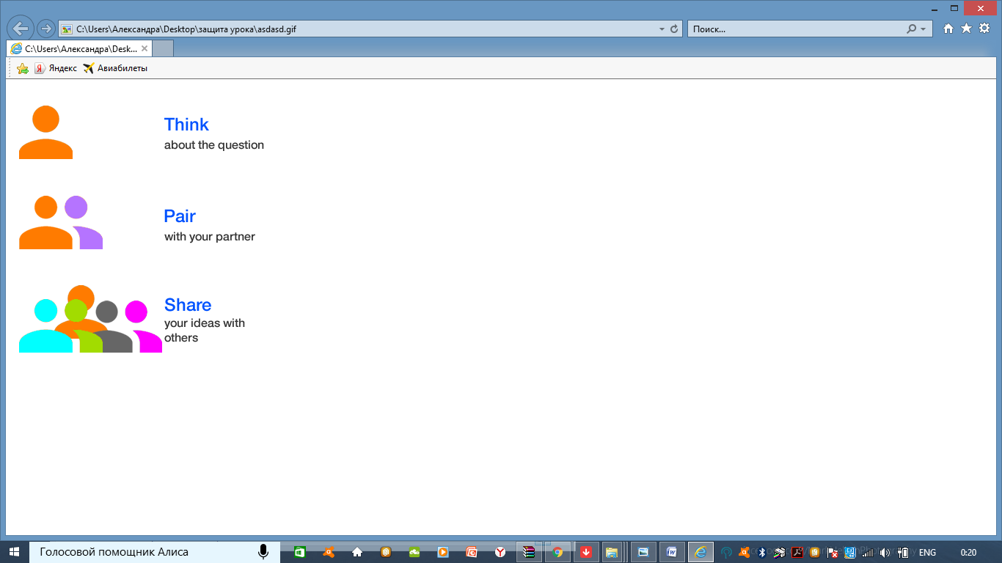  Beginning
CLT aproach  “Think, Pair, Share” activity  For learners with special pedagical needs: | Learners work in pairs and ask questions about the video and then swap the roles.  Task. Watch video and write down known words what you have heard. Explain the meaning of the words using English, First language or gestures. | Descriptor  *respect different points of view  *answer the questions  Peer assessment  S-S  Descriptor  *write correct spelling words from the video  *explain the meaning  Teacher-assessment | Speaking  Differentiation by content  Video https://www.youtube.com/watch?v=FzvEW1FHc60  Scaffolding
Natural aproach  Brainstorming method  CCQs | Learners read the questions. Write or speak their thoughts about the topic of the lesson. | Descriptor  *respect different points of view  *answer the questions  T-Ss | Pre-Reading  Graphic organizer
Intensive reading  Text-based approach  Scanning  For learners with special pedagical needs: | Learners read the text and choose true/false sentences.  Read and find the information in the text. Write correct sentences.  - 30.000  - 68.000  - In 2005  - In 2003  - 24 | Descriptor  *read the text  *mark True or False sentences  *correct the false sentences  Peer-assessment with answers.  S  Descriptor  *read the text  *find sentences with given words  Teacher-assessment  S | While-Reading  Differentiation by support  Scaffolding
Discussion  Inductive method  Free practice | Learners discuss the question and give their opinions. | Descriptor  *give creative opinion  *give ways to solve this problem  Self-assessment with this descriptor.  Ss-Ss-S | Post-Reading

