Краткосрочный план урока английского языка
Мустафинова Айдана Тлеуханқызы
Учёная степень: бакалавр
Казахский Университет Международных Отношении и Мировых
Языков имени Абылай хана
2011-2015гг
КГУ «Кокпектинская средняя школа»
ВКО, Кокпектинский район, с.Кокпекты
Категория: педагог-модератор

LESSON 33  Unit 3: Earth and our place in it |  |  | School: Kokpekty Secondary School
Date: |  |  | Teacher name: Mustafinova A.T.
Grade: 9 |  |  | Number present: |  | Number absent:
Theme of the lesson: |  | Talking about places
Learning objectives |  | 9.2.6.1- deduce meaning from context in unsupported extended talk on a wide range of general and curricular topics;  9.4.5.1- deduce meaning from context in extended texts on a range of familiar general and curricular topics;  9.6.1.13 - use a variety of modal forms for different functions and a limited number of past modal forms including If only+past participle express regret and criticism on range of familiar general and curricular topics  9.3.8.1- recount extended stories and events on a range of general and curricular topics
Lesson objectives |  | All learners will be able to:  Listen and read for gist, read for specific information, learn phrases to express regret  Most learners will be able to:  Listen and read for gist, read for specific information, learn phrases to express regret, roleplay a dialogue  Some learners will be able to:  Listen and read for gist, read for specific information, learn phrases to express regret, make up own dialogue or monologue
Criteria |  | Learners have met the learning objective if they can: express regret and use the situational language with the correct intonation in the dialogues
Previous lesson |  | Interpreting data
Plan
Planned timings | Planned activities |  |  | Learners’ activities |  | Evaluation | Resources
Begining  5 min | GREETINGS  The teacher introduces students to the statement  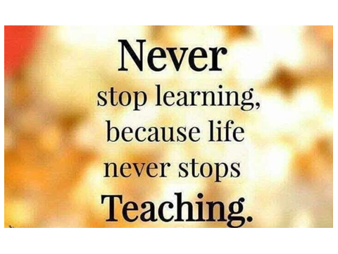  Teacher asks students to guess the theme of the lesson using the game “4 pcs 1 word”  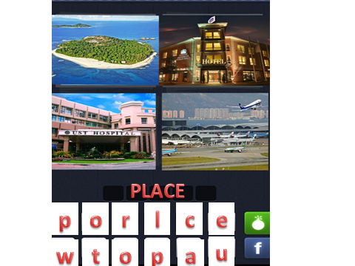  and sets the lesson objectives, letting students know what to anticipate from the lesson.  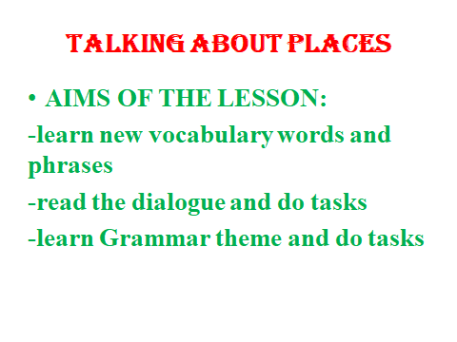  1 To practise pronunciation of situational language; to identify phrases which express/ask for opinions  Play the recording. Pay attention to Ss’ pronunciation and intonation and correct as necessary. Then elicit which of the items ask for an opinion or express a positive/negative opinion and ask Ss to mark them accordingly. Check Ss’ answers.  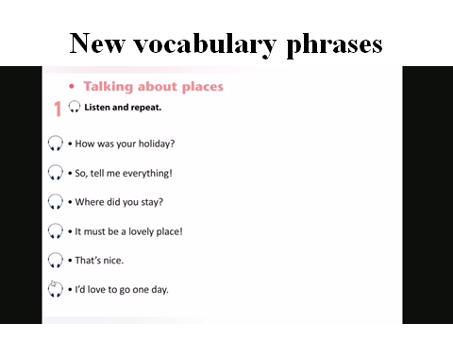 |  |  | Ss read the statement together and give explaning  SS try to guess the theme of the lesson and translate the aims of the lesson  Ss listen and repeat chorally and/or individually |  | Verbal evaluation | PPT 1  PPT 2  PPT  PPT  Youtube  https://www.youtube.com/watch?v=ZCS5ujUiTwg&t=142s  1 part
Middle  30 min | 2 To listen and read for specific information  Direct Ss' attention to the watching the video, where students can listen the pronunciation of the dialogue and its intonation.  Play the recording.  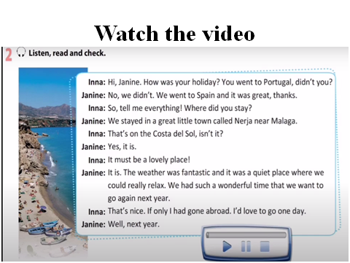  Teacher asks students what this dialogue is about.  Answer Key  The dialogue is about two friends talking about a holiday one of them had.  3. To answer the questions according to the dialogue.  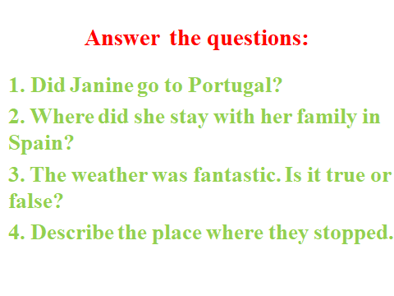  4. To learn synonymous phrases and consolidate situational language through translation  Elicit the LI equivalents for the sentences in Ex. 1 from various Ss around the class.  Refer Ss back to the dialogue and elicit the synonymous phrases from various Ss around the class.  Answer Key  I'd like to hear all about it. - So, tell me everything. I bet it is really nice there. - It must be a lovely place. We enjoyed ourselves so much that we would like to go on holiday there again. - We had such a wonderful time that we want to go again next year.  4 To practise role-playing  Explain the situation and ask Ss to act out their own dialogu using dialogue model given by teacher. Remind Ss that they can use the dialogue in Ex. 2 as a model as well as any ideas of their own to complete the task.  5 Grammar. IF ONLY + PAST PERFECT.  Practice task. Doing online task with the platform QUIZZIZZ  Teacher sends the web link to the chat group of students 9B.  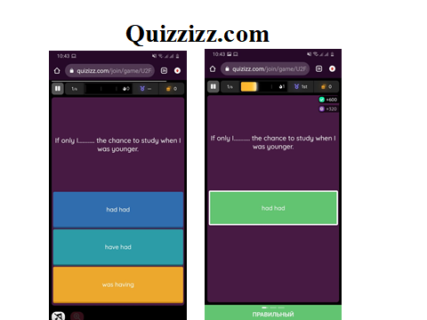 |  |  | Ss watch the video and give expression on it  Ss answer the questions according to the dialogue.  Ss learn synonymous phrases and consolidate situational language through translation  Ss complete the task individually  Ss listen to the explanation of using Regret construction then do online task in the platform QUIZZIZZ.COM individually |  | Mutual valuation  Individual  evaluation  Mutual valuation | PPT  Youtube  https://www.youtube.com/watch?v=ZCS5ujUiTwg&t=142s  2 part  PPT 5  PPT 6  PPT 7  https://quizizz.com/admin/private
End  5 min | Plenary  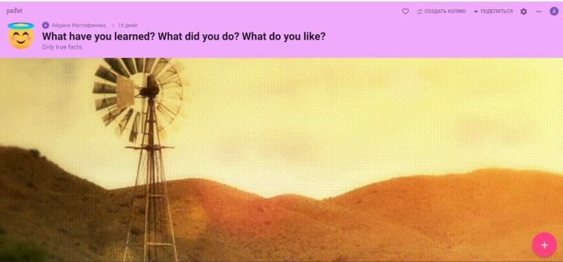Hometask: Make up your dialogue.  Saying goodbye |  |  | Ss answer the questions in the platform padlet.com |  | Self-assessment | PPT  https://padlet.com/aydanamustafinova93/9lywltd9mja5ebsr

