|  |  |
| --- | --- |
| Общее количество баллов: _______________________________________________  Уровень знаний ребенка ________________________________________________  Рекомендации для родителей: | TALANT School - ул. ​38-я, 6, Астана - Викисити  Ф.И.О. ребенка_________________________  Дата рождения_________________________________  Адрес ______________________________  Контактный телефон__________________________ |

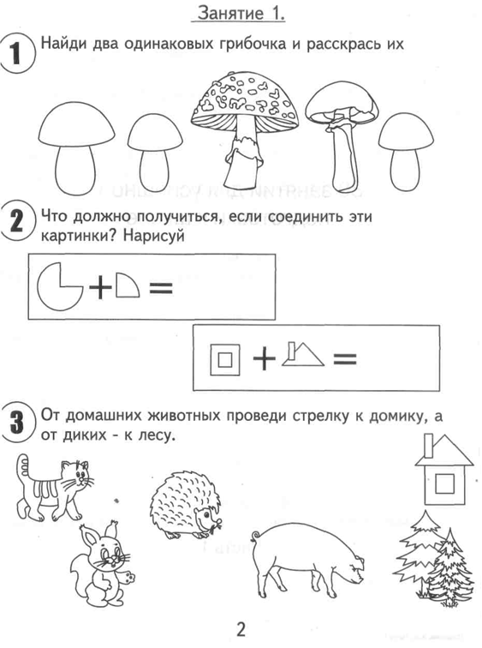 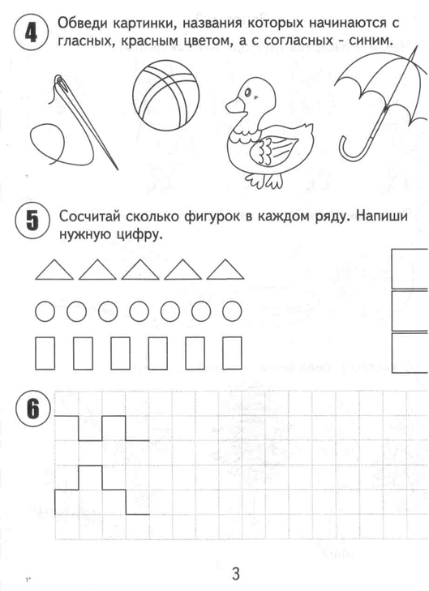

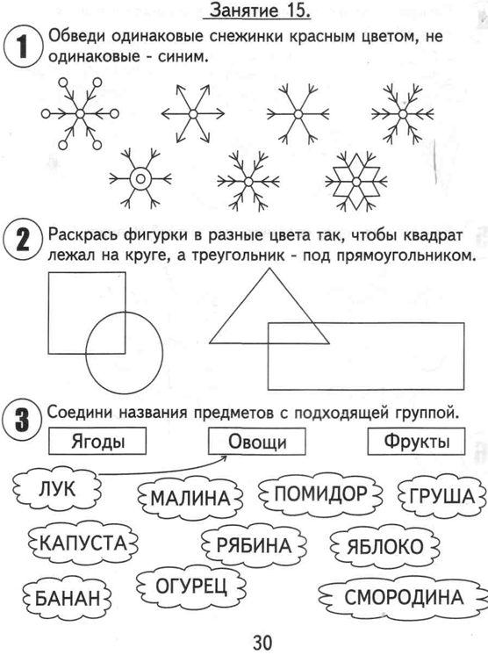 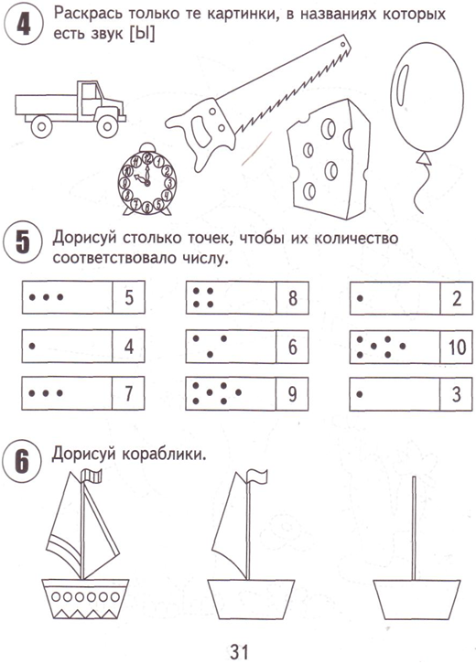

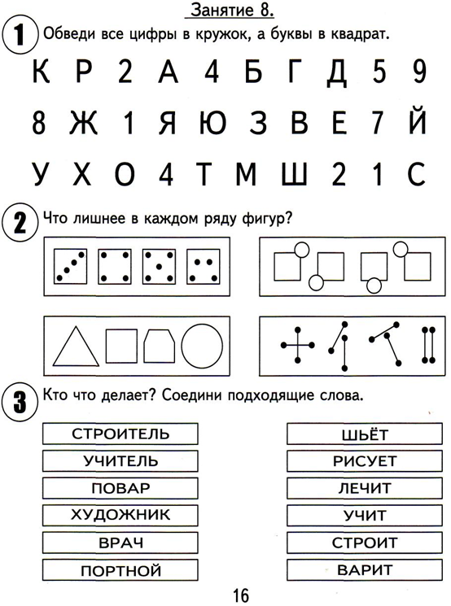 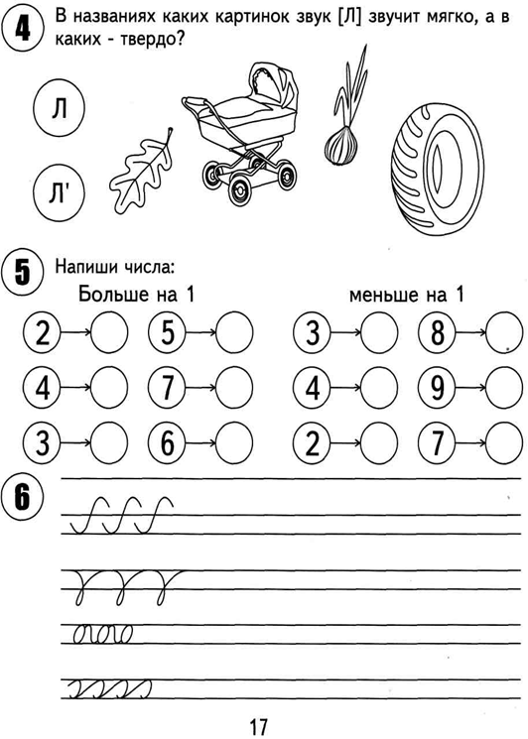

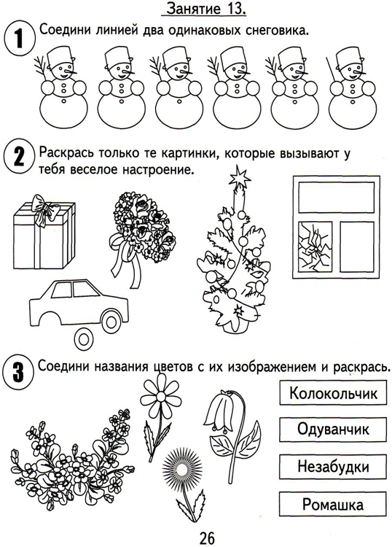 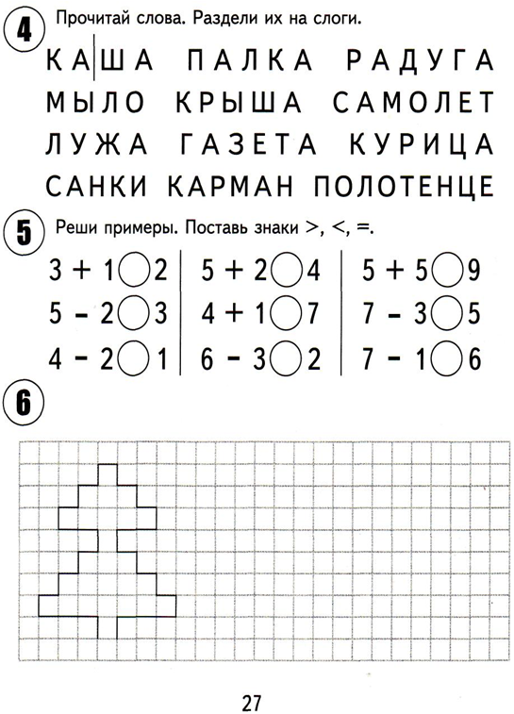

|  |  |  |
| --- | --- | --- |
| **Сведения о ребенке** | **Сведения о маме** | **Сведения о папе** |
|  |  |  |

|  |  |  |  |  |  |  |
| --- | --- | --- | --- | --- | --- | --- |
|  | Внимание  1 балл | Логика  2 балла | Окружающий мир  2 балла | Звуко-буквенный анализ, навыки чтения  2 балла | Математика  2 балла | Навыки письма  1 балла |
| 1 |  |  |  |  |  |  |
| 2 |  |  |  |  |  |  |
| 3 |  |  |  |  |  |  |
| 4 |  |  |  |  |  |  |

Рекомендации: ________________________________________________________________________________________________________________________________________________________________________________________________________________________________________________________________________________________________________________________________________________________________________________________________________________________________________________________________________________________________________________________________________________________________________________________________________________________________________________________________________________________________________________________________________________________________________________________________________________________________________________________________________