Short term lesson plan

Long-term plan  Unit 7: The natural environment  Term 4, Lesson 5 |  |  | School: № 9
Date: 17.05.2022 |  |  | Teacher's name: Nurgalieyva G.Sh.
CLASS: 2 g |  |  | Number present: |  | absent:
Theme of the lesson: |  | What can animals do?
Learning objectives(s) |  | 2.L4 recognise with support short basic questions relating to features such as colour and number (Ex 2 p 88 PB)  2.UE13 use can to talk about ability and to make requests and offers; use can / can’t to talk about permission  2.UE17 use me, too to give short answers
Lesson objectives |  | All learners will be able to:  - name the main vocabulary words;  Most learners will be able to:  -write names and actions of animals;  -use them in their speech.  Most of the learners will be able to:  -say the words correctly;  -use them in their speech;  - complete all worksheets correctly.
Success criteria |  | Learners have met this learning objective if they can:  -recognize spoken language slowly and distinctly;  - pronounce vocabulary words correctly  - say the names and actions of animals  - do most of tasks correctly.
Value links |  | Ls will work together as a group/pair showing respect and being polite with each other, respect to animals
Cross curricular links |  | Primary Science
ICT skills |  | PPT, Video
Previous learning |  | Seasons
Plan
Planned timings | Teacher’s activities |  |  | Pupil’s activities |  | Marks | Resources
Start | Greeting:  Good morning dear pupils!  -How are you today?  -What’s the weather like today? Is it rainy? Is it sunny?  1.Warm up game  T: - Let’s remember different animals. (Teacher shows the video with animals. The pupils must find the odd animal. -What animal is this?) (domestic or wild?) .  T: - Let’s remember the verbs  remember  Can [ kᴂn] уметь, мочь jump [dʒΛmp]прыгать run [rΛn] бежать fly [flaı] летать swim[swım] плавать dance |da:ns| –танцевать climb [klaım]лазить crawl |krɔːl| -ползать hop |hɒp| -скакать,прыгать sing |sɪŋ|-петь  T: -Look at the pictures and say “What can animals do?”  A cat ….  A horse …  A snake …  A bird …  A chimp ….  A rabbit …  A fish …  T:- Very good! |  |  | Pupils respond to greeting  Ls remember the names of the animals and what can they do. |  |  | Slide (useful phrases)  Video https://www.youtube.com/watch?v=BfnPx3CtSgE
Main part | The main part of the lesson.  T: - Pupils, I have prepared for a picture! Look at this picture! How do you think what’s this? Is it an animal? Is it a domestic animal or wild? Has it feathers or fur?  T: - Today we play games and do the tasks which connected with our topic. And I shall hang the letter after your answers. When you collect all the letters you will know the name of this animal. Let’s divide into pairs. Please, choose the lollypops!  Teacher invites learners to choose the lollypop from the box. (Learners choose lollypops and according to their colour make pairs)  1. – Let’s do listening. You must listen the sounds of the animals and write down the names of the animals.  The letter W.  2. Look and write. Teacher gives worksheets with vocabulary. Pupils do the tasks.  The letter O.  3.The second task is to answer my questions!  You say only Yes or No.  1.Can a fish swim? Yes  2.Can a dog run? Yes  3.Can a fox sing? No  4.Can a horse crawl? No  5.Can a tiger dance? No  6.Can a rabbit swim? No  7.Can a bird fly? Yes  8.Can a cat climb? Yes  The letter M.  4. Warming-up  T:- Look at the board and sing a song with action.  Song “What can animals do?  The letter B.  5.Puzzle.”Who is it?”  1.I can climb (cat)  2.I can crawl(snake)  3.I can sing(bird)  4.I can eat cheese(mouse)  5.I can hop(rabbit)  6.I can say “rrrrrrr”(lion)  (mystery word: Animal)  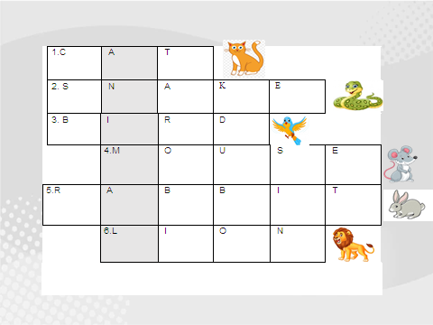  The letter A.  6. –Let’s play a game in the JeopardyLabs.  Teacher divides the pupils into 3 teams.  The letter T.  T: - Good job! I’ve find the animal. And it is a WOMBAT. 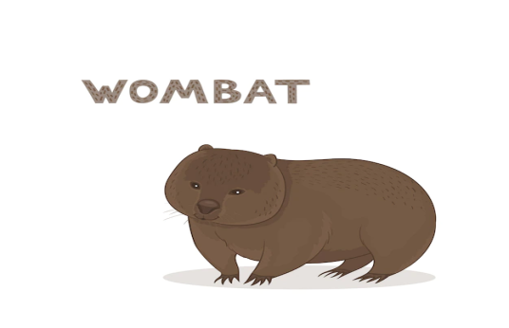 |  |  | Ls answer the questions  Ls do the worksheets and the tasks.  Ls do the puzzle.  Ls make warming – up.  Ls solve the puzzle.  Ls play JeopardyLabs . |  | Formative Assessment  Formative Assessment | Pictures  Ex 2 p 88 PB  https://www.youtube.com/watch?v=4MwdB3l_bS8  https://jeopardylabs.com/play/what-can-animals-do-gulvira
End | Learners give feedback. This might be done in oral form.  Teacher put three versions of rabbit. Learners put stickers.  H/T: Draw the picture of your favourite animal or you may draw a wombat. And write down what your animal can do? |  |  | Feedback    