SHORT TERM PLAN

Unit: 3 e Across cultures |  |  | School: Solonovka secondary
Date: |  |  | Teacher name: Issatayeva L.
CLASS: 8 |  |  | Number present: |  |  | Absent:
Lesson title: |  |  | Celebrations
Learning objectives(s) that this lesson is contributing to (link to the Subject programme) |  | 5.2.8.1 - understand supported narratives, including some extended talk, on an increasing range of general and curricular topics  5.4.6.1-recognise the attitude or opinion of the writer in short texts on a limited range of general and curricular topics  5.5.5.1-link without support sentences using basic coordinating connectors  5.5.4.1-write with support a sequence of short sentences in a paragraph to give basic personal information
Lesson objectives |  | All learners will be able to:
 |  | Identify some specific information in short texts and use, spell some target vocabulary correctly with support
 |  | Most learners will be able to:
 |  | Say most words correctly and talk about celebrations with little support; identify most specific information in short texts with little support
 |  | Some learners will be able to:
Use and pronounce all words correctly and write short paragraph about celebration using basic words without support;
recognize the opinion of the writer in short texts without support
Assessment criteria |  | - Identify specific information in the texts  - Make sentences using new words
Language objective |  | Learners can: pronounce words and make sentences using basic words
 |  | Useful classroom language for dialogue/writing:
What is the celebration?
What types of celebration do you know?
Which celebration is popular in our country?
- I love my mum, because…
- My dad’s very special to me, because…
- I love my brother/ sister, because…
Values links |  | Respect each other  Care about things
Cross-curricular links |  | -
Previous learning |  | Learners already know words about celebration
Plan
Planned timings | Planned activities (replace the notes below with your planned activities) |  |  |  | Resources
Start  3 min  2 min  2 min | Teacher greets learners.  Starter: (W) Teacher asks learners to make a circle then they should say their name and value about themselves  Ss make circle and say their name and value  Teacher gives them puzzle pictures.  Ss should assembly puzzle and guess theme  Ss choose the cards with celebration and sit according to groups (woman’s day, father’s day).  Lead in: (G) “Odd one out” Teacher shows learners either a set of pictures with a link to the lesson content). Ss should explain which one does not belong with the rest and give a reason why  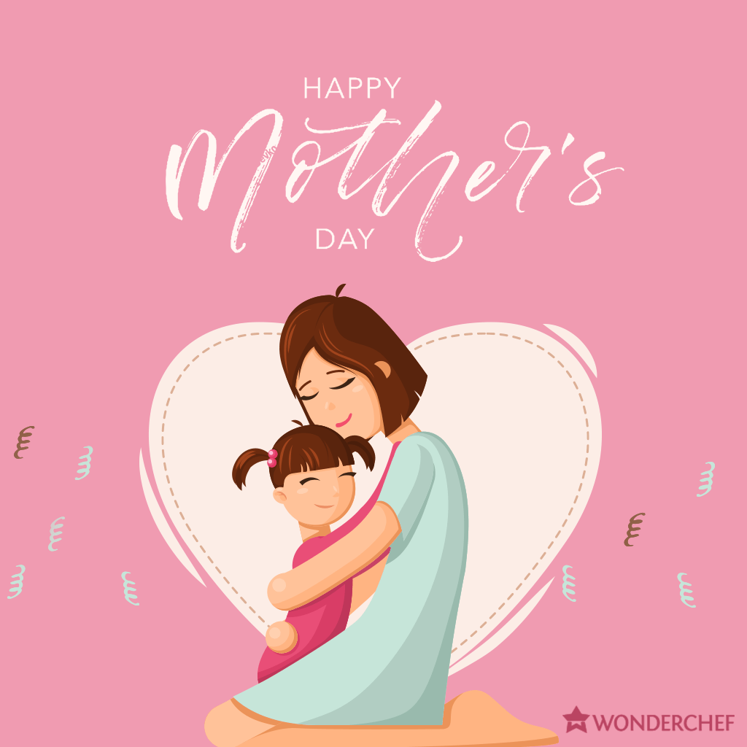 |  |  |  | pictures  Cards about celebrations
 |  |  |  |  | Pictures
Middle  2 min  2 min  2 min  2 min  3 min  2 min  2 min  2 min | Show the video about celebrations.  Pre- listening Teacher gives them worksheet with new vocabulary. And show this vocabulary on white board. Ss together repeat them, teacher teach how this words pronounce S-T  Teacher show the video, Ss watch video, “Freeze Frame” (W) Teacher stop the video and ask students  While- listening (P) “True or False” Teacher read the sentences about video. Ss should listen and say true or false.  Post- listening Discussion  (G) Answer the questions.  - What about this video?  - What types of celebration in this video  Jigsaw reading : (G) Teacher gives them text. They read the text and work with groups  Pre-reading (G) In groups to read and describe what they can see in the pictures, translation.  While-reading (W)  Reading questions: Teacher gives mini-white boards for student. Ss can all write an answer to hold up to the teacher  - What is the text about?  - Do you know other celebrations?  - Which celebrations do you know in Kazakhstan?  Post-reading: Inner-outer speaking activity (G)  Ss are dividing into the groups. They are told about their text, explain other groups |  |  |  | You tube  https://youtu.be/0a15UOja3JM  PP presentation  Flashcards with pictures  Text  Excel for Kazakhstan grade 5 PB p. 41 PB, p 41  Video You tube  https://youtu.be/388Q44ReOWE
5 min  3 min  5 min | Practice: (I) (F)  Teacher dividing students into groups according geometrical figures  Group A-  Group B  Group C  - Read the text again and mark sentences True or False  - Complete the sentences with missing words  - Match the pictures with the words |  |  |  | Geometrical figures  Appendix
 | (I) Ss open the book p.41 , ex 3, complete the sentences about themselves  (P) Teacher gives for pair’s worksheet. In this task they work in pairs, match the pictures with sentences ( sentence describing celebration, students should find this celebration in pictures) |  |  |  | Excel for Kazakhstan grade 5 PB p. 41  Worksheet  Worksheet celebrations
End  3 min | Plenary: (G) Make poster in groups. Divide into 2 groups. First group make a poster about mother’s day, second group about father’s day. Teacher gives them small pictures and they choose right picture and stick on poster. And they write any information about their theme.  Feedback  “Random name picker”  Reflection. “Let’s sing a song” |  |  |  | templates, markers, glue, scissors, small pictures  https://tools-unite.com/tools/random-picker-wheel  https://youtu.be/SDgfiB3c2t8
 | Teacher gives home-task. Says good-bye.
Additional information
Differentiation – how do you plan to give more support? How do you plan to challenge the more able learners? |  |  |  | Assessment – how are you planning to check learners’ learning? |  |  | Health and safety check
By support:  monitor less able groups in controlled tasks and highlight any errors in choice of word, structure and spelling for learners to self-correct in their writing;  Use for less able students word banks, explain using pictures, giving completing sentences, give time for thinking  By task:  Depending on the class level, students can be given less/more challenging tasks. More able students find correct sentences, middle able students complete sentences, less able students match pictures  More able students can answer high order questioning, explain their thinking: “How do you celebrate Mother’s day in your family?”, “Why is so important?” |  |  |  | Use mini-white boards for student so they can all write an answer to hold up to the teacher  Walking around and listening as they practice saying sentences and asking questions  Noting which learner says the word or sentence correctly  Formative assessment strategies:  “Traffic lights”  “Self- assessment”  “Peer assessment” |  |  | Being aware of Health care techniques.  Doing Physical activities (exercises).
Reflection  Were the lesson objectives/learning objectives realistic?  What did the learners learn today? |  |  |  | Use the space below to reflect on your lesson. Answer the most relevant questions from the box on the left about your lesson.  What two things went really well (consider both teaching and learning)?  1:  2:  What two things would have improved the lesson (consider both teaching and learning)?  1:  2:

Appendix
Formative assessment activity
English grade 5
Unit  Topic | Values  Celebrations
Learning objectives | 5.5.5.1-link without support sentences using basic coordinating connectors  5.5.4.1-write with support a sequence of short sentences in a paragraph to give basic personal information, ideas, experiences and feelings
Level of thinking skills | Knowledge, comprehension
Assessment criteria | Identify correct sentences using short texts  Make sentences using new lexical material  Matching pictures with words
Task
Group A- Read the text again and mark sentences True or False

Group B Complete the sentences with missing words

Group C Match the pictures with the words

Assessment criteria | Descriptor  Learners:
Identify correct sentences using short texts | - Work in group A  - Read the text and mark sentences True or false
Complete sentences with missing words | - Work in group B  - Read the text  - Fill in the gaps
Match pictures with words | Find correct words to according pictures  - Work in group C  - Find correct words according to pictures

