Module 6“Holidays and travel ”  Lesson 7  Theme: Parks around the world |  |  | School: Comprehensive school №4
Date: |  |  | Teacher name: Rodak Anna Yurevna
CLASS: 6 “A” |  |  | Number present: |  |  | absent:
Learning objectives(s)  that this lesson is  contributing to |  | 6.1.6.1- organise and present information clearly to others  6.2.8.1- understand supported narratives including some extended talk, on a range of general and curricular topics  6.5.7.1- use with some support appropriate layout at text level for a growing range of written genres on familiar general topics and some curricular topics;  6.4.2.1- understand independently specific information and detail in short, simple texts on a limited range of general and curricular topics
Lesson objectives |  | All learners will be able to recognize teacher`s instructions, recognize new words
 |  | Most learners will be able to: read the texts, understand specific information and details
 |  | Some learners will be able to: express own ideas
Plan
Planned timings | Planned(teacher) activities |  |  |  | Learners activities |  | Assessment | Resources
Beginning the lesson  1-2min | -Good day, guys! Take your seats, please.  -How are you? Are you o`k?  Boys and girls, I`m glad to see you and I hope we will friendly. |  |  |  | Hello, teacher!
Middle  38-40 min | Organization moment  -What day is it today?  -What date is it today?  -What season is it?  -What`s the weather like today? Do you like it?  -Have you got your English books?  -Have you got your English notebooks?  -Have you got your pens?  Very well! I see,you are ready to start the lesson.  Tongue twister  At the first, let`s practice pronunciation.  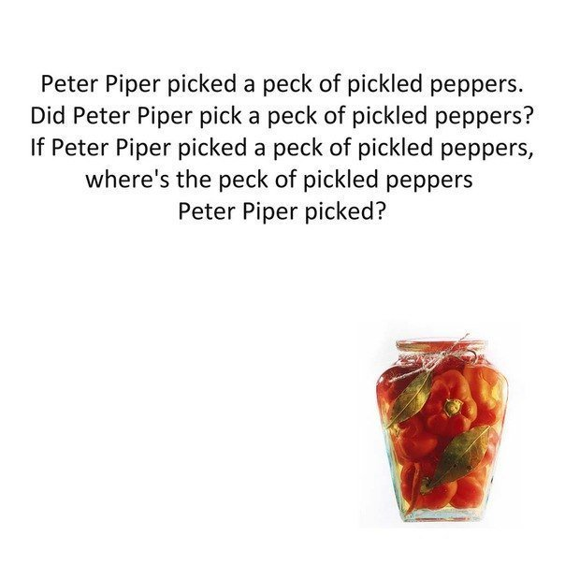  -How do you feel? Are you o`k?  Hook  Guys, do you like watching videos?  I suggest you to watch the video.  -Did you like the video? What about it?  -How do you think, what`s the topic of the lesson today?  Right you are.  Introduction of the new topic and lesson objectives  The topic of the lesson today is “Parks around the world”.  Think about the aims of the lesson.  -What will you learn?  -What will you able to?  You will learn new words. You will be able to give information about parks around the world.  Open your notebooks and write down the date.  Write down the topic of the lesson.  New vocabulary  -Look at the screen. These are new words.  Who would like to read?  And now, listen and repeat with me altogether.  amusement park-парк развлечений  arrangement-договоренность, соглашение  attraction-аттракцион  fairground-ярмарочная площадь  hidden-спрятанный  landmark-достопримечательность  light up-зажигаться  miniature-миниатюрный, маленький  ride-аттракцион для катания  tiny-крошечный  treasure-сокровище  You can find the words at p.136 of your book.  Pre-reading  Look at the pictures. What do you see in the pictures?  I`d like to show you the video about these parks.  Video  -Where is Babbacombe Model village  -What things are there in the Babbacombe Model village?  ( beautiful gardens, miniature vehicles, shops, houses, castles and famous English landmarks like Stonehenge)  -Where is Almaty Central park?  -What things are there in the Almaty Central park?  (fairground rides, a cinema and beautiful plants and flowers)  Reading  Now, open your books at p.73.  There are the texts about parks. You will read the texts one sentence one by one.  Post-reading  Work in groups  Ex.1.Make true and fall sentences to your partners. You will make 5 sentences.  Ex.2.Listen to the sentences and choose True or False.  Relaxation  Let`s have a rest!  Stand up, clap your hands, shake your body.  Clap your hands, show O`k.  Hands on your hips, turn left, turn right, show o`k.  Hands on your hips, stamp your feet-one, two,-2 one, two, three, stop.  Rise your hands, shake, shake.  Hands down, clap, clap. Show o`k.  Sit down.  Making a project  Imagine, you are designers. You have created a park in our town. Think about your perfect park and share your ideas with us. Make a poster.  The name of the park/it has…/there is/there are.  Choose the speaker and present your poster.  Evaluation  Self-assessment “Traffic lights”  Conclusion  Did you like the lesson? What did you like best? |  |  |  | It`s …  The 14th of February  It`s winter  Today is…. I like it/don`t like  Yes, I `ve got  Yes, I `ve got  Yes, I `ve got  Learners repeat with the teacher chorally  I`m o`k  Yes/no  Learners form the aims of the lessons  Learners read the words individually  Learners repeat the words  Learners describe the pictures  Showing the video  Learners answer the questions  Learners read the texts  Learners write 5 sentences  Learners mark T or F  Learners repeat activities with the teacher  Learners make a poster  Learners choose the circle |  | Well don!  Very well!  Very well  Well done  Very well  Well done  1-5  Peer assessment  1-5 | PPT  Slide 1  PPT  Slide 2  PPT  Slide 3,4  Video  PB  Worksheets  Sheets of paper, crayons  Colourful circles
Ending the lesson  5 min | Home-task: new words |  |  |  |  |  | Colour circles
Additional information
Differentiation – how do you plan to give more support? How do you plan to challenge the more able learners? |  |  |  | Assessment – how are you planning to check learners’ learning? | Cross-curricular links  Health and safety check  ICT links  Values links
have stronger pupils model final activity in step 1 before asking weaker learners to attempt. |  |  |  | monitor learner output in  choral drilling  eliciting task  speaking production tasks | cross-curricular link:  Literature  Language  Geography

