Almaty region, Talgar district
School – lyceum # 4 Talgar town
English teacher:
Suleimanova Lyazzat Abdrakhmanovna

Урок-спектакль по творчеству М.Твена
In the world of Mark Twain’s humour.

Learning Objectives
- to expand the horizons and increase the general culture of students, to introduce them to the world culture.
- to develop the intellectual, emotional and motivational spheres of the students ' personality.
- to form an interest in foreign language culture.

Lesson objectives:
* Introduce students to the life and work of the American writer M. Twain.
* Development of cross-cultural competence.
* Improvement of oral speech English skills

Grade 6 “A”, “B”, “C”

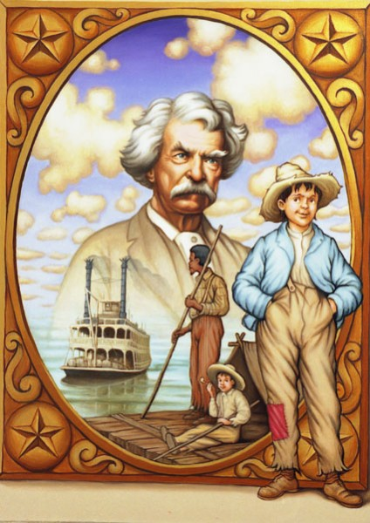
Plan:

Aitemir: Good afternoon, boys and girls! Glad to see you at our literary hall. Look at this portrait. Do you know this famous person?

Students: Yes, we do. This famous person is Mark Twain.

Aitemir: What do you know about Mark Twain?

Dasha P.: He was a famous American writer. He was also well known as a lecturer. Literary clubs invited him to speak.

Aitemir: Our literary club also “invited” Mark Twain and his characters. Meet the hosts of our literary hall.

Mazhit: His real name was Samuel Clemens. Mark Twain was his pen name.

Vika L.: He was born in 1835 in Hannibal on the Mississipi River. His family was poor. He was the son of a lawyer.

Petr D: When Samuel was 12 his father died. And the boy had to begin to work.

Emil: All his life Samuel was fond of reading. He spent much time in libraries and began to write short humorous stories and presented them in newspapers.

Mazhit: A lot of professions gave Mark Twain a knowledge of life and people, and helped him to find his true vacation to be a writer.

Vika L: American satirical literature began with Mark Twain.

Petr D: Some of his books are very popular with children in our country.

Emil: Do you know them?

Dasha:
“The Adventures of Tom Sawyer” («Приключения Тома Сойера»)
“The Adventures of Huckleberry Finn” («Приключения Гекльбери Финна»)

Mazhit: Both children and grown ups all over the world love his books.

Peter: In these books Mark Twain shows the joys and sorrows of children with such deep understanding and love, that children and grown-ups have feeling that the books are about them.

Aitemir: Now look at the main characters of these books.

Scene 1. Class 6 C

(Беки рассматривает книгу учителя. Том подкрадывается, пугает её и Беки нечаянно рвёт страницу).

Becky: You are bad, Tom Sawyer! Now the teacher will beat me and what shall I do! I have never been beaten at school. (Плачет)

Tom: How silly girls are! What is a beating at school? It`s nothing!

(Входит учитель, видит порванную страницу и грозно осматривает класс)
The teacher: Who has spoiled my book?

(Дети прячут глаза, боятся порки)

The teacher: Ben Rogers?

Ben: No.

The teacher: Joe Harper?

Joe: No.

The teacher: Amy Lawrence?

Amy: No.

The teacher: Grace Miller?

Grace: No.

The teacher: Rebecca Thatcher, look at me. Did you do this?

(Беки обомлела от страха, она уже готова признаться, но тут вскакивает Том)

Tom: I did it!

(Том подходит к столу учителя, готовый к порке. Учитель берёт длинную линейку)

Becky: Tom, you are so noble!

Tom: I just tried to be a gentleman.

Becky: Thank you so much! (воздушный поцелуй)

Scene 2. Class 6 B

Tom: I don`t want to go to school. What can I do to stay at home? Oh! My tooth is loose! .. No, it won`t do. Aunt Polly will put it out. Oh, what a wonderful idea came to me. (Том ложится и начинает плакать всё громче и громче) Sid… Sid!

Sid: What has happened, Tom? Tom… Tom! Say what has happened to you?

Tom: I die, Sid! I am not angry with you.

Sid: Oh, Tom, you don`t die. Don`t!

Tom: I`m not angry with you. I`m not angry with Aunt Polly. Tell her so, and … Sid, give my cat with one eye to the new girl at school and tell her …

Sid: Aunt Polly, come! Tom dies!

Aunt Polly: Dies!?

Sid: Yes, come quickly!

Aunt Polly: Don`t say so. Tom, Tom! What has happened to you, my boy?

Tom: Oh, Antie! Look at my right hand. It`s red and hot.

Aunt Polly: Tom, stop that nonsense! And get up!

Tom: But Antie, it is so hot, that I have forgotten about my tooth.

Aunt Polly: Your tooth? What has happened to your tooth?

Tom: It`s loose.

Aunt Polly: Open your mouth. Well, you are right, your tooth is loose. Sid, bring me some thread.

Tom: Oh, please, dear Antie, don`t put it out. It`s all right now. (Тётя пытается привязать нитку.Начинается возня) Oh, my tooth is all right, but I didn`t want to go to school.

Aunt Polly: Tom, you did all this because you didn`t want to go to school? Tom, Tom … I love you so dearly, and you … Now get up quickly and get ready to go to school!

Scene 3. Class 6a

Aunt Polly: Tom, go and whitewash the fence!

Tom: Oh, Antie, I can`t. I`ll do it … tomorrow.

Aunt Polly: Whitewash the fence, I say.
(Ставит ведро, кисть, уходит)

Ben: What are you doing?

Tom: I`m whitewashing the fence.

Ben: Do you want to say you like it?

Tom: Of course, I do. Do the boys whitewash the fence every day?
(Том продолжает белить забор)

Ben: Tom, let me whitewash a little!

Tom: (важно) No, I can`t. Jim wanted to whitewash, but Aunt Polly did not let him.

Ben: Tom, let me… I`ll give you my apple.

Tom: Apple? Well, all right.

Billy: Hello, boys! What are you doing here?

Ben: Tom and I are whitewashing the fence.

Billy: You don`t think it is interesting, do you?

Ben: We do! Jim wanted to whitewash, but Aunt Polly didn`t let him.

Billy: Tom! Let me whitewash a little! I`ll give you my knife.

Tom: OK.

Johnny: Tom! Let me do it and I`ll give you my dead cat.

Tom: All right!!! (Том очень доволен. Мальчики заканчивают белить забор).

Aunt Polly: Well, it`s done! You are a good boy, Tom. Now you may go and play.

Tom: Hurray!

Host 1: Do you like the stories about Tom Sawyer? Then go to the library and take a book “The Adventures of Tom Sawyer” by Mark Twain. You`ll really enjoy it.
Reflection “Two stars and a wish”
Students work in groups and make a poster describing what they liked or not.
