Lesson plan
Unit of a long term plan:  Communication and technology |  |  |  | School: №90
Date: 21.02.2020 |  |  |  | Teacher name: Ashirova M.Zh
CLASS: 7 Ж |  |  |  | Number present: |  | absent:
Lesson title: |  |  | Communication and technology: Technologies in our life
Learning objectives(s) that this lesson is contributing to (link to the Subject programme) |  |  | 7. L.2 understand with little support most specific information in extended talk on limited range of general and curricular topics.  7.S.7 use appropriate subject-specific vocabulary and syntax to talk about a growing range of general topics and some curricular topics  7.R.2 understand specific information and detail in texts on a range of general and curricular topics.  7.W.2write with minimal support about real and imaginary past events, activities and experiences on a growing range of familiar general and curricular topics
Level of thinking skills |  |  | Knowledge Understanding Application
Lesson objectives |  |  | All learners will be able to:  - read, listen and say information about technology  - make sentences using the new words  Most learners will be able to:  - read the text about “The wonders of technology and its tools” and answer the questions according to the text  Some learners will be able to:  - to make sentences using the phrases and their ideas and share with their minds
Assessment criteria |  |  | Identify the main idea of the text about “The wonders of technology and its tools”
Values links |  |  | Economic growth based on industrialization and innovation Communicate with the world through media and be one of the greatest country with much developed technology.
Cross-curricular links |  |  | computer science
Previous learning |  |  | Hobbies and Leisure. Summative assessment 1
Plan
Planned timings | Planned activities (replace the notes below with your planned activities) |  |  |  |  |  | Resources
Start  3-min  5 min | Greeting  Organization moment  Divide learners into two groups by cut of pictures  Checking up the homework with giving quick answers: with “SOME” or “ANY”  - We need bananas.  - You can't buy posters in this shop.  - We haven't got oranges at the moment.  - She always takes sugar with her coffee.  - There aren't pencils in my bag.  - I have magazines for you.  - There are apples on the table.  - Pam does not have pencils on her desk.  Video clip about technology  Pupils watch the video clip, discuss and find out the theme of the new lesson, and answer some questions.  - What do think about this video?  - Can you find the title of our lesson?  - Do you agree that now we couldn’t live without technologies?  - What types of technologies have you got?  Thanks a lot. And let’s begin our lesson with new words. |  |  |  |  |  | Cut of pictures
Middle  3-min  5 min  10-min  5-min  5-min | 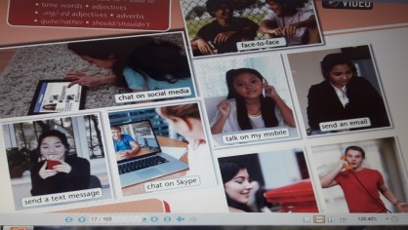  Drilling activities. Vocabulary work.  Communication-байланыс  Technology-технология  Tool-құрал  Inventions-өнертуынды  Face to face-бетпе-бет  Keyboard-пернетақта  Speakers-дыбыс ұлғайтқыш  Headphones-құлаққап  Network-желі  Website-вебсайт  Download-жүктеу  Share the link-ссылкамен бөлісу  Send email-хат жіберу  Choral drill, individual drill.  So, pupils as you know there were many types of communication.  Some of the oldest forms of human communication include talking or making sounds, drawing or painting, dancing, acting, and using symbols. Then the technology began to develop.  Now, let’s play the game. I hid the pictures everywhere in the classroom. They are some tools of new technologies. You should find these pictures quickly, then match them with the pictures. It is a group work. I’ll give you 2 minutes.  W.Task-1. To find the pictures and match with definitions.  For the groups:  1. A notebook or a laptop – is small computer you can carry with you.  2. Headphones – are a device that allow you to hear sound directly from a computer or portable media player  3. A monitor – is a screen that shows what the computer is doing  4. A microphone – is a device that can make your voice louder.  5. A keyboard – is a device with letters, numbers and other buttons. When you type on it, the symbols show up on the monitor  6. A computer case – is the box that houses the ‘guts’ of a desktop computer  7. An e-mail – is similar to a letter, it is sent via the internet to a recipient.  Descriptor:  Learners will:  - find the pictures quickly;  - put the pictures correctly;  Assessment: Peer assessment.  Thank you guys. And now I’ll give you a text about how the technology appeared.  I will read the text, you should listen very attentively, because after reading you must answer to some questions.  Task 2. To read the text and answer the questions according to the text.  The wonders of technology and its tools  It all started 350,000 years ago when humans discovered for the first time the fire. But why did people use the fire?!  - Fire paved the way human advancement, such as crafting tools and weapons  - It gave them light and warmth  - It allowed them to cook their foods, making them safer to eat.  So, technology would not exist without the early humans. But the modern technology begins after the 17th century.  It was the 17th century and there were some inventions that revolutionized the world. Isaac Newton and Galileo Galilei discovered the gravity, the telescope, the microscope, the solar system and other stuff that changed the way how people thought of the world. But the wonder of technology don’t end here!  Einstein’s theory helped technology all around the world. He won the Nobel Prize for his theory of the photoelectric effect. Einstein’s theory led to many inventions. And now the last chapter of technology’s evolution is the computer. In 1984 Steve Jobs developed for the first time ever Macintosh, the first computer with a graphical user interface. Computers are used in everywhere: in banks, in business, in medical science, in daily life etc. A hundred years ago you would have to read a book to find out information on a topic. Now, you can just ‘surf the net’. Today we also have robots, space rockets, satellites. And all of these are making our lives easier.  Questions:  - It started 300,000 years ago when humans discovered for the first time the fire. (F)  - It allowed them to cook their foods, making them safer to eat. (T)  - Isaac Newton and Galileo Galilei discovered the first computer (F)  - Fire paved the way human advancement, such as crafting clothes (F)  - Einstein won the Nobel Prize for his theory of the photoelectric effect. (T)  - In 1984 Steve Jobs developed for the first time ever Macintosh, the first computer with a graphical user interface. (T)  - The modern technology begins after the 16th century. (F)  - . Computers are used in everywhere: in banks, in business, in medical science, in daily life etc. (T)  Descriptor:  Learner will:  - Read the text attentively;  - Give answers ‘True or False’ .  Assessment: peer assessment.  Task-3. Doing exercises. Using the method: “Grasskirt”  Students, let’s do an exercise. As you know we have learnt the grammar Present and Past Passive Voice. First of all you should choose inside your group one player. He or she will be “a runner”. I hung out on the wall sentences with Present and Past Passive Voice. The runner should run and take one sentence and give to his or her group. And the members should do this sentence in right order. Then the runner will bring that sheet to me and I’ll check. If your answer is right, the runner continues his or her work. If your answer isn’t right you must do it again.  - How many newspapers(print) in Britain every day?  - German(speak) in Germany, Austria, and part of Switzerland.  - The royal wedding(watch) by millions of people in 2011.  - Nowadays, a lot of computers(make) in Korea.  - The Harry Potter films(not direct) by Steven Spielberg.  - In the UK, alcohol(not sell)to anyone under It's against the law.  Descriptors: A learners will:  - write the sentences correctly  Assessment: teacher’s assessment.  Task-4. The game “Bingo”  Now pupils, we have reached to our last task. It called “Bingo”. There are some boxes. Each group’s members one by one should choose the box and answer.  1. A mouse – is a small device that you move with your hand-it moves the cursor on the monitor  2. A scanner – is a device that scans paper, text, photos and drawings  3. A tablet – is a mobile computer that is controlled using a touch screen  4. A webcam – is a device that takes images and videos. It connected or built into a computer  5. Speakers – are the devices that emit sound. Sometimes they are built into the computer  6. A WIFI – is a wireless networking protocol that allows devices to communicate without direct cable connections.  7. A printer – is a device for printing a computer’s output onto paper  8. A computer case – is the box that houses the ‘guts’ of a desktop computer  9. A microphone – is a device that can make your voice louder.  Descriptors: A learner  -reads and answers the questions correctly |  |  |  |  |  | Excell-7th grade  pg.17-18  Photos  Sheets of papers  markers  posters , markers  power point
End  2 min | Conclusion: To make a poster about one of the types of technology.  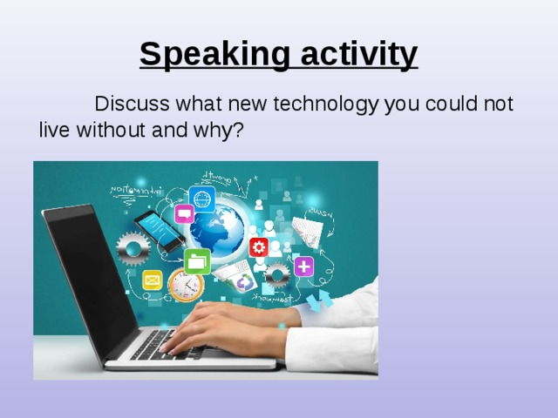  Giving homework. To write an assay about your favourite gadget.  Reflection:  What did you do well in today’s lesson?  What were the most interesting for you?  What did you understand?  What didn’t you understand?  What do you want to know about this lesson?  Successful stairs  Learners looks at the board and puts a tick or a cross for stairs what they have learnt or not  T-4  T-3  T-2  T-1
Additional information
Differentiation – how do you plan to give more support? How do you plan to challenge the more able learners? |  | Assessment – how are you planning to check learners’ learning? |  |  | Health and safety check
More able students:  Differentiation by outcome:  - to make sentences using the phrases and their ideas  Less able students:  Differentiation by outcome:  - find the key words from the text that describes the meaning of the text |  |  |  |  | Energizer: physical activity
Reflection  Were the lesson objectives/learning objectives realistic?  Did all the learners achieve the lesson objectives/ learning objectives? If not, why?  Did my planned differentiation work well?  Did I stick to timings?  What changes did I make from my plan and why? |  | Use the space below to reflect on your lesson. Answer the most relevant questions from the box on the left about your lesson.
Summary evaluation
What two things went really well (consider both teaching and learning)?
1:

2:

What two things would have improved the lesson (consider both teaching and learning)?
1:

2:

What have I learned from this lesson about the class or individuals that will inform my next lesson

ДОІЖО К.М.Бакирова

ӘБ жетекшісі: М.Ж.Аширова

