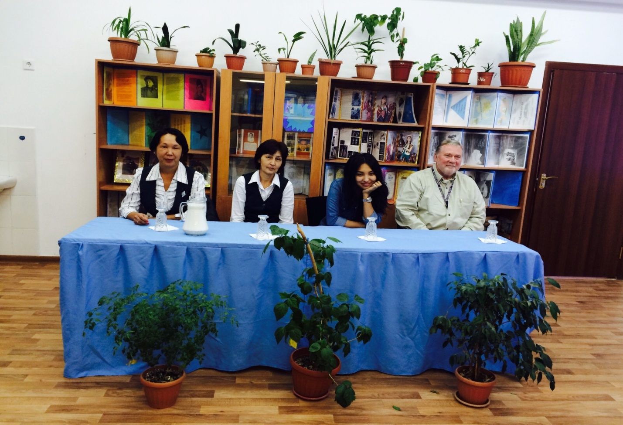
Guests form TCO company and our teachers
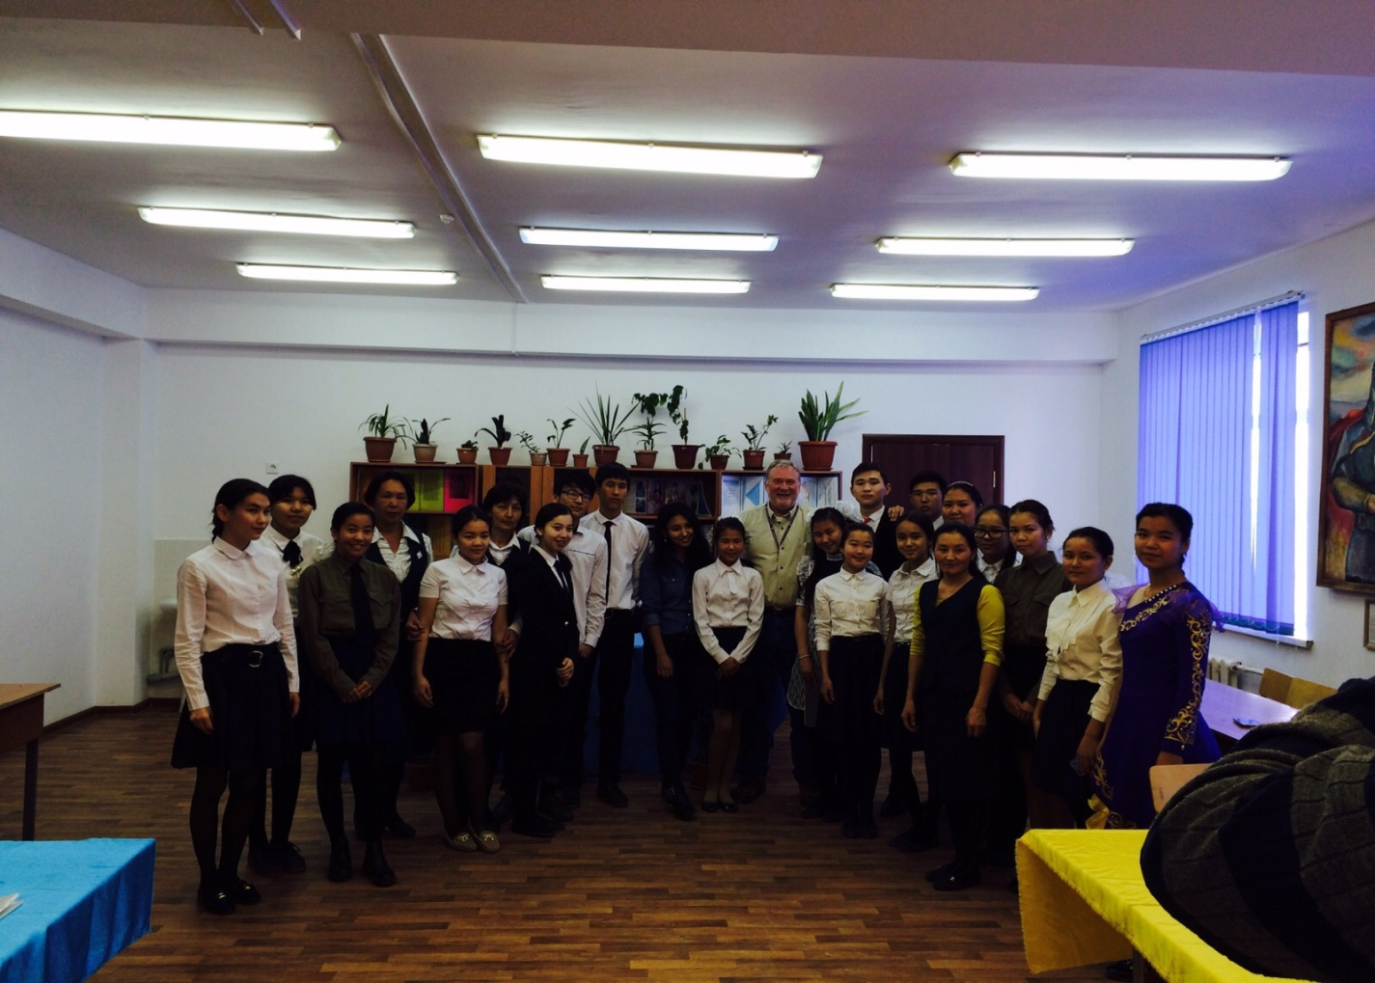
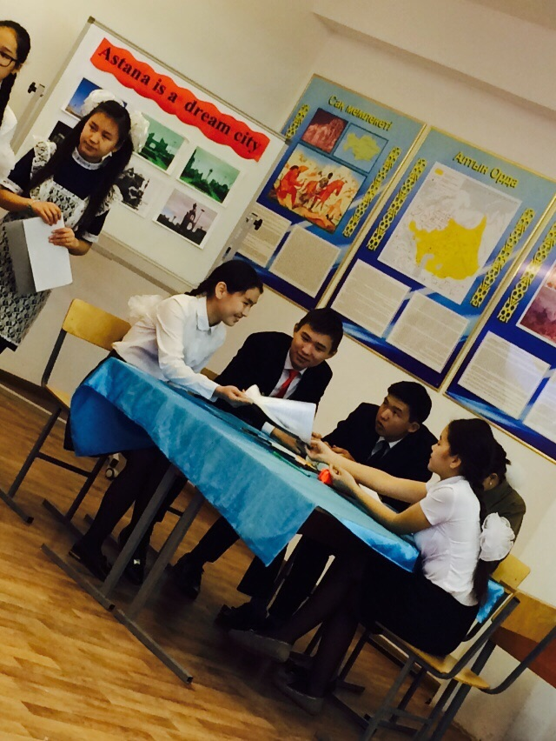
Students are preparing a poster about Astana
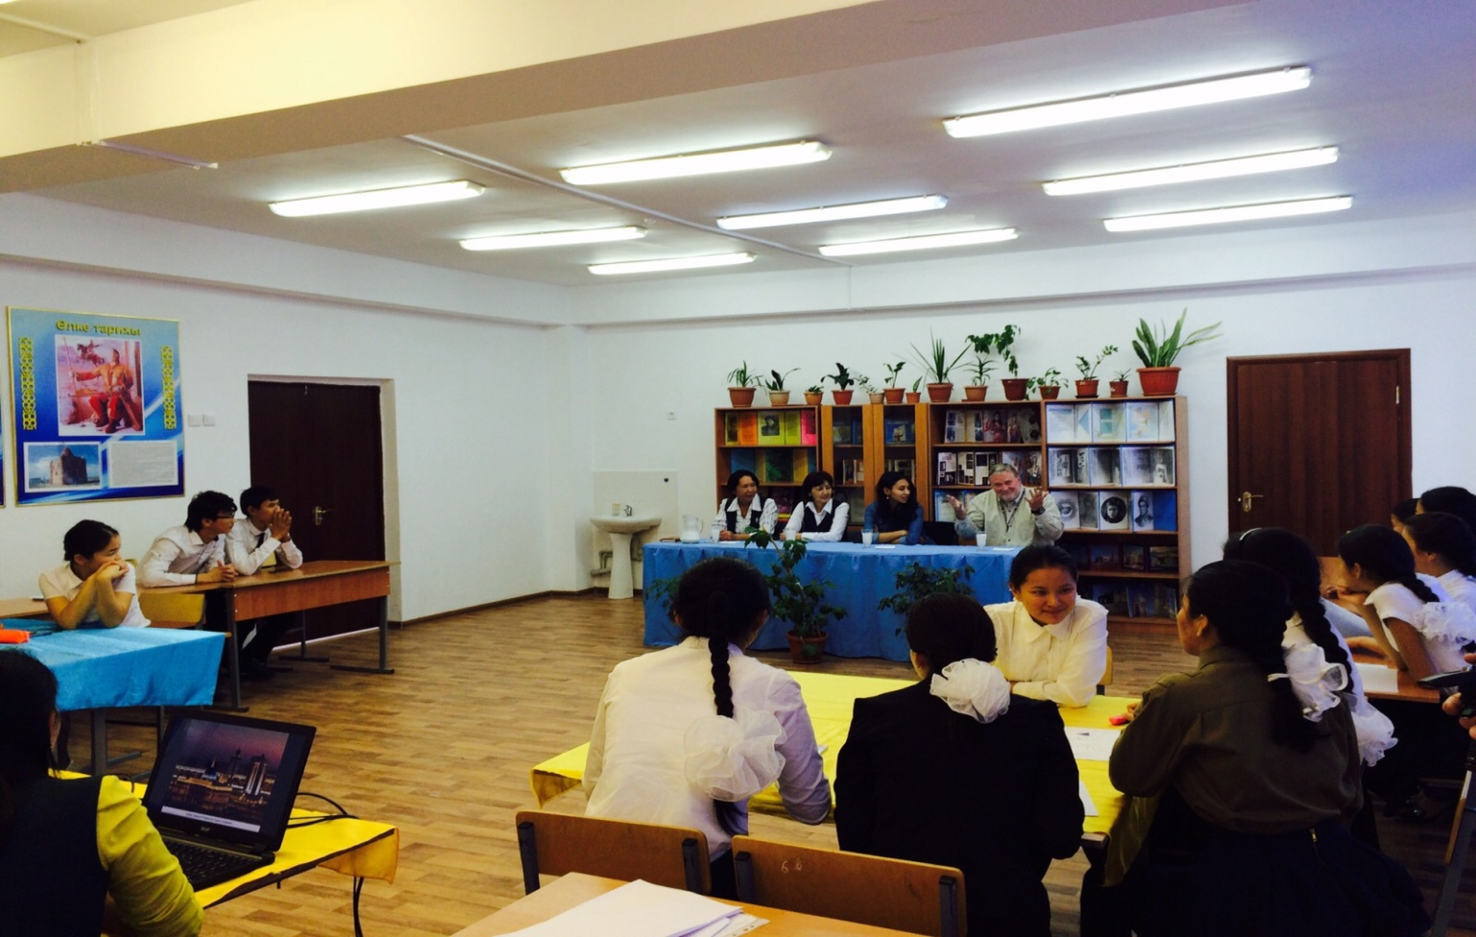
He is answering the students questions
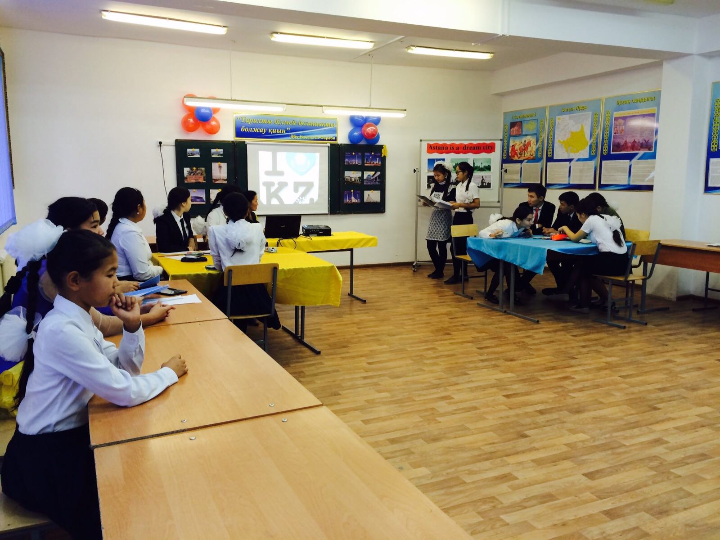
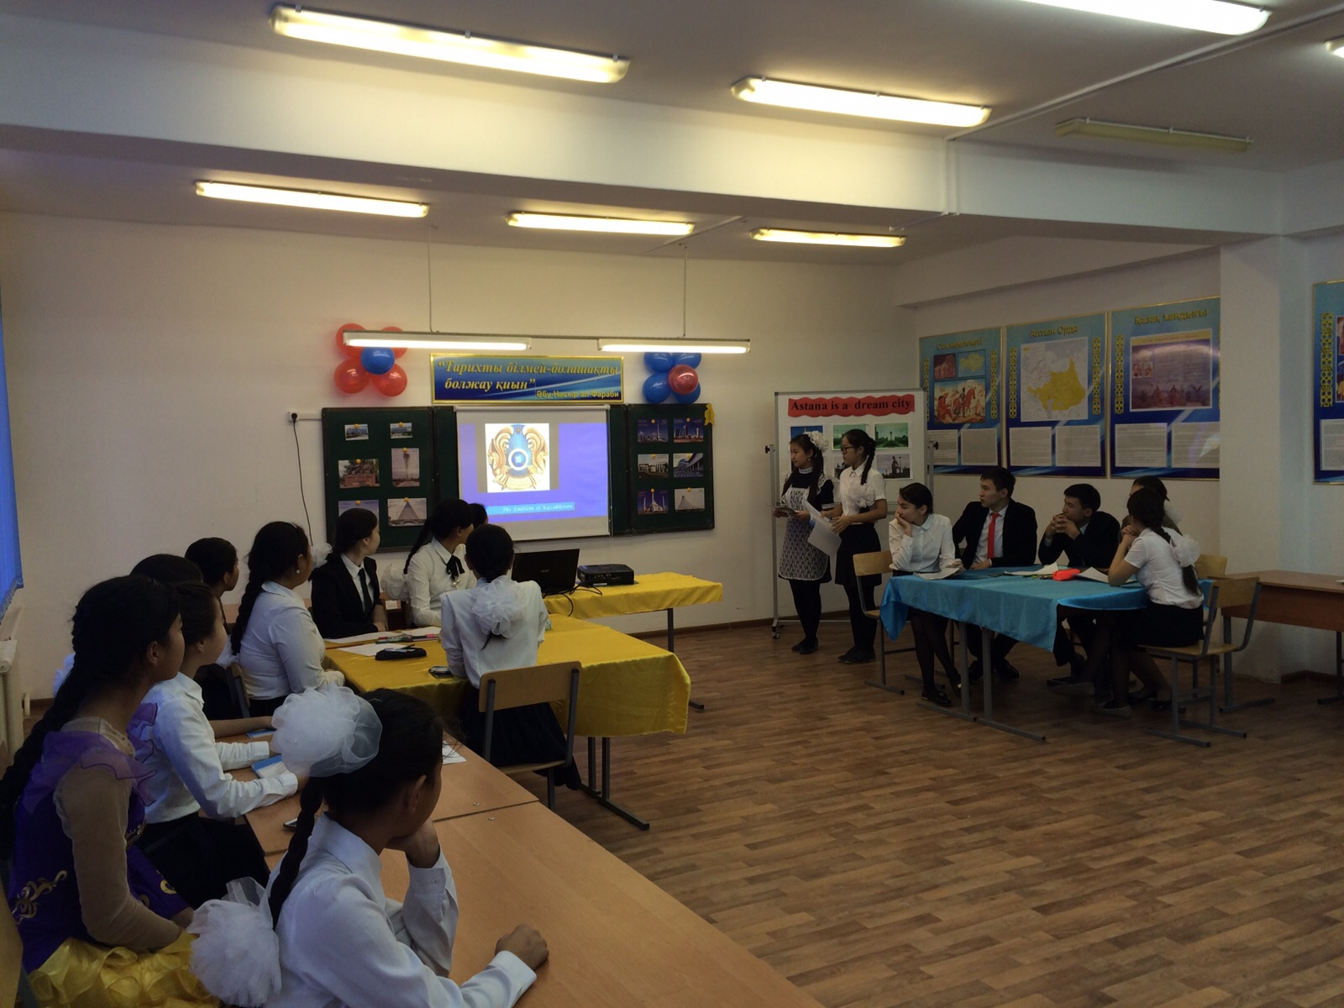

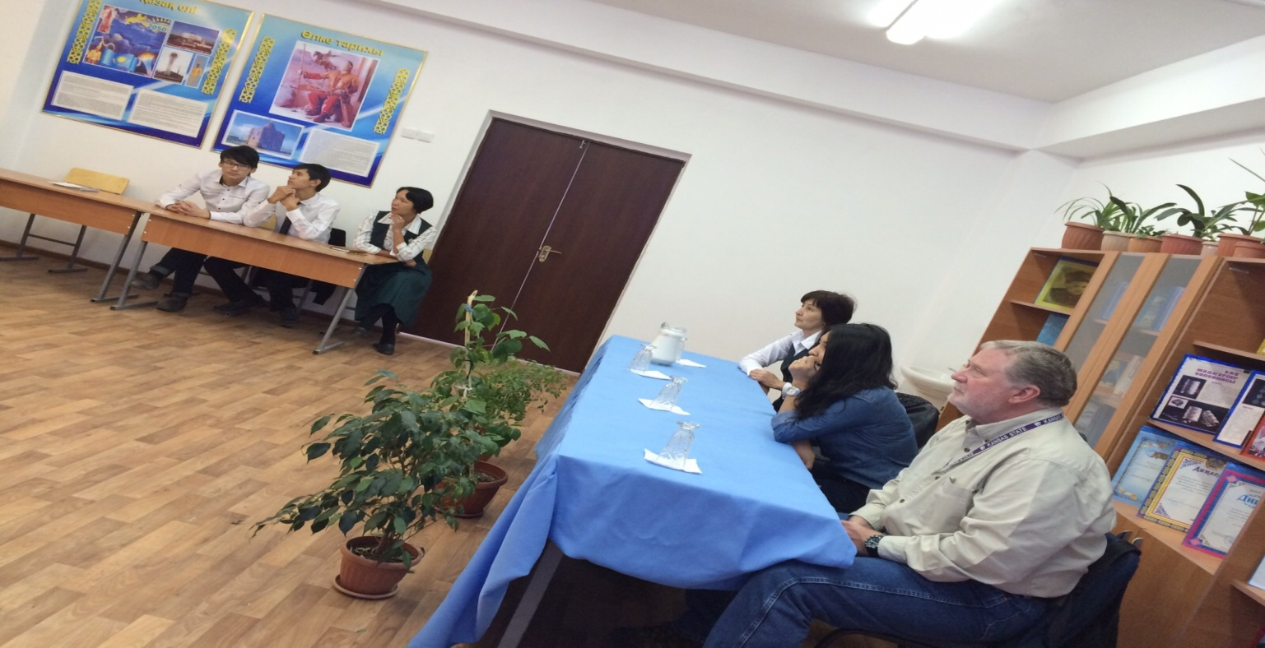
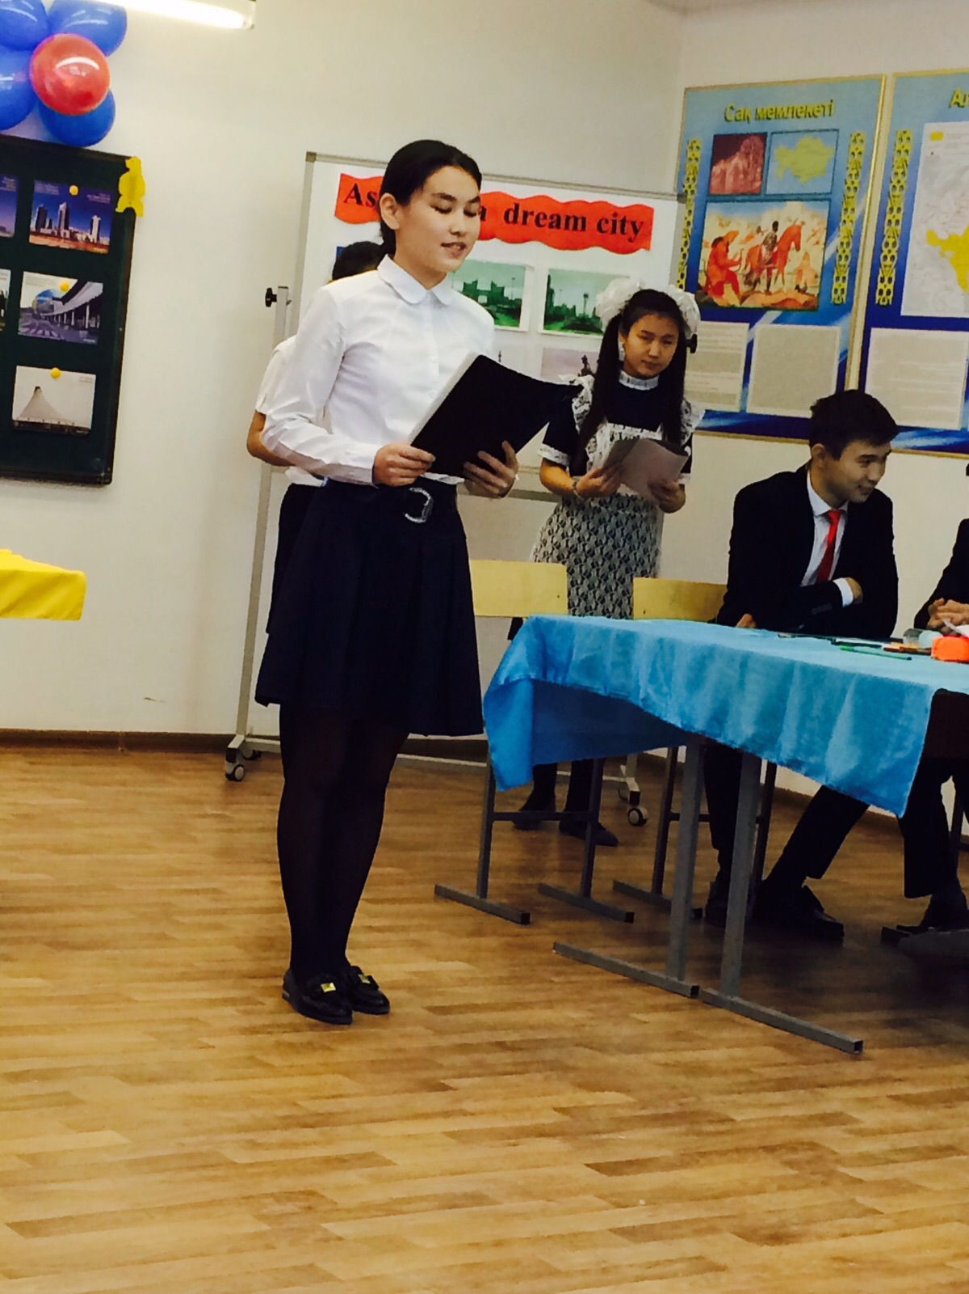
Student of the 10 form Bisenova Aibakht is reading a poem by
Zhuban Moldagaliiev "Astana"
Theme of the party: Astana is a dream city.
Aim of the party:
- According to the decree of President of the Republic of Kazakhstan N.A.Nazarbaev to enrich students’ knowledge of foreign languages, to show the importance of being well-educated
- To develop students’ intellect, speech habits through speaking, listening and writing in three languages
- To bring up the culture of communication and the need in practical use of languages
- Teaching children to respect and love their lives, their friends, be kind and trustful to them
The visual aids: an active board, pictures, balloons, videos
Plan of the party:
I Warm up
I leader: Kyrmyzy Good morning, dear guests and students. We are very glad to see you. Now students today we have guests from TCO company. Welcome them.
II leader: Aruzhan How are you dear guests. Welcome to our school. Now let's begin our party. The theme is Astana is a dream city. Let me ask some questions about Astana.
- What is Astana?
- Where does Astana situated?
- Do you like your capital Astana?
- Have you ever been to Astana?
- What kind of sightseeing do you know?
Now, watch a video about Astana.
I leader: Kyrmyzy
Students are going to tell you about Astana. Listen to them.
Student A is Aruzhan - Astana is the capital of Kazakhstan
Astana is a modern city with a favorable environment attractive for tourists and comfortable for residents and guests of the Kazakh capital to live in.
Astana became the capital of new Kazakhstan in 1998 for a variety of reasons. By the end of the XX century, the country’s former capital Almaty was facing a heap of difficulties hampering further development of the city: the problem of overpopulation (over 1.500.000 inhabitants); traffic congestion; deteriorating environmental conditions. Moreover, compact planning of the “southern capital” in practice, restricted modern development of the city.
Student B is Anel - Tower of Baiterek
This is a Kazakh version of the universe. Quite recently, Bayterek, a folklore symbol, was embodied in a beautiful tower, resembling the ever-lasting fight of good and evil. The Bayterek monumental structure was opened in the very center of Kazakhstan capital in 2002. It ushered in a new stage in the people’s life, becoming a symbol not only of Astana, but also of the whole country.
Student C is Danagul - Duman Entertainment Center.
Duman - Entertainment Center in Astana The Aquarium of the Entertainment Centre "Duman" is the first one over the world. There are more than 2, 000 of sea inhabitants of sea fauna from different parts of the world. The Aquarium consists of the large main tank and two big exhibitions areas with eleven tanks of different sizes. The most interesting part of Aquarium is the main tank with 70 - meter long tunnel equipped with a moving walkway. In this underwater tunnel you will be able to walk on the seabed.

II leader: Aruzhan
The next task our party is competition between two groups. Let's meet them.
1st group is Peace
2nd group is

I leader: Kyrmyzy
Our competition consists of 4 tasks.
The 1st task is Presentation. They have to introduce their team. Now, Let's listen to them.

Poem: "Astana" written by Zhuban Moldagaliev. will read student of the 10th form Bisenova Aibakht

II leader: Aruzhan
The 2nd task is Home task. Home task was to write about Astana. Let's listen to them.

I leader: Kyrmyzy
The 3rd task is Jeopardy game.
Every team has to answer the questions. It has points of 100, 200, 300 numbers. Every point has questions. You have to choose one of the points in terns and answer the questions. Theme of it is Astana and Sightseeing of Astana.
Now, please 1st team choose of the point. Listen and answer.

II leader: Aruzhan
The 4the task is to make Posters about Astana. You have 7 minutes.
While they are making their posters enjoy "Kazakh dance" by the student of the 9th form Esenova Dinara.

I leader: Kyrmyzy
Are you ready teams. Present your posters.
Thank you very much for your participations in our competition. You did excellent job.

II leader: Aruzhan
In Conclusion our students want to speak with our guests. They want to ask some questions.

Now, dear guests thank you so much for your coming to our school. We hope that you enjoyed our meeting. Good bye. See you soon.

