Short-term plan
Unit Our neighbourhood:
Teacher name: Palagina A.A., Deryabina S.V.
Date:
Grade: 6 «A» | Number present: | Number absent:
Тheme: Earth Day
Learning objectives that this lesson is contributing to | 6.3.7.1: use appropriate subject-specific vocabulary and syntax to talk about a limited range of general topics, and some curricular topics  6.6.13.1: use modal forms including should/shouldn’t on a range of familiar general and curricular topics
Lesson objectives | All learners will be able to:  • to work in groups  • to match the words with the pictures  Most learners will be able to:  • classify the words  • to tell the phrases correctly  • to answer the questions  Some learners will be able to:  • to use should/shouldn’t
Assessment criteria  Value links  Cross curricular links  ICT skills  Previous learning | • pronounce topic related vocabulary correctly  • apply topic related vocabulary in speech  • answer the questions correctly  • classify the words correctly  • to match the signs with the phrases correctly  • to use should/shouldn’t correctly  • to tell the phrases correctly  Collaboration, mutual respect, leadership skills  Geography, Biology  Presentation, video  Lexics and phrases on the theme «Earth Day»

Plan

Lesson stages/ time | Teacher’s activity | Students’ activity | Assessment | Resources
I Beginning of the lesson  5min | -Good afternoon boys and girls! Glad to see you! Sit down, please. Look at the screen  and sit according to the given algorithm.  The first group is called «Lake» , the second group is «River», the third group is «Sea», the fourth group is «Ocean»  We are going to have an unusual lesson.  Now let’s make a circle and greet each other. Say your best wishes. | Pupils greet the teacher in chorus («Good afternoon», «Glad to see you too»)  Pupils greet each other:  I wish you success!  I wish you luck!  I wish you health!  I wish you happiness!  Be clever! Be boldness! Be honest! |  | Presentation( Algorithm: The names of groups with the pupils’ names )  Pointers with names and pictures of the groups
Presentation of new theme  «Catch the question»  3min | - Now let’s watch the clip. (2min)  And let’s talk about this clip. The teacher  throws a ball to pupils and asks questions:  - What does it tell you about?  - We live on a beautiful planet. What is its name?  - Why is it called a blue planet?  - What are there on the planet?  - Can you guess the theme of the  lesson?  -Very good! So, today our theme is  Earh Day! | Pupils watch the clip  The pupil catches a ball and  answers the questions:  It tells us about nature  It tells us about wild animals  Its name is the Earth  Our planet is blue because there is a lot of water  There are continents and oceans,  mountains and rivers  The pupils gives their answers |  | Video «Earth song» (Michael Jackson)  The ball  Presentation (Theme)
Tasks of the lesson  1min  II. The middle of the lesson  Work in groups  1min  1min  3min  3min  2min  3min  Warming up  3min  2min  3min  2min  1min  III. The end of the lesson  3min  3min  Hometask  1min  Reflection  2min  1min  Differentiation: To give the phrases with the translation for less able learners  Most able learners use phrases  without Russian translation.  Some learners write phrases by heart | -So, pupils lets guess the tasks of our lesson  -Well done, look at the screen  - -So, pupils you will work in groups.  Let’s remember the rules of working in groups. Your task is to match the rules with the translation  Match the rules to the translation:  - Don’t cry! 1. Будьте доброжелательными!  - Don’t interrupt! 2. Уважайте друг друга!  - Don’t argue! 3. Не кричите!  - Be friendly! 4. Помогайте друг другу!  - Be polite! 5. Не перебивайте!  - Help each other! 6. Не спорьте!  - Respect each other! 7. Будьте вежливыми!  - -Let’s check up. The first group, read the first rule in chorus and translate it and so on  - -So, pupils, your task is to classify the words into containers: food waste, paper,plastic, glass:  banana peel-банановая кожура  egg shell-яичная скорлупа  lettuce-листья салата  fish bone-рыбная кость  bone-кость  apple core-огрызок от яблока  notebook-блокнот  newspaper-газета  box-коробка  paper bag-бумажный пакет  juice tetrapack-картонная коробка от сока  milk tetrapack-картонная коробка от молока  plastic bin-пластиковое ведро  plastic bottle-пластиковая бутылка  plastic glass-пластиковый стакан  liquid soap-жидкое мыло  canister-канистра  plastic bag-пластиковая сумка  glass milk bottle-стеклянная бутылка для молока  broken plate-разбитая тарелка  glass-стеклянный стакан  vine glass-бокал для вина  broken bottle-разбитая бутылка  vinegar bottle-бутылка для уксуса  olive oil-оливковое масло  - -Let’s check up. The first group , read the words in chorus which are made of plastic. The second group, the words which are made from paper and so on  - -So, pupils, let’s check if you are saving the world or hurting it?  Your task is to match the phrases with the pictures  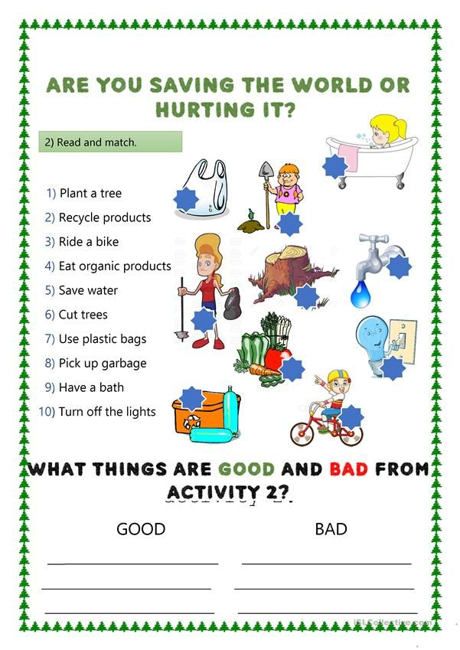  - –Let’s check up. Look at the answers  and check yourselves  Look at the scores and put the scores in your assessment  card  - -So, pupils, let’s have a little rest. Let’s sing a song «Save the planet»:  Let's see what we can do  to save the planet for me and you  Let’s see what we can do  to save the planet for me and you  EARTH  Planet Earth is a happy place  EARTH  Planet Earth is a happy place  Na na na na na na na na !  Na na na na na na na na !  Let's see what we can do  to save the planet for me and you  Let’s see what we can do  to save the planet for me and you  E is for environment, keep it clean  If we stand together, we'll make the best team  A is for the animals that we love  Swimming and walking and flying above  Na na na na na na na na!  Na na na na na na na na !  Let's see what we can do  to save the planet for me and you  Let’s see what we can do  to save the planet for me and you  r is for recycle, or use it again  Separate your trash into the right bin  t is for travelling every day  Leave the car and rather walking this way  Na na na na na na na na!  Na na na na na na na na !  Let's see what we can do  to save the planet for me and you  Let’s see what we can do  to save the planet for me and you  h is for humans that’s what we are  if we work together we can go so far  EARTH  Planet EARTH is a happy place  Na na na na na na na na!  Na na na na na na na na !  Let’s see what we can do  to save the planet for me and you  Let’s see what we can do  to save the planet for me and you  Let’s see what we can do  to save the planet for me and you  Let’s see what we can do  to save the planet for me and you  - –So, pupils your next task is to match the signs with their definitions  - –Let’s check up. Look at the answers and check yourselves  - Teacher gives chips to each groups  -Put your scores in your assessment cards  - -So, pupils let’s read the phrase and number of the sign. The first group read the phrase and name the number. So, and you, pupils if you agree show your green card. If you don’t agree show your red card  - -So, pupils, let’s revise the rule.  We use should for giving advice. For  example: You should go to the doctor  We use shouldn’t in negative sentences. For example: You shouldn’t be late.  Your task to look at the pictures and choose should or shouldn’t.  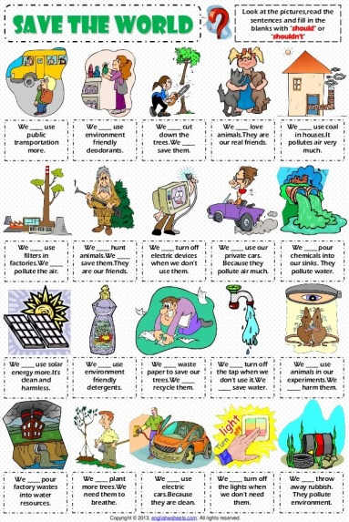  - –Let’s check up. Look at the answers and check yourselves. Then put your  scores in your assessment cards  - -So, pupils, your task is to glue the palms to the picture of the Earth and write down what  you do to save our planet. You may use these phrases. You must write different phrases:  I save water-я экономлю воду  I plant trees-я сажаю деревья  I recycle cans and bottles-я перерабатываю банки и бутылки  I turn off the lights-я выключаю свет  I use the papers wisely-я использую бумагу с умом  I throw waste in the gabbage-я бросаю отходы в мусор  I ride a bike-я катаюсь на велосипеде  I eat organic products-я ем органические продукты  I have a bath-я принимаю ванну  I use textile bags instead plastic bags-я использую текстильные пакеты вместо полиэтиленовых (пластиковых) пакетов  I clean out the coast- я чищу побережье  I don’t cut trees-я не вырубаю деревья  I pick up garbage-я собираю мусор  - -Let’ present your works. The first group name your phrases one by one. The second group… and  so on  So, pupils, open your record books and write down your hometask: cinquain on the theme  «Earth Day»  -So, pupils, lets sum up our lesson. Look at the apples and choose the one which suits you:  Pink- I totally understand  Orange- I need some help  Green- I have many difficulties  -So, go to the blackboard one by one and glue your stickers on the tree  The first group come to the blackboard…. and so on  - So, pupils. Thank you for good job today! And lets us give you and our guests some souvenirs to remember this lesson | Pupils name the tasks of the lesson  Pupils do the exercise in groups  Groups read the rule and translate it  Pupils do the exercise in groups  Pupils read the words in chorus.  Other groups access them using gesters «Big thumb»  Pupils do the exercise in groups  Groups exchange their answers  and access each other  Pupils look at the screen and sing a song doing physical exercises  Pupils do the exercise in groups  Group exchange answers with each other  Groups tell how many correct answers they have  Group reads the phrase in chorus and name the number. Other groups show green or red cards  Pupils do the exercises individually  Pupils look at the answers and check themselves and put the scores in their assessment cards  Pupils do the exercises in groups  Pupils look at the screen and choose the apple which suits them and come to the blackboard and glue their stickers. | Group assessment with the help of gesters  Group assessment  Group assessment  Self-assessment | Presentation (Taks)  Cards «Match the rules with the translation»  Containers, words  Cards «Are you saving the world or hurting  it?»  Presentation (Answers)  Presentation (Scores)  Assessment cards  Video  «Save the planet»,  Song  Cards «Match the signs with their definitions»  Presentation (Answers)  Chips from paper  Green and red cards  Cards «Should/Shouldnt»  Presentation (Answers)  Presentation (Scores)  Phrases  The picture of the Earth  Palms from paper  Presentation «Hometask»  Presentation(green apple, orange apple, pink apple)  Stickers  Hand-made souvenirs

