Long-term Plan Unit: |  | 12.1А | School: | NIS AEO Petropavlovsk
Date: | 02.09.2020 |  | Teacher Name: |  | Е. Жунусов
Grade: | 12 Advanced |  | Number Present: |  |  | Absent:
Theme of the Lesson: |  | Artificial Intelligence

Learning objectives to be achieved during this lesson (Subject Programme Reference)
Learning  Objectives | 12.4.3.1 describe application of artificial intelligence in industry, education, medicine, gaming industry, society
Lesson Objectives | describe spheres where artificial intelligence is applied: industry, education, medicine, gaming industry, society
Success  Criteria | Remember: | Learners get theoretical knowledge about Artificial Intelligence
 | Understand: | The fields where artificial intelligence is applied
 | Analyze: | Define the advantages and disadvantages of Artificial Intelligence
 | Create: | Posts where AI is used
Language  Objectives | Students can: |  | - take part in debates about the advantages and disadvantages of using artificial intelligence  - use terminology in discussing and describing the sphere of application of artificial intelligence
 | Vocabulary: |  | - Artificial Intelligence  - Machine Learning  - Neural Network  - Strong AI  - Weak AI  - Superintelligence  - Computer Vision  - Deep Learning
 | Language Scaffolding: |  | - Artificial intelligence is ... .. and can be applied in the following areas .......  - The advantages of using artificial intelligence are ... ..  - The disadvantages of using artificial intelligence are ......
Values  Instilled | Pair work: Respect for self and other opinions. Collaboration.
Cross-curricular  Links | Biology, Mathematics
Prior knowledge | Learners know the basic principles of computer systems from Unit 11.1A.

Differentiation | Assessment | Health and Safety
Peer feedback. Group discussion and group support. | Peer assessment and group discussion of students’ work. | Encourage students to follow the H&S rules of the department.

Lesson plan seen by HOD before the lesson
Name: |  | Signature:

Course of the lesson
G - Group Work |  | I - Individual Work | E - Learner Experiment | W – Whole Class Discussion
D - Teacher Demonstration |  | F - Supports Formative Assessment | T - Teacher Exposition | P – Pair Work
Planned  Timings | Planned Activities |  |  |  | Resources
 | Lesson 1
1 min | The teacher shares the link to presentation on nearpod.com  https://share.nearpod.com/vsph/eCJQ4id9Lu  Editable link (if there is necessary to copy to own library):  https://share.nearpod.com/e/f30JUh5xl9 |  |  |  | https://share.nearpod.com/vsph/eCJQ4id9Lu
2 min | The teacher congratulates students with new school year:  It’s been a fun summer, but now it is time to meet old school friends and learn new things! Wishing you a wonderful new school year! |  |  |  | Slide 1
3 min | The teacher discusses the curriculum for 2020-2021 years |  |  |  | Slide 2
5 min | Brain storming. Collaborating ideas  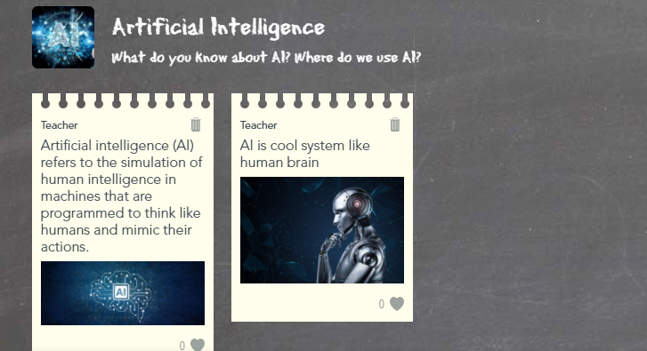  The students need to say what they know about Artificial Intelligence by responding to the following questions:  - What do you know about AI?  - Where do we use AI? |  |  |  | Slide 3
1 min | The teacher introduces the topic |  |  |  | Slide 4
2 min | 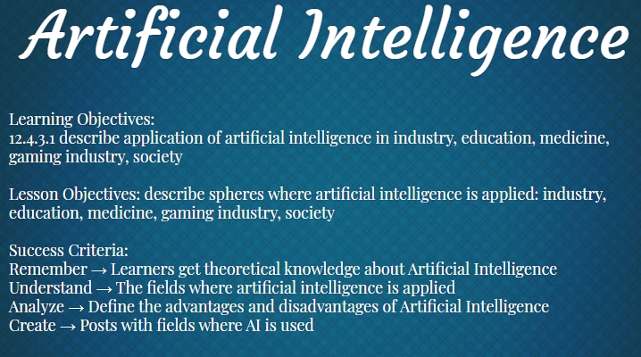  The teacher and students discuss the assessment criteria and lesson objectives |  |  |  | Slide 5
10 min | The teacher shares the video on YouTube  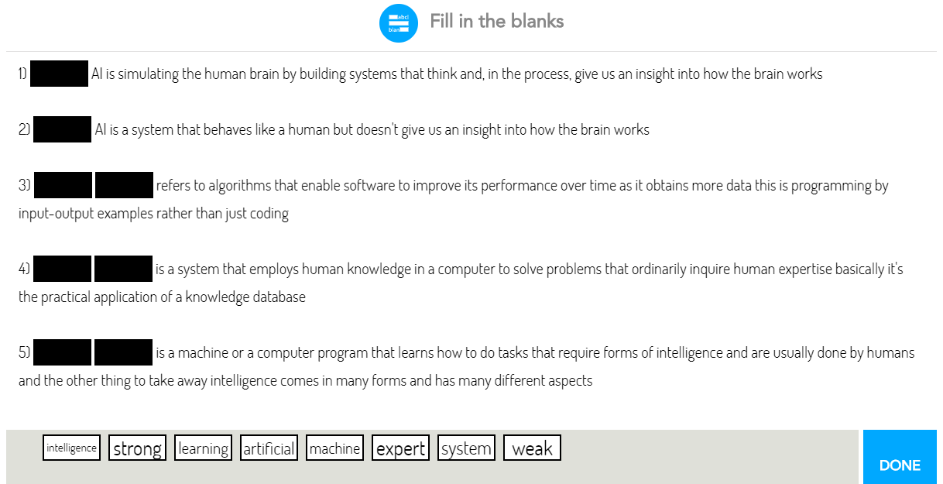  https://youtu.be/kWmX3pd1f10?t=10  The students watch the video and fill the gaps according the video |  |  |  | Slide 6
3 min | 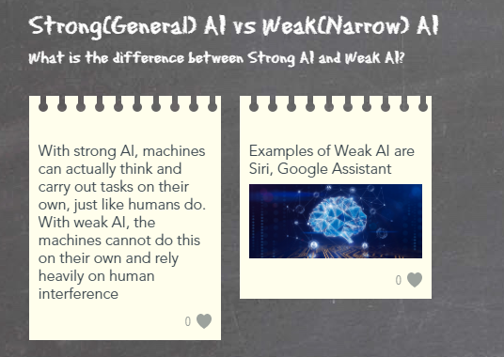  The class needs to compare Strong and Weak AI and discuss it |  |  |  | Slide 7
 | Lesson 2
7 min | 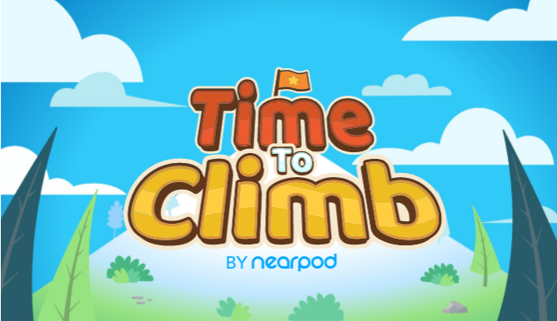  Consolidation of acquired knowledge by playing game |  |  |  | Slide 8
5 min | 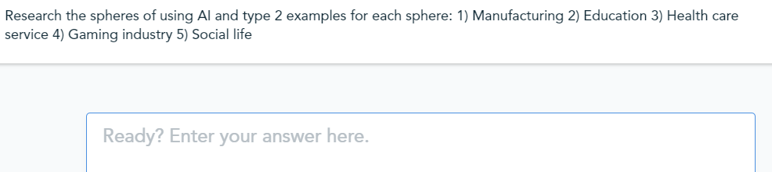  The students need to research the fields where we use Artificial Intelligence  The task is to type 2 examples for each field of using AI  1) Manufacturing  2) Education  3) Health care service  4) Gaming industry  5) Social life |  |  |  | Slide 9
1 min | 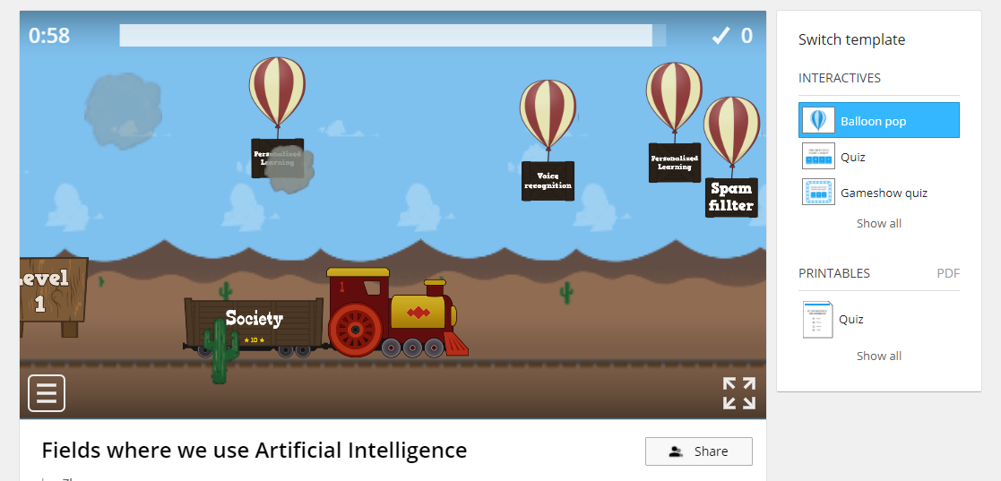  Homework  https://wordwall.net/play/3907/260/820  The students need to choose examples on clouds and put it into correct category (Manufacturing, Education, Health care service, Gaming industry, Social life) |  |  |  | Slide 10  https://wordwall.net/play/3907/260/820

Reflection
Were the lesson objectives/learning objectives realistic? Did I stick to timings?  What changes did I make from my plan and why? | Did all learners achieve the LO?  Did my planned differentiation work well?  If not, why?

Summary Evaluation
What two things went well (consider both teaching and learning)?
1:
2:
What two things would have improved the lesson (consider both teaching and learning)?
1:
2:
What have I learned from this lesson about the class or achievements/difficulties of individuals that will inform my next lesson?

