Name_________________________________________ Grade_________
Summative Assessment for the term IV
Listening
Listen and complete
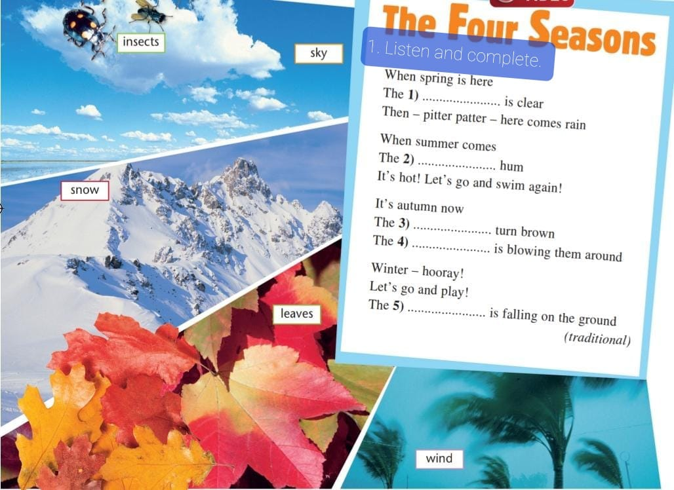 [5]
Reading

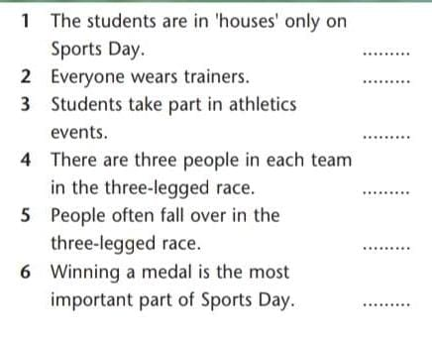 [6]
Writing
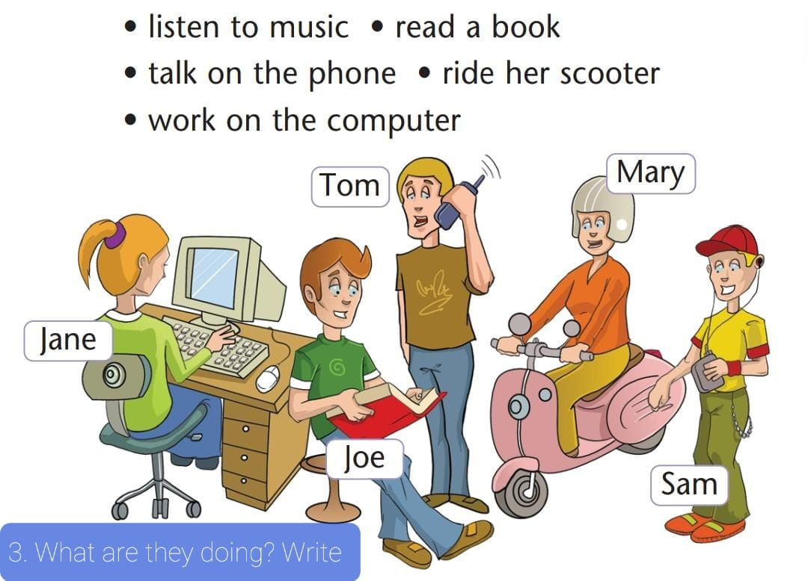 | 1._____________________________  2._____________________________  3._____________________________  4._____________________________  5._____________________________
[5]
Speaking
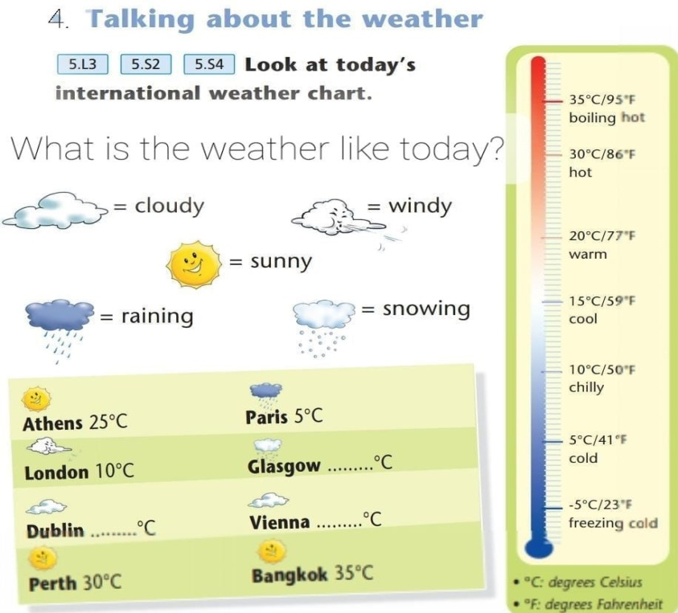 [4]

