Resource: English plus 5 LESSON: 34. Unit: Values  Unit 3: Values |  |  | School: Zhaisan secondary school
Date: |  |  | Teacher name: Abirova D.R.
Grade: 5 |  |  | Number present: |  | Number absent:
Theme of the lesson: |  | Holidays in different seasons.
Learning objectives |  | 5. L6 deduce meaning from context in short supported talk on an increasing range of general and curricular topics.  5.S6 communicate meaning clearly at sentence level during, pair, group and whole class exchanges  5.S7 use appropriate subject-specific vocabulary and syntax to talk about a limited range of general topics  5. C9 use imagination to express thoughts, ideas, experiences and feelings.
Lesson objectives |  | All learners will be able to:  improve listening and speaking skills by working in pairs, groups and whole class  use appropriate subject-specific vocabulary  Most learners will be able to:  improve listening and speaking skills by working in pairs, groups and whole class  express ideas building simple sentences, using appropriate subject-specific vocabulary  Some learners will be able to:  improve listening and speaking skills by working in pairs, groups and whole class  express ideas building extended sentences, using appropriate subject-specific vocabulary.
Previous learning |  | Special days in my home.
Plan
Planned timings | Planned activities |  |  | Learners’ activities |  | Evaluation | Resources
Beginning  10-min | Class organisation  Greeting.  Warm-up (G)  Teacher divides into two groups with the help of website  https://www.flippity.net/  Method “ Spinner”  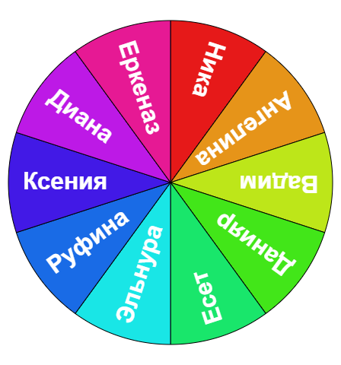  Before warming –up the task teacher asks students to listen to the song.  Teacher encourages learners to copy and complete the names of the months. Before writing, teacher tells learners to brainstorm criteria for the evaluation.  J_nu_ry _a_ch A_r_l  Fe_ruar_ M_y J_ne _ul_  Au_us_ _ _ ptem_ _r Oc_ _ ber  N_ _emb_r D_c_m_er. |  |  | Learners are organized into two groups  Learners complete the names of the months. Listen and check yourselves.  Give feedback following the criteria  50% - try more!  70%- good job  100%--excellent |  | Individual evaluation | PPT  Writing  Worksheet  https://www.youtube.com/watch?v=Fe9bnYRzFvk  Writing  Worksheet
Middle  25 min | Lead-in  Pre - listening  Teacher asks students to look at the magazine cover. Do you like travelling? When do you usually travel? What is the title of the magazine? What do you think how old is Lady Tara? Who is Mr Diddly? What do you think what this audio is about?  Vocabulary  Teacher encourages learners to pronounce the names of the countries.  While - listening  Teacher stops the audio on the first minute and asks learners.  Are your answers right or wrong? Is this audio about travelling?  Task 1. Listen to an interview with Lady Tara. Match season 1-4 with four of the places.  Winter London  Spring Switzerland  Summer Australia  Autumn Rio de Janeiro  New York and Boston .  Task 2. Listen to the text again. Then make five sentences from the words in columns A and B.  Post- listening (P)  Learners work in pairs  Task 1  Imagine that you are a billionaire. Say what you do in different months.  In January I go to the Caribbean with my friends.  Task 2 (G)  Teacher divides into two groups with the help of website  https://www.flippity.net/  ‘Random name picker” Regrouping.  Match the words with the photos in the months quiz.  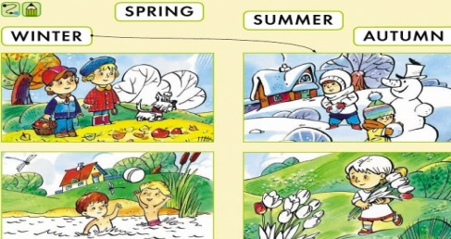  1. When is New Year’s day ?  2. When is Kurban Ait?  3. When is Midsummer’s Day?  4.What are your favourite months and seasons? Why?  4.Which months and seasons are not your favourite? |  |  | Learners answer the questions and make predictions.  Learners answer the questions and check their predictions.  Learners listen to the text and match  Learners listen to the text again and make sentences  Learners write their answers according to the given situation.  Learners match the words with the photos and talk about holidays. |  | Verbal evaluation  Peer- checking  Verbal evaluation | Slide 1  Slide 2  Slide 2  Slide 3  Slide 4  Handouts  Slide 5
End  10 min | Reflect, Revisit Learning Goals & Check with Questions  The five finger paragraph  Teacher asks students to write a paragraph in three easy steps using their hands and organize a discussion about holidays.  1)Thumb = Topic sentences  2) Three middle fingers – three describing sentences  3)Little finger- summary sentence  Differentiation  Less able students are let to read their sentences from the text.  What do you think what is the theme of our lesson today?  Home task: Write about your holidays in different seasons.  Saying goodbye |  |  | Learners write their sentences.  Learners identify the lesson objectives |  | Self-assessment | Slide 6

