Lesson plan
Unit: 10.2: Causes and Consequences of Natural Disasters  Lesson 1 |  |  | School #53
Date: |  |  | Teachers’ names:
Class 10 |  |  | Number present Absent
Learning objectives(s) that this lesson is contributing to |  | 10.1.9 - use imagination to express thoughts, ideas, experiences and feelings;  10.3.5 - interact with peers to make hypotheses about a wide range of general and curricular topics  10.4.5 - deduce meaning from context in extended texts on a wide range of familiar general and curricular topics, and some unfamiliar topics  10.5.3 - write with grammatical accuracy on a range of familiar general and curricular topics
Lesson objectives |  | -explain new words for discussing natural disasters, their causes and their consequences.  -read and identify the main idea and specific information from the text  -compose (complete) sentences using new vocabulary (from the text)  - analyze and express ideas in group
Language objectives |  | understand specific information of Natural Disasters, causes and consequences  explain new words for discussing natural disasters  read the text and do differential tasks  formulate questions and answering using new vocabulary
Assessment criteria |  | identify specific information from the text  understand causes and consequences of natural phenomena
Value links |  | Respect, support
Cross curricular links |  | History, Biology, Geography
ICT skills |  | PPT and Smart board for presenting PPT
Previous learning |  | Students learnt about environment , pollution from previous year
Planned timings | Planned activities |  |  |  | Resources
5 min | Organization moment (Lead in)  Greet students and show them pictures (Natural disasters ) in the slide  Ask them to discuss what about our lesson  (students answers)  students identify theme  then teacher show the next slide with the theme and lessons objectives  Divided class into two groups “Puzzles” |  |  |  | PPT Slide  Two puzzle pictures  “Earthquake ”  “Flood”
7 min  25 min | New theme  Causes and consequences of natural disasters  Pre-reading  New vocabulary:  - Teacher show slide with words natural disaster with their definitions, transcriptions, it help them to understand natural phenomena.  G- (students read in a group)  HURRICANE  TORNADO  EARTHQUAKE  LIGHTNING  FOREST FIRE  FLOOD  TSUNAMI  DROUGHT  AVALANCHE  VOLCANIC ERUPTION  POLLUTION ….  Task1. Match describing of natural disaster with pictures, and say what is the natural phenomena (Students should match in pairs - P)  1 extremely strong winds concentrated in one area DROUGHT A 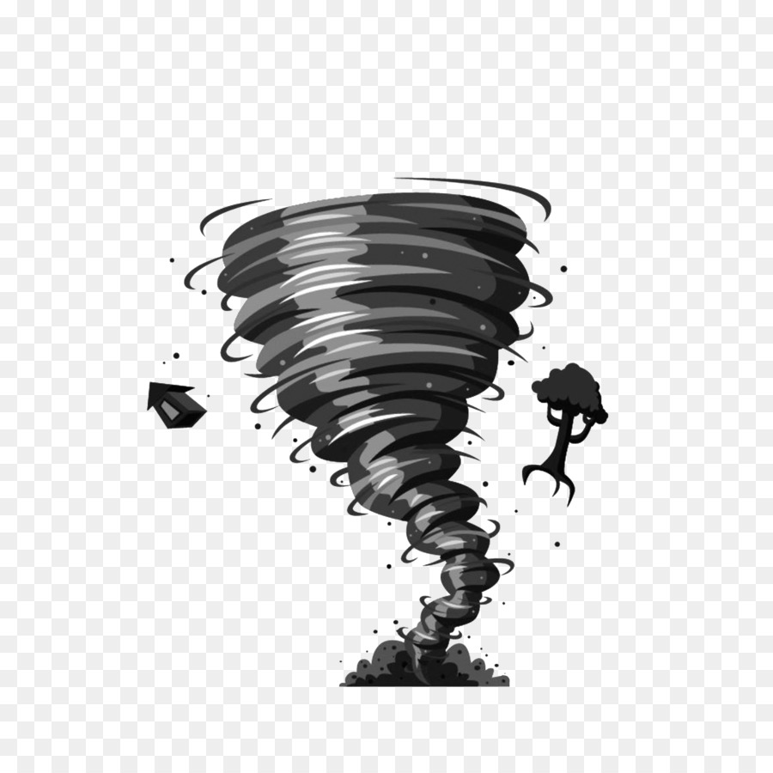  2 a prolonged period of abnormally low rainfall, leading to a shortage of water TSUNAMI B 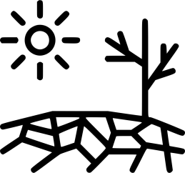  3 a long, high sea wave caused by an earthquake or other disturbance TORNADO C  Task 2. Look at the pictures of natural phenomena and say what natural disasters happen in Kazakhstan.  For example: Earthquakes are happen in Kazakhstan.  Task 3. Work with book p.21  Activity from the book. Look at the natural disasters in the picture and complete the sentences with verbs: burnt/rescued/caused/erupted/hit  Assessment criteria: work in group and explain new words for discussing natural disasters  Descriptors: - match words with definitions and pictures  - identifies the natural disaster in Kazakhstan  - complete the sentences  Reading:  Reading text, strategy “SCANNING” (this strategy to identify specific information from the text).  Students read text about natural disaster and find and underline causes and consequences.  Post –reading activities  (differentiation activity after text) work individual - I  1 fill in (this activity for low level students).  Activity 2 correct sentences. (this activity for middle level students)  Activity 3 complete the chart (this activity for high level students)  Assessment criteria: identify specific information from the text  Descriptors: - read the text  - complete sentences  - interprets information and correct wrong sentences  - use information from the text and complete the chart  work in group (G) Activity “Ask and answering questions”, use underline words and phrases from the text.  (Each group prepare 3 questions, and try to answer)  Descriptor: ask and answer questions use identify specific information from the text, which underline while reading  work in group (G) Activity make posters |  |  |  | PPT Slide 3  Slide with new words  And list for each students  Pictures PNG  https://yandex.kz/images/search?text=tsunami%20png&from=tabbar&pos=5&img_url=https%3A%2F%2Fwww.pngkey.com%2Fpng%2Ffull%2F620-6204888_sea-svg-png-icon-easy-drawings-of-tsunamis.png&rpt=simage  Action for Kazakhstan  grade 10  Students book p.21  Text from the site  http://oaji.net/articles/2016/1170-1462484983.pdf
3 min | Reflection “Answer the questions”, its active method to summaries all that has been done at the lesson, and it good relax at the end of the lesson.  Activity: “Answer the questions” the questions of reflection at the end of the lesson.  What new information have I learned from this assignment?  What surprised me about what I learned?  How quickly was I able to finish this work?  Where were my roadblocks?  Have I achieved the goal I set for myself with this assignment?  Am I proud of my work?  Students answer the questions. (I-individual)  Home task:  Create presentation about causes and consequences of Aral Sea  Descriptors |  |  |  | https://www.weareteachers.com/reflection-questions/
Additional information

Differentiation – how do you plan to give more support? How do you plan to challenge the more able learners? |  |  |  | Learners ‘Assessment – how are you planning to check learn learning? | Cross-curricular links
Summary evaluation
What two things went really well (consider both teaching and learning)?
1:
2:
What two things would have improved the lesson (consider both teaching and learning)?
1:
2:
What have I learned from this lesson about the class or individuals that will inform my next lesson?

