Short term plan
School № 132
Lesson 7
Term: II  Unit 3 | Unit 3. Interview and instructions
Teacher’s name: | The 1 -st group - Poltusheva G.Y.
Date: | 22.11.2021
Grade: 11Б | Number present: | Number absent:
Theme of the lesson: | Technology
Learning objectives(s)  that this lesson is contributing to | 11.S3 - explain and justify own and others’ point of view on a range of general and curricular topics, including some unfamiliar topics;  11.S5 - interact with peers to make hypotheses and evaluate alternative proposals on a range of familiar and some unfamiliar general and curricular topics;  11.S7 - use appropriate subject-specific vocabulary and syntax to talk about a range of familiar and some unfamiliar general and curricular topics.
Lesson objectives | By the end of the lesson, the students will be able:  to learn how technological progress is important in the modern world;  to develop their listening skills in the context of ideas about technology;  to interpret texts about the use of modern technology in the life of people;  to use modal structures in a written or oral speech;  to express with fluency their opinions on good used of technology for schoolwork.
Lesson plan:
Stages of the lesson/ Time | Teacher’s activity | Student’s activity | Assessment | Resources/ materials
Organisation moment:  3 min.  Greeting | Good morning, dear pupils. How are you today? How did you spend a day off?  May this lesson bring us the joy of communication and fill our souls with wonderful feelings. | Expected student responses, modes of operation.  -Good morning. We are glad to see you. How are you? |  | Whiteboard  Slide (useful phrases)
Warm up:  7 min. | The teacher sets the lesson objectives, letting students know what to anticipate from the lesson.  Play a quick game of Snowman to elicit the words source. Discuss the meaning of the words with students in relation to modern life and science, then ask them to work in pairs to think what unites two words. Tell students the lesson is going to focus on the use of technology nowadays and allow them time to read though the Life skills objectives and the Key concepts before starting the lesson. | SS play the game “Snowman”, then brainstorm some ideas with the words source in relation to science and technology.  Look at these 2 words and say what unites them.  Sts. give their own answers.  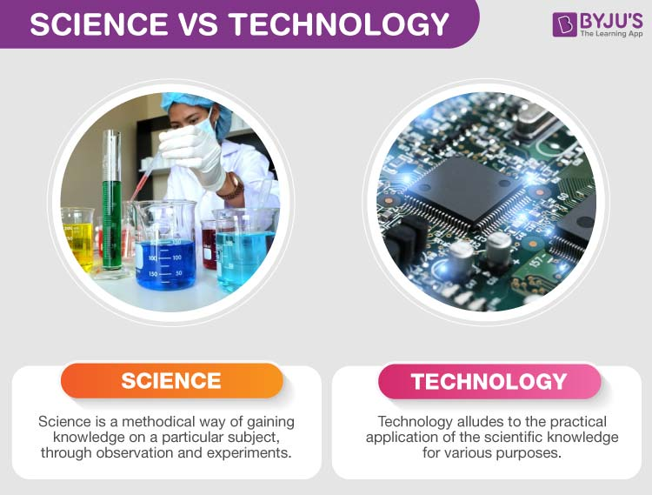 | Pair Assessment  Observe learners when participating in use of English activities.  Record what they considered they had learned from the lesson. Could they express what they had learned about content and language? Could they express which skills they had developed?  Formative assessment is held through observation/  monitoring. | Whiteboard  Pictures  Presentation
Main Activities  15 min. | A teacher asks Sts. to listen to the text about technology and do the task on it: fill in word – combinations and speak about the importance of technology.  http://www.listenaminute.com/t/technology.html  The teacher asks Sts. to listen to the second text and fill in words. Why has the world changed a lot? Give your reasons.  The teacher asks Sts. to fill in a table about advantages and disadvantages of technology.  Technology has changed our lives. But is this a good or a bad thing?  Now, a teacher asks Sts. to work with a table.  Allow students time to think about their answers individually, then hold a brief class discussion on the question.  Encourage as many students as possible to join in and express their opinions. | Sts. listen twice and try to do the best doing exercises connected with words.  LISTENING GAP FILL  What ____________________ technology? Would we still be living in caves? Probably. I think there are two ____________________ technology. The kinds before and after computers. When we think about technology before computers, it ____________________. It was all mechanical. Things like steam trains and fridges. At the time, that ____________________ technology. But today’s technology is really cutting edge. It’s the kind of technology that ____________________ soon as it hits the shelves. I love this. It’s so exciting seeing it all happen. I love ____________________ technology we’ll have in the future, and then buy ____________________. It’s like buying technology from science fiction movies. I’d love to live to be 200 so I can see what technology ____________________.  Sts. listen to the text twice and fill in the words. This work is done in pairs.  “Technology”  Technology experts, government officials, and engineers are meeting this week in Italy. They have in Rome for the first Green Standards Week conference.  Italy’s Ministry of Economic Development and the International Telecommunications Union organized the . The event calls attention to the need for information and communication technologies to fight climate change and to build greener, more economies.  In recent years, the world has changed because so many people now use computers, mobile phones and other kinds of . But the increasing use of information and technologies, also known as ICTs, also has led to more pollution, especially greenhouse gas . This is mostly because of the energy used to manufacture, transport and operate such equipment.  Fill in a table:  Advantages of technology Disadvantages of technology  Sts. write good and bad sides of technology.  In groups Sts. present advantages and disadvantages of technological devices.  Possible answers:  You cannot imagine your world without technology. Today it is one of the essential things that the world needs. Technology refers to the practical application of scientific knowledge for a purpose. It enhances the usefulness of goods and services and helps in creating value. It helps make any work easier and helps us in multiple ways. Technology has both positive and negative effects. Many people use it for their growth, and some use it to harm society and the ecosystem.  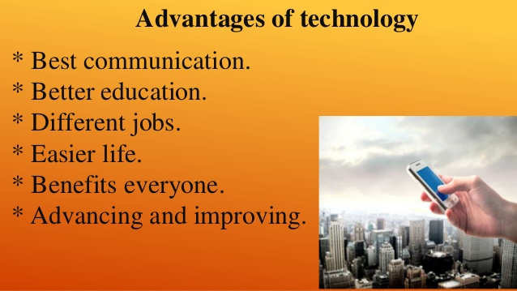  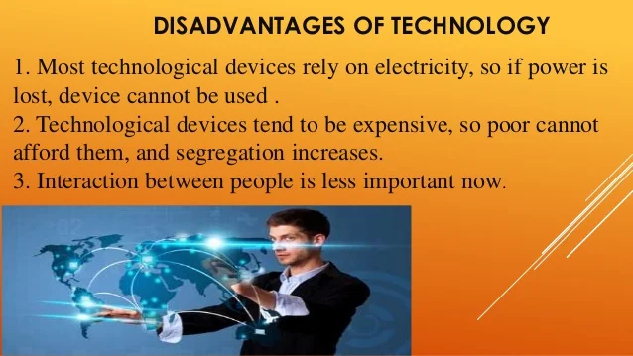 | Self- Assessment.  Assessment criteria:  - Consider different perspectives of using technology in a written form.  - Apply topic related vocabulary in speech appropriately arranging words and phrases into well-formed sentences.  - Identify the main idea of text on unfamiliar and curricular topics  - Evolve arguments, reasons, and evidence for a limited range of written genres/  Key:  What would we do without technology? Would we still be living in caves? Probably. I think there are two main kinds of technology. The kinds before and after computers. When we think about technology before computers, it was quite basic. It was all mechanical. Things like steam trains and fridges. At the time, that was cutting edge technology. But today’s technology is really cutting edge. It’s the kind of technology that is out of date as soon as it hits the shelves. I love this. It’s so exciting seeing it all happen. I love reading about what technology we’ll have in the future, and then buy it a few years later. It’s like buying technology from science fiction movies. I’d love to live to be 200 so I can see what technology is around then.  Pair – Assessment.  SS work in pairs comparing their answers. In case of having different choices, they explain their reasons. Then SS listen the CD to check.  For each answer Sts. get 1 score.  Answers:  1.policy makers  2.gathered  3.conference  4. environmentally friendly  5. electronic devices  6. communication  7. emissions  Descriptor:  A learner:  - gives evaluation to the problem;  - uses appropriate subject-specific vocabulary;  - chooses the right answer.  Think-pair-share  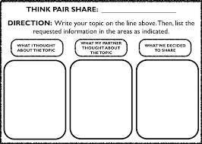 | http://www.listenaminute.com/t/technology.html  Worksheet  https://ielts-up.com/listening/listening-exercise-3.html  Worksheets  Evaluation list  A table  Presentation  Pictures
Physical Training  5 min. | A teacher asks one St. to watch a video and hold a physical training minute. | Sts. listen to the song, watch the main characters on the screen and do physical exercises.  https://youtu.be/JEIHogpVJ1k |  | Music
10 min. | The teacher asks Sts. to look at the table and remind the rule about modal verbs.  The teacher gives worksheets to students to do exercises with modal structures. In the worksheets there is some information of using modal structures.  After the rule and explanations, the teacher asks Sts. to do exercises:  Ex. 4 – 5 p.p.78 - 79 | Sts. look at the rule and give the examples with modal verbs.  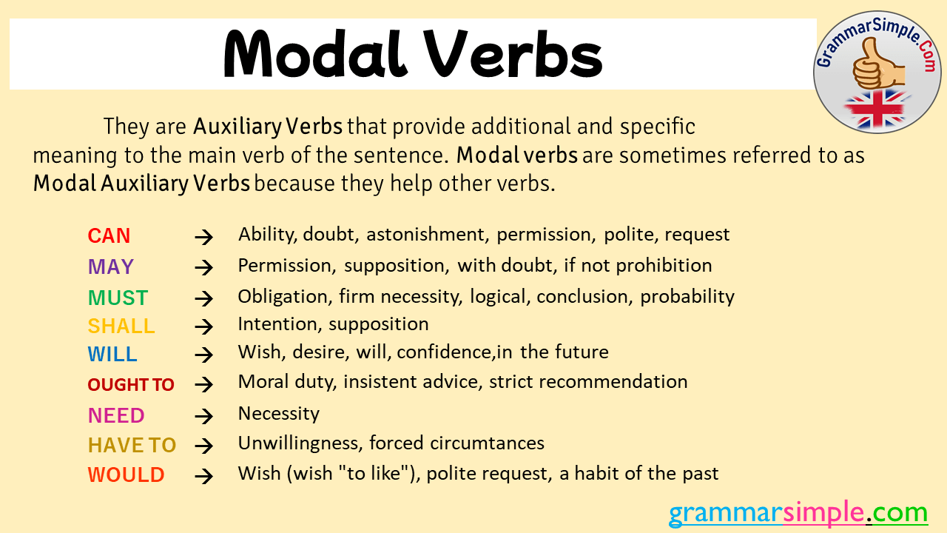  Sts. read the information and do the exercises.  Use of English. Modal structures: supposed to, bound to, due to, about to.  Apart from modal verbs, there are a lot of words which also express modality. They are words which express degrees of certainty or obligation.  Be supposed to  Be supposed to is used to talk about obligations and arrangements:  Where were you? You were supposed to be at the party!  You’re supposed to have an hour for lunch. That’s the law.  It’s also used to talk about people’s expectations or beliefs about something:  [talking about some medicine]  A: Take some of this.  B: What’s it supposed to do? (What does it do to you?)  And then I’m gonna get a train over to Brussels which takes all day as well. It’s supposed to be a nice route with forests and mountains and things. (gonna represents ‘going to’, as it is pronounced in informal speaking.)  bound to, be  Be certain or destined to; also, be determined or resolved to. For example, we are bound to hear from them soon, or No matter what they say, she is bound to run for mayor.  Be due to  Be due to is used to talk about things that are expected or planned to happen at a certain time. We often use it with a time expression:  Are you due to hand in homework today?  The train is due to arrive at Glasgow Central at 12:12.  Be about to  Be about to is used to talk about things which are going to happen very soon:  I’m about to eat. Can I phone you back?  It is often used with just:  We’re just about to set off for a walk. Do you want to come?  When used in the past, be about to can refer to things that were going to happen but didn’t:  I was about to complain but he came over and apologised.  We don’t use be about to with time expressions:  I was about to call you.  Sts. do exercises in a book. | Observe learners when participating in use of English activities.  Self- Assessment.  Pair/ group assessment  Assessment criteria:  - Demonstrate the ability of using modal structures correctly.  Observe learners when participating in use of English activities.  Record what they considered they had learned from the rule. Could they use a right modal structure in speech and grammar? Could they express which skills they had developed?  Formative assessment is held through observation/ monitoring.  Students evaluate the results of done exercises.  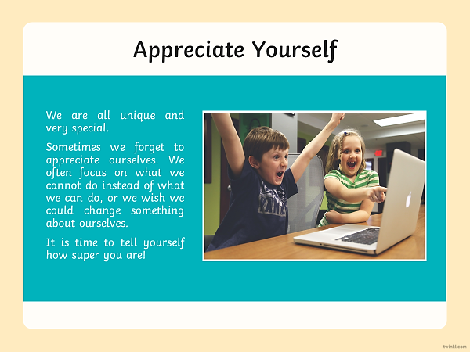 | Student’s Book “English.  Humanities. Grade 11. Kazakhstan edition”. (Cambridge)  + Worksheets  A table  St. Book p. 78  St. Book  p. 78 – p.79
The end of the lesson  5 min. | Teacher gives a homework and comment the work of Sts. The lesson is going to its end. I think, you have got much useful information today and you can easily give instructions.  Home Assignment:  SB ex.5 p.81(w). | Sts. give a mark to themselves for working at the lesson.  Students think critically, exploring, developing, evaluating and making choices about their own and others’ ideas.  SS write their homework for the next lesson. | Reflection.  Self-assessment. Hand signals  How well do I understand?  I understand this and can explain it (thumbs up).  I don’t yet understand (thumbs down)  I’m not completely sure (thumbs side).  Pair share  At the end of a lesson learners share with their partner:  - Three new things they have learnt  - What they found easy  - What they found difficult  Something they would like to learn in the future. | Whiteboard

Supplementary material for the lesson
LISTENING GAP FILL
What ____________________ technology? Would we still be living in caves? Probably. I think there are two ____________________ technology. The kinds before and after computers. When we think about technology before computers, it ____________________. It was all mechanical. Things like steam trains and fridges. At the time, that ____________________ technology. But today’s technology is really cutting edge. It’s the kind of technology that ____________________ soon as it hits the shelves. I love this. It’s so exciting seeing it all happen. I love ____________________ technology we’ll have in the future, and then buy ____________________. It’s like buying technology from science fiction movies. I’d love to live to be 200 so I can…

LISTENING GAP FILL
What ____________________ technology? Would we still be living in caves? Probably. I think there are two ____________________ technology. The kinds before and after computers. When we think about technology before computers, it ____________________. It was all mechanical. Things like steam trains and fridges. At the time, that ____________________ technology. But today’s technology is really cutting edge. It’s the kind of technology that ____________________ soon as it hits the shelves. I love this. It’s so exciting seeing it all happen. I love ____________________ technology we’ll have in the future, and then buy ____________________. It’s like buying technology from science fiction movies. I’d love to live to be 200 so I can see what technology ____________________.

“Technology”

Technology experts, government officials, and engineers are meeting this week in Italy. They have in Rome for the first Green Standards Week conference.
Italy’s Ministry of Economic Development and the International Telecommunications Union organized the . The event calls attention to the need for information and communication technologies to fight climate change and to build greener, more economies.
In recent years, the world has changed because so many people now use computers, mobile phones and other kinds of . But the increasing use of information and technologies, also known as ICTs, also has led to more pollution, especially greenhouse gas . This is mostly because of the energy used to manufacture, transport and operate such equipment.

