( Внеклассное мероприятие для 6 класса к неделе английского языка)
Материал основан на УМК «New Millennium English- 6»
Funny English Party
Цели:
Образовательные: расширение лингвистического кругозора, актуализация лексики, изученной на уроках английского языка и закрепление культурологических знаний о стране изучаемого языка
Развивающие: развитие познавательной активности и умения применять полученные знания в новой коммуникативной ситуации; развитие интеллектуальных способностей; формирование мотивации к изучению языка; развитие логического мышления, способностей к языковой догадке
Воспитательные: развитие интереса к современной культуре и традициям других народов; умение работать в команде; развитие чувства ответственности
План- конспект
T: Good afternoon dear children. You are welcome to our party. Today we are going to have good time, a lot of fun and joy. We will laugh and may be cry but only because of extreme laugh.
Firstly, let’s think over a little bit about names of your teams. And choose, please, the captains, who should be the most creative, the funniest and the smartest people.
Presentation of the teams (5 min)
T: Ok so let’s start. Party firstly means some games to relax. So let’s start with them. The first competition will be connected with the image of an ideal pupil
1 tour (5 min) AN IDEAL PUPIL IS A PARTY PERSON
T: Do you know what an ideal pupil should be? He should be clever, smart, hard-working, fast, mobile, active, and attentive. He must like going to school, he must do sports and participate actively in everything and look great. It’s unreal for one person so you should create a fantastic pupil. Follow the instructions on the screen. 21 components should be included
- Draw 2 heads, one neck, two bodies, four ears, 4 eyes, seven arms, 7 fingers on each hand, four legs, short hair
- Clothes – costume, jeans and T-Shirt, trainers, boots, glasses and sunglasses.
- Things – mobile phone, notebook, Walkman, schoolbag, earphones.

2 tour The Smartest Person (Quiz) (10 min)
T: No one party can manage without quizzes. So, let’s start with defining the cleverest team.
Вопросы к викторине(10 min)
1. What is the official language in Great Britain?
a) English; b) French; c) Russian; d) Chinese
2. Big Ben is:
a) a clock; b) a horse; c) an animal in the zoo; d) seven streets;
3. Piccadilly Circus is the meeting point of:
a) four streets: b) six streets; c) five streets; d) seven streets
4. The changing of guard happens every day at:
a) 12.30; b) 12 o'clock; c) 11.30 A.M; d) 10 o'clock;
5. Great Britain is divided into:
a) three parts; b) five parts; c) four parts; d) two parts;
6. What is a Piccadilly Circus?
a) a circus; b) a square; c) a street; d) a house;
7. What is the tower of London now?
a) a prison; b) a museum; c) a house; d) a fortress.
8. The name of the Palace where the Queen lives is:
a) The Tower of London; b) the White House; c) the Windsor palace; d) the Buckingham Palace;
9. The capital of Great Britain:
a) Paris; b) Moscow; c) London; d) Cardiff.
10. What can you see in Trafalgar square?
a) Nelson statue; b) King memorial; c) Queen memorial; d) Michail Gorbachev memorial
11. The legend says that without them the Tower will fall. They are:
a) the pigeons; b) the cats; c) the squirrels; d) the ravens;
12. When can you see the flag over the Queen's Palace?
a) When she's out; b) when she is abroad; c) When she has a party; d) When she is at home.
13. England is in:
a) Europe; b) Africa; c) America; 4) Asia.
14. Where is London's Zoo?
a) Regent's park; b) Hyde park; c) St. James park; d) Central park.
15. The Raven Master is the person who:
a) is the main raven; b) kills the ravens; c) feeds the ravens; d) chases the ravens.
16. Sir Christopher Wren built:
a) St. Paul's Cathedral, b) the Tower of London; c) Westminster Abbey; d) the Parliament.
17. The name of the river in London is:
a) The Volga; b) the Thames; c) the Nile; d) the Medvediza
18. Where can you say everything you want?
a) Regent's park; b) Hyde park; c) St. James park: d) Central park.
19. Westminster Abbey is:
a) the chapel; b) the monastery; c) the inn; d) the famous Royal church.
20. London is more than:
a) one thousand years old; b) two thousand years old; c) three thousand years old; d) four thousand years old;
21. Who is the head of England?
a) the Queen; b) the Tsar; c) the Princess; d) the Prince.
22. Where can you see pelicans and ducks?
a) Hyde park; b) St. James park; c) Central park; d) Regent's park
23. Where are the tombs of many British Kings and Queens and other famous people?
a) In the Tower of London; b) on the Cemetery; c) on the river bank; d) In Westminster Abbey.
24. In what country do men wear skirts?
a) France; b) England; c) Scotland; d) Norway.
25. You can get from Russia to England by:
a) bicycle; b) airplane; c) car; d) foot.
26. The British Parliament is in:
a) the Buckingham Palace; b) the House of Parliament; c) Baker Street; d) Westminster Abbey.
27. Covent Garden is now:
a) a cinema; b) a fruit and apple garden; c) theatre; d) a tourist shopping centre.
28. The Princess Diana was the wife of:
a) Prince John; b) Prince Robert; c) Prince Edward; d) Prince Charles.

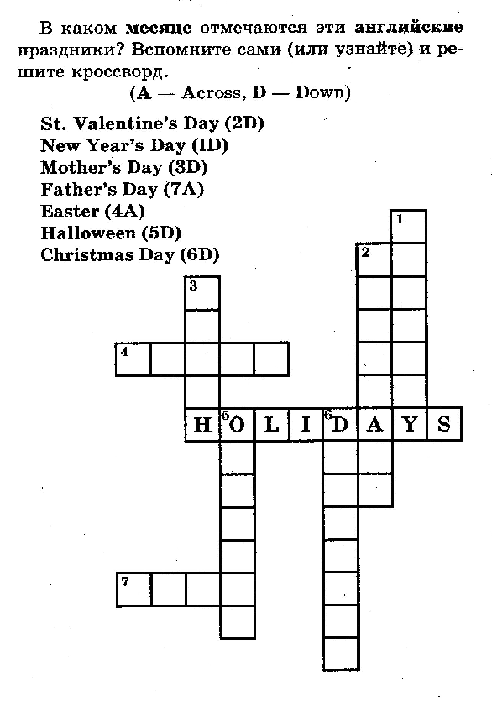

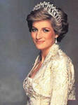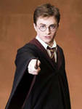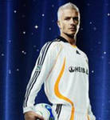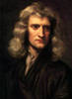
5 6 7
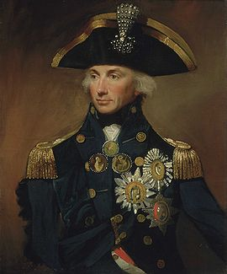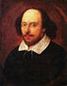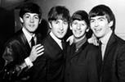
8 19
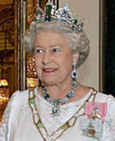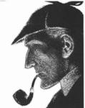
T: And know the coolest people are invited here to demonstrate their coolness.
5 tour (Captain’s tour – SUPER DANCE)
T: Now, captains are invited here. Every will have to show all they dancing abilities. Listen to the English or American songs and try to dance to it.
1. It’s my life
2.David Guetto
3 DJ Noice, DJ Julia Belle
4.Lady Gaga
5.Papa Roach
6.The clovers

T: Ok our party is close to the end and now it’s time for summing up the results
so, according to the results the…..are the coolest party people today. Goodbye and good luck! Have fun on a real English Party in future!

