Date: 31.01.2022 |  |  | Teacher’s name: Bekkasymova D.K.
Grade: 11 |  |  | Number present: |  |  | Number absent:
Theme of the lesson: |  | Famous people in Great Britain
Learning objectives |  | 11.S2 - ask and respond with appropriate syntax and vocabulary to open-ended higher-order thinking questions on a range of general and curricular topics, including some unfamiliar topics  11.S7 - improving listening and speaking skills about a range of familiar and some unfamiliar general and curricular topics  11.R.6 - navigate the text and answer questions and corrections in conversation on a wide range of familiar and some unfamiliar general and curricular topics
Lesson objectives |  | - identify the theme, active words and use them as the basis for discussion;  - provide a point of view in conversations and discussions; speak about famous people in Great Britain;  - respond to and discuss the reading passage using interpretive, evaluative and creative thinking skills.
Plan of the lesson
Planned timings | Planned activities |  |  | Learners’ activities | Evaluation |  | Resources
Begining  10 min | Greetings  Good morning, boys and girls. I am glad to see you. Sit down, please. Let's start our English lesson.  Who is absent today?  How are you?  What is the weather like today?  What date is it?  What day of the week is it?  Brainstorming  The teacher shows the picture and asks questions.  - What do you see in the picture?  - What is the topic of our lesson?  - What unites these people?  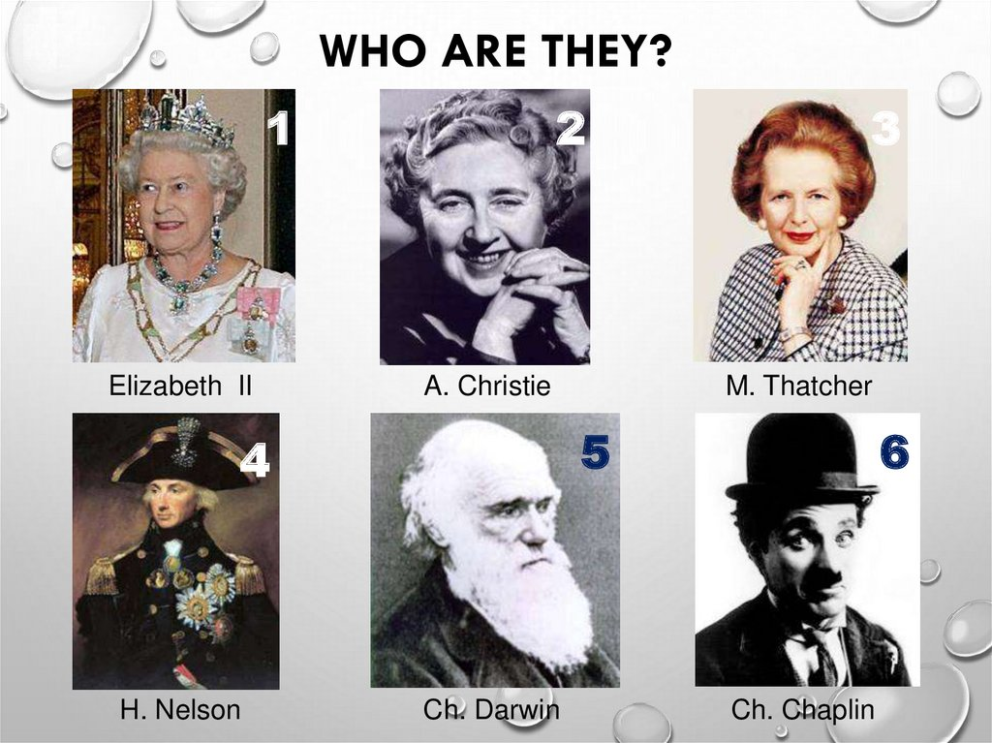  What country is London the capital of? What famous people of Great Britain do you know?  So what topic are we going to discuss at the lesson?  The topic of our lesson is «Famous people of Great Britain». I want you to speak about famous British people. The question we will answer is “There are many famous people in Great Britain, aren’t there?” But first of all let’s revise what we know about these people.  Painter  Scientist  Writer  Architect  Teacher  Musician  Poet  Politician |  |  | Pupils greetings and answer the questions  About famous people in Great Britain  Pupils repeat after teacher |  |  | 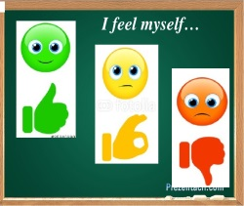  Pictures  Vocabulary-books
Middle  30 min | Task 1. Pair work  I will tell you about any famous man or woman. You must guess who she/he is.  - He was born in London in 1889.  Later he lived in the USA. He was a film actor. He had a funny way of working. (Charlie Chaplin)  - She was born in 1891. She wrote  the 75 detective stories. She died in 1976. She was known as the Queen of Crime. (Agatha Christie)  - A well known British Politician.  She was the first woman Prime Minister of Britain. She was called “An Iron Lady”. (Margaret Thatcher)  - A great English scientist. He  studied many different kinds of plants and animals. He built up his own theory of evolution. (Charles Darwin)  - He was a British flag office  famous for his participation in the Napoleonic Wars, most notably in the Battle of Trafalgar, during which he lost his life. His monument stands in the centre of Trafalgar Square. (Horatio Nelson)  - She is the Queen of sixteen  independent countries and their territories. She holds the crown of each country separately, but she lives in the United Kingdom. She has reigned for 58 years (in 2010) . (Queen Elizabeth II)  Task 2. Individual work  Find the second part of the name.  - Charles - Margaret - John R.R. - Joseph - William - Daniel - Agatha - Charlie - Chaplin - Christie - Shakespeare - Defoe - Darwin - Thatcher - Tolkien - Turner  Task 3. Individual work  Say what these people are famous for.  I give you 1 minute to think it over.  A. Christie is famous for the wonderful colours in his pictures  D. Defoe his novel « Robinson Crusoe»  C. Chaplin his films  J. Turner her detective stories  W. Shakespeare his books «The Hobbit», «the Lord of Ring»  J. Lennon his theory of evolution  M. Twain his songs  J. Tolkien his poems and plays  C. Darwin his books  Task 3. Group work. Method “Debate in Progress”  Speak about famous British people using the box.  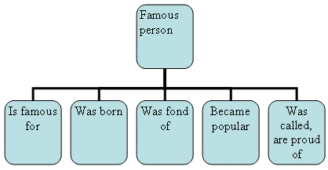 |  |  | One pupil reads, another pupil guesses who she/he is.  Pupils finds the second part of the name  Pupils say what these people are famous for  Pupils in a group discuss the task and tell | Mutual evaluation  Self- evaluation  -Green The task was clear for me  -Yellow I understood but I need a little help  -Red I didn’t understand anything  Verbal evaluation  Each group evaluates with a method  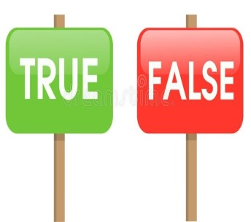 |  | Handouts with task  Cards  Cards  Handouts with task
End  5 min | REFLECTION  At the end of the lesson, learners reflect on their learning and evaluate the lesson :  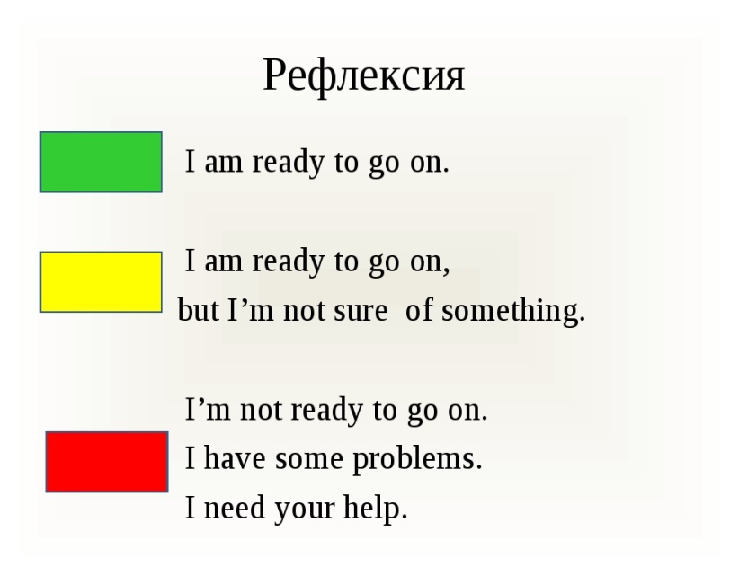  Home task:  Write about any famous people in Great Britain whom you admire.  Saying goodbye |  |  | Pupils evaluate themselves  Pupils write at home about any famous people in the UK that they admire.  Pupils say goodbye |  |  | Evaluation  card

