Учреждение «Костанайский социально технический колледж»

ПОУРОЧНЫЙ ПЛАН

Тема занятия | Interesting facts about genetics. DNA
Наименование модуля /дисциплины/ | Иностранный язык
Подготовил преподаватель  "07"сентября 2020г | Турарова Замзагуль Темиржановна
Курс 1 | Группа ВТиПО -01
Тип занятия | Комбинированный. Практический
Цели, задачи | 1) organize and present information clearly to others  2) understand the main points in unsupported extended talk on a wide range of general and curricular topics, including talk  3) on a limited range of unfamiliar topics;  4) evaluate and comment on the views of others in a growing variety of talk contexts on a growing range of general and curricular topics;  5) use a growing variety of past modal forms including must have, can’t have, might have to express speculation and deduction about the past on a wide range of familiar general and curricular topics
Перечень профессиональных умений, которыми овладеют обучающиеся в процессе учебного занятия | All learners will be able to: Understand general and specific information without support  Most learners will be able to: Discuss and analyze given information  Some learners will be able to: Explain and justify their points of view using past modal forms
Оснащение занятия:  -учебно-методическое оснащение, справочная литература  -техническое оснащение, материалы | Action for Kazakhstan Jenny Dooley, Bob Obee 10 grade students book Express Publishing
 | презентация, ноутбук, раздаточный материал, карточки
Ход урока:
1. Beginning:
Greeting: To draw pupils’ attention and prepare a class for the acquisition of new knowledge/material:
T: Hello pupils!
P: Hello teacher!
T: Are you ready for the knowledge trip?
P: Yes teacher!
T: Ok, let us go!
2. Brainstorming:
To engage pupils interest teacher shows the extract from the article of Robert Polmin (famous scientists on behavioral genetics): Our families, schools and the environment around us are important, but they are not as influential as our genes. Active board Presentation, https://www.amazon.co.uk/Blueprint-How-
Pupils start to expresses their ideas and thoughts on these quotation.
Teacher asks pupils to divide into 4 groups and work together.
3. Middle
Task 1. Match the words to their corresponding meaning
- Cell | The smallest structural and functional unit of an organism
- DNA | A substance that carries genetic information in the cells of body
- Nucleotide | is an organic molecule that is the building block of DNA and RNA
- Molecule | The smallest unit into which any substance can be divided without loosing its own chemical nature, usually consist of two or more atoms
- Bacteria | A small living thing, some of which causes diseases and illness
- Hemoglobin | A red protein responsible for transporting oxygen in the blood of vertebrates.
- Pepsin | chemical substance made by living cells that breaks down protein in food in the stomach and is produced by glands there.
- Keratin | A fibrous protein forming the main structural constituent of hair, feathers, hoofs, claws

https://youtu.be/5MQdXjRPHmQ
Longman dictionary.com
Pupils should understand the meaning of specific words according to the video
Every group is marked by correctness of their answer
8-6 well done 6-4 good

Task 2. Say if the sentences true or false and discuss them in your groupshttps://youtu.be/5MQdXjRPHmQ
- Nucleotides come in five different types which scientists have labelled ACTG and H
- A gene contains information for a cell to read
- DNA contains millions of genes
- Pepsin is a protein structure found in red blood cells
- Humans and chimps share 50% of their genetics code
- Engineers have mixed and matched the genes of different organisms to produce many new creatures
- A gene is the entire strand of DNA
- Each of our cells contains 46 stiches of DNA
- Pupils will disscuss and analyse given statements then will be evaluated according to the correctness of the listening video
8-6 Well Done 6-4 Good
Task 3. Read the textand put the words into right placehttps://youtu.be/5MQdXjRPHmQ

DNA | Strand | Genes | Protein | Hemoglabin | Molecules
A gene is a special stretch of____, a sequence of As Cs Ts and Gs that codes for something. A single____of DNA contains thousands of____or unique protein recipes. The length and sequence of a gene determine the size and shape of the____ it builds. The size and shape of a protein determine the function that protein will have inside the body. ______ for example is a protein structure found in red blood cells. It’s unique shape and size allow it to capture oxygen_____ when blood flows near the lungs and then later when blood flows near oxygen starved ____.
- Every group group will discuss and analyse then evaluated by correctness of the listening text
7-6 Well Done 6-5 Good

Grammar
Modals in the past
“Must have”-we believe the action definitely happened
“Can’t have”-we believe the action definitely did not happen
“Might have”-we believe it is possible that the action happened, but we don’t know
www.ecenglish.com/learnenglish/lessons/past-modals-deduction

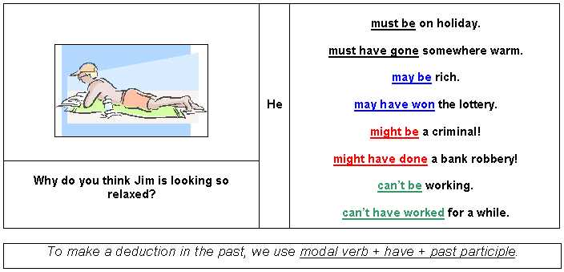

Differentiation tasks:
In organisms called eukaryotes, DNA must be found inside a special area of the cell called the nucleus. Because the cell is very small, and because organisms can have many DNA molecules per cell, each DNA molecule must be tightly packaged. This packaged form of the DNA is called a chromosome. During DNA replication, DNA unwinds so it can be copied. At other times in the cell cycle, DNA also unwinds so that its instructions can be used to make proteins and for other biological processes. But during cell division, DNA is in its compact chromosome might form to enable transfer to new cells.
www.genome.gov/about-genomics/fact-sheets/Deoxyribonucleic-Acid-Fact-Shee
Task1. Find and underline modal verbs
- They determine and sort information
Task2. Find Modal verbs, write down their past forms
- They understand given information and use it
Task3. Find modal verbs, write down their description, retell the text to the class using active vocabulary
- They understand the given information, can explain it, retell it

4. Ending:
Reflection. Will be used KWL chart
What I Know | What I learned | What I want to know

Were the lesson objectives/learning objectives realistic?
What did the learners learn today?
What was the learning atmosphere like?
Did my planned differentiation work well?
Did I stick to timings? What changes did I make from my plan and why?
7. H/w: Ex 3, 4, 5 p-9
5. Additional information
Differentiation – how do you plan to give more support? How do you plan to challenge the more able learners? | Assessment – how are you planning to check learners’ learning?
Less able students – greater support by means of prompts, visuals or writing difficult words on the board  More able students – independent work on definite tasks with little/no support  Allow for flexible groupings and cooperative learning, depending on the appropriateness to the task  Allow for extra time for students needing it, when appropriate  Give extra text or visual support to students needing extra English support  Create small learning groups for students needing extra support or enrichment with the co-teacher, when appropriate | through observation

