**Краткосрочный план #13**

|  |  |  |  |  |  |
| --- | --- | --- | --- | --- | --- |
| **Раздел** | | **Unit 4: Drama and Comedy** | | | |
| **ФИО педагога** | |  | | | |
| **Дата** | |  | | | |
| **Класс 6** | | **Количество присутствующих:** | | **Количество отсутствующих:** | |
| **Тема урока** | | **Drama and Comedy** | | | |
| **Цели обучения в соответствии с учебной программой** | | 6.4.3.1-understand the detail of an argument on a limited range of familiar general and curricular topics, including some extended texts;  6.1.9.1-use imagination to express thoughts, ideas, experiences and feelings;  6.5.3.1 write with some support about personal feelings and opinions on a limited range of familiar general and curricular topics. | | | |
| **Цели урока** | | * Revise and learn vocabulary on the topic “Movie Genres”; * Use the vocabulary to express ideas and opinions on the topic; * Read a short text on the content and understand its main content. | | | |
| **Ход урока** | | | | | |
| **Этап урока/время** | **Действия педагога** | | **Действия учеников** | **Оценивание** | **Ресурсы** |
| **Beginning**  4 min  6 min | **1. Organizational moment**  The teacher greets the Ss, asks what the **day/date** is, asks the Ss to write down the date and introduces the topic through a warm-up activity.  **2. Warm-up activity (team work - puzzle)**  T. divides Ss into 2-3 teams and suggests Ss put together the jigsaw puzzles. After the puzzles are completed, Ss should name the movies and their characters. T. suggests Ss to look at each other’s pictures and find out the difference (movies of different genres). Encourage Ss to name the topic of the lesson and set up goals for the lesson.  Answers – Slide 1 (Kung Fu Panda, Thor, Tomiris). | | **1. Organizational moment**  Ss greet the T., answer what the **day/date** is, write down the date and take part in the warm-up activity. T. and Ss set up goals for the lesson.  **2. Warm-up activity (team work - puzzle)**  Ss work in teams; Ss put together the jigsaw puzzles. After the puzzles are completed, Ss should name the movies and their characters. Ss to look at each other’s pictures and find out the difference (movies of different genres). Ss to name the topic of the lesson and set up goals for the lesson. | verbal feedback  verbal feedback | PPT  PPT  puzzle cards |
| **Middle**  7 min    5 min  3 min  6 min  10 min | **3. Presenting vocabulary: Movie Genres**  T. demonstrates Slides 4-14 and suggests Ss look at the pictures and name the genres. Encourages Ss make examples of sentences containing the words (f.e. by asking questions).  2) T. suggests the question to discuss:   * *What does each movie have?*   T. demonstrates Slide 15 and introduces the meaning of the words by giving examples (f.e. characters – name a movie and a famous character, “In “Sponge Bob” – Sponge Bob, Patrick Star, Mr.Krabs).  Hands out *Movie Genres vocabulary cards* to glue into Ss’ vocabulary books.  **3. Pre-reading:**  T. demonstrates Slide 17, asks Ss to read the phrase and say the title of the movie it belongs to (if they are struggling, demonstrate Slide 18). T. may ask the questions:   * *Have you watched the movie?* * *Can you name the characters?*   **4. Reading & post-reading**  T. hands out *Worksheet Reading Templates* and gives instructions: Ss should read the text using the vocabulary box and answer the questions (Slide 19). T. organizes a discussion of the questions.  **5. Writing practice**  T. demonstrates Slides 20, 22 (Slide 1 is optional, may be suggested as supportive templates). Gives instructions: Ss should write a paragraph about the last movie they watch. They should answer the following questions while writing:   1. What was the last movie you watched? 2. What was it about? 3. What was the genre? 4. Who were the characters (heroes and the villains)? 5. Did you like it? Why?   Ss should use the text (Worksheet Reading) as a template. | | **3. Presenting vocabulary: Movie Genres**  T. demonstrates Slides 4-14 and suggests Ss look at the pictures and name the genres. Encourages Ss make examples of sentences containing the words (f.e. by asking questions).  2) T. suggests the question to discuss:   * *What does each movie have?*   T. demonstrates Slide 15 and introduces the meaning of the words by giving examples (f.e. characters – name a movie and a famous character, “In “Sponge Bob” – Sponge Bob, Patrick Star, Mr.Krabs).  Hands out *Movie Genres vocabulary cards* to glue into Ss’ vocabulary books.  **3. Pre-reading:**  T. demonstrates Slide 17, asks Ss to read the phrase and say the title of the movie it belongs to (if they are struggling, demonstrate Slide 18). T. may ask the questions:   * *Have you watched the movie?* * *Can you name the characters?*   **4. Reading & post-reading**  T. hands out *Worksheet Reading Templates* and gives instructions: Ss should read the text using the vocabulary box and answer the questions (Slide 19). T. organizes a discussion of the questions.  **5. Writing practice**  T. demonstrates Slides 20, 22 (Slide 1 is optional, may be suggested as supportive templates). Gives instructions: Ss should write a paragraph about the last movie they watch. They should answer the following questions while writing:   1. What was the last movie you watched? 2. What was it about? 3. What was the genre? 4. Who were the characters (heroes and the villains)? 5. Did you like it? Why?   Ss should use the text (Worksheet Reading) as a template. | verbal feedback  verbal feedback  verbal feedback  verbal feedback  self-check  FA 10 points | PPT  PPT  Movie Genres vocabulary cards  PPT  PPT  Worksheet Reading Templates  PPT |
| **End**  4 min | **Reflection**  The Ss answer the q-s:   * What has been revised? * What remained unclear? * What is necessary to work on? | | |  |  |

**Writing templates for less able:**

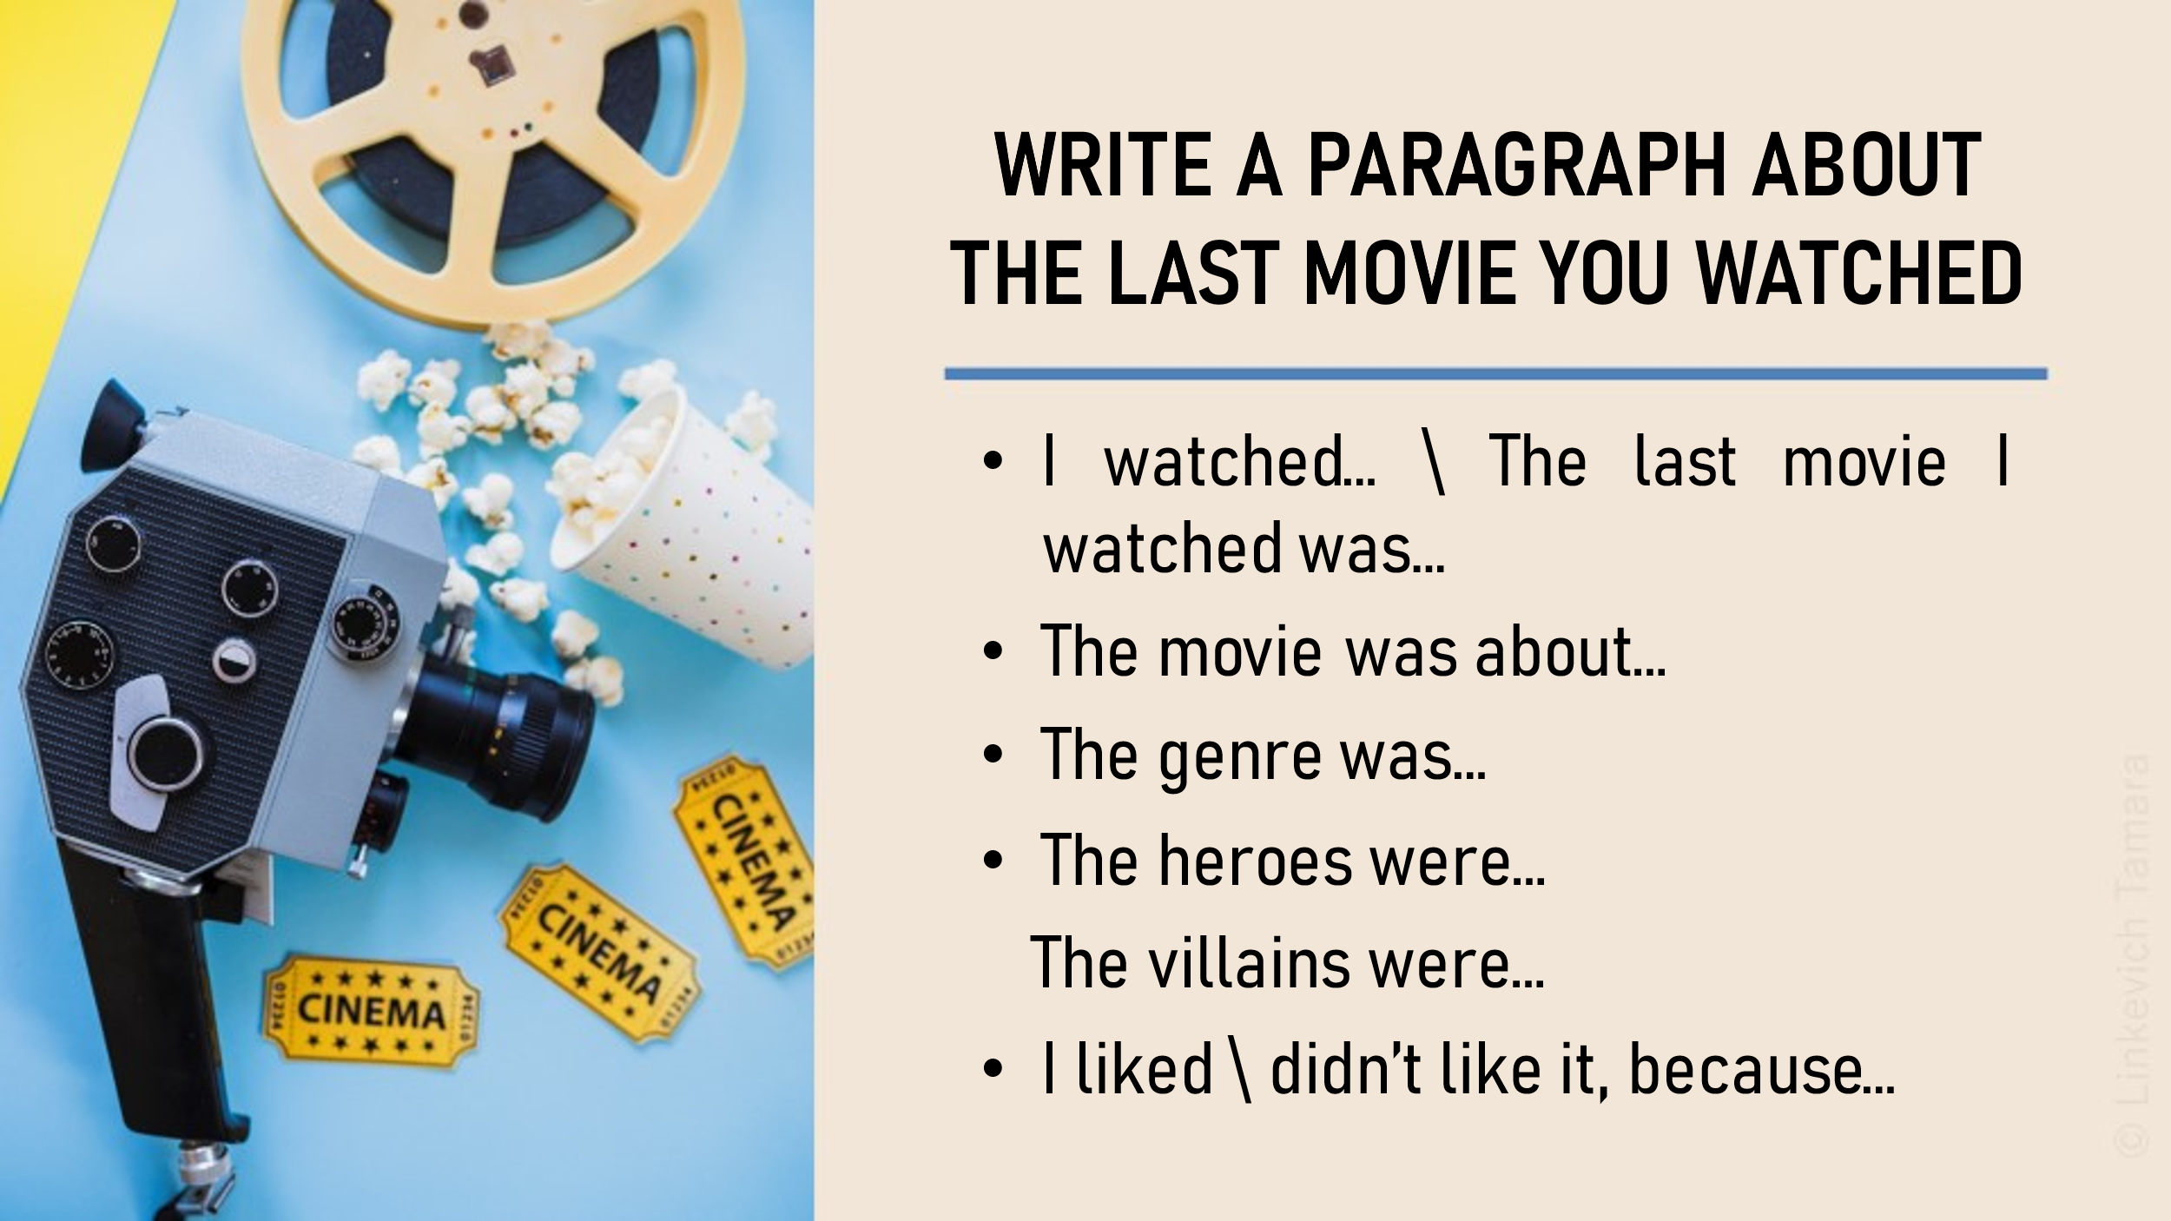

|  |  |  |  |
| --- | --- | --- | --- |
| **Assessment descriptor** | **№** | **Descriptor** | **Mark** |
| **1** | **Learners** |
| • writes a paragraph on the given topic; | 2 |
| • spells the words correctly (0-3 mistakes); | 2 |
| • writes grammatically correct sentences (0-2 mistakes disturbing the meaning); | 2 |
| • uses the past tenses correctly; | 2 |
| • includes all the necessary information. | 2 |
| **Total marks:** 10 points | | | | |

© Linkevich Tamara +7 (705) 197-44-58