Unit of a long term plan: Unit 1. Our class. |  |  | School: lyceum #20 named by A.S.Pushkin
Date: |  |  | Teacher’s name: Orlova O.I.
Grade | 6 |  | Number present: |  | Absent:
Lesson title: | Students around the world.
Learning objectives | 6.3.1.1. Provide basic information about themselves and others at discourse level on a range of general topics.  6.4.1.1. Understand the main points in a limited range of short simple texts on general and curricular topics.  6.6.1.1. Begin to use basic abstract nouns and compound nouns and noun phrases describing times and location on a growing range of familiar general and curricular topics.
Lesson objectives | - Supply information about students from another countries and about themselves;  - Recognize the main points from the given information;  - Can identify the types of nouns.
Assessment criteria | - Identify the people/subjects from the text;  - Make sentences using given information;  - Can identify the types of nouns.
Level of thinking skills | low and high order thinking
Stages/Time | Teacher’s actions | Student’s actions |  | Assessment |  | Resources
Beginning of the lesson  (2 min) | Teacher greets learners | Learners respond
Brainstorming  Pre-reading task  (5 min) | Teacher shows the pictures with school subjects (TPR) and ask CCQ questions:  - Is this subject History?  - Do you study this at school?  - Is it your favourite subject?  - Is it Math or PE?  - Where are you from?  - What is your native language?  - What subjects do you learn at school?  - What is the theme of the today’s lesson? | Learners needs answer the questions |  | verbal assessment |  | appendix 2 (pic)
Main part  While reading task 1  (5 min) | Task 1.  Teacher tells learners skimming the text and match each paragraphs with pictures | Learners skim and match |  | Verbal assessment |  | appendix 1  (text)
While reading task 2  (5 min) | Task 2.  Teacher tells learners scamming the text and complete the sentences  Scaffolding: teacher gives learners with individual needs worksheets | Learners filling the missing information |  | - Descriptors:  - Fill the gaps using their memory – each correct answer is 1p..  - Descriptors:  - Fill the gaps using key words – each correct answer is 1p.. |  | appendix 3
Post reading task  (speaking)  (5 min) | Specific skills  Teacher gives the instructions with information.  Scaffolding: building on previous knowledge and establishing a link between the students and the material. (quick – writes) | Learners must tell about themselves/ one student from the text |  | - Descriptors:  - Make 4-5 grammatical correct sentences – 2p.;  - Uses key words – 1p;  - Tell to the class – 1p.  - Descriptors:  - Make 2-3 grammatical correct sentences – 2p;  - Uses key words – 1p;  - Tell to the class – 1p. |  | appendix 4
Presentation of grammar material  (10 min) | Implicit teaching  Teacher divide learners in 3 groups and give them clearly instructions of learning the rule of compound nouns. After that groups need prepare the cluster with their theme. | Learners work in groups to prepare clusters. They present their material to other groups. |  | verbal assessment |  | appendix 5
Practice grammar  (5 min) | Teacher tells learners (in groups) find in the text compound nouns:  - Compound nouns  - Abstract nouns  - Noun phrase | Learners are looking for compound nouns |  | groups assess each other  Descriptors:  compound nouns: school trip, football, basketball  abstract nouns: fun, humour  noun phrases: English class, favourite subject, favourite sport, best friend |  | Appendix 1
Conclusion  (5 min) | Teacher gives learners a list with open-ended questions to self-assessment and gives instructions for completing it. | Learners are completing the list with questions. |  | Descriptors:  - Noun+noun =1p  - Ing+noun  - Adj+noun  - Abstract nouns =1p  - Name favourite sport = 1p  - Name favourite subject =1p  - Name the school subjects =1p |  | Appendix 6
Home task  3 min | Teacher tells learners to complete the assessment table of their evaluation Teacher gives home task | Learners are completing the table. (know/ don’t know/ need to know) |  |  |  | worksheet

Appendix 1
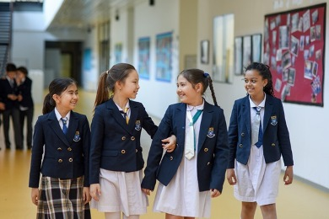
My name is Dina and I’m 12 years old. I’m from Almaty, Kazakhstan. My favourite subject is History of Kazakhstan because it’s really interesting and my favourite sport is basketball. This is my best friend, Zarina. She has a great sense of humour. Her favourite subject is Art. She’s very good at drawing and planning. She’s also interested in gymnastics.
Hi. My name’s May. I’m 15 years old. I’m from Tokyo, Japan. My favourite subject is Science. I’m really good at badminton; it’s easy! This is my friend Lynn. Her favourite subject is Maths and her favourite sport is basketball. In this picture we’re on a school trip. We’re having a great time!
Hello. I’m Miguel and I’m 13 years old. I’m from Monterrey, Mexico. This is a photo of me in my English class. My favourite subject is Geography and my favourite sport is football.
My name is Brenda and I’m 12 years old. I’m from Cambridge, England. In this photo, I’m in my ICT class. I think ICT is really fun and it’s my favourite subject. I also like Music. My favourite sport is hockey.

Download
https://sites.allegheny.edu/gatorblogs/2014/01/23/what-are-classes-like-in-japan/
https://www.searchassociates.com/news-events/international-school-opportunities-in-kazakhstan/
https://www.thoughtco.com/asking-questions-in-class-4093551
https://www.techprevue.com/ict-in-education/

Appendix 2
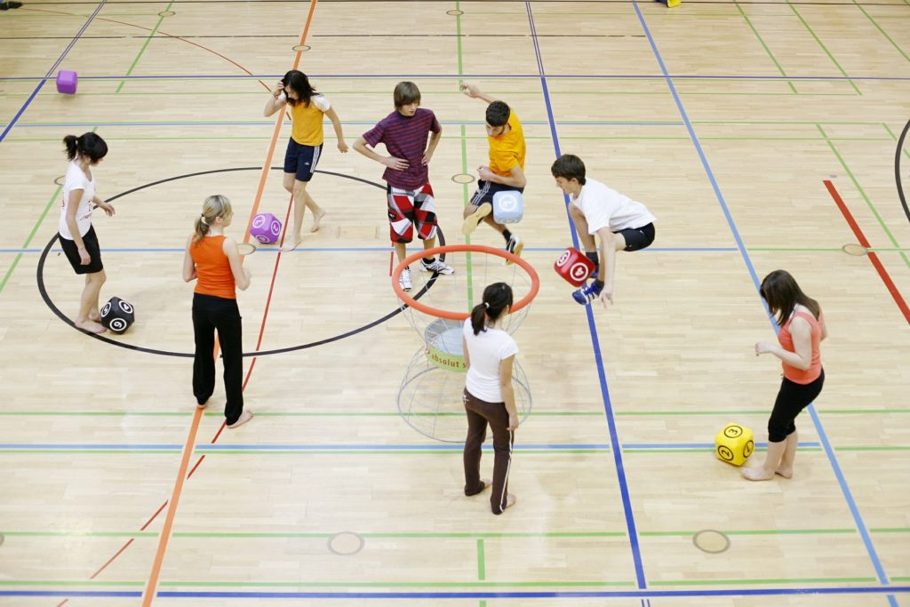
Download
https://www.techprevue.com/ict-in-education/
https://www.pescholar.com/insight/should-physical-education-be-a-core-subject/
https://www.techlearning.com/tl-advisor-blog/223
http://meredithgracehistory.weebly.com/world-history.html

Appendix 3
Maths gymnastics 12 badminton hockey Monterrey

- Brenda’s favourite sport is …………………….. .
- Miguel’s from …………………………………. .
- May is good at …………………………………. .
- Lynn’s favourite subject is …………………….. .
- Dina is …………………………………………. .
- Zarina interested in ……………………………. .

Appendix 4
Name | Country | Favourite subject | Interests
BRENDA
MIGUEL
MAY
LYNN
DINA
ZARINA

Name | Country | Favourite subject | Interests

Appendix 5
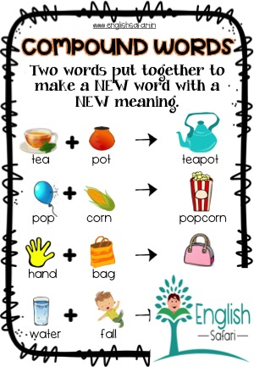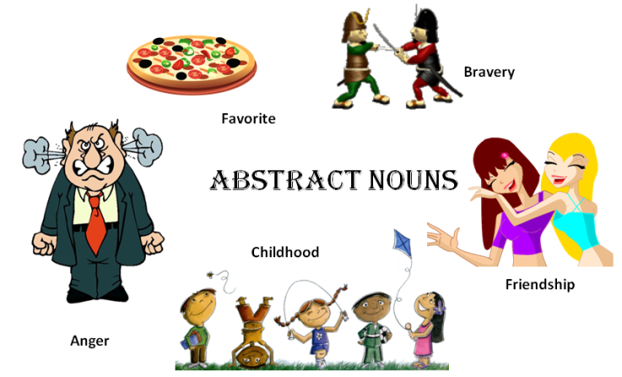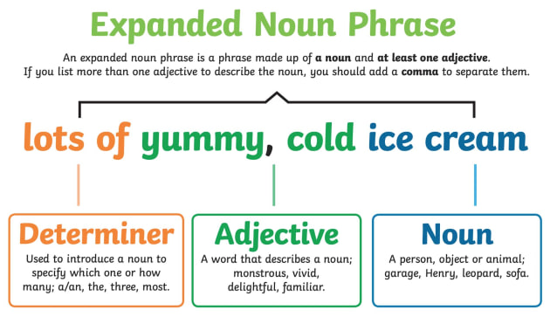
https://www.tes.com/teaching-resource/compound-words-meaning-12209422
https://pediaa.com/difference-between-concrete-and-abstract-nouns/
https://www.twinkl.co.uk/teaching-wiki/noun-phrase
Compound nouns consist of two parts:
- Noun + Noun = school bus
- -ing + noun = swimming pool
- Adjective + noun = whiteboard
Abstract nouns express an experience, an idea or something that you cannot see, hear, touch, taste or smell. Love, honesty, dream, friendship
Noun phrases can be a word or a group of words that act like a noun and change its meaning. My Maths teacher is Canadian.
Exel Grade 6 Student’s book
Task
Compound nouns | Abstract nouns | Noun phrases

Appendix 6
Name ___________
Question | Answer | Point
- What parts do compound nouns consist of? |  | __/1
- What nouns do express something that you cannot see, hear, touch, taste or smell? |  | __/1
- Continue the sentences:
- My favourite sport is ………….. |  | __/1
- My favourite subject is ……….. |  | __/1
- At school I learn ………………. |  | __/1
 | overall | __/5

