Unit 8. Healthy habits |  |  |  | School: 11
Date: 25.04.22 |  |  |  | Teacher name: Minkina AA
CLASS: 7 |  |  |  | Number present: |  | absent:
Lesson title |  |  | Food for Sport
Learning objectives(s) that this lesson is contributing to (link to the Subject programme) |  |  | 7.L5recognise the opinion of the speakers in supported extended talk on a range of general and curricular topics  7.L6 deduce meaning from context with little support in extended talk on a limited range of general and curricular topics
Lesson objectives |  |  | All learners will be able to:  - Understand the meaning of the context of the video/ audio while listening;  - Understand the meaning of the context of the text while reading
Assessment criteria |  |  | - Understand the meaning of the video with little support while talking about food for sport;  - Apply suitable topical vocabulary and syntax to talk about food for sport;
Level of thinking skills |  |  | Comprehension, Application
Values links |  |  | Respect, cooperation
Cross-curricular links |  |  | Biology, Physical training
Previous learning |  |  | Writing a short paragraph of an essay about healthy lifestyle
Plan
Planned timings | Planned activities (replace the notes below with your planned activities) |  |  |  |  |  |  | Resources
Start  5min | Greeting  Organization moment.  Teacher greets learners  ‘The Circle of Joy’ Ss say wishes each other  The survey homework. Ss count one/ two and stay two lines. Teacher ask questions  - Learners look at the pictures / words and find out the theme of the lesson.  - Learners aren’t divided into groups. Work in the pair |  |  |  |  |  |  | Pictures / words
Middle  35 min  Warm up  4 minutes  Task 2  10 minutes  Task 2  7 minutes  Task 4  10 min | Task I  Read the quotation and give your opinion are you agree or disagree  “A healthy mind in a healthy body” Tales of Miletus  Descriptor A learner:  - Read the quotation  - Formulate answers  FA – feedback of teacher  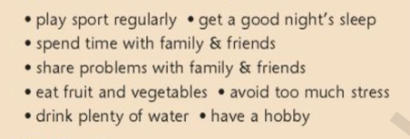  Task II Learners talk about healthy habits using adverbs of frequency. (Always,sometimes, usually, never) Read out the activities, in pairs tell each other activities the do and how often.  Task. Work in a pair  Descriptor A learner:  -Makes the sentences correctly  FA–Self-assessment  Task IIIcreate a poster promoting a healthy lifestyle.  Learners are decided into group of four.  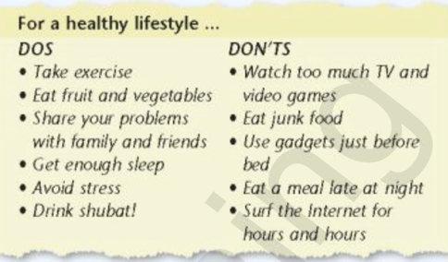  1 s writes the “dos” section, another s writes “don’ts”, the other two should find or draw appropriate pictures.  Descriptor A learners:  - Make posters  - Write sentences  FA- Feedback from students/ teacher  Task IV:Learners read the statements and decide weather is true or false  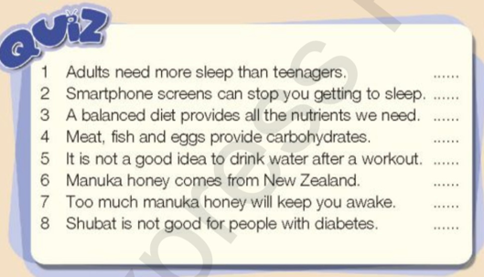  Descriptor A learner:  - listensanswer true or false  FA-Feedback from students/ teacher  Answer keys: 1. F, 2.T, 3.T, 4.F, 5.F, 6.T, 7. F, 8.F  Task V Learners listen to the song and discus |  |  |  |  |  |  | SB p.98  worksheet #1  SB  p.98, ex. 3  disk
End  4 minutes | Learners reflect on by: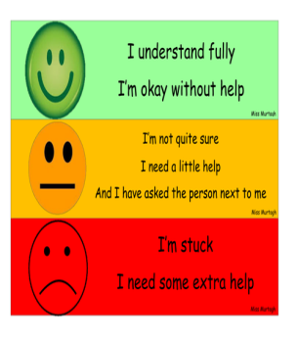
Additional information
Differentiation – how do you plan to give more support? How do you plan to challenge the more able learners? |  |  |  |  | Assessment – how are you planning to check learners’ learning? |  | Health and safety check
Differentiation:  Task 2.  - by support they will watch a video and match the sentences halves  Task 3.  - By task listen for specific information |  |  |  |  | - assess with smiles  - oral assessment |  | Health saving technologies.  Using physical exercises and active activities.
Reflection  Were the lesson objectives/learning objectives realistic?  Did all the learners achieve the lesson objectives/ learning objectives? If not, why?  Did my planned differentiation work well?  Did I stick to timings?  What changes did I make from my plan and why? |  | Use the space below to reflect on your lesson. Answer the most relevant questions from the box on the left about your lesson.
Summary evaluation
What two things went really well (consider both teaching and learning)?
1:
2:
What two things would have improved the lesson (consider both teaching and learning)?
1:
2:
What have I learned from this lesson about the class or individuals that will inform my next lesson?

