Short term plan: term 1

Unit 1: Investigate and report on animal world: bats, eagles, bees and dolphins lesson 14 |  | School: 14
Date: 20.09.2023 |  | Teacher name: Kalpakova A
Grade: 11 |  | Number present:21 | absent:1
Theme of the lesson: | Magnificent eagles
Learning objectives | 11.5.6.1 - write coherently at text level using a variety of connectors on a wide range of familiar general and curricular topics  11.2.8.1 - recognize inconsistencies in argument in extended talk on a range of general and curricular subjects, including some unfamiliar topics  11.3.7.1 - use appropriate subject-specific vocabulary and syntax to talk about a range of familiar and some unfamiliar general and curricular topics
Lesson objectives | Learners will be able to:  Listen and read for gist  Read for specific information
Plan

Stages / Timing | Teachers’ actions | Students’ actions | Assessment criteria | Resources
Beginning of the lesson  5 min | Organization moment  1.Greeting.Teacher greets everyone.  Lead in  Teacher shows picture and ask:what bird is it?Does this bird live in Kazakhstan?Sts work in pairs and answer the questions  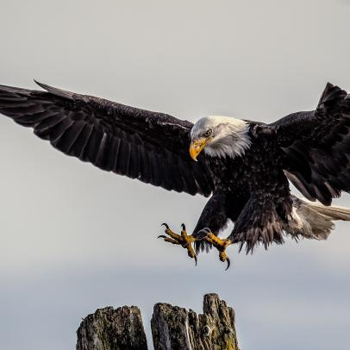 | Students' attention is drawn to the lesson.  Students discuss the pictures in pairs.  Students say different words from the picture | - Discuss and answer the questions  Total: 1 point | Pictures  Student’s book
Main part  30 min  8 min | 3. Presentation  Teacher presents new vocabulary  Large eyes-үлкен көздер  Hooked beak-тұмсық  Dark brown-қара қоңыр  Plumage-қауырсын  Golden features on head and neck-бас пен мойындағы алтын түсті белгілер  White markings on the underside-төменгі жағындағы ақ белгілер  Feathers on legs-аяқтарындағы қауырсындар  Plumage-қауырсын  Golden features on head and neck-бас пен мойындағы алтын түсті белгілер  White markings on the underside-төменгі жағындағы ақ белгілер  Feathers on legs-аяқтарындағы қауырсындар  Enormous wingspan-орасан зор қанаты  Sharp talons-өткір тырнақтар  Prey-олжа,табыс  Full grown-толық өскен  Mate-жолдасы  Hatch-люк  Rodent-кеміргіш  Soar-қалықтап  Retina-көз торы  Breed-тұқым  Teacher asks sts to make 3 sentences with new vocabulary.After in open class every student reads hids sentence.  Ex 1a p22 Teacher asks sts to use these new vocabularies to describe the bird.  Large eyes,hooked beak,dark brown,plumage,features.  Ex 2p.22 Sts read in detail the text about Eagles and sts find the main idea of the text.  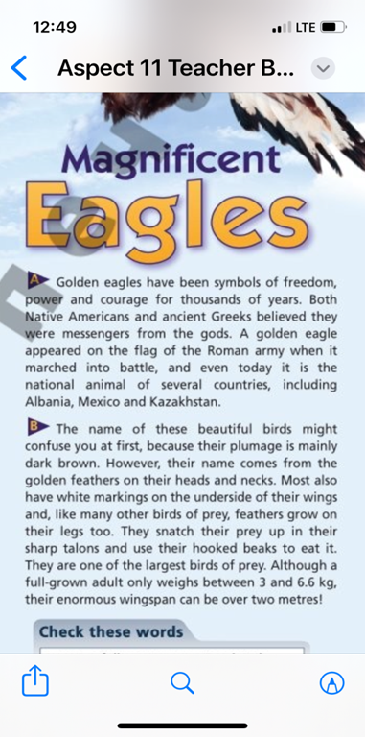  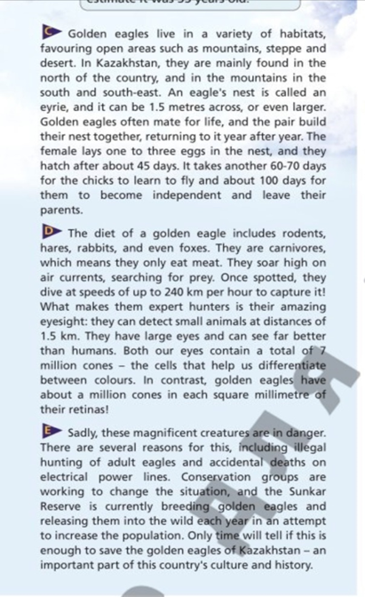  Exercise 3 p.22 sts do in pairs find answers to the questions.  1.B  2.D  3.A  4.D  5.A  6.B  Golden eagles have dark brown plumage with white markings on the underside of their wings. They have a hooked beak, large eyes and sharp talons. They have golden feathers on their heads and necks; they also have feathers on their legs. Golden eagles have an enormous wingspan.  Ex4p.22 Sts listen to the text and answer questions in their own words.  1.In what type of places do we usually find golden eagles?  2.What happens to golden eagle eagle chicks after they hatch?  Answers:  1 Golden eagles usually live in open areas such as mountains, deserts or grasslands.  2 After they hatch,golden eagle chicks learn how to fly. This might take around 60 to 70 days. After about 100 days, they don’t need their parents anymore and they leave the nest.  3 The work of the Sunkar Reserve is important because they are helping to maintain the population of golden eagles in the wild. Without their help, the number of wild eagles could drop drastically because of threats such as hunting.  Exercise 5 sts find words in the text that mean the opposite of:  Captivity(ParaA),dependent (para C)herbivore (para D)  Giving home task with instructions.  -At the end of the lesson Teacher give home task, exercises 7 at page 23 SB.  Conclusion during the lesson some tasks differentiated by outcomes of the students and by their abilities. | Students look at the photograph. What is this bird? What do you know about it?  Answers:  The bird is a golden eagle. Golden eagles are birds of prey  Students check any unknown words in your dictionary.  Answers:  Golden eagles have dark brown plumage with white markings on the underside of their wings. They have a hooked beak, large eyes and sharp talons. They have golden feathers on their heads and necks; they also have feathers on their legs. Golden eagles have an enormous wingspan.  Students read the text quickly.  Answers:  1 Golden eagles usually live in open areas such as mountains, deserts or grasslands.  2 After they hatch,golden eagle chicks learn how to fly. This might take around 60 to 70 days. After about 100 days, they don’t need their parents anymore and they leave the nest.  3 The work of the Sunkar Reserve is important because they are helping to maintain the population of golden eagles in the wild. Without their help, the number of wild eagles could drop drastically because of threats such as hunting. | Descriptor:  - answer the question  Total: 1 point  Descriptor:  - read the text quickly.  Total: 1 point  .  Descriptor:  - choose the best answer  Total: 1 point  Descriptor:  - listen and read the text.  Total: 1 point
End  2 min | FEEDBACK  Learners provide feedback on at they have learned at the lesson. |  | Students evaluate each other and encourage classmate with phrases like:  Well done! Brilliant! Good job! I like it!

