LESSON 81  Unit 8: Our Neighbourhood |  |  | School: Nizhniy Burluk Secondary School
Date: 5.04.22 |  |  | Teacher name: Lavrinenko V.V.
Grade: 6 |  |  | Number present: 4 |  | Number absent:
Theme of the lesson: |  | Places and buildings in a town. Language focus. Is there/Are there…?
Learning objectives |  | 6.6.1.1- begin to use basic abstract nouns and compound nouns and noun phrases describing times and location on a growing range of familiar general and curricular topics;  6.5.6.1- link, with minimal support, sentences into coherent paragraphs using basic connectors on a growing range of familiar general topics;  6.5.2.1- write with some support about real and imaginary past events, activities and experiences on a limited range of familiar general topics and some curricular topics;  6.1.5.1 use feedback to set personal learning objectives
Lesson objectives |  | All learners will be able to:  -Do exercises with grammar material;  - Practice direction vocabulary for the instructions to find different places  - Use subject specific vocabulary (4-5)  Most learners will be able to:  - Do exercises with grammar material;  - Use subject specific vocabulary (5-6)  - Listen and identify the names of objects and their directions with minimal support  Some learners will be able to:  - Use grammar to make sentences  - Speak about places in the city
Previous learning |  | A description of a modern city
Plan
Planned timings | Planned activities |  |  | Learners’ activities |  | Evaluation | Resources
Begining  5 min | 1.Organization moment. Pre-learning  Teacher greets learners and asks them about the season, month, the day of the week and the weather.  Teacher sets positive atmosphere by asking some ice breaking questions.  Learners take one piece of paper and give to each other a compliment.  2.Teacher tells the learners the objectives of the lesson |  |  | Greeting  Learners answer the questions |  | Verbal evaluation | Cards  The box with compliments
Middle  35 min | 4. Practice  Revision of learnt vocabulary: buildings and prepositions  Revision there is/there are  Speaking. A teacher demonstrates a city simulation. Gives to learners examples how to describe a city. For example. There is a fire station next to the police station. Learners gives their own sentences.  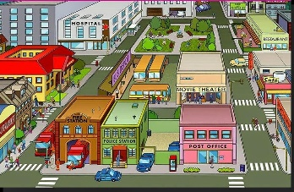  Formative assessment.  Task. Learners look at the city plan and complete the sentences with prepositions. Some of the prepositions they may use twice.  Assessment criteria:  • Demonstrate the correct use of prepositions before nouns and adjectives in prepositional phrases  •Use prepositions of time, location and direction  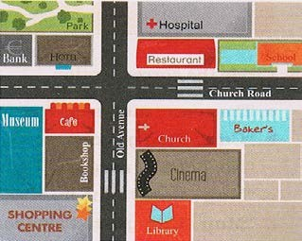  Prepositions: behind, under, between, near, next to, opposite, in front of  1. The school is ____________the restaurant.  2. The baker´s is ___________ the school.  3. The cinema is ___________the church and the library.  4. The park is ____________ the bank.  5. The café is _____________ the bookshop.  Descriptor A learner  • selects the appropriate preposition from the box;  • completes sentences  Writing. A description of learner’s own town. Everyone has a template and pictures of some buildings. They should glue pictures in any order and write some sentences.  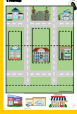  For example: This is my town. There are different buildings. There is a toy shop near the bakery and etc. |  |  | Learners say buildings words  Learners complete the sentences  Learners do the task |  | Individual avaluation  Mutual avaluation | Visuals  Poster  Worksheets  Templates.
End  5 min | Reflection  Learners provide feedback on what they have learned at the lesson.  Tree of success  Green leaf - I totally understand  Yellow leaf - I understand the lesson but I need some helps  Red leaf - I don't understand  Home task: to revise grammar themes  Saying goodbye |  |  |  |  | Self-assessment | Reflective journals

