Form: 11
Theme: Our natural world
Aim: to present and consolidate vocabulary, to practice intensive listening skills
I.Warm-up
Which picture show?
Ex.1,p.21 Write the numbers of the pictures
Animals- Mountains-
Birds- River-
Ocean- Lake-
Forest- Desert-
Waterfall-
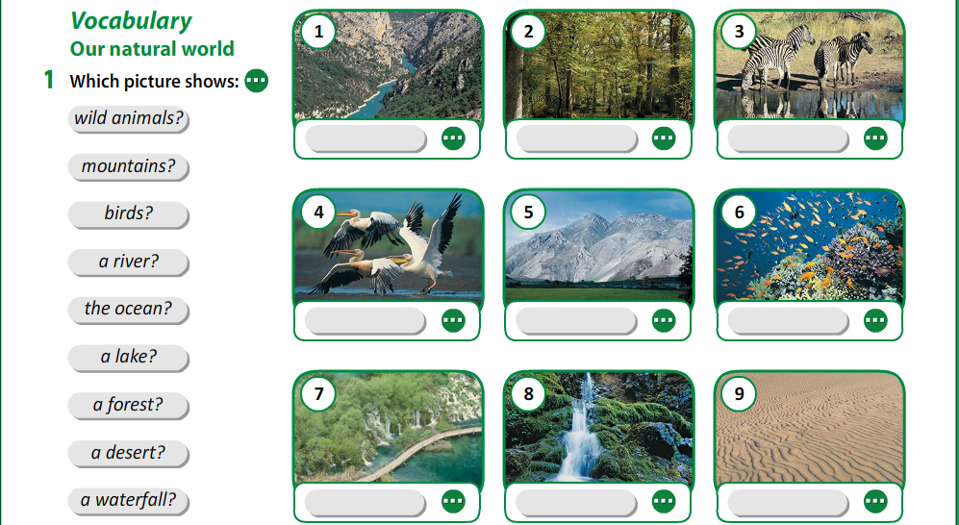

Watch video, listen and check, then say

II.Vocabulary

Provide-обеспечивать
Cover-покрывать
Lack-отсутствие
Shelter-убежище
Area-площадь
Drop-падать, понижение
Insect-насекомое
Treasure-сокровище
Surface-поверхность
Creature-существо
Mammal-млекопитающие
Exist-существовать
Refer-относиться, ссылаться

III.Practice
Ex.2a,p.21 Fill in:
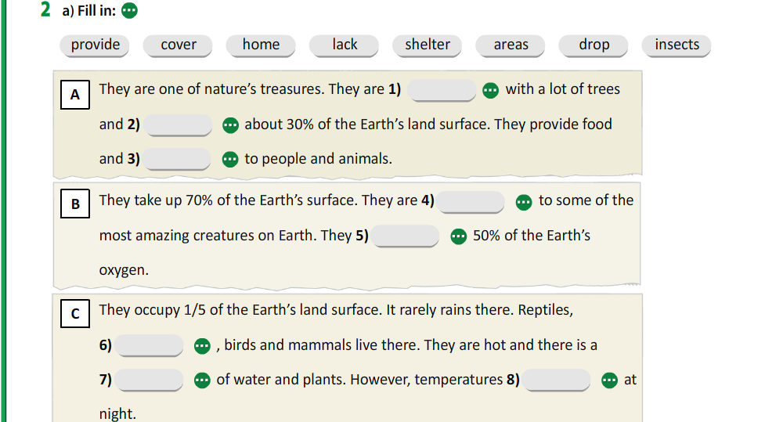
Ex.2b,p.21 Which of the pictures 1-9 does each text refer to?
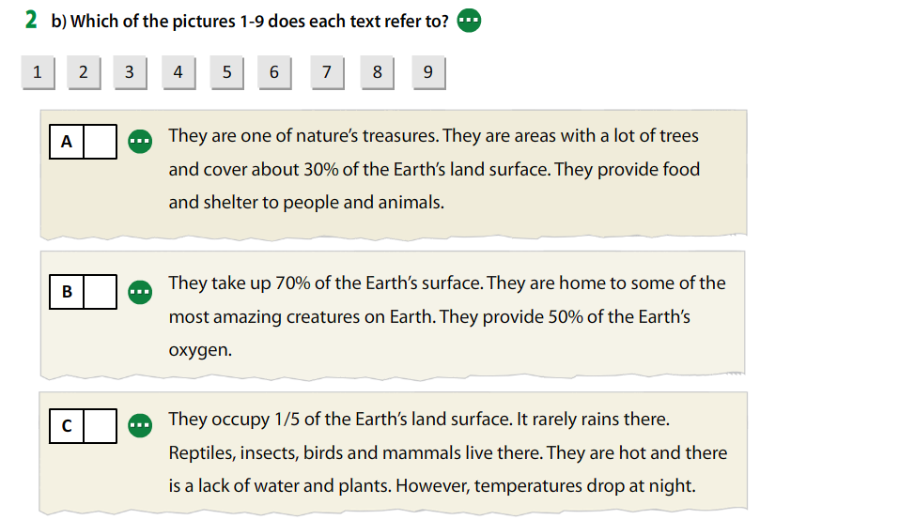

IV.Writing
Ex.3,p.21 Which of the things in the picture exist/don’t exist in your country? Write a few sentences about your country
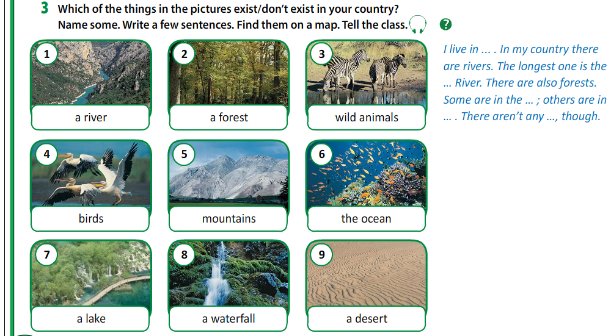
V.Reflection

VI.Homework
To learn new words by heart

