Summative assessment for the unit “Space and Earth” V-I
Reading Task 1. Read the text and answer the questions.
Planet Facts
Mercury takes 59 days to make a rotation but only 88 days to circle the Sun. That means that there are fewer than 2 days in a year!
Many astronomers believe that Mercury might be the core of what was once a much larger planet -- it appears to be a huge ball of iron covered by a thin layer of rock.
Venus is the brightest planet in our sky and can sometimes be seen with the naked eye if you know where to look. It is the solar system's brightest planet -- yellow clouds of sulfuric acid reflect the sun's light.
Mars is the home of "Olympus Mons", the largest volcano found in the solar system. It stands about 27 kilometers high with a crater 81 kilometers wide.
Jupiter is the largest planet in the solar system, but it spins very quickly on its axis. A day on Jupiter lasts only 9 hours and 55 minutes. I get dizzy just thinking about it!
Jupiter is so big that you could fit all the other planets in the solar system inside it.
The red spot of Jupiter is the biggest, most violent storm in the known universe -- that spot is at least three times the size of earth!
1) How many days does Mercury take to circle the Sun?
2) What planet is the brightest?
3) Is Mercury or Mars home of the largest volcano?
4) Does the largest volcano stand about 37 kilometers high on Mars?
5) What is the largest planet in the solar system?
6) Why could Jupiter fit all other planets in the Solar system inside it?

Task 2. Connect numbers and letters and find the right pictures.
The Sun | - They are holes made when a large moving rock hit the moon. | 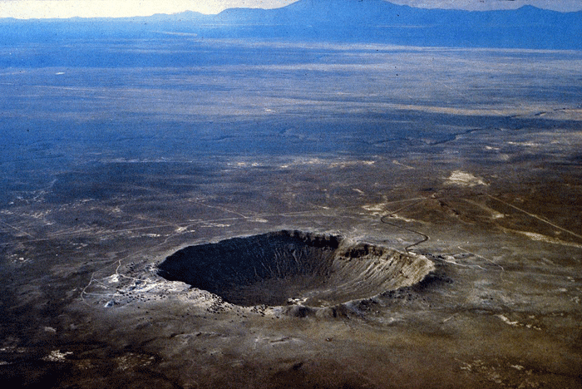 a
Craters | - The Sun together with all the planets and other bodies that revolve around it. | 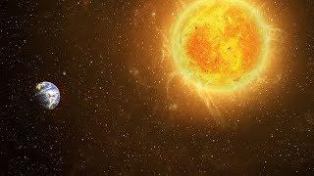b
Solar system | - The star that provides light and heat for the earth | 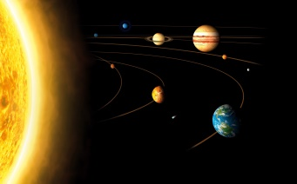 c

Speaking
Task 3: Work in a group of 3-4. Answer the questions below.
Where are you planning to travel to? Name the planet? How far is it from the Earth? Temperature ? Water? Surface? Will people live there in the future? What will you do if you see aliens or unusual animals there?
Summative assessment for the unit “Space and Earth” V-II
Reading Task 1. Read the text and answer the questions.
What do you know about planets?
Mercury is very hot during the day and very cold at night. It is also the fastest planet in the Solar system. Venus is the hottest planet in the solar system. One of its volcanoes, Mat and Olympia’s Mons, is named after the Egyptian god of truth and justice. The beautiful blue color of Earth comes from the oceans which cover 70 per cent of the planet. More than seven billion people live there. The fourth planet, Mars, is named for the Roman god of war. Until 1976 scientists believed there could be life on Mars. Jupiter is the largest planet that we know of. It is a very stormy planet because it spins so fast. Saturn is 100 times the size of Earth, but it is even lighter than water, so it would float in a gigantic swimming pool! Uranus is strange because it spins at an angle. Each pole of Uranus, north and south, has 42 years of sunlight, then 42 years of darkness. Neptune takes more than 160 years to go round the sun. It has the strongest winds in the solar system – up to 2 400 kph. Pluto is not considered as planet anymore because of its strange orbit.
1) Where are Mat and Olympia’s Mons situated?
2) How many pre sent of water cover our planet?
3) Who believed in life on Mars?
4) What planet spins so fast?
5) Would Neptune or Saturn float in a gigantic swimming pool?
6) Why is Pluto not considered as a planet anymore?

Task 2. Connect numbers and letters and find the right pictures.
1)Comets | - a very large ball of burning gas in space that is usually seen from the earth | 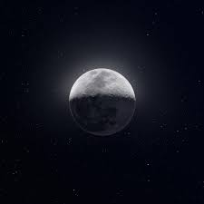 a
2) Stars | B.. It is the largest object you can see in the night sky. | 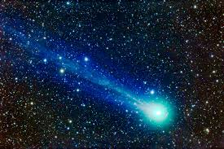 b
3) The Moon | C. A small, frozen mass of dust and gas revolving around the sun. | 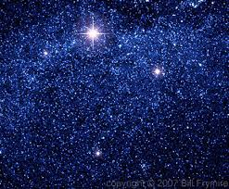 c
Task 3: Work in a group of 3-4. Answer the questions below.
Where are you planning to travel to? Name the planet? How far is it from the Earth? Temperature ? Water? Surface? Will people live there in the future? What will you do if you see aliens or unusual animals there?

Assessment criteria  V-1 | Task | Descriptor | Mark | Additional information
 |  | A learner
Identify the correct form of a word, appropriate sentence structure and text layout.  Identify the meaning and details of the reading texts. | 1 | 88 days
 |  | Venus
 |  | Mars
 |  | No, about 27 km
 |  | Jupiter
 |  | It is very big
 | 2 | Chooses 1- C - b
 |  | Chooses 2 - A - c
 |  | Chooses 3 - B - a
Provide a point of view in conversations and discussions.  Interact in a pair, group and a whole class work presenting logically connected information with ideas of other people. | 3 | answers the questions; | 2
 |  | participates in the discussion; | 2
 |  | presents logically connected information. | 2
Total marks
Assessment criteria  V-2 | Task | Descriptor | Mark | Additional information
 |  | A learner
Identify the correct form of a word, appropriate sentence structure and text layout.  Identify the meaning and details of the reading texts. | 1 | Mercury | 1
 |  | 70 % | 1
 |  | Scientists | 1
 |  | Jupiter | 1
 |  | Saturn | 1
 |  | Because of its strange orbit | 1
 | 2 | Chooses 1- C - b | 2
 |  | Chooses 2 - A - c | 2
 |  | Chooses 3 - B - a | 2
Provide a point of view in conversations and discussions.  Interact in a pair, group and a whole class work presenting logically connected information with ideas of other people. | 3 | answers the questions; | 2
 |  | participates in the discussion; | 2
 |  | presents logically connected information. | 2
Total marks |  |  | 18

