School- gymnasium # 113

Intellectual game

**“Funny English”**

**Grades**: *3 “B”, 3 “G”*

**Teachers**: *Nurzhauova Zh.M.*

Almaty, 2022

**Aim:** to revise and consolidate the studied lexical and grammatical material through games.

**Objectives**:

*1) learning*

• Consolidation of grammatical structure

• Generalization of knowledge on different lexical topics

*2) developing*

• Development of speaking skills

• Development of logical thinking

• Development of group work skills

*3) educational*

• raise attentive attitude towards each other

• foster ability to work in pairs and in a team

• increase motivation to learn a foreign language

**Lesson equipment:** blackboard, tablets with the names of the rounds, task cards, colored pencils, glue.

**Rules of the game**:Two teams of 10 students from 3 grades: “Stars” and “Smiles” compete in 8 rounds: “Riddles”, “Grammar”, “Numbers”, “Description”, “Vocabulary”, “Puzzles”, “Noughts and crosses”, “Drawing” . In each round, team captains draw cards with tasks that they must complete within a certain time. The team that completes the task without errors receives a certain number of points. The team that gets the most points wins.

**Course of the game:**

***I. Introduction: Greetings. Presentation of teams.***

*Good afternoon, dear friends. I’m glad to see you at our intellectual game. Two teams are going to compete now. So, let’s start!*

*Meet the first team – “Stars”!  
Meet the second team – “Smiles”!*

*And now I would like to introduce our jury. They will keep the score.*

**II. Rounds:**

**Task 1. “Riddles”** *Guess the riddles [5 points]*

*CARD №1*

1. Готов обед у миссис Эйбл, для нас она накрыла …(table)
2. Я с иголочки обут, теперь не жмет мне левый …(boot)
3. Кудрявый очень негр Джек, от солнца стал совсем уж…(black)
4. Стреляли в волка Пиф и Пуф, волк по английски будет …(wolf)
5. Очень любит меня Джим, я шоколадное …(ice-cream)

*CARD №2*

1. После того как съеден обед, всем детям нужно go to …(bed)
2. Так забавны и ловки обезьянки - …(monkey)
3. Вот Санта Клауса портрет, он там в наряде цвета …(red)
4. Прыгнула из лужи прямо на порог, заквакала от радости пучеглазка…(frog)
5. Трудный вам задам вопрос, rак называют лошадь? - …(horse)

**Task 2**. **“Grammar”** *Chose the right article (a/an) [10 points]*

**A An**

*Ball apple  
sister egg  
hand orange  
bag eye  
book elephant*

**Task 3. “Numbers”** – *Do sums.* [5 points]

Ten plus ten is … (20)

Eight plus two is … (10)

Six plus thirteen is … (19)

Twenty minus twelve is … (8)

Fifteen minus ten is … (5)

**Task 4**. **“Description”:** *Read the text and chose the right number. [5 points]*

Hi! My name is Ben. I’m 10 years old. I have got brown hair, blue eyes, big ears and a small nose. I am wearing blue jeans, red and green sweatshirt and blue shoes.

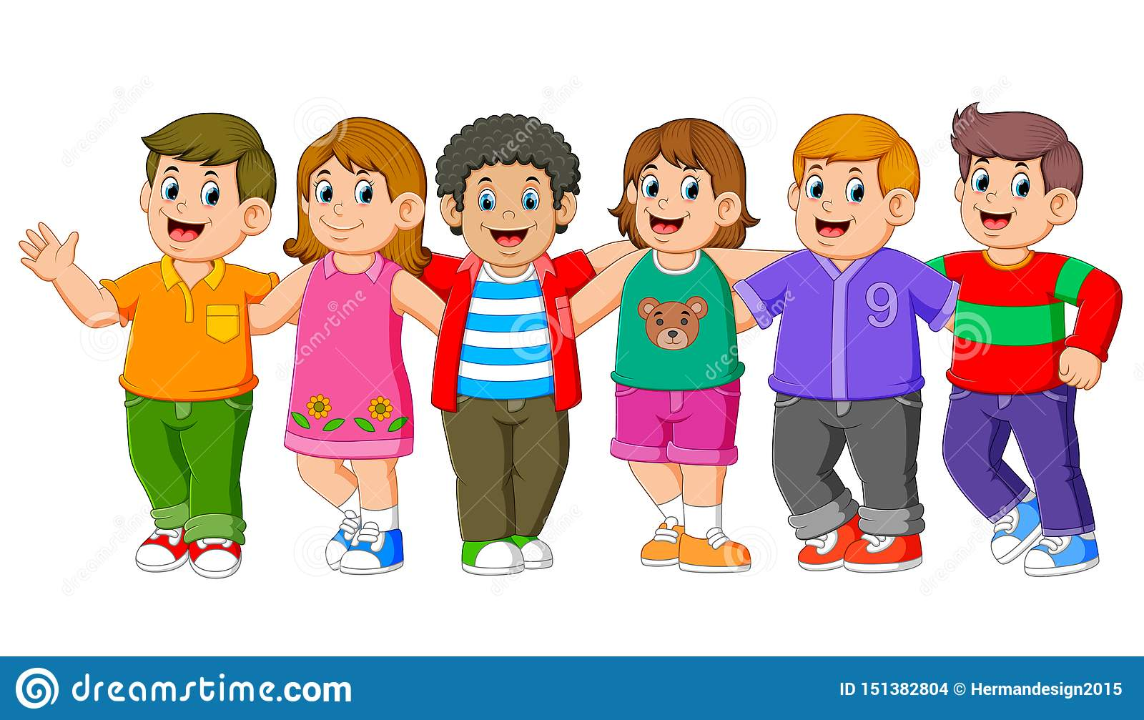 1 2 3 4 5 6

**Task 5.** **“Vocabulary”:** *Put the words into the right column [15 points]*

FAMILY FOOD TRANSPORT

mother cheese car  
dad milk bus  
brother bread bike  
sister tomato train  
grandma ice-cream plane

**Task 6. “Puzzles”** *Find 5 school items in this puzzle*

*Mesapendrubberorjfschooleuyrofbpencilifgjbnccbookldkfmdeskslswpodgboardwg*

**Task 7. “Noughts and crosses”** *Name the animal*

|  |  |  |
| --- | --- | --- |
| *Horse* | *cow* | *sheep* |
| *lion* | *wolf* | *bird* |
| *crocodile* | *elephant* | *monkey* |

**8. “Drawing”** *Draw and paint a picture*

*CARD №1 “Draw and paint a picture”*

1. A blue ball
2. A yellow flag
3. A red apple

*CARD №2 “Draw and paint a picture”*

1. A green table
2. A black cat
3. A pink pig

**III. Conclusion.**

Summing up and awarding the winners with diplomas.