Unit 5: Hot and Cold |  |  | School: Lesnoy secondary school
Date: 16.10.2020 |  |  | Teacher name: Kishkunova T.Y.
CLASS: 4 |  |  | Number present: | absent:
Theme of the lesson: |  | Weather
Learning objectives |  | 4.R5 understand the main points of short simple text on a limited range of familiar general and some curricular topics by using contextual clues.  4.S4 respond to questions on an increasing range of general and some curricular topics.  4.S1 make basic statements which provide information on an increasing range of general and some curricular topics.
Lesson objectives |  | All learners will be able to:  - Read and write a short text about weather.  - Can correctly use new words.  Most learners will be able to:  - Tell about weather phenomena and distinguish them.  - Ask and answer the question “What is the weather today?” with support.  Some learners will be able to:  - Show leadership qualities in group and pair work.  - Demonstrate speaking skills using new words.  - Ask and answer the question “What is the weather today?” without support.
Assessment criteria |  | - Talk about the weather using new words.  - Read the text correctly  - Make fundamental explanations which give data on an expanding run of common and a few curricular topics
Language objective |  | Key words: weather, heat, cold, rain, snow, wind, cloudy, nature.  Useful phrases for dialogue: What іs the weather likе tоdаy?  It’s cold / hot today. The weather is…  Degrees of Comparison of Adjectives
Values links |  | Instill communication skills, mutual respect, collaboration
Cross-curricular links |  | Natural science, ICT.
Previous learning |  | Learners have studied structures: there is / there are, present continuous.
Plan
Planned timings | Planned activities |  |  |  | Resources
Start  3  min  (W)  3  Min  (W) | Organizational moment (Greeting, Declaring the objectives of the lesson)  Warm – up task: Riddles  - Dropping from the sky  More beautiful than rain  There are no two pieces  That’ll ever look the same  (Snow)  - If you look up during the day  Than you will see this lit  Because it is Earth’s closed star  Around which we orbit  (Sun)  - I am a breeze or squall  A cyclone or gale  I am what is measured  On the Beaufort scale  (Wind)  Students are divided into 2 groups using weather – themed puzzles.  Task 1. Look at the words and pictures on the Interactive Whiteboard. Match the words and pictures.  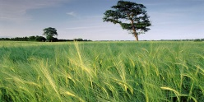 CLOUD  SNOW  WIND  RAIN  SUNNY  FROST |  |  |  | https://kratkoe.com/zagadki-pro-pogodu-na-angliyskom/  Handout 1  https://list-english.ru/articles/weather.html
Middle  6  min  (W,I)  3  Min  (G)  5  min  (W,I)  4  min  (W,I)  4 min  (W,I)  3 min  (W)  4 min  (G) | Task 2. Watch the video about the Weather.  Look in the window and answer the questions.  - What season is it?  - How is the weather?  - What is your favorite season?  Differentiation  Children with low motivation perform task with the help of a teacher.  Peer assessment “Smiles”  Descriptor  A learner:  - Answers the questions correctly  Pre – reading task 3. Look at the pictures. What can you see? What do they have in common?  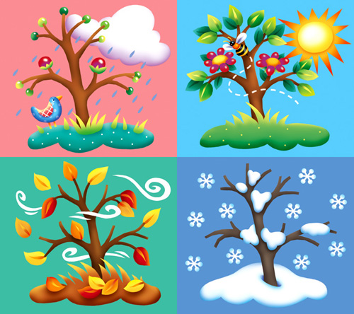  Seasons  It is spring now. March, April and May are spring months. The weather is fine in spring. It is cool or warm. It sometimes rains. In May it is very warm. You can see flowers in the fields.  It is summer. June, July and August are summer months. It is hot and sunny in summer. The weather is nice. The days are long and the nights are short. The fields and trees are green. Children run and play in the streets.  It is autumn. September, October and November are autumn months. It is cool in autumn. The weather is rainy and windy. The trees are yellow and red. There are many fruits and vegetables in the gardens.  It is winter. December, January and February are winter months. The weather is cold in winter. It usually snows. The streets and fields are white. The days are short and the nights are long. Children play snowballs in the streets.  While – reading task. Read the text and mark the sentences T (true) or F (false).  1 March, April and May are spring months. (T)  2 It is cold and sunny in summer. (F)  3 In May is very warm. (T)  4 The trees are yellow and red in winter. (F)  Differentiation  Weak learners receive support from their peers  Assessment  Teacher observation  Descriptors  A learner:  - reads the text carefully  - marks the sentences T (true) or F (false).  Post-reading task. Answer the questions:  - What the weather like in summer?  - What are 3 months there in spring?  - When do children play snowballs in the street?  - What color are threes in autumn?  Physical minute for learners “Weather”  Let’s go walking in the snow / rain  Walking, walking, on tiptoe  Lift your one foot way up high  Then the other to keep it dry  All around the yard we skip  Watch your step! Or you might slip!  Game “The Weather chart”. Students are divided into 2 groups and make a Weather Chart using the handouts.  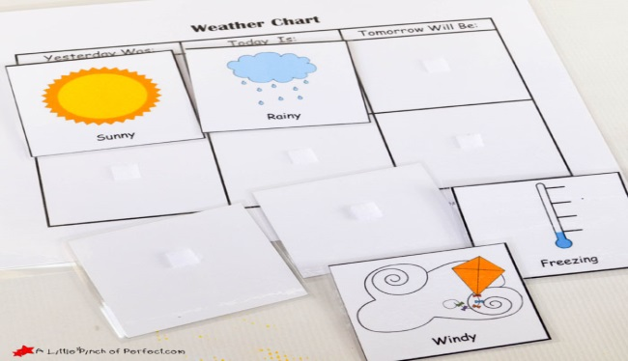  The speaker of the group presents the weather chart to the whole class.  Differentiation  Group leaders help students with low motination  Assessment  Peer – assessment using “Smiles”  Descriptors  A learner  - discusses in a group  - presents the weather chart to other group. |  |  |  | https://yandex.kz/video/preview/?filmId=8847650113643621661&url=http%3A%2F%2Fwww.youtube.com%2Fwatch%3Fv%3Did1Ft22Ptmg&text=Seasons%20and%20Weather&path=sharelink  https://ds04.infourok.ru/uploads/ex/0695/00020264-fbeca78c/hello_html_55c30374.jpg  Handout 2  https://www.klass39.ru/wp-content/uploads/2011/11/6a00d8341cb5e153ef0147e04c9c57970b-800wi.jpg  https://lizasenglish.ru/anglijskij-dlya-detej/tekst-sezony.html  https://infourok.ru/tematicheskie-fizkultminutki-dlya-urokov-angliyskogo-yazika-v-nachalnoy-shkole-3500352.html  Handout 3  https://drive.google.com/file/d/0BwLmG5A_TPcxeDZ6NzBaSnZ5YWc/view
End  5  min  (W,I) | Reflection and Good – Bye  - Learners evaluate their work in the lesson.  Everything worked out  Not everything worked out  Nothing succeeded  - Pupils singing a song “Weather” |  |  |  | Handout 4  https://multiurok.ru/uploads/1/4/b/14bdf5e62ec578c7a2d4c6efe944c0fd7767e62b/php3N3L52_ha6daa09.jpg  http://clipart-library.com/images/8izno77xT.jpg  https://fsd.multiurok.ru/html/2017/08/29/s_59a54b83ede2a/img3.jpg  https://youtu.be/_jHsV6Q8q8A

