Short term plan: term 2

Unit 3 Values |  | Lesson 35
School
Teacher name:
Date:
Grade:5 |  | Number present: | absent:
Lesson title | Writing: An email about your best friend
Learning objectives | 5. 4. 6. 1 identify the author's opinion or point of view in short texts on some general and educational topics  5. 5. 3. 1 write specific details with the support of the teacher, describing people, places and objects at the text level;
Lesson objectives | Learners will be able to:  - listen for specific information  -read for specific information  -understand the use of also
Value links | The value based on the integrated educational program is to educate students for justice and responsibility  For any type of service or activity take responsibility
Plan

Stages / Time | Teachers actions | Students actions | Assessment criteria | Resources
Beginning of the lesson  Warming-up    Pre-learning  «Brainstorming» method | Organization moment :  1.Greeting.  Greeting. ( Individually)  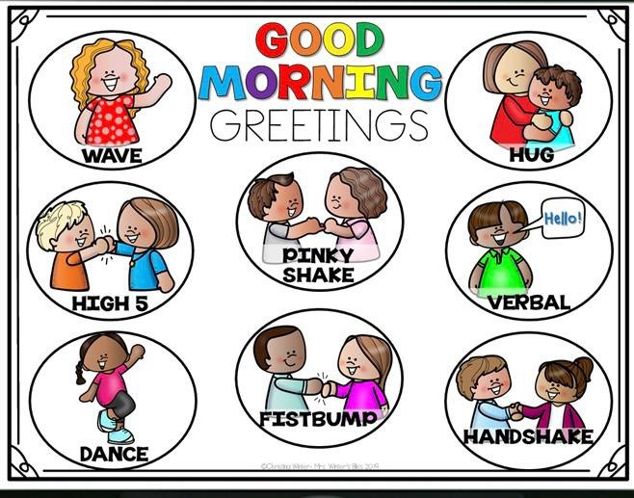 Warm up: Warming up  Where are you from?  How old are you?  What color is it?  How many students are there in class?  What day of the week today?  VOCABULARY  1 Comedy- комедия  2 favorite- сүйікті  3 Free time –бос уақыт  4 Laugh-күлу  5 Person-адам  6 Together -бірге | The aim: To develop pupils speaking skills and create friendly atmosphere  Efficiency: By wishing each other they feel better and feel the support of others  Students of the class are listed.  Students' attention is drawn to the lesson.  Read vocabulary  Learn new words | The teacher to assess learners for their ability.  “Good job!  Well done!”  Formative Assessment  Good job!  -know key phrases  - know vocabulary | Pictures    worksheet  Student’s book
Middle of the lesson  Presentation part. | Task1  Ex:1 p43 Explain the task. Allow Ss time to fill in the gaps with the appropriate word.  Play the CD. Ss listen and check that they have chosen the correct word.  Check Ss' answers.  Complete the text with words from the list  Funny, name, free,class  Hi Anna  I want to tell you about my best friend. Her ________ Sofia . She’s 11 years old and we’re in the same 2) ________at school .  Sofia is very clever . She’s also a very______person. She always makes me laugh. In our 4)______  Time, we love watching films together .Comedies are our favourites .How about you ? Have you got a best friend? Write back soon.  Task 2  Ex: 2 P: 43  Allow Ss time to read and answer the questions.  Checks Ss' answers.  Read the email and answer the questions  1 What is the email about ?  2 Who is Sezim‘s best friends?  3 How does she know her?  4 What is Sezim’s best friends like?  5 What do they like doing together?  6 What does Sezim ask Anna to do?  Ex: 3 P: 43  Write the sentences in the correct order  1 playing/likes/computer/Kulai  2 he /strong/also/very/is  3 like/ to the gym/going/we  4 the piano/can/she/also/play  5love/together/playing/we/  basketball  6 early/Ernolat/getting up/hates  7 15/is/she/old/years  8 a/person/is/Dauren/quite  Ex4 p43  Writing (an email about your best friends)  Hi, Thanks for ____ touch. It was great to about your school trip.  The photos were awesome Tommo and I have ____a party tomorrow on his boat. He’s bought lots of yummy food including sausage and chees . I’m ___my famous chicken salad. It’s really easy. ____, I fly the and ___some eggs . Then I _____them. After ____ , I chop tomatoes into small___ and ____everything together with some _____ I can’t tell you _____good it is! Anyway , I was ___if you did like to come .Were asking everybody to ___some juice because we want to make smoothies of different flavours .Let me know if you ___it  Alisha  Task5 Answer the questions about your best friend  1 What is his/her name?  2 How old is/she ?  3 How do you know him/her?  4 What is he/she like?  5 What do you like doing together? | ANSWERS  1 name  2 class  3 funny  4 free  I want to tell you about my best friend. Her name Sofia . She’s 11 years old and we’re in the same 2 class at school .  Sofia is very clever . She’s also a very funny person. She always makes me laugh. In our 4)free time, we love watching films together .Comedies are our favourites .How about you ? Have you got a best friend? Write back soon.  ANSWERS  1 It's about Sezim's best friend.  2 Sofia  3 They are in the same class at school.  4 She is clever and funny.  5 They like watching films.  6 To write about her best friend  Answer  1 Kulai play computer games  2 Also he is very strong  3 We like going to the gym  4 She can also play the piano  5 We love playing basketball together  6 Erbolat hates getting up early  7 She is 15 years old  8 Dauren is quiet person  ANSWERS  Pupils read the email and complete the task  1 getting in  2hear  3 just  4decided  5 making  6 first  7 boil  8 slice  9 that  10 pieces  11 mix  12 mayonnaise  13 how  14 wondering  15 bring  16 can make  Amswer  1 Her name is Diana.  2 She is 13 years old.  3 We are in the same class at school.  4 She's helpful and friendly.  5 We like going for walks together and listening to music | Descriptor:  - complete the text  Total: 2 point  Descriptor:  - read the email  - answer the question  Total: 2 point  Descriptor:  - write the sentences in the correct order  Total: 2point  -Make CCQ questions Yes / No  Descriptor  Answer the questions  Write correct sentences  Point 2  Descriptor:  - write the sentences in the correct order  Total: 2point  -Make CCQ questions Yes / No  TOTAL 10 points | LUMIO  EDUCA  PLAY  EDUCA  PLAY  GENIALLY  
End of the lesson | 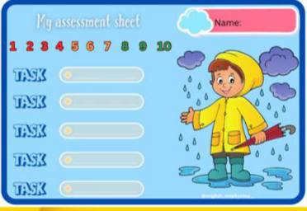  FEEDBACK  Learners provide feedback on what they have learned at the lesson.  Ex:  Home task: | 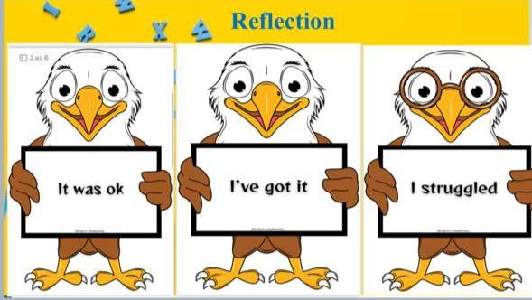  What worked well for you in today’s class?  What could we have done differently to make today’s class better for you?  What are you wondering about after today’s lesson?  What did you find difficult about today’s lesson? |  | Poster Success  

