Lesson plan
Unit: |  | School
Date: |  | Teacher's name:
Class: 5 |  | Number present: |  | Number absent:
Theme of the lesson: |  | Prepositions of location
Learning objectives(s) that this lesson is contributing to |  | 5.6.6.1 recognize with support common names and names of places; recognize the spoken form of a limited range of everyday and classroom words  5.6.7.1 use the basic prepositions of location and position; pronounce familiar words
Lesson objectives to: |  | -learn more Prepositions of location and do the tasks  - use prepositions of location to describe the location of objects.
The course of the lesson.
Planned timings | Teacher's actions |  | Pupil`s actions |  | Assessment | Resources
Organization moment.  2 min. | Good morning, dear students. I’m glad to see you.  - How are you today?  - What is the weather today?  - What date\day is it today?  In order to create friendly atmosphere in class Pupils should make a circle, touching each other with hands and say some wishes or warm words. I wish you… |  | The students greet the teacher.  Good morning, good morning to you,  We are glad to see you too.    How are you?  It’s sunny/ cold/ hot.  By telling the wishes they show their appreciations.  Students of the class are listed.  -I am brave  -I am smart  -I am important |  | Formative assessment | Whiteboard    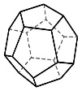
 | Teacher check the home task by method  "Umbrella" method. |  | Students check the home task |  |  | 
 | Teacher divides the students into 2 groups the numbers of the picture  1st group –  2nd group |  | Students divide into 2 groups by online and take their places |  |  | 
2 min | Teacher asks students to look at the blackboard and watch video then answer the questions  - What did you see in the video?  - How do you think what is our theme?  The teacher sets the lesson objectives, letting students know what to anticipate from the lesson. |  | Students watch the video and answer the questions |  | Descriptor:  -answers the questions | Whiteboard  PPT  https://youtu.be/77ywmL82l-4?si=5Pk7x-Vf6UqytVrb
 | Teacher explain the rule to the students  A preposition of location is a preposition which is used to refer to a place where something or someone is located. There are many location prepositions, however they can be used to discuss an almost endless number of places.  The plane is in the hangar.  The keys are in the drawer.  The fish is swimming in the aquarium.  The medicine is in the cabinet.  My brother lives in New York. |  | Students listen to the teacher’s explanation and say their opinion about rule |  | Good job! | Whiteboard  PPT  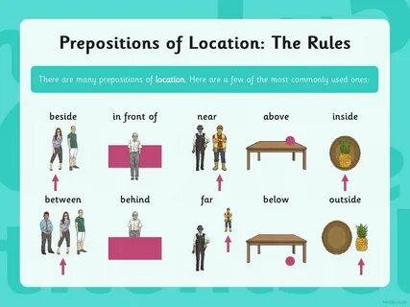
Middle of the lesson  5 min | Teacher asks students to complete the description of a castle with prepositions from the box.  GROUP WORK  READING AND SPEAKING  List of words: at on next to behind  against outside in inside  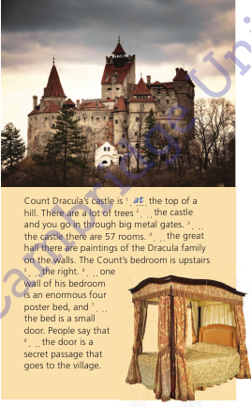 |  | Students work in groups, complete the description of a castle with prepositions from the box. |  | Descriptor:  A learner  -work in groups  - read and complete the description | Whiteboard  PPT  Eyes open p 73
 | Teacher asks students to complete the examples from the listening on page 72 by methods of “Who is quickly?”  INDIVIDUAL WORK  SPEAKING  “WHO IS FASTER?” METHOD  List of words: outside, in, at, on, on the left  1.What’s that against the wall?  2. We can play table tennis the garage.  3. Come and have a look at the garden.  4. There are fruit trees the end of the garden.  5. There’s a vegetable garden  6. You can play football the grass. |  | Students work individually and complete the examples from the listening on page 72 by methods of “Who is quickly?” |  | Descriptor:  A learner  -work individually  - complete the examples  - listening on page 72  Students evaluate each other by emotion fans   | Whiteboard  PPT  Eyes open p 73
 | Teacher asks pupils to work individually and gave them unusual task. She asks pupils: Dears do you like French fries? Each pupil takes one fries and choose the correct prepositions to complete the sentences.  INDIVIDUAL WORK  WRITING  FRENCH FRIES’ METHOD  1. His house is opposite of / opposite the skate park.  2. There’s someone outside / on the grass on / in the garden!  3. The sports stadium is on / at the left, next to the shopping centre.  4. I’m playing a basketball match at / on the sports centre today.  5. There’s a big tree in / at front of my bedroom window. |  | Students work individually, takes one fries and choose the correct prepositions to complete the sentences. |  | Descriptor:  A learner  - Work individually  - takes one fries  - choose the correct prepositions  - complete the sentences. | Whiteboard  PPT  
Physical training exercise –  3 min. | A break for physical activity.  Teacher plays the video with physical exercises. |  | Students watch and do physical exercises. |  |  | Music  https://www.youtube.com/watch?v=ZmJEhpBFKEY
 | Teacher asks students to work in pairs and find hidden words in 3 minutes  PAIR WORK  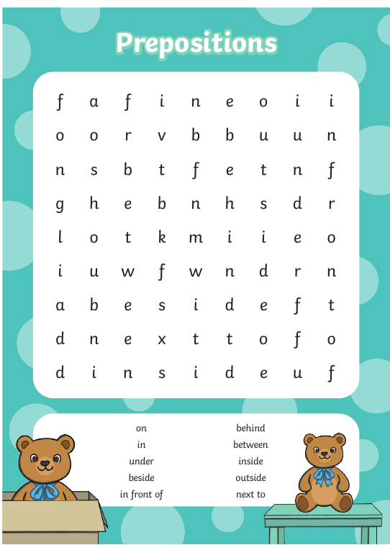 |  | Students work in pairs and find hidden words in 3 minutes |  | Descriptor:  A learner  -works in pairs  - find hidden words in 3 minutes | Whiteboard  PPT  Worksheet
 | Teacher asks students to play Preposition Tree Game. Students should take pictures and put them in special places. This game can be used to support listening to instructions and understanding of prepositions.  GROUP WORK  SPEAKING  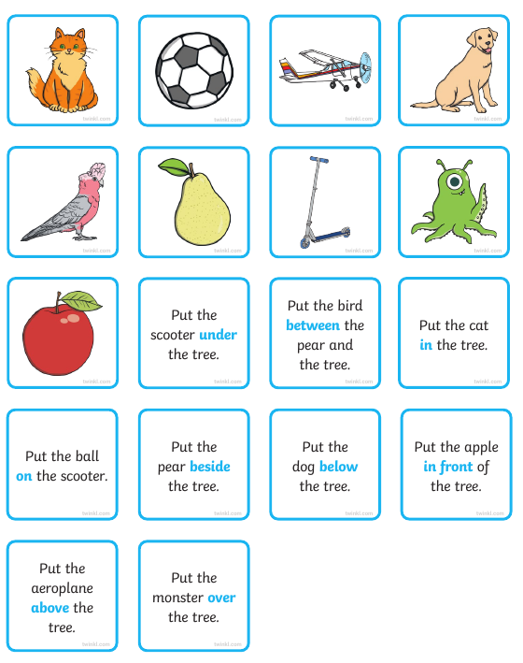 |  | Students work in groups and play Preposition Tree Game. Students should take pictures and put them in special places. This game can be used to support listening to instructions and understanding of prepositions. |  | Descriptor:  A learner  -work in groups  - play Preposition Tree Game  - take pictures  - put them in special places. | Whiteboard  PPT  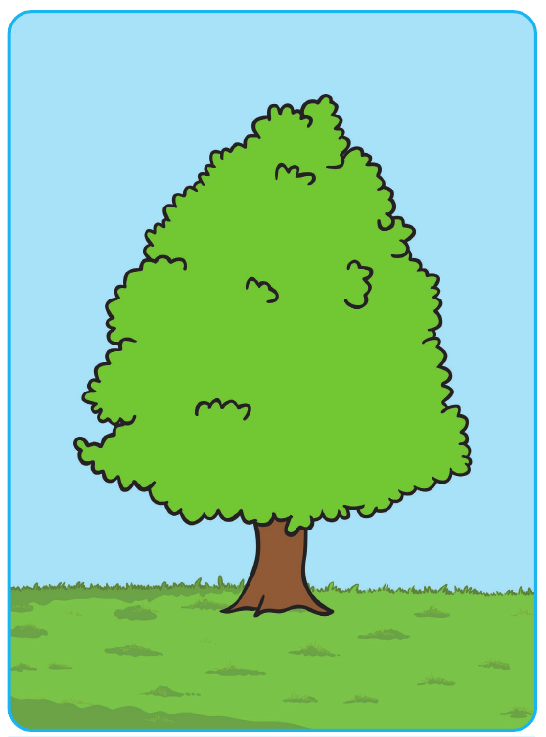
 | Teacher asks students to look at the active board and play an online game. They should choose correct answer looking to photos. Students play this game in groups |  | Students play an online game |  | Descriptor:  A learner  -works in a group  - choose correct answer | Whiteboard  PPT  https://wordwall.net/ru/resource/17403488  extra task  https://wordwall.net/ru/resource/18337092
 | At the end of the lesson teacher asks students to make sentences about Madi’s bedroom. Use the prompts and the picture  GROUP WORK  SPEAKING  1. The desk is next to the bed.  1. desk / bed  2. laptop / desk  3. bookshelves / wall  4. chair / desk  5. brown guitar / wall  6. pictures / wall |  | Students work in groups and make sentences about Madi’s bedroom. Use the prompts and the picture |  | Descriptor:  A learner  - work in a groups  - make sentences about Madi’s bedroom  - Use the prompts and the picture | Whiteboard  PPT  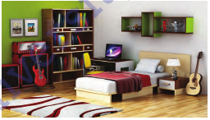
The end of the lesson  2 min | Teacher gives a homework and comment the work of Sts.  Home Assignment:  Reflection  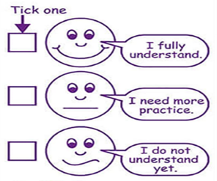 |  | Student write their homework for the next lesson.  Pupils. give a mark to themselves for working at the lesson.  Students think critically, exploring, developing, evaluating and making choices about their own and others’ ideas. |  | Pupils evaluate themselves using evaluation lists.  Reflection.  Self- Assessment. | Whiteboard  PPT

