The plan of the extracurricular activity for the 7th grade
“Quiz show”
Aim: to support students' interest in learning English.
Objectives:
- to provide a practical orientation of teaching English to students, fixing the vocabulary by topics.
- to develop memory, attention;
to develop language, intellectual and creative abilities of students;
- to develop student’s communication
The course of the event
Teacher: Good day dear students and guests. I’m glad to see you today in our auditorium at our quiz show. Let us start. I’d like the team introduce themselves.
- The name of the team of the sevenths A class is….
- The name of the team of the sevenths B class is….
- The name of the team of the sevenths V class is….
- The name of the team of the sevenths G class is….
- The name of the team of the sevenths D class is….

Teacher: The name of the first round is “puzzles”
Look at the whiteboard, there is a puzzle. Your task is to solve it. The main rule of our quiz show is to do each tasks all together, in team. You’ve got a minute to discuss. The team that solved the puzzle gets one smile. In the end of our show, we’ll count the result.
Fiction
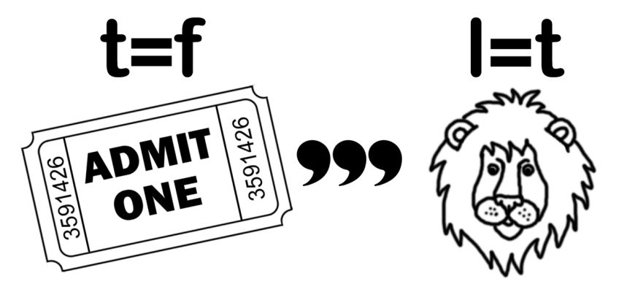

Novel
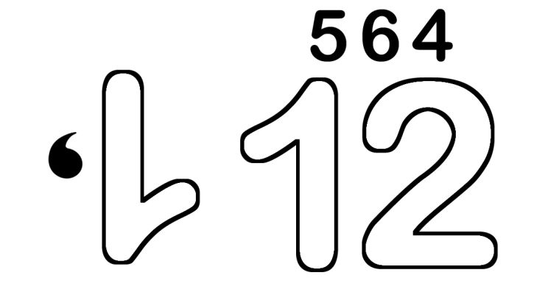

Theatre
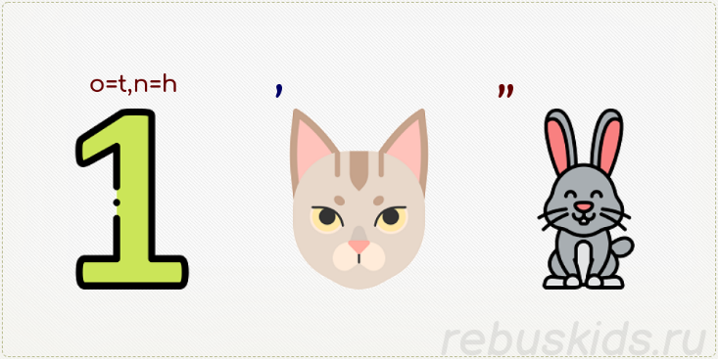

Boring

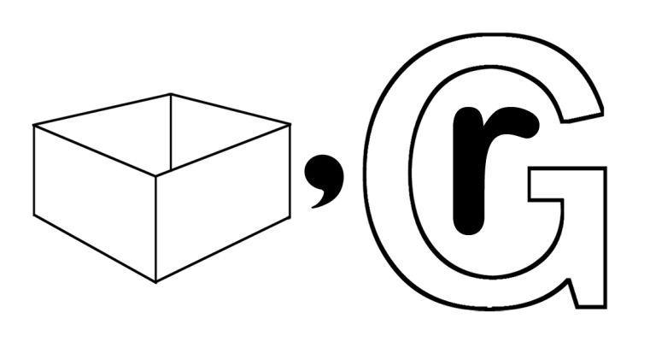
Imagination
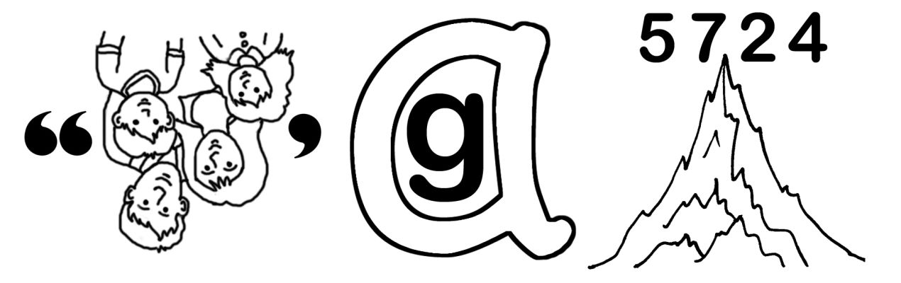

Teacher: Your results are wonderful. Get points.
The second round, we have named “Reading for pleasure”. Each of the question is connected with the stories, which we have read during the term. I call the question and you have to up your hand if you know the answer. For each right answer, your team gets smile.
- Who is the author of the “hound of the Baskervilles”? (Arthur Conan Doyle)
- What was the lord of Baskerville’s name? ( Sir Henry)
- The name of one of the most popular science-fiction story of G. Wells is… (the time machine)
- Call the heroes of the epic story “Madadai-Kara” (Kogudei Mergen, Altyn Kusku)
- What was the mystery in the story “The magic garden poor”? (no one could enter the garden except those who needed help)

Teacher: Well done. Let us go on and come to the third round. It’s title is “synonyms and antonyms” There are two envelops on your desk. Open the first and match the synonyms.
Synonyms:
Cry- shout
Big- huge
Happy- pleased
Fear-horror
Awful –terrible
Old- ancient
Antonyms:
Enemy- Friend
Rich- poor
High- low
Sweet- salt
Last- first
Healthy- sick

Teacher: The next round is “Captain’s fight”. Have you ever heard about the game who am I? You have to guess who you are with the help of your team. You may ask them a question.
What questions can you use?
- Am I an object/person/ fruit/?
- Can I be eaten?
- Am I a living being?
- Can I fly/run/jump?
- Am I a furniture?

Teacher: The last our round is called “fairy tale teller “
Your task is to write a fairy tale by the picture.

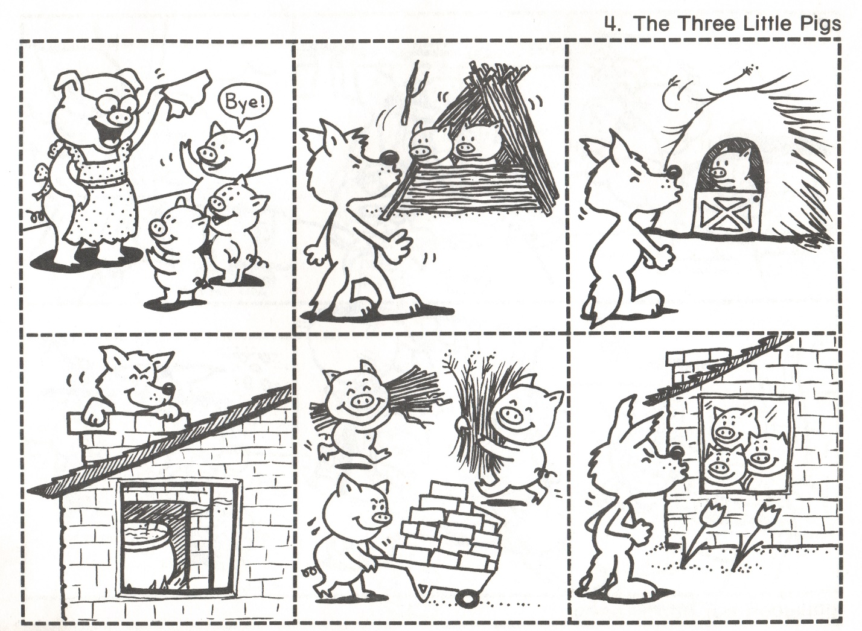

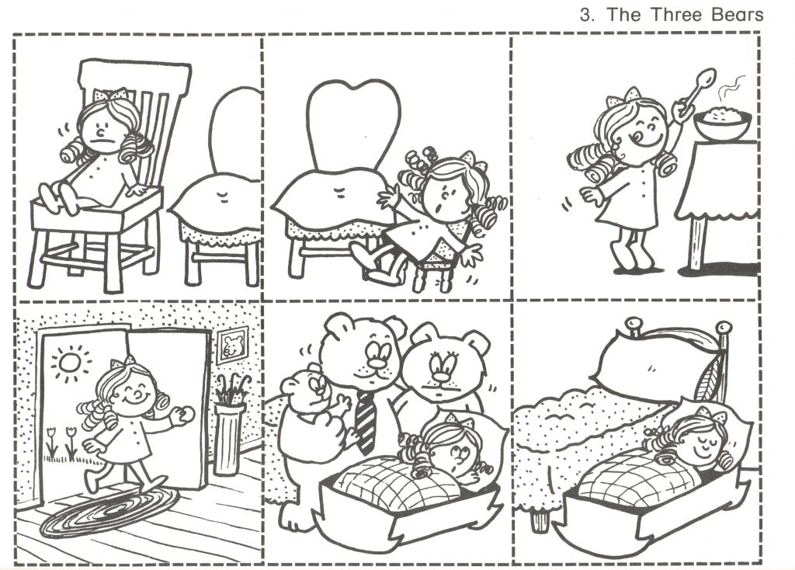

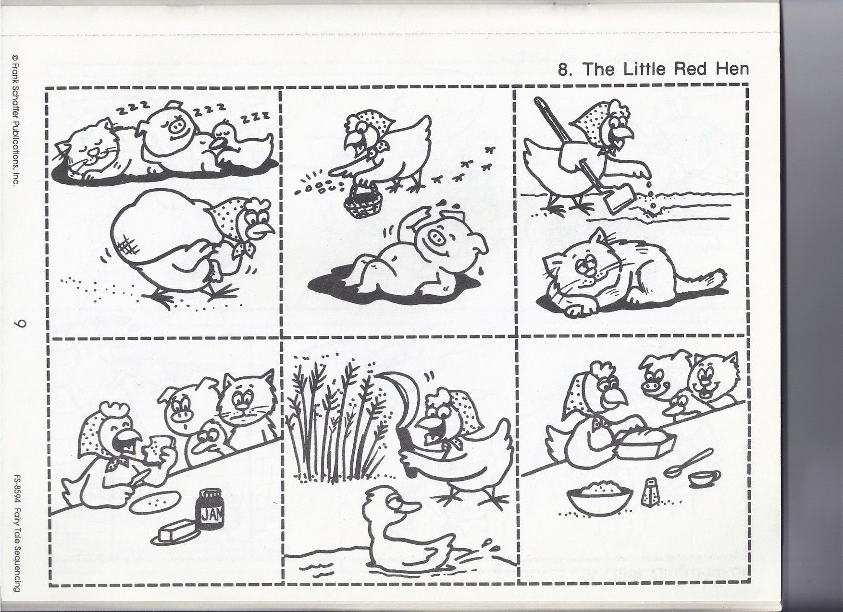

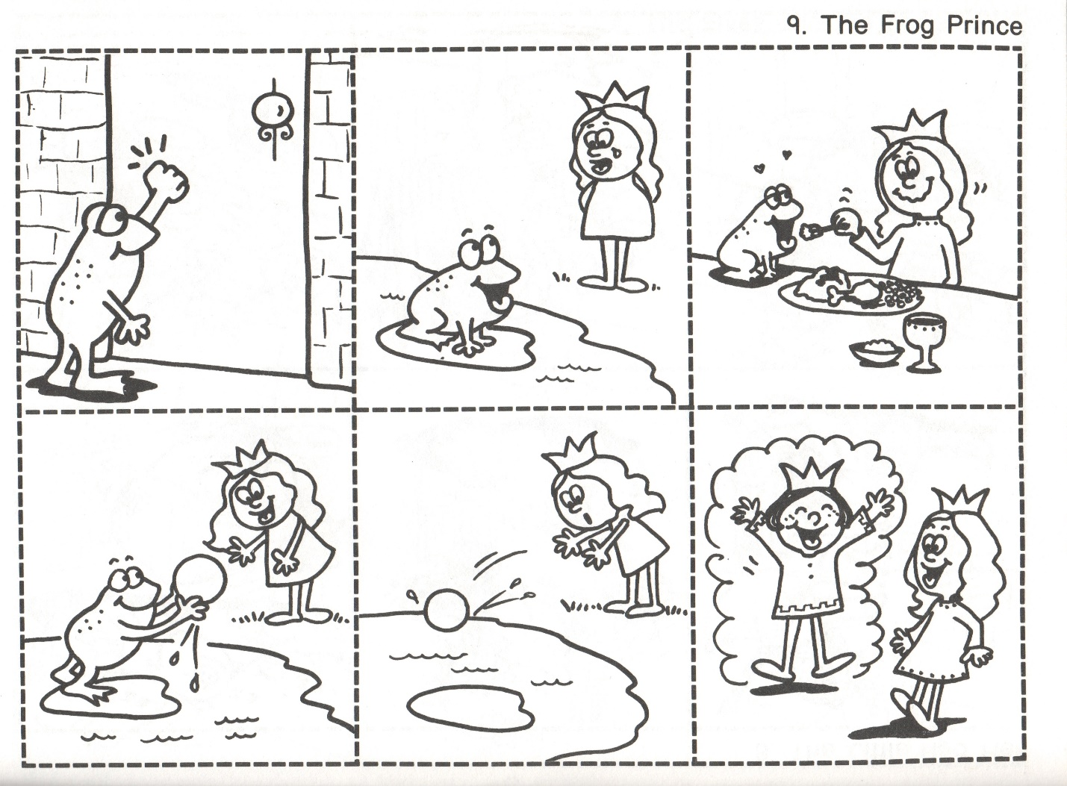

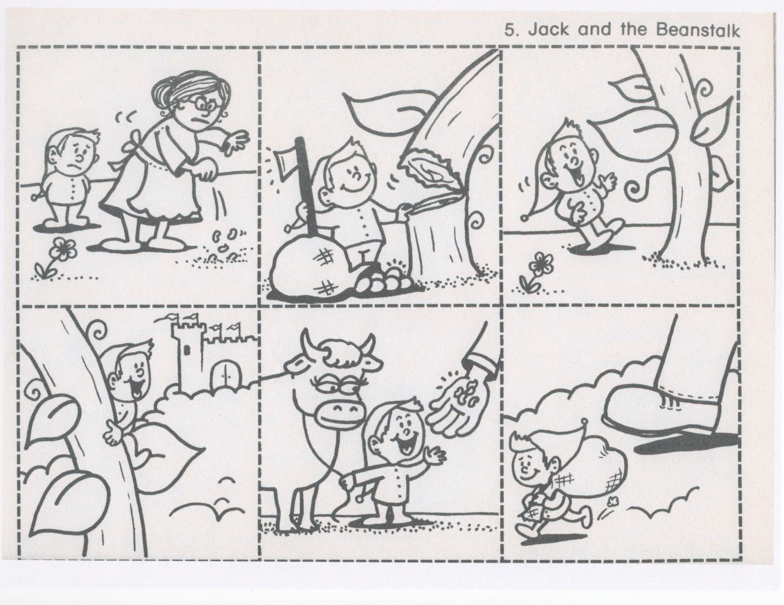

Teacher: The quiz show is over. Let us count your points. And the winner team is ….

