Lesson plan

Unit of a long term plan: “Music and Films” |  |  |  |  | School: School-gymnasium №18, Kostanay
Date: |  |  |  |  | Teacher name: Madaeva Elena Andreevna
CLASS: 9 |  |  |  |  | Number present: |  | absent:
Lesson title: |  |  | Films around the world
Learning objectives(s) that this lesson is contributing to (link to the Subject programme) |  |  | 9.3.7.1 use appropriate subject-specific vocabulary and syntax to talk about an increased range of general and curricular topics;  9.2.1.1 understand the main points in unsupported extended talk on a wide range of general and curricular topics;  9.1.6.1 organise and present information clearly to others.
Lesson objectives |  |  | All students will be able to:  make up a dialogue of 6-7 sentences using the active vocabulary on the topic “Films around the world”;  Most students will be able to:  produce a dialogue of 8-9 sentences using the active vocabulary on the topic “Films around the world”;  Some students will be able to:  create a report about the favourite types of films of the classmates using the active vocabulary.
Assessment criteria |  |  | Student can speak about the topic “Films around the world” using the active vocabulary.
Values links |  |  | Support  Cooperation  Respect  Help
Cross-curricular links |  |  | Art
Previous learning |  |  | Traditions and Language
Plan
Planned timings | Planned activities (replace the notes below with your planned activities) |  |  |  |  |  |  | Resources
Start  5 min | Good morning, dear children! I am glad to see you. How are you today? Are you ready for our lesson? Yes, so let’s start!  Watch the video and guess the topic of our lesson:  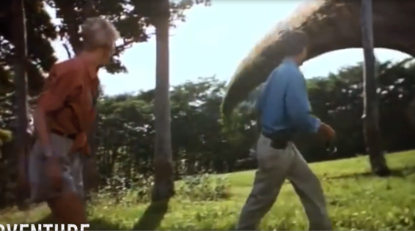  Answer questions  1. Do you like going to the cinema?  2. What do you prefer, going to the cinema or watching films on TV?  3. What is your favorite film? |  |  |  |  |  |  | https://youtu.be/ZgRj3eC0d3I?t=25
Middle  3 min  4 min  2 min  7 min  2 min  7 min  5 min | Activity №1: Learn the active vocabulary:  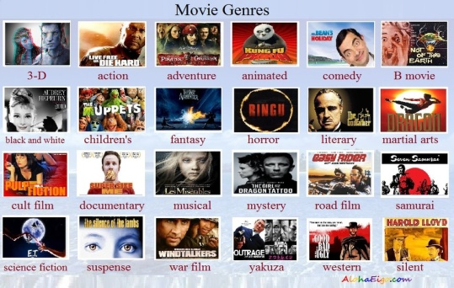  Activity №2: “Fill in the gaps” (using the active vocabulary)  Definition Film type  1. A short humorous film in which the characters are drawn. a. Drama  2. A film that is set in the future and there are some imaginary scientific developments. b. Cartoon  3. A type of film which combines comedy with a love story. c. Horror  4. A film with a very exciting story that often involves a crime. d. Science fiction  5. A film that tries to make the audience laugh. e. Costume drama  6. A film that tells a true story, often shown on television. f. Romantic comedy  7. A film in which the characters are drawn, made by computer or made from models. g. Animated film  8. A historical film, often made famous by the clothes the actors wear. h. Documentary  9. A film which tries to make the audience very frightened. i. Thriller  10. A serious film. j. Comedy  Answers: 1 2 3 4 5 6 7 8 9 10  Answer: 1b; 2d; 3f; 4i; 5j; 6h; 7g; 8e; 9c; 10a.  GROUP DIVISION (3 groups)  “Blindfold”  Reading  Activity №3.  Method “Cine-film”  Learners have different texts for reading without title.  Adventure film  There are exciting stories, with new experiences or exotic locales. These films are very similar to the action film genre, in that they are designed to provide an action-filled, energetic experience for the film viewer. Rather than the predominant emphasis on violence and fighting that is found in action films, however, the viewer of these films can live vicariously through the travels, conquests, explorations, creation of empires, struggles and situations that confront the main characters, actual historical figures or protagonists. They can include traditional swashbucklers or pirate films, serialized films, and historical spectacles (similar to the epics film genre), searches or expeditions for lost continents, "jungle" and "desert" epics, treasure hunts, disaster films, or searches for the unknown.  Horror film  These films are designed to frighten and to invoke our hidden worst fears, often in a terrifying, shocking finale, while captivating and entertaining us at the same time in a cathartic experience. They feature a wide range of styles, from the earliest silent Nosferatu classic, to today's CGI monsters and deranged humans. They are often combined with science fiction when the menace or monster is related to a corruption of technology, or when Earth is threatened by aliens. The fantasy and supernatural film genres are not always synonymous with the horror genre. There are many sub-genres: slasher, splatter, psychological, survival, teen terror, 'found footage,' serial killers, paranormal/occult, zombies, Satanic, monsters, Dracula, Frankenstein, etc.  Comedy  There are light-hearted plots consistently and deliberately designed to amuse and provoke laughter (with one-liners, jokes, etc.) by exaggerating the situation, the language, action, relationships and characters. Whether it's an animated movie suitable for the whole family or a bawdy adult film, if it's meant to be funny, it's ... There are many sub-genres of comedy, including romantic comedies, physical or slapstick comedy, and dark comedy. In this genre the plot is usually light, with the focus on the actors and their ability to amuse their audiences.  They should read the text and do the following tasks:  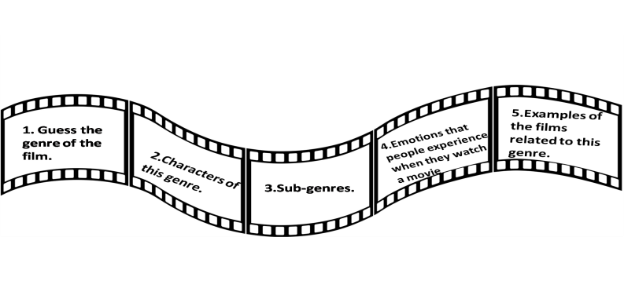  Physical activity  Activity №4:  Make up a dialogue or a report using the active vocabulary on the topic “Films around the world”.  Descriptor:  1.A learner make up a dialogue of 6-7 sentences using the active vocabulary on the topic “Films around the world”; 1 point  2. A learners produce a dialogue of 8-9 sentences using the active vocabulary on the topic “Films around the world”; 1 point  3. A learners use more 6 new words in the dialogue; 1 point  4.A learners make up a questionnaire about 5-6 complex questions to ask classmates about their favorite type of film; 1 point  5.A learners create a report about the favorite types of films of the classmates using the active vocabulary. 1 point  Activity №5:  “Crossword”  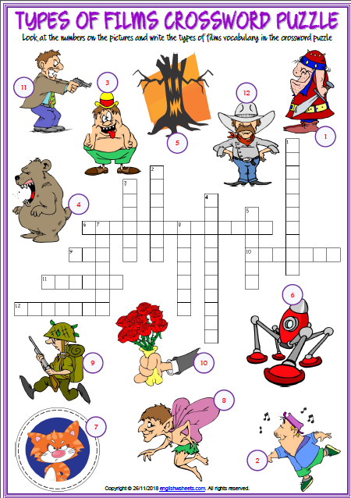  Descriptor:  1.Learners identify the genre of the film according to the pictures.  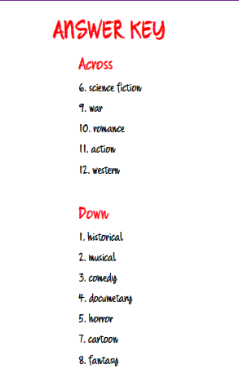 |  |  |  |  |  |  | https://www.alohaeigo.org/uploads/1/8/7/6/18762152/_____3205158.jpg?868  Handouts  https://en.islcollective.com/resources/printables/worksheets_doc_docx/lets_watch_a_film/cinema-preintermediate-a2/5550  Handouts  https://www.filmsite.org/genres.html
End  3 min | Feedback  Reflection  Method “Sinkvein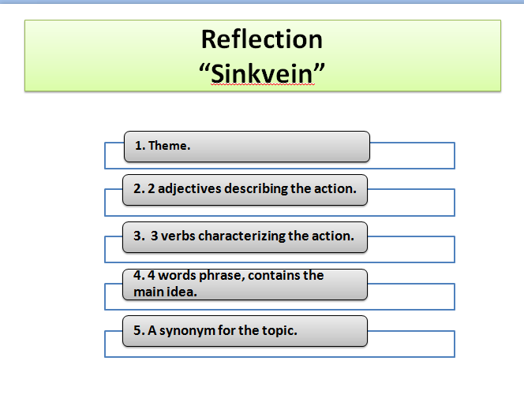 |  |  |  |  |  |  | Article: “Developing critical thinking through reading and writing”
Additional information
Differentiation – how do you plan to give more support? How do you plan to challenge the more able learners? |  |  |  | Assessment – how are you planning to check learners’ learning? |  | Health and safety check
Differentiation was achieved through the task, the lesson objectives, the division into groups. |  |  |  | I use the formative assessment in the form of spreadsheet. |  | Using physical exercises and active activities.
Reflection

Were the lesson objectives/learning objectives realistic?
Did all the learners achieve thelesson objectives/ learning objectives? If not, why?
Did my planned differentiation work well?
Did I stick to timings?
What changes did I make from my plan and why?

Summary evaluation

What two things went really well (consider both teaching and learning)?

1:

2:

What two things would have improved the lesson (consider both teaching and learning)?

1:

2:

What have I learned from this lesson about the class orindividuals that will inform my next lesson?

