Урок английского языка по теме "Travelling"
Тип урока: комплексное применение функциональной грамотности
Цель урока: создать содержательные и организационные условия для практического применения функциональной грамотности на уроке при закреплении темы.

Образовательная: содействовать формированию навыков устной и письменной речи.

Воспитательная: содействовать формированию коммуникативных навыков и развитию активности на уроке.

Развивающая: содействовать развитию речевой активности, памяти, образного мышления, познавательного интереса, рефлексии деятельности.

Задачи:
- отработать лексику по теме “Путешествие”, “Транспорт
- отрабатывать навыки говорения и письма.

Оборудование урока:

- классная доска;
- проектор и экран;
- наглядные материалы:
- слайды (страны/достопримечательности, транспорт);
- вещи в дорогу (сумка, одежда)
- текст физ.минутки;
- раздаточный материал:
- бланки лексически заданий;
- конверты для групповой работы;

LESSON: Module 9 Lesson 12 |  |  | School - lyceum
Date: |  |  | Teacher name: Balmukhambetova M.M.
CLASS: 6 A |  |  | Number present: |  | absent:
Learning  objectives(s) that  this lesson is  contributing to |  | 6.1.10.1 - use talk or writing as a means of reflecting on and exploring a range  of perspectives on the world  6.6.6.1 use basic personal and demonstrative pronouns and quantitative  pronouns some, any, something, nothing anything on a limited range of  familiar general and curricular topics  6.3.7.1 - use appropriate subject-specific vocabulary and syntax to talk about  a limited range of general topics, and some curricular topics;
Lesson objectives |  | All learners will be able to:
 |  | take part in some exchanges using some target language accurately and use
Most learners will be able to:
take part in some exchanges using a range of target language accurately and
use some target vocabulary with correct word stress
Some learners will be able to:
take part in some exchanges using a range of target language accurately and
use most target vocabulary with correct word stress
Previous learning |  | lexico-grammatical structure (missing words)
Plan
Planned timings | Planned activities |  |  | Learner’s activity |  | Evaluation |  | Resources
Beginning the lesson  6.4.4.1 | Organisation moment  Hello, students! Nice to see you again! Sit down, please! How are you today? : I am glad you are fine! Let’s start our English lesson  Warm – up  People usually travel in summer. So, today we are going to speak about travelling. Please, look at the board and read the saying.  Quotation « The world is the book. And those who do not travel read only one page»  What do you think about it?  Do you agree ?  What country would you like to visit?  Aim of the lesson  So, today we are going to make a plan of travelling. What points should we mention to make a plan? (на основе высказываний учащихся составляем “схему” с основными аспектами путешествия: куда? на чем? что взять? чем заняться?) |  |  | Greeting  Learners discus the quotation through the questions |  | Emoticon |  | Presentation 1slide  2 slide
Main  Activities  6.1.8.1  6.1.10.1 | Today you’ll write a letter – advice. I enjoy travelling but can’t choose country, transport and so on. I hope you will help me.  I prepared a map with the tasks. We’ll work together and at the end of the lesson you’ll give me advice. Let’s start. (На доске появляется карта с пунктами остановки )  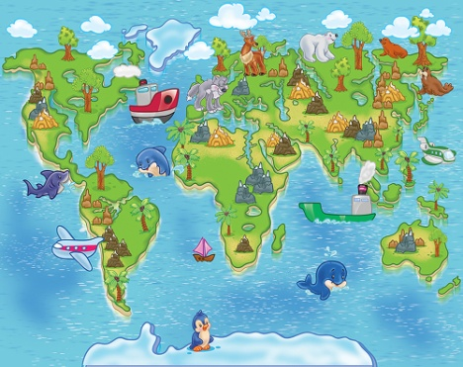  - Country.  Let’s start with the countries. What countries do you know? Look at the board , you see the flags and symbols of different countries. Your task is to match flag, symbol and make the sentence .  ( на доске флаги и символы из разных стран)  Ex. I think you should visit ….. and take photo of …..  I’m sure you should go to ….. and visit ……  - Clothes  Fine. And what things should we take? Work in groups of four. There are a lot of different things on the desks, choose only those you need and call them.  (учащиеся в группах подходят к столам, на которых разложены различные предметы, их задача: отобрать необходимые для путешествия вещи, сложить их в чемодан и прокомментировать свой выбор)  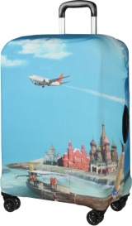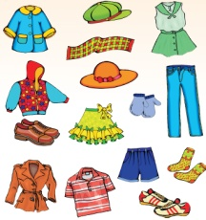  - Transport  You should choose transport and explain pros and cons of this transport.  - Let’s review vocabulary with cards.  You will work in groups. (Учащиеся в группах выполняют задание на карточке, взаимопроверка)  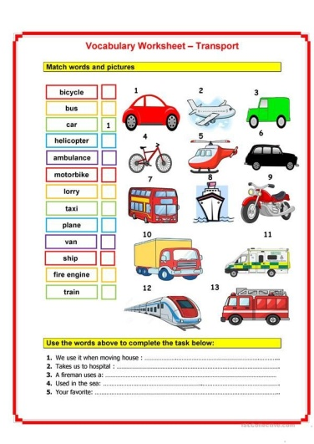  - Finish the sentences . Use keywords:  Comfortable , safe, cheap, expensive, dangerous, fast, slow.  I think …. is ….. .  I’m sure …..is …… .  In my opinion you should choose …. because it is …..  - Physical minute  Stand up. We a little bit tired and should rest. Look at the board and follow the instructions. (Учащиеся повторяют действия разных видов путешествия, которые демонстрируются на экране)  5)Letter – advice  Write a letter about pros and cons of travelling (60 words) . Follow the plan below.  Plane  Hello, my friend! How are you? I’m fine , I want to write you about my trip.  We all like travelling to different places, but I prefer to go to ……. I’m sure , this country is …… .  The weather in this country is …… that’s way you should take …. (clothes).  By the way don’t forget to choose the best transport. There are certain advantages to travelling by …. . Firstly, … . Also, … .  On the other hand , there are certain drawback s to travelling by … . First of all, …. . Secondly , …. .  To sum –up, …. . Although …, they are … . |  |  | Learners discuss task through the map  Learners make the sentences  Learners work in groups , choose the clothes for holiday  Learners review transport and give advice  Learners write a letter |  | Individual evaluation  Group evaluation  Group evaluation  Individual evaluation |  | 3 slide  4 slide  5 slide  6 slide  Video
Ending the  lesson  6.5.3.1 | Reflection  Learners provide feedback on what they have learned at the lesson. Learners will continue the following sentences:  In this lesson I was a little bit surprise about ….  I got interested in ….  The most difficult point for me was…..  Saying goodbye |  |  |  |  | Self - assesssment

