Lesson plan
Long-term plan unit:  9.3A: Traditions and Language (Language with content) |  | School: 45 school-gymnasium
Date: 05.02.2021 |  | Teacher name: Musakhal S.B.
Grade: 9 |  | Number present: |  | absent:
Theme of the lesson |  | Films in Kazakhstan
Learning objectives(s) that this lesson is contributing to |  | 9.S6 link comments with growing flexibility to what others say at sentence and discourse level in pair, group and whole class exchanges  9.L5 recognise the opinion of the speaker(s) in unsupported extended talk on a wide range of general and curricular topics  9.R6 recognise the attitude or opinion of the writer in extended texts on a range of familiar general and curricular topics
Lesson objectives
All learners will be able to:
- Participate in discussion about kazakh artifacts
- Understand the new words with their definition
- Retell their information
Most learners will be able to:
- Retell the information using new words and grammar
Some learners will be able to:
- Support peers with explanation within group work
- Evaluate others following all points of success criteria
Success criteria |  | - Explain the information clearly  - Use topic vocabulary  - To read the text and do tasks  - Evaluate others’ points of view and make conclusion
Value links |  | Respect by listening to other’s points of view, being tolerant towards their opinions  Co-operation
Cross curricular links |  | History of Kazakhstan, Kazakh literature
ICT skills |  | Internet resources
Previous learning |  | Traditions and languages
Plan
Planned timings | Planned activities |  |  |  | Resources
Beginning  1-20 min | Greeting.  Setting the aims of the lesson  Organization moment  Teacher gives new vocabulary related to film and shows the trailers of famous 3 films, after they have to find out which of these films are concerned with new words.  Skills: speaking, listening, reading |  |  |  | https://www.youtube.com/watch?v=2e-eXJ6HgkQ  https://www.youtube.com/watch?v=SPNogu64jvE  https://www.youtube.com/watch?v=Y6U7mAnPtw4
Middle  20-37 min | Teacher asks the students about the Kazakh film industry and discuss with each other.  Teacher shows the task related to the films and pupils guess films with smiley3. |  |  |  | 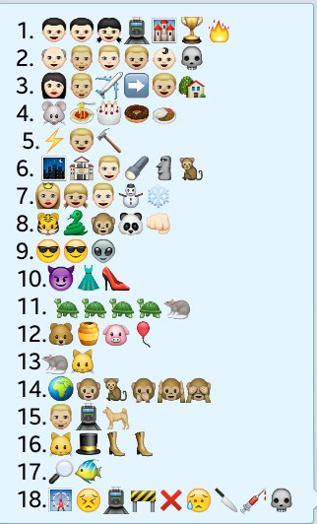
End  37-40 min | Feedback: Two stars and one wish |  |  |  | Stickers
Additional information
Differentiation – how do you plan to give more support? How do you plan to challenge the more able learners? |  |  | Assessment – how are you planning to check learners’ learning? | Health and safety check  ICT links  Sit straight
Differentiation by teacher’s support |  |  | Assessment is going to be held by success criteria and as a feedback  “Two stars and one wish” | A Break at the lesson for 2 minutes
Reflection  Were the lesson objectives/learning objectives realistic? Did all learners achieve the LO?  If not, why?  Did my planned differentiation work well?  Did I stick to timings?  What changes did I make from my plan and why? |  |  | Use the space below to reflect on your lesson. Answer the most relevant questions from the box on the left about your lesson.
Summary evaluation
What two things went really well (consider both teaching and learning)?
1:
2:
What two things would have improved the lesson (consider both teaching and learning)?
1:
2:
What have I learned from this lesson about the class or achievements/difficulties of individuals that will inform my next lesson?

