Unit of a long term plan “Values” |  |  | School: Communal Public Institution "Secondary school №29”
Date: 26.11.2019 |  |  | Teacher name: Shakayeva D.Kh.
Class: 5B |  |  | Number present: |  |  | Absent:
Lesson title: | Unit revision
Learning  objectives(s) that this  lesson is contributing to (link to the Subject programme) | 5.R2 understand with little support specific information and detail in short, simple texts on a limited range of general and curricular topics  5.S3 give an opinion at sentence level on a limited range of general and curricular topics  5.W3 write with support factual descriptions at text level which describe people, places and objects
Lesson objectives | All learners will be able to:  - formulate with support a limited range of familiar general topics when writing with 75% accuracy  - recognize most specific information on unit “Values” when listening a few errors  - apply appropriate specific vocabulary when talking about “Values”  Most learners will be able to:  - write with support a sequence of short sentences on a limited range on the topic when writing about family, friend with 85% accuracy  - recognize most specific information on a wide range of “Values” with few errors  - apply appropriate specific vocabulary when talking about “Values”  Some learners will be able to:  - invent text on the topic  - figure out information of “Values”  - compose a text about the features about the Values of family and friend
Assessment criteria | - formulate information and details of short, supported talk on a range of familiar topics  - apply appropriate subject specific vocabulary when talking about general topics
Values links | organize and present information clearly to others
Cross-curricular links | Self-knowledge
Previous learning | What we value
Plan
Planned timings | Planned activities (replace the notes below with your planned activities) |  |  |  | Resources
Beginning  0-10 min | What’s in this module?  Circle of values  Children stay in a circle. Pass around a box filled with questions connected to the topic of the lesson. Play music, when the music stops, the child with the box must pick out a question, read it and answer. Suggested questions: Do you love your family? Do you have a best friend? What is health? What do you like doing? What does your friend hate doing? What does your father love doing?  We are a big family where the main values are respect, friendship and love.  FA. “Three claps”?  Descriptor  - answer to the questions |  |  |  | Appendix 1  Box with questions  PPT slide 1
Middle  10-15  15-20 min  20-21 min  21-33 min | Task 1. (I)  Each student has a coloured card on the table. This colour determines the level of the task.  Who has purple card, you must to complete the sentence.  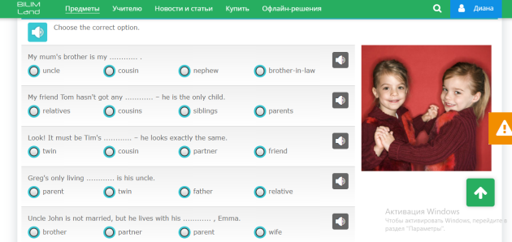  Who has orange card, you must mark the family members who are women and girls.  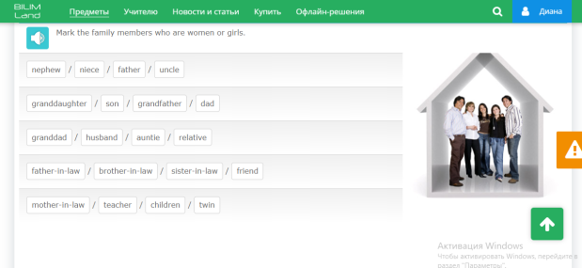  Who has yellow card, you must mark the odd one word out.  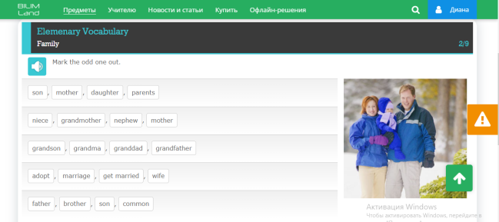  FA: “Traffic lights”  Descriptor  - 3 mistakes  - 2 mistakes  - 0-1 mistake  (fill out the self assessment)  Divided into pairs by pictures.  Task 2 (I, P)  Students must describe the picture in 2 sentences.  Descriptor:  - pronounce the sentences  - use Present Simple, love, like, hate + -ing form  (fill out the self assessment)  TPR sing a song “My family”  Task 3. (G)  Divide to two groups with cards: first group “Family” (father, mother, sister, brother), second group “Friend” (clever, kind, helpful, intelligent)  Group “Family” and “Friend” you must write around gingerbread adjectives, adjective phrases and verbs + nouns to describe values of family and friend e.g. short, dark hair, blue eyes, quite tall, friendly, helpful, kind, likes swimming, doesn’t like football, can play the guitar, can’t play a recorder, like watching TV together, love helping to mother/father/sister/brother, spend time together, to be healthy, celebrate family holiday, friendly, big, small  FA “Give mark”  Descriptor  “5” – excellent  “4” – good  “3” – alright  (fill out the self assessment)  Conclusion  Our unit about values is coming to the end. And I wish you to be so friendly, cheerful, and happy and most importantly, always have mom and dad nearby. |  |  |  | https://bilimland.kz/ru/courses/english-language/mskills-english/elementary-level-vocabulary/lesson/006-family  PPT slides 2,4,6 tasks  3,5,7 answers  PPT slide 8  PPT slide 9  PPT slide 10  Video  A4, markers  PPT slide 11  PPT slide 12
Ending the lesson  33-40 min | Reflection “Ladder of success”  On the blackboard is the poster with a ladder of success with a ten point scale. Each should choose a colour man and assessment yourself on a ten-point scale.  Blue men – numbers 8-10  Green men – numbers 5-7  Yellow men – numbers 2-4  Homework  I have just received a letter from Bill.  Spending time with my family is the most desired pastime! On weekdays, we usually get together for dinner, and on weekends we spend the whole day together. These are the best moments of my life. We love traveling, going hiking, walking in the park, rollerblading and playing board games. Sometimes we go to the cinema. We have a friendly family and we are never bored!  And you? Who do you spend your weekends with family?  Who is at a number 8-10 your homework is to write essay with 5-6 sentences.  Who is at a number 5-7 your homework is to make sentences with construction  I love …  I like …  I hate …  Who is at a number 2-4 your homework is to (underline the sentences with construction love\like\hate +-ing form) |  |  |  | Poster, men  Music SMS  PPT slide 13
Additional information
Differentiation – how do you plan to give more support? How do you plan to challenge the more able learners? |  | Assessment – how are you planning to check learners’ learning? |  | Health and safety check
FA “Who is the best?”  Descriptor  “5” – excellent  “4” – good  “3” – alright |  | Peer assessment  Strategy “Ladder of success” |  | Using physical exercises and activities
Reflection  Were the lesson objectives/learning objectives realistic?  Did I stick to timings?  What changes did I make from my plan and why? |  | Answer the most relevant questions from the box on the left about your lesson.
Summary evaluation

What two things went really well (consider both teaching and learning)?
1: ____________________________________________________________________________________
________________________________________________________________________________________________________________________________________________________________________________________________________________________________________________________________________________________________________________________________________________________

2: ____________________________________________________________________________________
________________________________________________________________________________________________________________________________________________________________________________________________________________________________________________________________________________________________________________________________________________________

What two things would have improved the lesson (consider both teaching and learning)?
1: ____________________________________________________________________________________
________________________________________________________________________________________________________________________________________________________________________________________________________________________________________________________________________________________________________________________________________________________

2: ____________________________________________________________________________________
________________________________________________________________________________________________________________________________________________________________________________________________________________________________________________________________________________________________________________________________________________________

What have I learned from this lesson about the class or achievements/difficulties of individuals that will inform my next lesson?
______________________________________________________________________________________
________________________________________________________________________________________________________________________________________________________________________________________________________________________________________________________________________________________________________________________________________________________

