Long-term plan unit: Unit 6: Food and drinks  LESSON 53: Hot and cold (1) |  |  |  |  |  | School: КГУ «ОШ (РЦ) «ОШ им Ы Алтынсарина» |  |  | Утверждаю:  заместитель директора по УР
Date: |  |  |  |  |  | Teacher name: Куприянчик Виктория Игоревна
CLASS: 1 |  |  |  |  |  | Number present: |  |  |  | absent:
Learning Objectives(s) that this lesson is contributing to |  |  | 1.L3 recognize with support common names and names of places recognize the spoken form of a limited range of everyday and classroom words;  1.UE9 use common present simple forms [positive, negative and question] to give basic personal information;  1.UE7 use personal subject and object pronouns to give basic personal information
Lesson  Objectives | All learners will be able to:
- recognise 1-3 words according to the topic, follow the instruction according to the task;
- make up correct 1 positive and 1 negative sentence about the things they like and dislike;
- answer questions using pronouns with teacher’s support.
 | Most learners will be able to:
- recognise 4-6 words according to the topic, follow the instruction according to the task;
- make up correct 2 - 3 positive and 2 - 3 negative sentence about the things they like and dislike;
- answer questions using pronouns with some mistakes.
 | Some learners will be able to:
- Recognise the most of words according to the topic, follow the instruction according to the task;
- make up correct more 3 positive and 3 negative sentence about the things they like and dislike;
- answer the most of questions using pronouns.
Previous learning |  |  | Food’s words, asking and answering the questions using hmm, nice, yuk, urghhh, making up dialogues about food.
Plan
Planned timings |  | Planned activities |  |  |  |  |  |  |  |  | Resources
Beginning |  | - Class organization  - Revising previous learning  - Video  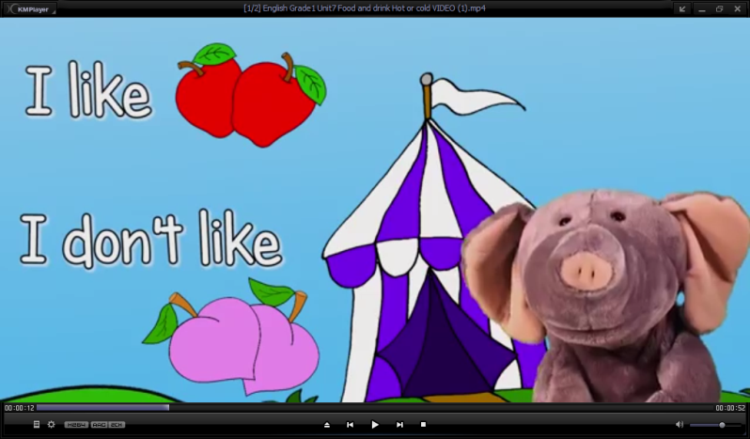  - (W) Listen and repeat  Go to school, brush your teeth, dry your hair, take your bath, wake up, eat breakfast, study, get dressed, wash your face, get home  - (W/I) Listen to the recording. Circle the correct answer in the worksheet. Appendix 1.  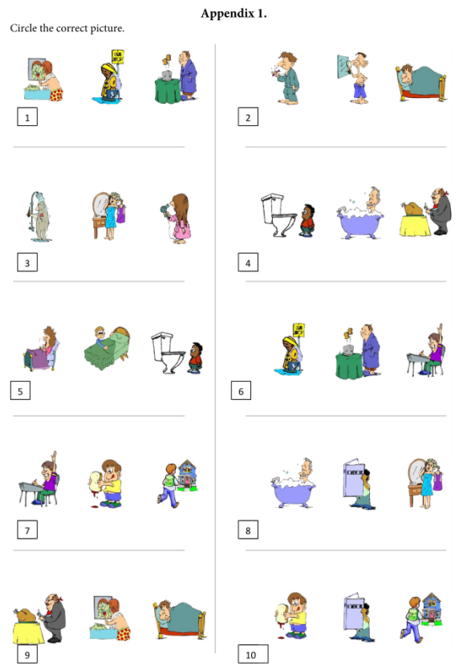  - (W) Listen and repeat  Meat, chicken, salad, pasta, rice, cheeseburger, fish, beans, he/she likes, he/she doesn’t like  - (W/I) Look at the pictures. Say what Ben and Penny like and don’t like. Talk about them.  Example: Ben likes chicken. He doesn’t like beans.  Kim likes salad. She doesn’t like fish.  - (W) Listen and repeat  Hot milk, vegetables, orange juice, Do you like … ? Yes, I do. / No, I don’t. What would you like? I would like … . Does Kim/Ben like … ? Yes, Kim/Ben does. / No, Kim/Ben doesn’t. What does he do? I … .  - (W) Look at the pictures. Answer the teacher’s questions. |  |  |  |  |  |  |  |  | Cards or poster  https://www.youtube.com/watch?v=W_siaVSv3Qs  Cards or poster  http://www.123listening.com/freeaudio/dailyroutines1-1.mp3  Cards or poster  Cards or poster  Cards or poster  Cards or poster  Cards or poster
End  Feedback |  | Evaluation of the lesson by means of oral feedback from students – images of smiles.  Teacher asks guiding questions:  - Can you name hot and cold food?  - Can you say I like/ I don’t like?  - Can you say He / She doesn’t like?  - Can you answer the questions?  - Homework: learn words |  |  |  |  |  | 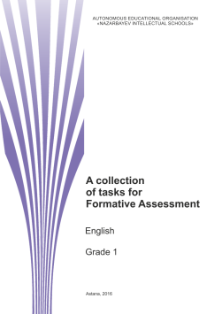  AUTONOMOUS EDUCATIONAL ORGANISATION  «NAZARBAYEV INTELLECTUAL SCHOOLS» Astana, 2016  English  A collection of tasks for Formative Assessment  Grade 1  1.L3, 1.UE9, 1.UE7
Additional information
Differentiation – how do you plan to give more support? How do you plan to challenge the more learners? |  |  |  |  | Assessment – how are you planning to check learners’ learning? |  | Cross-curricular links  Health and safety check  ICT links  Values links
- Struggling learners will be given more prompts to help them speak;  - More able learners will be encouraged to make their speaking more complex;  - more able learners will be challenged by prompting their groups to develop speaking;  - Pair/ group work. |  |  |  |  | - Success criteria for FA;  - Observing;  - Feedbacks;  - SA  - PS |  | - White board is used no more than 10 minutes;  - Use water based pens;  - Health promoting techniques;  - Breaks and physical activities used;  - Cross-curricular links: the world around us;  - ICT links: use tracks or video no more 10 min;  - Students in pair work learn to be patient and helpful;  - The value of following interest;
Reflection  Were the Lesson Objectives/Learning Objectives realistic?  What did the learners learn today?  What was the learning atmosphere like?  Did my planned differentiation work well?  Did I stick to timings? What changes did I make from my plan and why? |  |  |  | Use the space below to reflect on your lesson. Answer the most relevant questions from the box on the left about your lesson.
Summary evaluation

What two things went really well (consider both teaching and learning)?

1:

2:

What two things would have improved the lesson (consider both teaching and learning)?

1:

2:

What have I learned from this lesson about the class or individuals that will inform my next lesson?

